ROBERT BURNS
Цілі і завдання заходу:
1. вдосконалення навичок виразного читання віршів;
2. активізація лексичного та граматичного матеріалу;
3. розвиток інтересу до поетичних творів Роберта Бернса;
4. розвиток мовної здогадки;
5. розвиток міжкультурної компетенції;
6. вдосконалення навичок усного мовлення та вимови;
7. вдосконалення навичок аудіювання;
8. розвиток інтелектуальної, емоційної і мотиваційної сфери особистості учнів.
Виховні цілі: здійснення морального виховання, формування інтересу до іншомовної культури.
Освітні цілі: розширення кругозору, підвищення загальної культури учнів.

Boy 1: Good day , ladies and gentlemen ! Welcome to our Scottish party!
Boy2: Nice to meet you to our special party dedicated to Burns Birthday!
Boy 3: Welcome, dear friends! We are starting!
Boy1: Today is the 25th of January and we are nice to see you here to remember the birthday of the famous poet of Great Britain and the national poet of Scotland – Robert Burns!
Boy 2: He was a remarkable lyric poet and he wrote humorous, ironical and satirical poems as well. Besides he glorified true love and friendship.
Pupil: The biggest city of Scotland Glasgow which lies on the river Clyde is the largest port of the country. But to the south-west of Glasgow lies the pleasant town of Ayr, notable as the homeland of Robert Burns. It was there that in 1750 William Burns, a farmer gardener, accepted an offer to rent a few acres of land in a small village of Ayrshire. He wanted to become an independent farmer but all the land belonged to the landlords, and in order to take a farm one had to pay for a lease first, and then a monthly rent to the landlord. So William Burns borrowed one hundred pounds and became a farmer in Alloway. He was a hard-working man. With his own hands he built a small clay cottage, married a pretty girl, Agnes Brown, with beautiful eyes and soft singing voice, and brought her to his modest home. It was there that on January 25,1759 Robert Burns, Scotland’s national poet was born ( the first of seven children)
The storms were terrible that year, the wind blew the roof off and, just imagine, the mother with her new-born baby had to seek shelter in a neighbour’s house.
(The pupils perform a short play about Robert's first day of life.)
Scene: A room in the Burns' neighbour's house. A man and a woman with a baby in her arms are sitting there. The man is making something with a hammer. The baby is asleep.
Woman: The night is so stormy. It is snowing. Somebody is knocking.
Husband: I'll open the door.
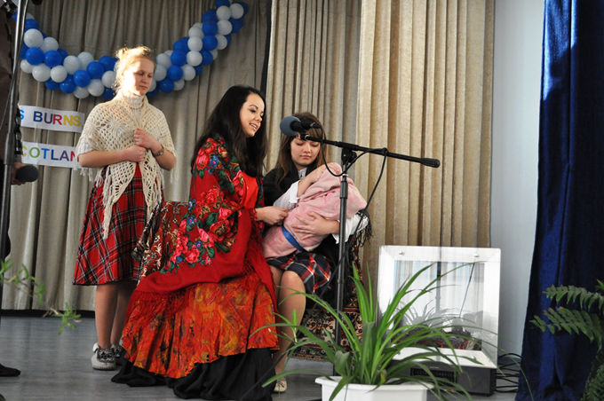
Burns' Mother (coming in): My dear neighbours! The storm has broken the roof of my house. May I spend this night at your place?
Woman: Oh, dear! You are welcome! Sit down, please. Let me have a look at your baby. What a handsome boy!
Husband: Hush! Somebody is knocking again. Who can it be? The snowstorm is so terrible!
Woman: Oh, a stranger may have lost his way. We can't leave anyone without help. Open the door, my dear.
Gypsy (entering the room): Hello! How are you? I'm cold and wet. May I warm myself in your house?
Woman: Of course, my dear Sarah. She is a Gypsy. She can tell fortunes.
Gypsy: What a nice baby! Let me see his hand. Oh, this boy won't be a fool. He'll be famous! He will glorify his family and country.
Man: The Gossip keekit in his loof,
Gypsy: Quo' scho wha lives will see the proof,
This waly boy will be nае coof,
I think we'll ca' him Robin
He'll hae misfortunes great and sma',
But ay a heart aboon them a':
All: He'll be a credit till us a',
We'll a' be proud o' Robin.
Разжав младенческий кулак,
Гадалка говорила так:
- Мальчишка будет не дурак.
Пускай зовется Робин.
Немало ждет его обид,
Но сердцем всё он победит.
Парнишка будет знаменит,
Семью прославит Робин.

(All the four personages sing the following lines of Burns' poem "Robin "):(Here a couplet and refrain of the song "There Was a Lad" by Mark Karminsky are heard recorded on a tape-recorder.)
Rantin', Rovin' Robin
There was a lad was born in Kyle,
But whatna day o' whatna style,
I doubt it's hardly worth the while
To be sae nice wi' Robin.
Chor. - Robin was a rovin' boy,
Rantin', rovin', rantin', rovin', 2 times
Robin was a rovin' boy,
Rantin', rovin', Robin!
Pupil: In 1765 Robert was sent to school, but his school days did not last long because his teacher soon got another job and left. Then Burns' father persuaded some neighbours to hire a young man as a teacher for their children. This young man was John Murdoch. He was very clever and taught his pupils grammar, history, English prose and poetry and even some Latin. They read Shakespeare, Milton and other most important writers of the 16th — 18th centuries.
Pupil: Here, in Alloway, Robert spent the first seven years of his life, listening to his mother’s old Scottish songs and to his aunt’s Betty’s tales and songs about devils, ghosts, fairies and witches. Years later Burns put much of this into his great poems “Tam O’ Shanter” and “Hallowe’en”. (U Tube “Tam O’Shanten Video”)
Pupil: Robert's childhood and adolescence were not happy. Hard work on the farm made it impossible for Robert to continue his studies. Being the eldest in the family Robert had to begin working on the farm at a very early age. He worked in the field on a par with grown-ups. And very often Robert composed his poems and songs when going behind the plough driven by oxen.
Pupil: Robert could continue his studies in 1772 when William Burns sent him and his brother to study at the village school at Dalrymple, four miles from Ayrshire. But the boys had only one pair of shoes, so they went to school in turn: one week Robert and the next – Gilbert. But in the summer Robert was sent by his father for three weeks to Ayr to live and study with Murdoch, now an English master at the Ayr school. Burns even started learning French.
Pupil: By the way, do you know that his first love song was dedicated to Nell, a country girl, who helped him in the field? Nell was 13 at that time and Robert was a year older. “My Handsome Nell” became the most popular song in the neighbourhood. Let’s listen to it.
(U Tube O, Once I Loved a Lass)
Pupil: It’s interesting to note that at 14 Burns decided to write his poetry in the Scottish dialect. His letter show that he could write English well, but he loved the richness of the Scottish language. He composed verses to the melodies of old folk –songs, which he had admitted from his early childhood. The song “Mally’s Meek” is one of them.
Chorus—Mally's meek, Mally's sweet,
Mally's modest and discreet;
Mally's rare, Mally's fair,
Mally's every way complete.
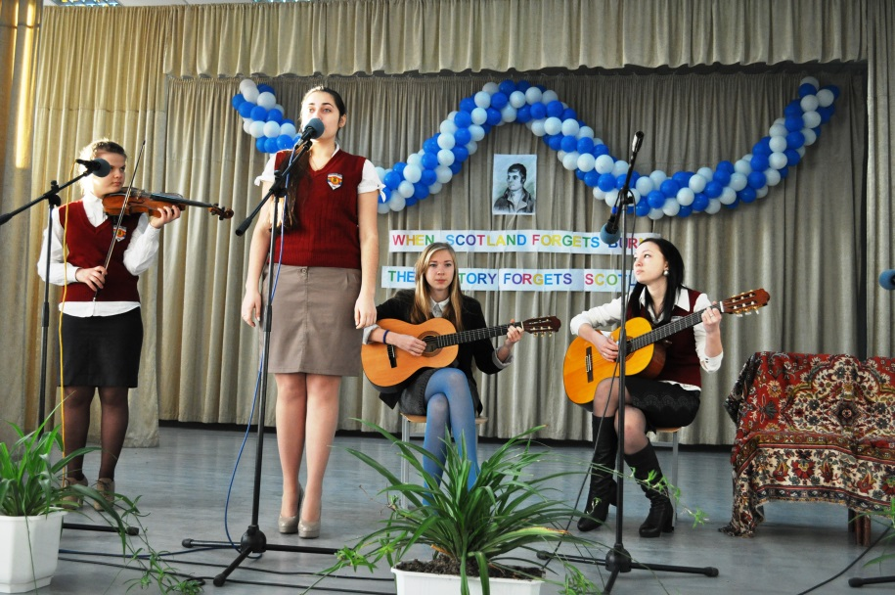
As I was walking up the street,
A barefit maid I chanc'd to meet;
But O the road was very hard
For that fair maiden's tender feet.
Mally's meek, &c.

It were mair meet that those fine feet
Were weel laced up in silken shoon;
An' 'twere more fit that she should sit
Within yon chariot gilt aboon,
Mally's meek, &c.

Her yellow hair, beyond compare,
Comes trinklin down her swan-like neck,
And her two eyes, like stars in skies,
Would keep a sinking ship frae wreck,
Mally's meek, &c.

Pupil: The first songs were composed by Robert to the tunes of popular folk songs. They were sung by his mates and neighbours and made him famous in his parts. Robert wrote about the lasses and lads he knew well, about everything that happened to them. Here is one of those songs, "Comin' thro' the rye".

Coming thro' the rye, poor body,
Coming thro' the rye,
She draiglet a' her petticoatie
Coming thro' the rye.
O, Jenny's a' wat, poor body;
Jenny's seldom dry;
She draiglet a' her petticoatie
Coming thro' the rye.
Gin a body meet a body
Coming thro' the rye,
Gin a body kiss a body—
Need a body cry?
Gin a body meet a body
Coming thro' the glen,
Gin a body kiss a body—
Need the warld ken?

Glossary: thro'=through; draigl't=drenched; weet=wet; gin=if; warld=world; ken=know.

Пробираясь до калитки
Полем вдоль межи,
Дженни вымокла до нитки
Вечером во ржи.

Очень холодно девчонке,
Бьет девчонку дрожь:
Замочила все юбчонки,
Идя через рожь.

Если кто-то звал кого-то
Сквозь густую рожь
И кого-то обнял кто-то,
Что с него возьмешь?

И какая нам забота,
Если у межи
Целовался с кем-то кто-то
Вечером во ржи!..

Pupil: And again the changes in the life of the Burns family occurred. The family moved to Lochlea, a larger farm close to the small town of Tarbolton. Rober was almost twenty. What kind of a youth was he at that time?
Pupil: He was a handsome, educated lad, well read, well mannered (he even went to dancing classes “to give his manners a brush”) with a reputation of a poet and a brilliant conversationalist
Pupil: All great poets began to write poems when they fell in love with girls. The same thing happened to Robert Burns. “A Red Red Rose” is, without any doubt, one of his famous love poems. I’m sure you’ll be glad to listen to it . (U Tube)
A Red, Red Rose

О my Luve's like a red, red rose,
That's newly sprung in June;
O my Luve's like the melodie
That's sweetly play'd in tune.-

As fair art thou, my bonie lass,
So deep in luve am I;
And I will luve thee still, my Dear,
Till a' the seas gang dry.-

Till a' the seas gang dry, my Dear,
And the rocks melt wi' the sun:
I will luve thee still, my Dear,
While the sands o' life shall run.-

And fare thee weel, my only Luve!
And fare thee weel, a while!
And I will come again, my Luve,
Tho' it were ten thousand mile! '-

Любовь

Любовь, как роза, роза красная.
Цветет в моем саду.
Любовь моя — как песенка,
С которой в путь иду.

Сильнее красоты твоей
Моя любовь одна.
Она с тобой, пока моря
Не высохнут до дна.

Не высохнут моря, мой друг,
Не рушится гранит,
Не остановится песок,
А он, как жизнь, бежит...

Будь счастлива, моя любовь,
Прощай и не грусти.
Вернусь к тебе, хоть целый свет
Пришлось бы мне пройти!

Моя кохана — пишна рожа,
Краса весняних днів;
Моя кохана — мелодійний,
Приємно-зграйний спів.

Яка краса твоя безмежна,
Така й любов моя;
Тебе любитиму я, поки
Всі висохнуть моря.

I висохнуть моря, кохана,
Й розтопиться граніт;
Тебе любитиму я, поки
Не западеться світ.

Прощай, прощай, моя кохана,
Я йду, я йду звідсіль!
Та знову я прийду, кохана,
Й за десять тисяч миль!

Pupil: In 1784, at a dancing party, Robert Burns met the "beauty of the village" — Jean Armour, the daughter of a rich master-mason. It was "love at first sight". Robert was going to marry her, but the girl’s father did not want to have a poor peasant for his son-in-law. The fact that young people loved each other did not alter his intention to marry Jean to a rich man. Jean had a beautiful voice. Robert composed songs for her and she sang them with great pleasure. We’d like you to enjoy listening to the Russian version of the song “For the Sake of Somebody”.
Song
For the Sake O' Somebody
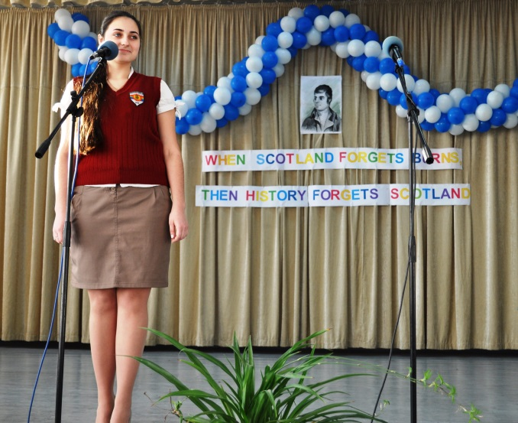
My heart is sair—I dare na tell,
My heart is sair for Somebody;
I could wake a winter night
For the sake o' Somebody.
O-hon! for Somebody!
O-hey! for Somebody!
I could range the world around,
For the sake o' Somebody.
Ye Powers that smile on virtuous love,
O, sweetly smile on Somebody!
Frae ilka danger keep him free,
And send me safe my Somebody!
O-hon! for Somebody!
O-hey! for Somebody!
I wad do—what wad I not?
For the sake o' Somebody.
Pupil: Only when Robert obtained a job, earned money, Jean’s father agreed to have the poet as his son-in-law. He composed beautiful love poems, some tender, some sassy, about the many women he loved. He wrote them with affection, respect and tenderness .

Pupil: Once Burns fell in love with Mary Campbell whom he had seen in church while he was still living in Tarbolton. He dedicated to her a touching song "Will ye go to the Indies, my Mary, And leave auld Scotia's shore?" suggests that they planned to emigrate to Jamaica together. ( U Tube)

Pupil: To get some money for his passage, he published some of his poems. He was 27 when his first book “Poems Chiefly in the Scottish Dialect” was printed in 600 copies in July 1786. To his great surprise the book won him immediate success! The edition was quickly sold out and R. Burns became well-known and popular.

Pupil: That was the reason for the fact that instead of going to Jamaica, Burns went to Edinburgh, the capital of Scotland. He received invitations from several scholars, who praised his verses. In Edinburgh Burns was welcomed as one of the “wonders” of the world. Burns became a celebrity.

Pupil: In April 1787 the second edition of Burns' poems appeared in Edinburgh. It brought him money and gave him an opportunity to see more of his native land. Robert made several trips around the country and saw beautiful landscapes and lochs of the Highlands. He visited some historical places, which made a great impression on him. He composed his verses to the melodies of old folk – songs, which he had admired since his early childhood. He sang about the woods, fields and picturesque valleys of his native land. The source of his poetry was the life of common toilers and Scottish folklore.

"My Heart's in the Highlands"
My Heart's in the Highlands, my heart is not here;
My heart's in the Highlands a chasing the deer;
Chasing the wild deer, and following the roe;
My heart's in the Highlands, wherever go.-
Farewell to the Highlands, farewell to the North;
The birth-place of Valour, the country of Worth:
Wherever I wander, wherever I rove,
The hills of the Highlands for ever I love.-
Farewell to the mountains high cover'd with snow;
Farewell to the straths and green vallies below:
Farewell to the forests and wild-hanging woods;
Farewell to the torrents and loud-pouring floods.-
My heart's in the Highlands, my heart is not here;
My heart's in the Highlands a chasing the deer;
Chasing the wild deer, and following the roe;
My heart's in the Highlands, wherever I go.-
Pupil: R. Burns’ poems were translated into almost every language. In Russia six of his poems were translated for the first time by Mikhailov in 1856. Shchepkina-Kupernick, Bagritsky and other poets translated Burns' poems, too. But the best translations were made by Marshak. Thanks to Marshak's translations we know and love Robert Burns. S. Marshak is considered to be the best Russian translator of Burns’ poems. So now you’ll listen to one of the best – known translations of this poem.
В горах мое сердце... Доныне я там.
По следу оленя лечу по скалам.
Гоню я оленя, пугаю козу.
В горах мое сердце, а сам я внизу.
Прощай, моя родина! Север, прощай,—
Отечество славы и доблести край.
По белому свету судьбою гоним,
Навеки останусь я сыном твоим!
Прощайте, вершины под кровлей снегов,
Прощайте, долины и скаты лугов,
Прощайте, поникшие в бездну леса,
Прощайте, потоков лесных голоса.
В горах мое сердце... Доныне я там.
По следу оленя лечу по скалам.
Гоню я оленя, пугаю козу.
В горах мое сердце, а сам я внизу!
Pupils: Why is it difficult to translate R. Burn’s poems? (Because the structure of languages is different and it’s necessary to find a rhyme, rhythm, the Scottish dialect is extremely difficult to understand, etc.) Although it’s very difficult, some pupils have translated R. Burns’ poems and I think it will be very interesting to listen to them.
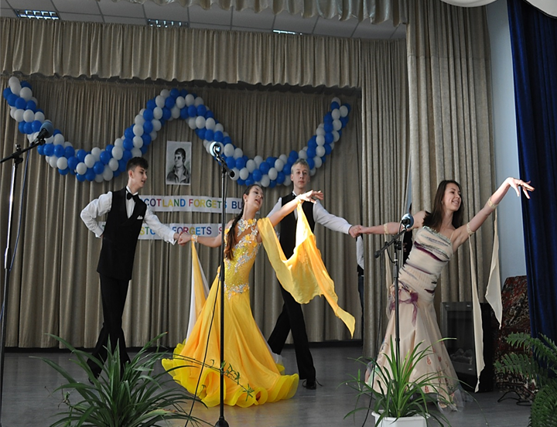
(Pupils’ translations)
Pupils: Robert Burns’ poems and verses inspired many famous composers who wrote music to them. The best known song to his verse “O Wert Thou In The Cauld Blast” was composed by A. G. Gradsky. Now let’s listen to it. ( U Tube)
Pupil: The talented poet was a true son of the Scottish peasantry. His poems embody their thoughts and aspirations, their human dignity and love of freedom. One more event had a tremendous influence on R. Burns – the Revolution in France in 1789. It impressed the poet greatly. Burns always stood for liberty and was against social inequality. He believed that the "world would live in peace".

Like brethren in a common cause, Забудут рабство и нужду
We'd on each other smile, man; Народы и края, брат,
And equal rights and equal laws И будут люди жить в ладу,
Wad gladden every isle, man. Как дружная семья, брат!
.
Pupil: Burns openly expressed his feelings and ideas. Handwritten copies of his poem “The Tree of Liberty” were read by all his friends.
The Tree of Liberty

Heard ye o' the tree o' France,
I watna what's the name o't;
Around the tree the patriots dance,
Weel Europe kens the fame o't.
It stands where ance the Bastile stood,
A prison built by kings, man,
When Superstition's hellish brood
Kept France in leading-strings, man.

Wi’ plenty o’sic trees, I throw,
The world would live in peace, a man
The sward would help to make a plough,
The din o’war would cease, man.
Like brethren in a common cause,
We’d on each other smile, man;
And equal righs and equal laws
Would gladden every isle, man.

Pupil: Burns’ honest criticism, his hatred of oppression was the reasons why the rich and mighty had forsaken him. When the Edinburgh’s society saw his views and moods, felt the spirit of liberty in his poetry, they grew tired of him and forgot about the poet. So he left Edinburgh and returned to his native village and bought a farm where he worked hard but still he went bankrupt and had to sell it. It seemed there was no way out.
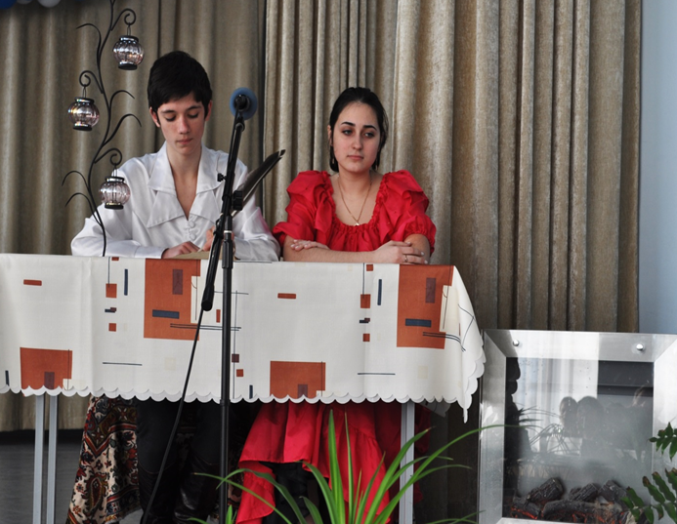
(R. Burns and Jean are sitting at the table. A candle is burning. Robert is writing something and his wife is knitting. )
Burns: “…a shopkeeper whom I owe a large sum of money took a proceeding against me. All that remains of me – bones and skin – they would surely throw into prison. Can you do me a favour and send me ten pounds? Oh James, if you knew my proud heart you would know how I feel. I am not accustomed to beg. Save me from the terror of prison”
Jean: Hard work had destroyed my husband’s health, but he continued the literary work. We lived in poverty, our farm was sold,. The problem of earning money rose every day.

Pupil: “A Winter Night” is the saddest, most bitter and moving poem he had ever written (a few days before his death).

You banks and slopes of bonnie Doon
How can you bloom so fresh and fair!
How can you sing, you little birds,
And I so weary, full of care!
Pupil: Robert Burns died on July 21, 1796 at the age of 37. Thousands of people from all over the country followed him through the streets of Dumfriers to his last resting –place. Now we understand why Burns is so beloved by the people in Scotland and indeed by people throughout the world. He was of the people; he shared their life, feelings and beliefs.
The Scottish national anthem "Auld Lang Syne" composed by Robert Burns is often sung at parties or meetings of friends all over the world. And I think that today we shall honour the memory of the great bard of Scotland by singing his song.
(The pupils sing the song.)
Should auld acquaintance be forgot
And never brought to mind?
Should auld acquaintance be forgot,
And auld rang syne!
Chorus:
For auld lang syne, my jo,-
For auld lang syne,
We'll tak a cup o' kindness yet
For auld lang syne.
And there's a hand, my trusty fiere!
And gie's a hand o' thine!
And we'll tak a right gude-willie-waught,
For auld lang syne.
Chorus.

The End

ВИКОРИСТАНІ ДЖЕРЕЛА:

http :// en . wikipedia . org / wiki / Robert _ Burns
http :// www . amazon . co . uk / Scottish - Quest - Robert - Burns
http://esolcourses.blogspot.com/2010/01/january-25-burns-night-english-lesson.html Red red rose song
http://www.robertburns.plus.com/MonumentsDumfries.htm
http://www.encyclopedia.com/topic/Robert_Burns.aspx
http://esolcourses.blogspot.com/2010/01/january-25-burns-night-english-lesson.html

