Урок 3
Тема : Охорона навколишнього середовища .

Мета: практикувати використання активної лексики за темою для вираження власних думок та обговорення проблем ; сприяти накопиченню лексичних одиниць за темою ; вчити учнів вести бесіду за темою ; тренувати вживання різних граматичних структур ;
- розвивати навички усного монологічного та діалогічного мовлення ; навички аудіювання та письма; розвивати навички читання тексту з метою повного розуміння змісту прочитаного ;
- сприяти формуванню в учнів екологічного мислення ; сприяти розвитку пізнавальних інтересів учнів , розширенню їх світогляду .

Тип уроку : комбінований .

Обладнання : text “ Greenpeace “ .

Хід уроку .
I . Introduction . Aim .
- Today we are going to continue speaking about relations between people and nature . We’ll try to name the reasons of the main ecological problems , and of course we’ll think about the way out .
Warm – up .

Brainstorm .
- We see letters . Name your associations with each letter on the topic “ Environment “ .
R – rubbish , reduce , reuse , resource .
D – destroy .
S – species , survive , save .
P – pollute , protect , planet .
E – environment , endangered .
II . Main part of the lesson .
Vocabulary Practice .
- Find and underline the odd word out .
- pollution , radiation , destruction , population , environment
- to damage , to endanger , to destroy , to ruin , to create
- safe , nuclear , dangerous , poisonous , harmful
- paper , waste , glass , wood , plastic
- habitat , fox , insect , reptile , pigeon
- rare , valuable , disappearing , extinct , diseases

- Match the word with its definition .
1) Garbage a) something in a crumbled or broken condition
2) Litter b) an unwanted by-product of a manufacturing process
3) Rubbish c) food waste , discarded or useless material
4) Trash d) an untidy accumulation of objects lying about
5) Waste e) useless or rejected matter

- Choose one word to best complete the sentences .
- I don’t like their house – it’s always full of _ .
- The main problem of ecology today is thousands of tons of industrial _ .
- She always leaves a lot of _ in the kitchen .
- In Singapore a person throwing _ on the road may be put to prison .
- Sometimes it seems that _ accumulates itself .
- Complete the collocations below by adding an appropriate noun . Some can combine with more than one noun .

- changes a) acid
- pollution b) tropical
- resources c) exhaust
- waste products d) global
- effect e) ozone
- rain f) nuclear
- fuels g) public
- transport h) traffic
- warming i) natural
10) jams j ) air
11) disaster k) sea
12) rainforest l) greenhouse
13) energy m) clean
14) layer n) recycled
15) gases o ) solar

Reading .
- Read the text .

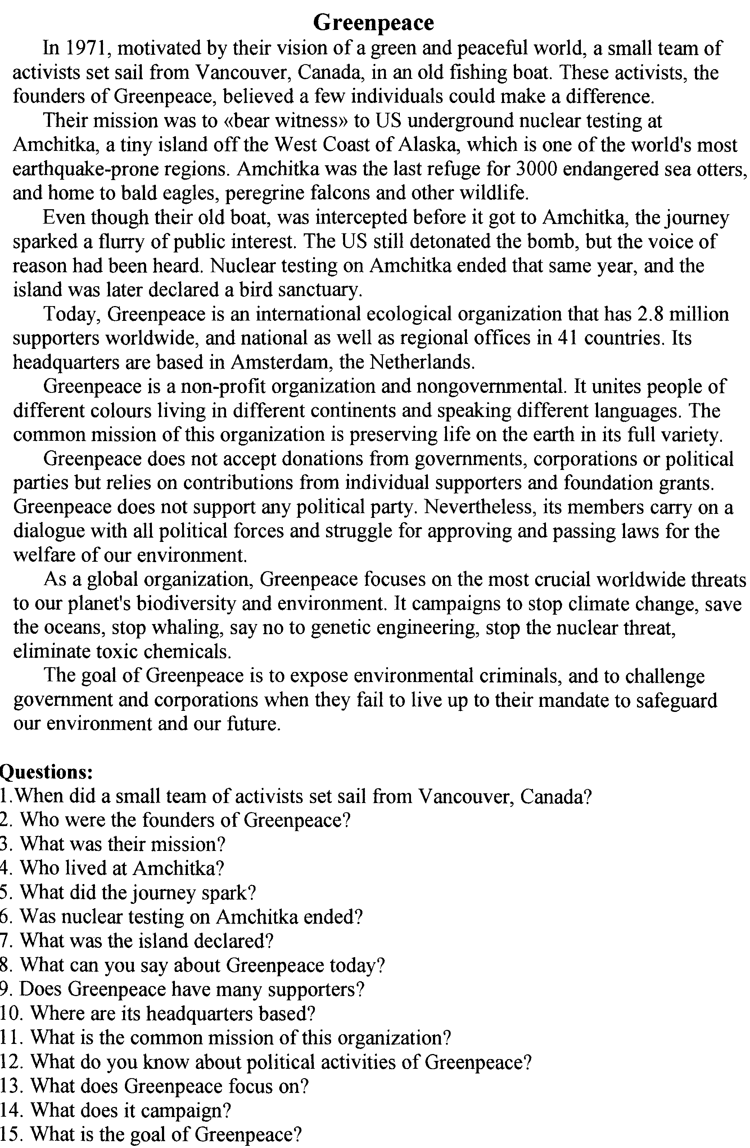

After-reading task .
- Answer the questions after the text .

Dialogue speaking .
- You are a Greenpeace activist . You see the factory that pollutes the river. Make up a dialogue with the manager of this factory on this problem .

Grammar .
- Read the text below and choose the correct word for each space .
Rainforests
In the last forty years , half of the world’s rainforests ____________ (1) . If this ___________ (2) , millions of species , animals and plants will become extinct . Rainforests grow in countries near the equator . They ___________ (3) 2 metres – 10 meters of rain every year . There have been rainforests on Earth _________( 4) over 75 millions years . Half _________ (5) all the species of butterflies , birds , flowers , trees and insects live in rainforests. Fifty species become extinct every day . The world’s rainforests _________ (6) a total disaster . Some scientists say it’s even _________ (7) than the effects of a nuclear war .
But it’s not just a question of _________ (8) tribes , trees and species . It’s question of climate , too . Our planet needs rainforests to control ________(9) temperature . ________(10 ) them , the greenhouse effect will just get worse and worse . It’s impossible to stop rainforest destruction completely. Too many countries – rich and poor – depend _______ ( 11) it . The people in the Third World _______ (12 ) enough land to grow food for ________ (13) families . 250 millions of ______(14 ) are destroying the rainforest simply to live . Modern life in __________ (15) First World depends on rainforest products , too . These include minerals , wood , rubber , medicine ( for 25% of all medicines ____ (16) rainforest products ) .
But it is possible to make this problem ______ (17) serious . To do this , Governments _________ (18) plan and work together .

 | A | B | C
1. | Disappear | Disappeared | Have disappeared
2. | Continues | Continued | Will continue
3. | receive | receiving | Have received
4. | From | For | At
5. | ----- | Of | Among
6. | Are facing | Faces | Faced
7. | Worse | Worst | Better
8. | Disappeared | Disappearing | Disappear
9. | Its | It’s | Her
10. | With | Besides | Without
11. | On | of | From
12. | Don’t have | Have had | Have
13. | Them | Their | Themselves
14. | Them | Their | Themselves
15. | The | a | For
16. | Make | Gather | Contain
17. | Less | More | The least
18. | May | Must | Have to

Project work / Group work .
- Make up 2 or 3 groups . Think over the leaflet on ecological problem .
III. Summing – up .
- We worked hard today. What did we do today ? What topics did we speak about ?
Homework.
- to write 10 tips on the topic “ Ways of saving our planet “ .



