1/Watch the video:

https://drive.google.com/file/d/1i00tO51dLgk7qQoFeQvXBxK1H6vm7Rxi/view?usp=sharing

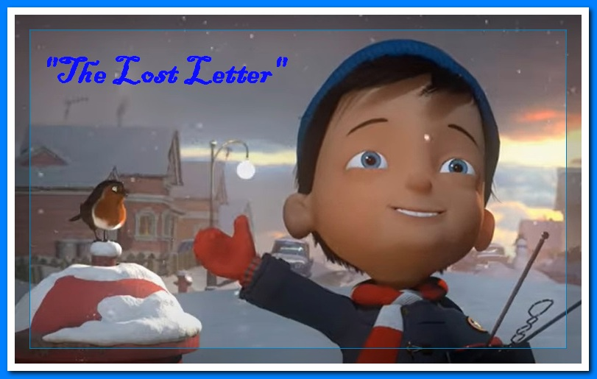

2/Complete the rows:

The light from a window glows warm and 1) ________
A young 2) _________ was busily writing
At last with his letter to 3) ________ complete
Cadet 4 ) _______ Frankling ran out to the street
One house remained dark
No 5) ______,no 6) ________ not so much as a spark

3/Order the next rows:

1. | There in a room stood Henry delighted
 | And so he began to dispense Christmas cheer
 | Henry was out implementing plan B
 | Until the old girl made her feelings quite clear
 | Ready to help though he’d not been invited
 | Even now as the lady sat sipping her tea

4/ True or false
1.Henry came into the chimney.
2.He broke a picture of the lady’s daughter.
3.Long time ago a girl asked Santa to bring her a daughter.
4.That wish came true.
5.Henry decided that Santa doesn’t exist.
6. The lady got Henry out the house.

5/ Answer in few sentences to the questions:
1.What really happened with the lady’s letter?
2.What did she do with letters later?
3.What happened the next morning?

