«The Smartest show»
Good morning! You’re welcome to the intellectual English contest “The Smartest show”. Our aim is to show pupil`s knowledge not only of English but of Literature and Geography of Great Britain. I’d like to introduce our jury to you… I know they will judge our competition fairly.
And we have 2 teams today. Please, introduce yourself!
Good luck!
- The first contest is ‘The facts about Great Britain’. Each team will receive 4 questions. Each correct answer costs 1 point. Team… is starting.
- What is the official name of Britain? (the United Kingdom of Great Britain and Northern Ireland)
- Where is the United Kingdom situated? (on the British Isles)
- What parts does the United Kingdom consist of? (England, Scotland, Wales, Northern Ireland)
- What is the capital of Scotland? (Edinburgh)
- What is the capital of Wales? (Cardiff)
- What is the main square in London? (The Trafalgar square)
- Name the most famous church in the UK noted for its royal weddings, coronations, and burials (Westminster Abbey)
- Who is the most famous royal monarch in the last 50 years? (Queen Elizabeth)
ІІ. The next contest is “True or false”. I invite here one member from each team. You have one minute. Each correct answer costs 1 point. Team… is starting.
1. Lviv is the capital of Ukraine. (false)
2. Japanise is situated in Europe (false)
3. There are 50 states in the USA (true)
4. Kangaroose live in Australia (true)
5. A skill means an ability to do something well, especially because you have learned and practiced it (true)
6. The official language in Canada are English and Italian (false)
7. Dnipro is the longest river in Ukraine (true)
8. Rugby first appeared in England in the 15th century (true)
9. Ternopil is your native city (true)
10. Borsch is the national British dish (false)
11. The largest ocean in the world is the Pasific ocean (true)
12. The monkeys like bananas (true)
13. The elephants are good swimmers (true)
14. Great Britain is washed by the Black sea (false)
15. Hollywood is situated in London (false)
16. The baseball was invented in the USA (true)
17. Orange is a vegetable (false)
18. Pizza is a healthy food (false)
19. The fastest way of travelling is by plane (true)
20. There are 4 oceans in the world (true)
21. Big Ben is the highest clock in New York (false)
22. Kyiv is the capital of Ukraine (true)
23. English is an international language (true)
24. Whale is the biggest animal in the world (true)
25. London is situated on the river Thames (true)
26. Thanksgiving Day is the national holiday in the USA (true)
27. Children go to school 6 days a week (false)
28.English is the language of international trade, air and sea transport, tourism, sport and entertainment (true)
29. English Christmas pudding include: raisins, currants, candied peel, chopped almonds, walnuts, grated carrot, brandy, whisky or old ale (true)
30.Gap year is necessary in Ukrine (false)
31. The most famous English universities are Oxford and Cambridge (t)
32. William Shakespere is the famous English writer (true)
33. Pancakes made from grated potatoes, flour, fried and served with sour cream (true)
34. Ternopil is situated in the centre of Ukraine (false)
35. Ukraine is an European country (true)
36. The United Kingdom consist of 2 parts (false)
37. Football is very popular in Great Britain (true)
38. Honest people never tell lies (true)
39. Potato is a fruit (false)
40. Food which is kept very cold is frozen (true)
41. Blue and yellow are the colors of Ukrainian flag (true)
42. Tea is very popular in Great Britain (true)
43. Mean people hate spending money (true)
44. Bricklayer has a skill to build walls (true)
45. A respect means admiration for someone, especially because of their special qualities, knowledge and skills (true)
46. Indian food like curry is very spice (true)
47. Fresh vegetables have more vitamins than when they are cooked (t)
48. Mexican food is too sweet (false)
49. Download means copy information from a website to your own computer (true)
50. Floods are the rain drops that have formed together into ice (false)
III. The next contest is “Guess the action”. The task for each team is to show the action they get in miming. And the team has to guess what they show. You need to choose 1 contestant from each team.
Task 1
You have a broken arm. You go to the hospital and ask for help.
Task 2
You go to the shop and buy mineral water.


IV. And the last contest is “Who I am”. You need to guess who is on the picture. You`ll have 1 minute.
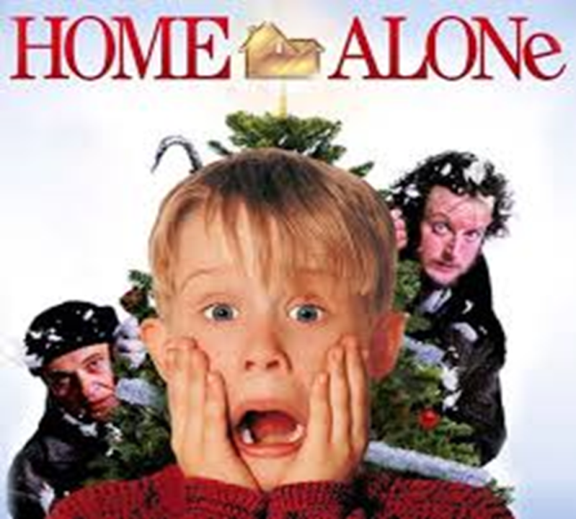
The jury, please, announced the results of “The Smartest show”.

