ST. PATRICK’S DAY
(Plan of the interactive lesson)
План-конспект уроку
з англійської мови для учнів 5-х класів,

Тема уроку: "ST. PATRICK’S DAY".
Мета уроку: ознайомити учнів із звичаями та традиціями святкування Дня Святого Патріка; розвивати фонематичний слух; розвивати довільну пам’ять та мовну здогадку, мовленнєву реакцію; розвивати вміння працювати у групах; розвивати загальну культуру спілкування; виховувати повагу та формувати в учнів інтерес до традицій країни, мова якої вивчається
Обладнання: інтерактивна дошка, презентаційна дошка, роздатковий матеріал, аудіо та відеоматеріали.

Хід уроку
І. Організаційний етап.

Good morning, dear students and guests! Let’s start our lesson. You know a lot about the traditions and holidays of English-speaking countries: Christmas, St. Valentine’s Day, Easter, and Halloween. But today we’ll speak about another holiday: St. Patrick’s Day. You’ll learn about its history, symbols and traditions.
II. Основна частина уроку.
- Take a look at the screen, please, watch and sing a song. https://www.youtube.com/watch?v=6wvNLk451DE
ST.PATRICK’S DAY SONG
Whoa-ho, Saint Patrick's day, it's a day for fun
So grab a fiddle, grab a friend, come on, everyone
You may find a leprechaun or you may find some gold,
So come on out Saint Patrick's day
It's for the young and old.

Old Saint Patrick was a saint who comes from Ireland
We celebrate his story now
With family and with friends
It may be your lucky day so wear a lot of green
and if you spot a rainbow
well, that would be a dream.

Whoa-ho, Saint Patrick's day, it's a day for fun
So grab a fiddle, grab a friend, come on, everyone
You may find a leprechaun, a shamrock, maybe two
So come on out Saint Patrick's day
There’s so much to do.

Did you know that Saint Patrick's day
comes from a country called Ireland.
It's right here on the map.
On this day of March 17 we celebrate with fun parades
and we're in lots of green
and if you're lucky real lucky you may even see a leprechaun,
but don't call thinking he'd be willing
to share his pot of gold to the end of his rainbow

Come on out Saint Patrick's day, it's a day for fun.
Now, answer the questions:
What holiday do we celebrate today on the 17th of March? (St.Patrick’s Day)
What is the main colour of this holiday? (Green)
Who is the small man in green? (Leprechaun)
What country does this holiday come from? (Ireland)

- Watch a video with key words to this holiday. Let’s say them aloud.
https://www.youtube.com/watch?v=E3jv6uxLgnI
Words to the video: shamrock, pot of gold, leprechaun, rainbow, March, St.Patrick, Ireland, green, horseshoe, gold coins, hat.

- Students, come out to the board, take a card, read it and put it under the correct headings “St. Patrick’s” or “Other holidays”
St. Patrick’s | Other holidays
green | Christmas tree
shamrock | turkey
Leprechaun | heart
Pot of gold | eggs

- There are four poems. Your task is to put the lines into the correct order than stick them on the board and read the poems. (All students are divided into four groups. Students in each group work together to make poems. Then one student from each group represents the poem.)
https://www.classroompoems.com/st-patricks-day-poems.html
Everything is green today,
the cookies and the drinks.
It’s all about St. Patrick’s Day.
I say this with a wink.

We all just love St. Paddies.
It’s a day for having fun.
There’s no need to be Irish, just
put on your green and come!

If you spy a little man,
a small guy, wearing green,
it might just be a Leprechaun
that lucky-you has seen.

Don’t ask him for his pot of gold.
just search around instead.
'cause if he knows you’ve found it
he might hit you in the head.

- Would you like to learn more about the history of St.Patrick’s Day? Let’s watch a video and do some tasks.
https://www.youtube.com/watch?v=8OO-bw9m6U4 (YouTube Video)

https://en.islcollective.com/english-esl-video-lessons/listening-comprehension/deep-listening-focus-on-meaning/saint-patricks-day/410351 (Video with tasks)
Script:
Hello! Welcome to our St. Patrick's Day parade. We have lots of fun on St. Patrick's Day. Do you know what St. Patrick's Day is?
St. Patrick was born in Britain. His family was very rich. When Saint Patrick was 16 years old something terrible happened. A group of pirates attacked Saint Patrick's home. Then they kidnapped the young man and took him to Ireland. The pirates sold Saint Patrick as a slave. Saint Patrick spent six years as a slave, he worked as a shepherd. Being far away from his family made Saint Patrick feel sad and lonely, but St. Patrick prayed every day. His faith grew stronger and stronger. One day, Saint Patrick heard a voice telling him to run away. So Saint Patrick listened to the voice. He escaped and went to France. In France St. Patrick became a priest. When Saint Patrick was about 60 years old, he returned to Ireland. He wanted to tell the Irish about his faith. Almost everybody loved Patrick. He carried a shamrock with him. A shamrock is a three-leaf clover. St. Patrick used a shamrock to teach people about God. According to legend, St. Patrick drove out all the snakes in Ireland. Snakes were a symbol of evil. Saint Patrick wanted to remove all evil from Ireland. When Saint Patrick died, the people of Ireland were very sad. They decided to honor his death. That's how Saint Patrick's Day began.
Can you guess why we are all wearing green? Green is the color of spring! Since Saint Patrick died in the spring we wear green to show that we honor him. Oh, a four-leaf clover, that's a sign of good luck. On Saint Patrick's Day, it is good luck to find a four-leaf clover.
As for me, I'm a leprechaun. I am part of Saint Patrick's Day because I am Irish too! Now that you know about Saint Patrick's Day, why don't you join our fun?

- Relaxation. We are to play the game, so, students, let’s divide into two teams. You have to guess the word and put the letters into the correct order. Listen to me reading the sentences and guess. (Teacher gives the students cards with letters. Each student has only one card.)
- The colour of grass, plants and trees. (green)
- A long thin animal with no legs and a smooth skin. (snake)

- Matching game. Have a look at the board. There are pictures with symbols of St. Patrick’s Day. You have to label them with the correct words you take from my desk. (Pictures and words are in additional materials)

- DIY. Making a clover.
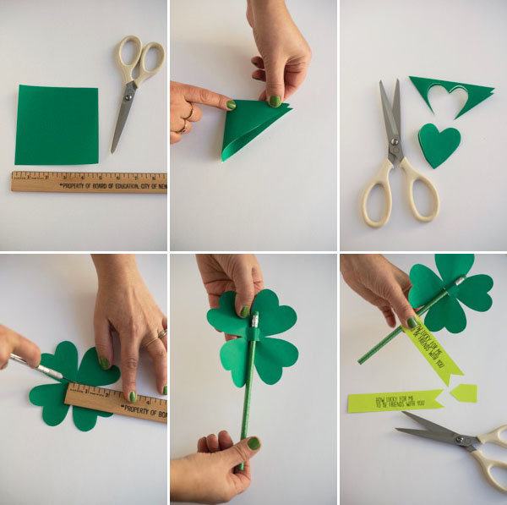
https://ohhappyday.com/2017/02/st-patricks-day-clover-pencils-diy/
Materials needed: thin green paper, St. Patrick’s Day pencils, scissors, x-acto knife, ruler, St. Patricks Day tags template (optional), tape.

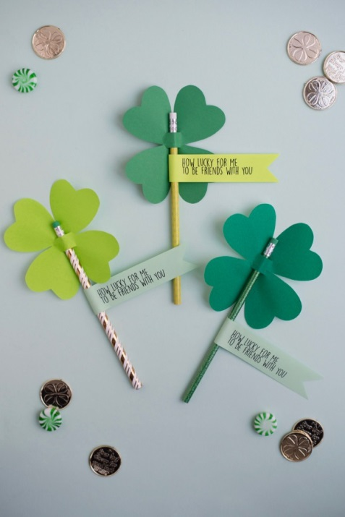
Step 1: Cut out a 5” x 5” square of paper.
Step 2: Fold in half diagonally, then fold in half again.
Step 3: Holding the point at the bottom, cut out a heart shape, starting and ending about 1/2 inch from the point.
Step 4: Unfold one fold, and cut two ½” slits in the center of the clover.
Step 5: Insert the pencil into the slits and adjust so the clover is at the eraser end of the pencil.
Step 6: Print out, cut out and attach the tags with double-stick tape. Notch the ends if desired. Or, create your own personalized tags for friends or classmates.

III. ЗАКЛЮЧНА ЧАСТИНА УРОКУ.
So, now you know a lot about St. Patrick’s Day, its history and how people celebrate this day not only in Ireland but around the world. Thank you, my students! You were brilliant!
ADDITIONAL MARERIALS:
Matching game:
SHAMROCK
BEER
POT OF GOLD
RAINBOW
GOLD COINS
HAT
IRELAND MAP
SAINT PATRICK

SNAKE
IRISH FLAG
LEPRECHAUN
PARADE
HORSESHOE

