Teacher`s words

SHAKESPEARE'S LIFE
Very little is known for certain about William Shakespeare. What we do know about his life comes from registrar records, wills, marriage certificates and his tombstone in Holy Trinity Church, Stratford-upon-Avon.
(Вчитель ділить клас на три групи, кожній групі роздаємо розрізані на частини тексти. Потім кожна група складає свою частину та зачитує, презентація повністю співпадає з текстом)
Group 1
William Shakespeare was baptized on 26 April 1564 at Holy Trinity in Stratford-Upon-Avon. Traditionally his birthday is celebrated three days earlier, on 23 April.
John and Mary Shakespeare ,who were William`s parents, had eight children: four daughters, of whom only one (Joan) survived childhood. William was the eldest of the four boys.
Group 2
William almost certainly went to one of Stratford's junior schools where he would have learnt his letters with the help of a hornbook (азбука).
Later at the King's New School , he was studying Latin, considered to be the international language of Europe in the 1500s.
No wonder why many of his ideas for plots and characters came from Ovid's tales, the plays of Terence and Plautus, and Roman history. Probably at the age of 14, William left school, and it is still unknown what Shakespeare did then.
Group 3
In 1582, when he was 18, Shakespeare married Anne Hathaway. She was 26. Anne was the daughter of a well-to-do farmer. They had three children- Susanna and the twins, Hamnet and Judith.
Anne’s home, now known as Anne Hathaway's Cottage, still stands in the village of Shottery.
From 1585 until 1592, again very little is known about Shakespeare. These are generally referred to as 'The Lost Years'.

Group 1

WRITING AND ACTING
Plague broke out in London in 1593, forcing the theatres to close. But Shakespeare turned to writing poetry. He left his family and moved to London.In 1593 Shakespeare published his narrative poem, Venus and Adonis. ( pronounce Vines and Adonis) (Венера та Адоніс)
Shakespeare's earliest plays included Henry VI Parts I, II & III, The Two Gentlemen of Verona, and Titus Andronicus. The sonnets were also written about this time, though they were not published until 1609.
In 1594, Shakespeare became a founding member, actor, playwright and shareholder of the Lord Chamberlain's Men (a company of actors, or a "playing company).They performed at court (двір короля) more often than any other company. In 1599 the Globe Theatre was built by Shakespeare's playing company and it is always associated with William Shakespeare too.
Group 2
William Shakespeare managed to amass great wealth in his lifetime.
In 1597, he bought a New Place, one of the largest properties in Stratford, besides he paid £320 in cash for roughly 107 acres of land in Old Stratford. He also bought a cottage and more land in Chapel Lane. In 1605 Shakespeare bought a half-interest in a lease of many tithes which brought him an annual interest of £60.
Group 3
After 1611 Shakespeare retired to Stratford. On 25 March 1616, Shakespeare revised and signed his will. On 23 April, his presumed birthday, he died, aged 52. On 25 April, he was buried at Holy Trinity Church in Stratford.
Shakespeare's wife was also buried beside him. Shakespeare's family line came to an end with the death of his grand-daughter Elizabeth in 1670.
Seven years after Shakespeare's death, John Heminge and Henry Condell (two actors from The King's Company) had Shakespeare's plays published by William Jaggard. This first folio (том) contained 36 plays and sold for £1.

Teacher`s words
Shakespeare wrote 154 sonnets, which were collected and published posthumously in 1609.
Many critics segment the sonnets into three groups:
- The Fair Youth Sonnets (Sonnets 1 - 126)﻿: The first group of sonnets is addressed to a young man with whom the poet has a deep friendship.
- The Dark Lady Sonnets (Sonnets 127 - 152): In the second sequence, the poet becomes infatuated with a mysterious woman. Her relationship with the young man is unclear.
- The Greek Sonnets (Sonnets 153 and 154): The final two sonnets are very different and draw upon the Roman myth of Cupid, to whom the poet has already compared his muses.
(A student recites the Sonnet 130)

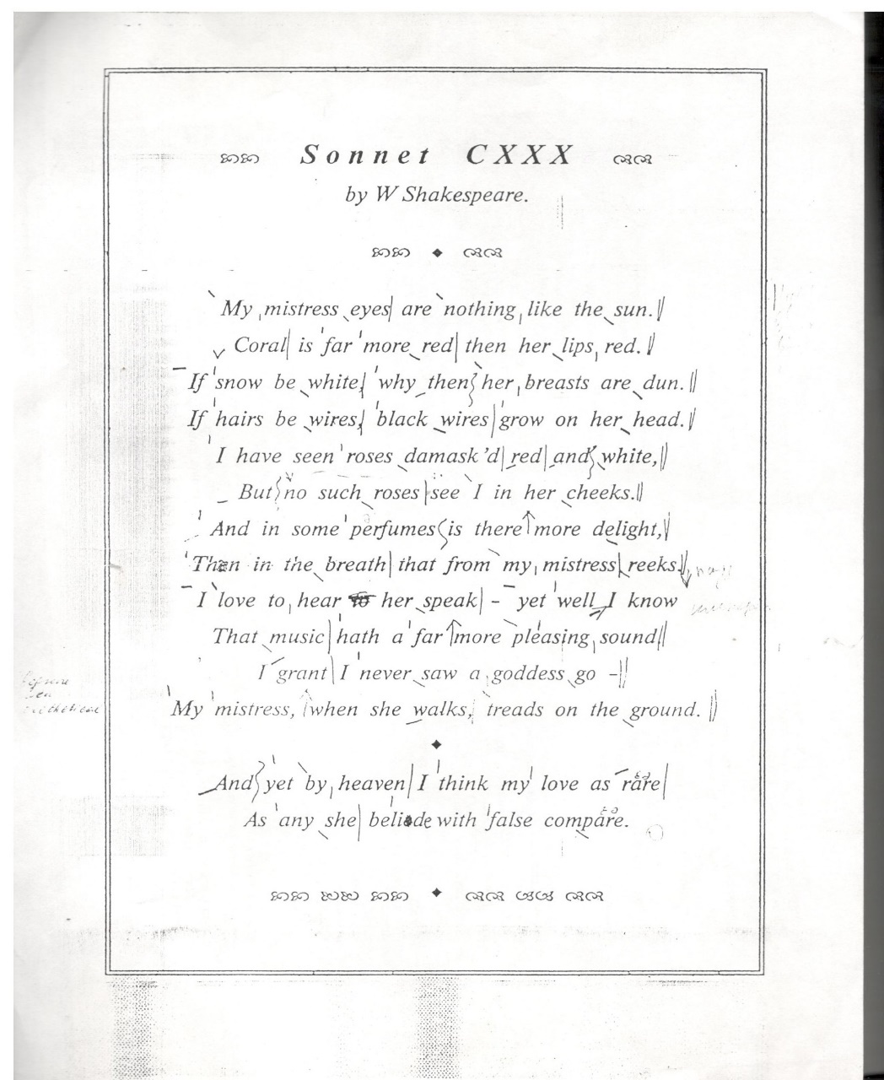

(Teacher`s words, but you can make the speech shorter) Time turn to plays
Scholars generally assign each of his plays to one of four periods, depending on the quality and maturity of the writing and characterization. Textbooks classify these as the Early Period, the Balanced Period, the Overflowing Period, and the Final Period. Not everyone agrees on which plays belong to which period.
Following is a listing of the plays according to their periods, as well as a description of the characteristics of the four periods.
Early Period
Plays with boldfaced titles are listed in more than one period, reflecting the disagreement among scholars on the period to which they belong.
Plays: The Comedy of Errors, Henry VI Part I, Henry VI Part II, Henry VI Part III, King John, Love's Labour's Lost, A Midsummer Night's Dream, Richard II, Richard III, Romeo and Juliet, The Taming of the Shrew, Titus Andronicus, The Two Gentlemen of Verona, The Merchant of Venice
Style in General: Technically rigid; somewhat immature. The plots generally are well organized.
Balanced Period
Boldfaced plays are listed in more than one period, reflecting the disagreement among scholars on the period to which they belong.
Plays: All's Well That Ends Well, As You Like It, Hamlet, Henry IV Part I, Henry IV Part II, Henry V, Julius Caesar, Measure for Measure, The Merchant of Venice, The Merry Wives of Windsor, Much Ado About Nothing, Othello, Troilus and Cressida, Twelfth Night.
Style in General: Less technically rigid; more creative. The plots are generally well designed.
Overflowing Period
Plays: King Lear, Antony and Cleopatra, Hamlet, Macbeth, Coriolanus, Timon of Athens.
Style in General: Highly creative; bursting with insight. Shakespeare ignores many rules to allow his genius to "overflow." The plots of this period sometimes twist and turn,
Final Period
Plays: Cymbeline, Henry VIII, Pericles, The Tempest, The Winter's Tale.
Style in General: Masterly. Shakespeare has just the right mix of technical skill, creativity, and wisdom while exhibiting hope for flawed humanity
Test on the plays (see the presentation)The teacher is showing the slide and asks to name the play.
Here are the answers
- Romeo and Juliet
- Hamlet
- The Merchant of Venice
- The Taming of the Shrew
- Julius Caesar
- King Lear

The acting of a play King Lear
(можна запропонувати учням зіграти уривок з п’єси Король Лір, слова розподіляємо заздалегідь)
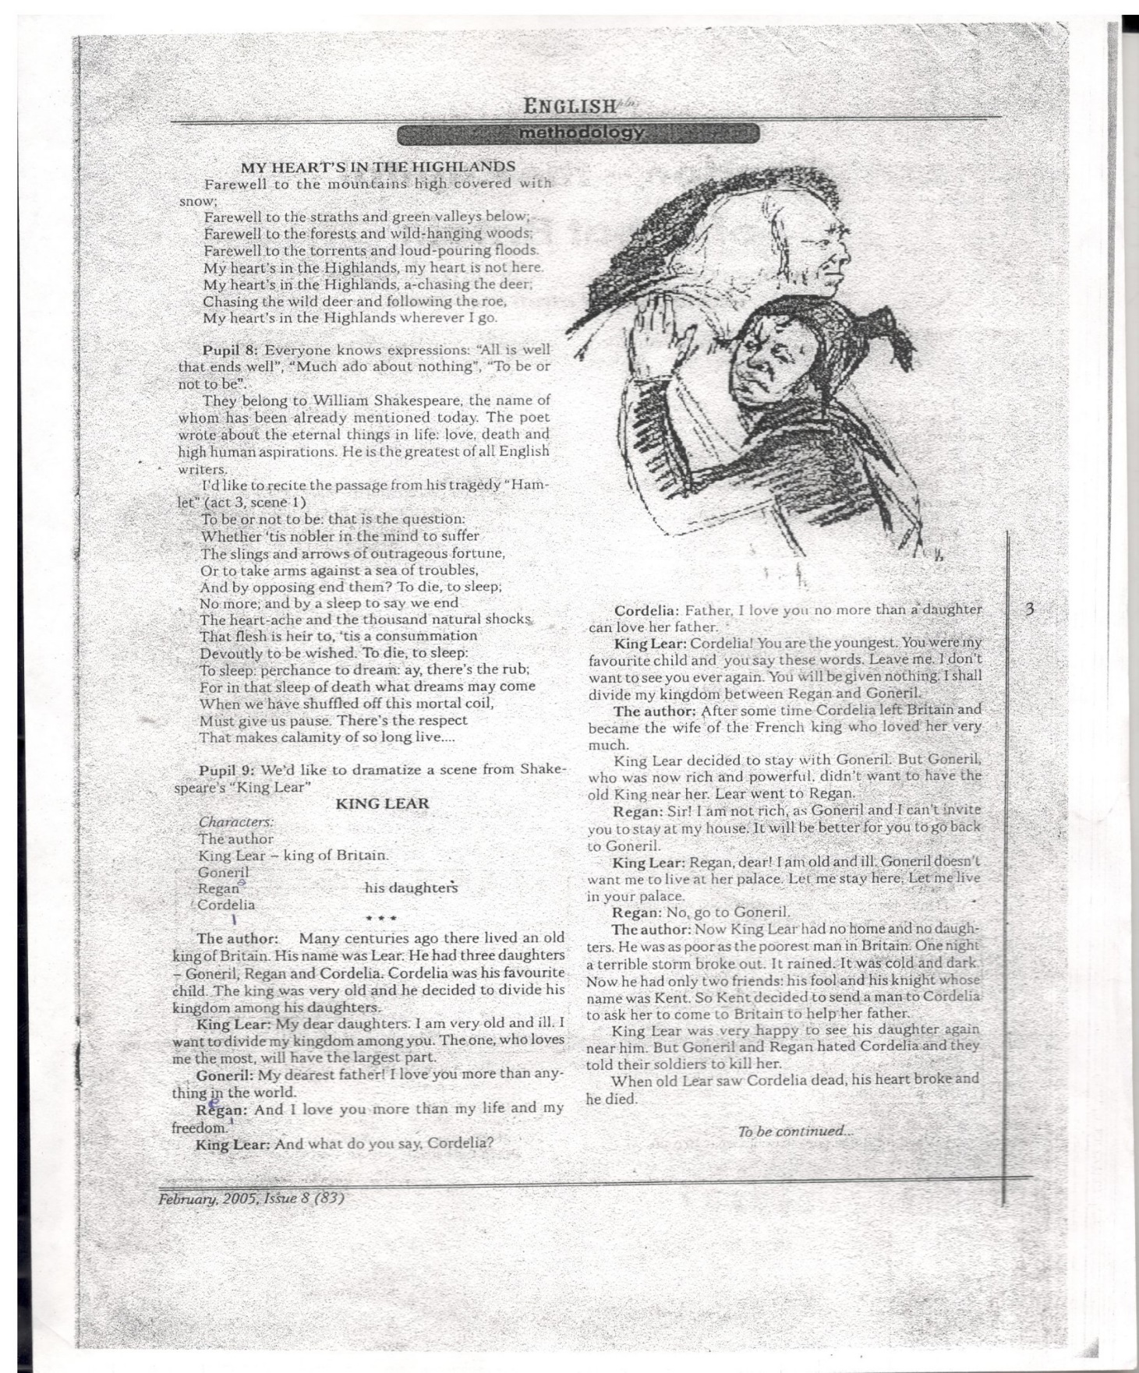

Teacher’s words
William Shakespeare played a major role in the transformation of the English language. Many words and phrases were first written down in his plays.
The early modern English language was less than 100 years old in 1590 when Shakespeare was writing. No dictionaries had yet been written and most documents were still written in Latin. He contributed 1,700 words to the English language because he was the first author to write them down.
As well as inventing completely new words, he used existing words in inventive ways, for example he was the first person to use 'friend' as a verb, as well as 'unfriended’ (Twelfth Night) and from 'gloom' he invented the word 'gloomy' (Titus Andronicus).
(Просимо команди попрацювати окремо знову і роздаємо слова, які треба зібрати в алфавітному порядку)
I group (a, b, c, d, e f, g h i)
II group ( j k l m n o p q)
III group (r s t u v w x y z)
A ambitious
B brutal
C callous (бездушний), castle, crazy
D doomed (приречений), dagger (кінжал)
E evil
F freezing, fullgrown
G – guilty
H - human
I ill-tempered
J
K
L ladybird
M -married , murderer, mean, menancing (погрожуючий)
N noiseless
O outbreak, overcool
P - paranoid
Q
R –ruthless (жостокий)
S - scheming (інтриги,махінації), superstitious, selfish
T – tempted, Thane (Anglo-Saxon England) a man who held land granted by the king or by a military nobleman, ranking between an ordinary freeman and a hereditary noble.) ,treacherous (коварний, небезпечний))
U upstairs
V violent
W- warrior, weak
X
Y
Z –zany (простак, смішний)
Shakespeare shaped and used language with great power besides he employed rhetorical devices such as alliteration and repetition to produce dramatic effect.
(наступна інформація може бути як додаткова, якщо клас швидко виконує всі завдання)
Iambic pentameter https://www.youtube.com/watch?v=jjXyqcx-mYY
This is the rhythm that Shakespeare uses in his plays. The rhythm of iambic pentameter is like a heartbeat, with one soft beat and one strong beat repeated five times. In the video below, RSC Voice Practitioner Nia Lynn defines what we mean by Iambic Pentameter and explores, together with RSC actors, what it can reveal about characters and their emotions (video on Obama’s speech with the rhythm of iambic pentameter)
Робота в командах, завдання - зібрати відомі цитати з шекспірівських творів.
You are citing Shakespeare if you know these famous quotes (Teacher says)
- All that glisters … is not gold.\ Не все то золото …… що блищить.

- All’s well that …… ends well.\ Все добре … що добре закінчується

- Brave new … … world.\ Дивний новий …… світ

- Not to Budge an …… inch.\ Не поступитися ні на … йоту

- Eaten me out of … house and home.\ Він пасся ……… і в моїй корчмі, і в хаті

- If music be the food of love …… play on.\Як музика — це пристрасті пожива …… то грайте!

- Be all …… and the end all.\ Все те, …… що наповнює життя сенсом

- Dead as a …… doornail.\ Без будь-яких … ознак життя

- Knock knock …… who’s there.\ Стук! Стук! …… … Хто там?

- Wild goose …… chases.\ Навіжена … ідея

11 . Break the …… ice.\Розтоплювати … лід

- Own flesh …… and blood.\Рідна плоть …… і кров

- Vanished into ……thin air .\Як вітром здуло

- Green eyed ….. jealousy.\Страждати від ревнощів

- Fast and …loose .\Грати у шахрайські ігри
(як додаткові прикласди)
- Tongue …..tied .\Відібрало мову

- Tower of…. Strength - Надійна опора
17. Hoodwinked - вводити в оману

18. In a pickle -між двох вогнів

19. High time - прийшов час

20. Long and short of it - усі подробиці

21 Game is up - все пропало й гру скінчено

22 Truth will out -все з’ясується і правда випливе

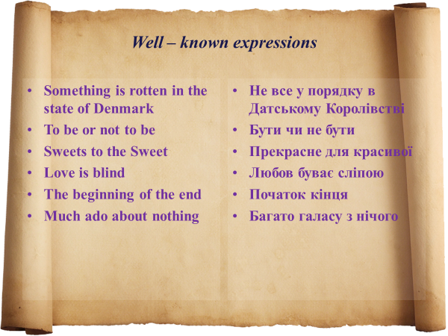

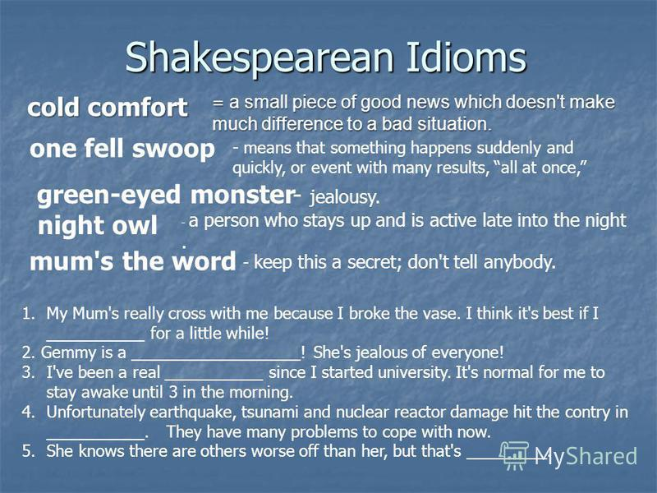
- Mum`s the word
- Green-eyed monster
- Night owl
- One fell swoop
- Cold comfort
Підводимо підсумки уроку та можемо запропонувати короткий уривок із фільму Закоханий Шекспір посилання -https://www.youtube.com/watch?v=kgtRCiypTyo

Додаткові відео (які можна використати)
https://www.youtube.com/watch?v=FAfih_YUgMk супер фільм

https://www.youtube.com/watch?v=ccuEBKaxlbw (songs)
https://www.youtube.com/watch?v=gk1rTKB6ZF8
https://www.youtube.com/watch?v=OHgbhWHsJVk

