Region embroidery

Ukrainian needlewomen know about 250 types of embroidery seams based on 20 techniques.

- Kharkiv region
If we look at the shirts of t the XIX-XX centuries , we will see mostly black and red colors (men's) and multicolored squares (women's). Both men and women wore embroidered shirts with collars. These clothes’ details are decorated with patterns. The Distinguishing feature of the region is that the embroidery ornaments were sewn with a rough thread to create a peculiar relief.
Among other famous themes of embroidery is a "Tree of Life". It was either a zigzag-shaped ornament (meander), symbolizing underground water, or flowers flipped upside down, which symbolize the underworld life.
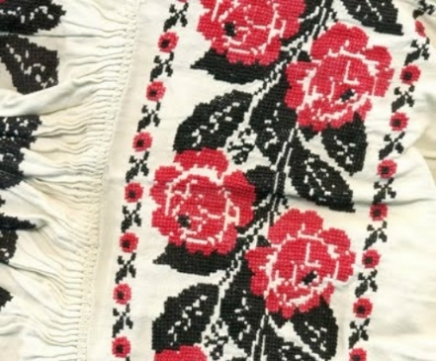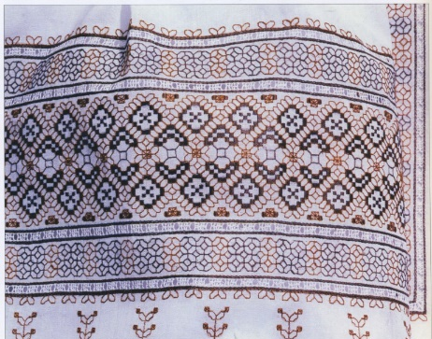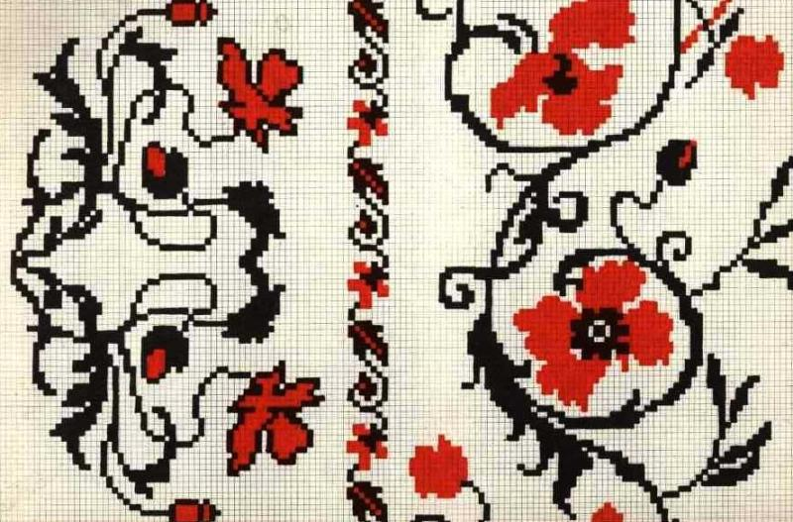

- Luhansk region
We know that vyshyvankas from the East have mostly plant ornament. Among other features of Lugansk embroidery is polychromatic patterns sewn by crosses rough thread and thanks to this it looks like a relief surface.Traditional combination of different thread textures make pattern relief too. There has been cross- stitched technique and satin-stitched emdroidery since ancient times. The ability to embroider in the Luhansk region passed down from generation to generation. One more interesting fact is that the girls were taught this craft even at the preschool age. Traditionally on the day of the wedding, the girl must had at least twelve embroidered towels.

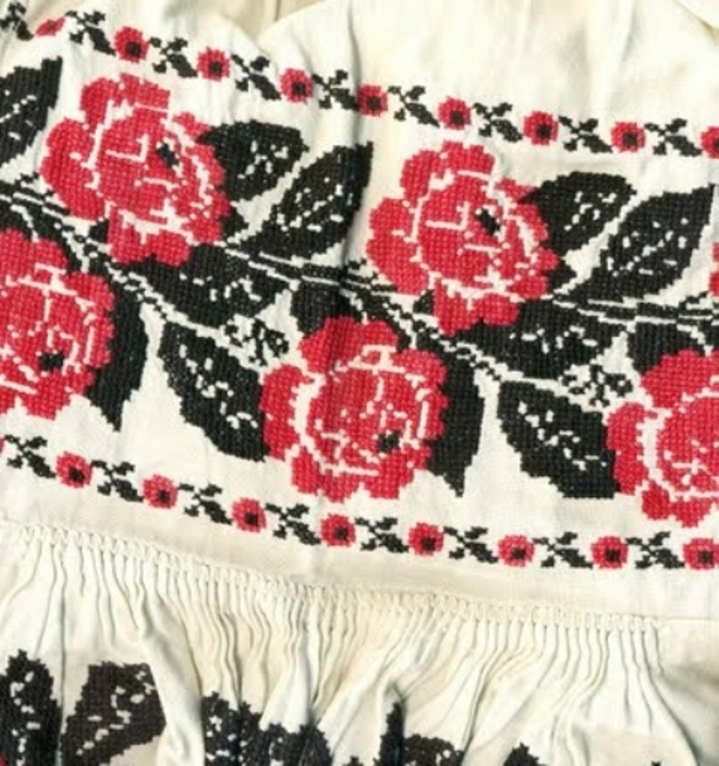

- Dnipropetrovsk region

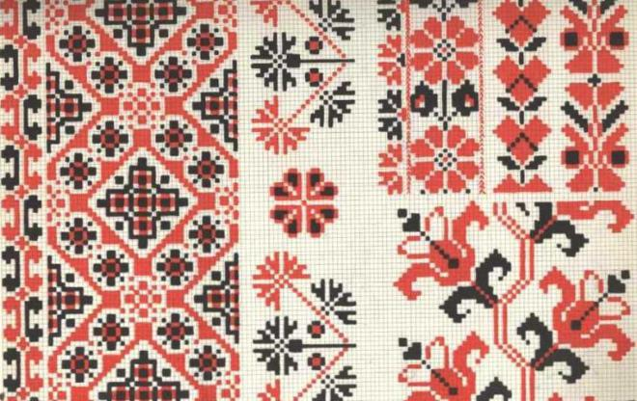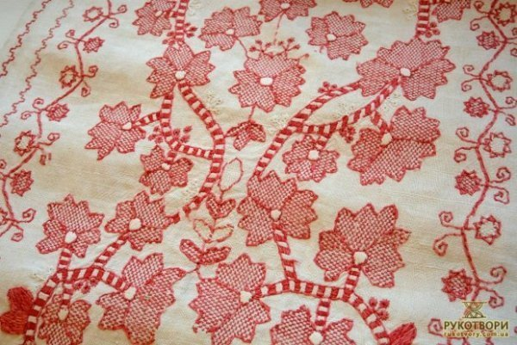

Ancient classical techniques in the Dnipropetrovsk region were embroidered in nizz and open work nets techniques. Cross-stitch embroidery is mostly geometric, as well as the floral one .
The researchers who viewed the oldest embroidery collections in the Dnipropetrovsk region said: "It's hard to imagine such a variety of diamonds, crosses, oblique crosses, swastika, stars, triangles, squares, their combination, the inclusion of some elements to others sometimes even difficult to emagine."

Shirts sleeves cuffs and necklines were embroidered with colored threads and black plush. The men's embroidered shirt was dominated by red and black colors.

- Donetsk region

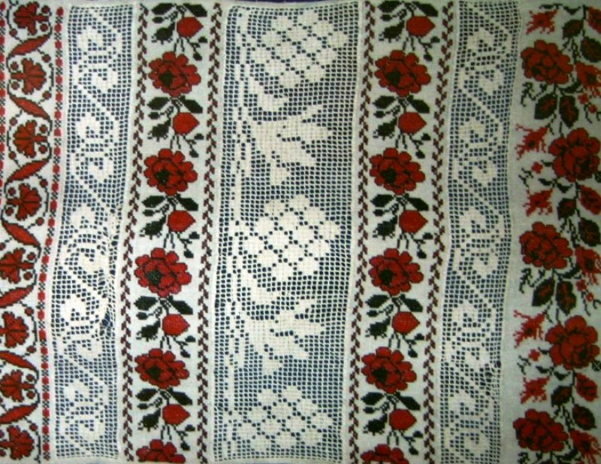

Although members of the National Union of Folk Art of Ukraine Lyudmila Ognevy managed to find the "Cossack" ornament of the late 19th century found on the territory of modern Donetsk. There are also Greeks, Germans, Belarusians, and Russians, except for Ukrainians. Therefore, we cannot talk about a special Donetsk embroidery. In Donetsk you can find everything. One can also talk about traditional ornaments in Ukraine, their influence on the state of health of a person. Also about embroidery of children's clothes - this is said a little.
In folk embroidery there are plant ornaments. At the heart of the ornaments there are mythical parallels. They are the oldest - the stars, the sun, the moon. There are ornaments with folk parallels. If you look at folk songs of the 15th-16th century, they begin with a parallel with nature (e.g. flowers, birds). These are plant ornaments, but the old ones are geometric, stylized. In embroidery in the Donetsk region, white and silver, and gold, and blue, and green are used. In the Donetsk region embroidery was decorated with a drawn thread work.

- Zaporizhye region
Zaporizhye region is well-known throughout Ukraine for so called a man's shirt or Chumatska shirt with wide sleeves, where only the collar was decorated with embroidery. (it is interesting to know that such a sleeve served as a kind of flag for signaling while crossing through the Dniepo). Black and red tones are dominated here. Patterns are simple but with big, geometric shapes, in the form of circles (symbols of the sun) or rhombuses.
Among floral themes one can find different flowers.

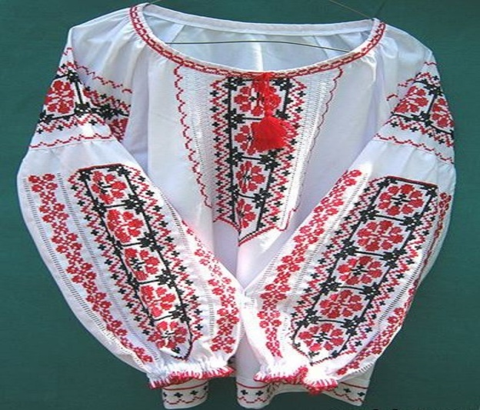

- Poltava region

Poltava embroidery is characterized by a delicate color scheme, pastel colors. Most often it is embroidery of white geometric ornaments (associated with frosty patterns), as well as combining them with herbs. To enhance the effect, were added ash threads. Poltava embroidery is the most difficult of all Ukrainian ones. The "counting" (platbands) technique has long been "native" for Poltava residents.
For example, women's Poltava embroidery can be recognized by a very rich, complex, and at the same time gentle in color, "thin" sleeve trim.

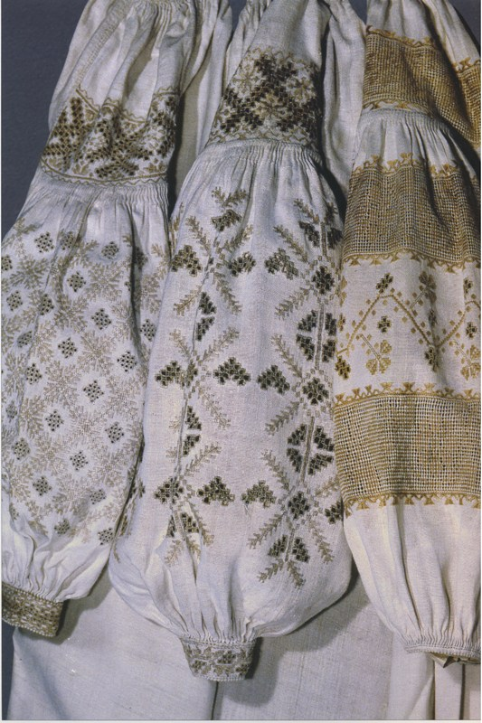

- Sumy region
women' shirts-embroideries of Sumy region, mainly of Poltava type. Stitching with white threads, cutting, typing, using different types of nets. Multicolored patterns are also characteristic here. It is a delicate embroidery with a small cross and a half-cross, as well as with embossed rough thread. Geometric and floral-geometric patterns were embroidered. Birds prevailed among zoomorphic motifs: eagles, swans, ducks, pigeons.

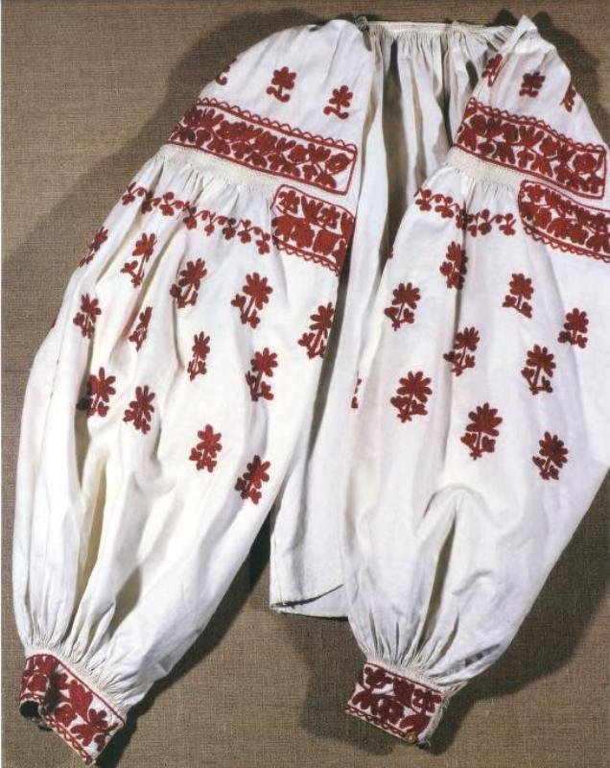
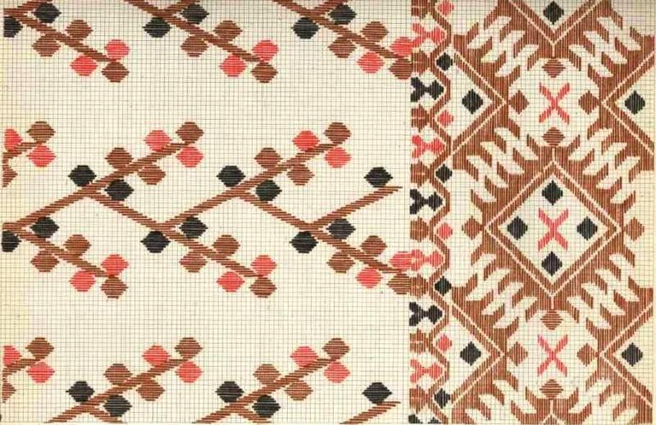

- Herson region
- The Crimea region

Crimean Tatars also liked to embroider. Naturally, their embroidery will be dreaded by most of the typical ones in mainland Ukraine. Important here are the contrasts (which can see it also on people's outerwear). They often use floral ornaments with delicate colors, correctly selecting each flower. The main sounds. used by the masters here are the following: female sign - curved branch (egri dal) -means variability, dynamism, development. Male is a family tree — reliability, strength and strength. Carnation-old man. Tulips symbolize young boys, and roses are women. € is also a symbol of "scarves", which is quite common in embroidery and ornaments, especially the main covers and belts of wide woolen fabric (urakx uchuk) is the "tree of life".
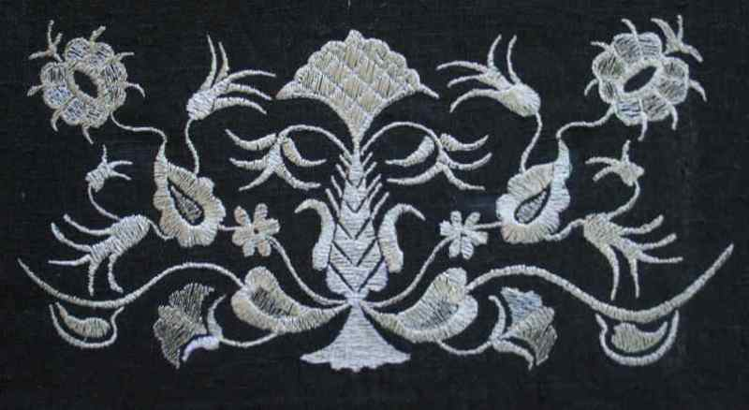

10. Mykolaiv region
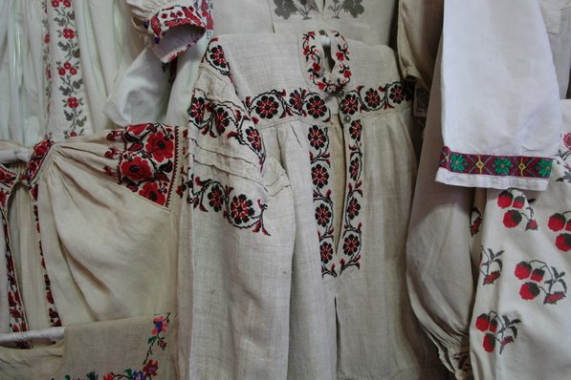
Women's shirts in this region of Ukraine were special. They were distinguished by a quadrangular neckline around the neck and loose, without assemblies in the bundle of sleeves. Strongly-styled vegetable motifs. These are pine trees, oak leaves and cones of hops, various flowers and flowering branches. It is interesting that such an element as a line used as a demarcation component of the embroidery was a symbol of the earth or the boundary between good and evil. No less popular were zoomorphic motives. Shirts of different cut had a variety of necks - with a narrow or wide collar-resistant, with the end of the rack with a picked up clip, with a collar and others. The peculiarity of the embroidered embroidery was a quadrangular neckline around the neck and sleeves, sewn straight with a free ending, without assemblies in the wrists. Colors - red, black and sometimes gray, gray-blue.

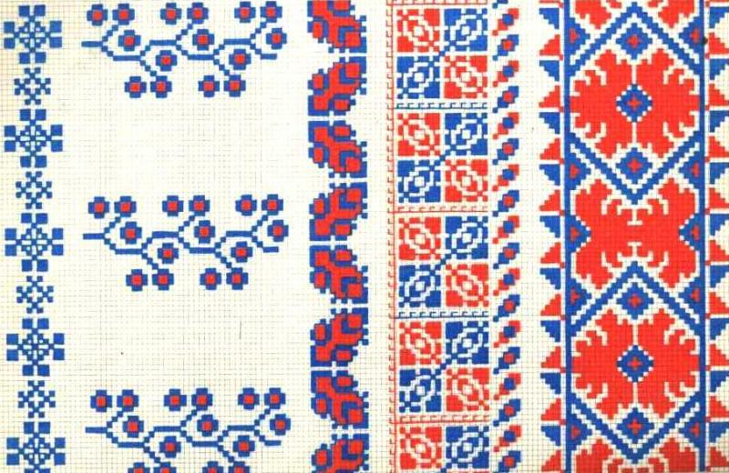

- Kirovogradskiy region
- Cherkasy region
Cherkassy region is a very beautiful sophisticated embroidery that required great. Skill and time consuming work. Small stitches formed a complex mainly geometric pattern. Different from the rest of the regions here was the horiront placement of pattern unes on the sleeves of women’s shirts. The village of Subotov had a special embroidery. Here they loved golden shades: from yellow to cherry. In the southern regions of Chernihiv region embroidered matly white with a small bloth of red and black.
- Kievan
- Chernihiv region
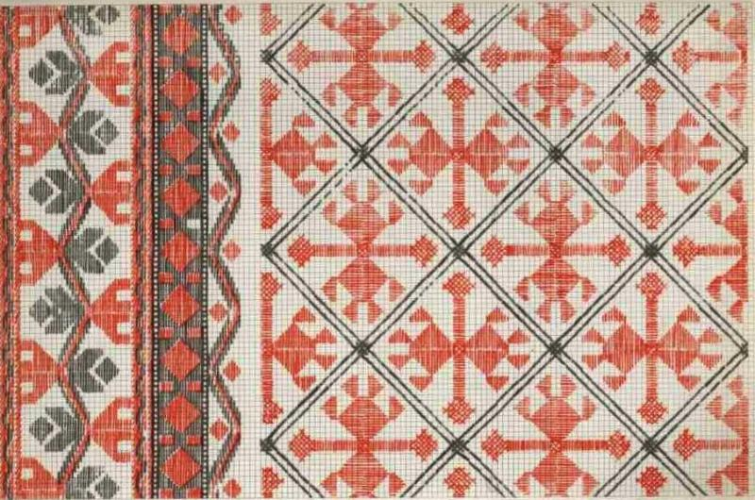

This region is characterized by white embroidery. The geometric or plant ornament is embroidered with white threads or with an inlay of red and black. Executed with very small stitches resembling beaded embroidery, typical of Chernihiv shirts. Very thin threads were used, which required extraordinary craftsmanship from handkerchiefs. In order to enhance the overall expressiveness of the embroidery, two or more types of seams were used in it, for example, transparent with glider. Very popular was embroidery.
Embroidered sleeves with distinctive oblique stripes. Also, they used the technique of smooth, small crochet and twisted seam. The ornaments were applied mainly with black and burgundy filaments, which were well placed on the background of a colorful outfit. Some people embroidered with silk threads. Beadwork, silver and gold thread, silk, wool and sequins were used for decoration. Also embroidered here are especially flared shirts.

14.Odessa region

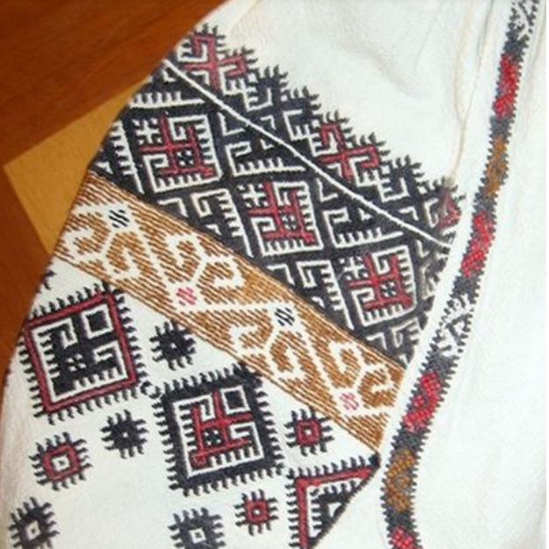
Odessa embroidery was influenced by eastern Podolian, Moldavian and Romanian decorations. Black geometric motifs were common here. Setting embroidery in the form of compositions of 2 or 3 rows, supplemented by yellow or red stripes. The motifs of the church crown, cross and two-headed eagle were often used. Odessa vyshyvanka is colored. In general, the richness of the colors of Ukrainian shirts increases from north to south. Traditional Odessa t-shirts were sewn from white cotton fabric. Tumble is a cloth on the sleeve just below the shoulder. It is the tumble that adds to the sleeves of splendor and volume. Standing wide collar densely collected in small "wrinkles", which were stuffed with a thin scar. The upper edge of the sleeves was picked up, and the bottom was embroidered with a geometric-plant pattern in the technique of a cross. The main colors were mostly red, black, blue and yellow. Narrow strip was processed by the edges of the sleeves.

15. Zhytomyr region
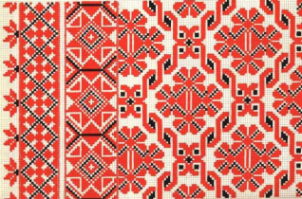

The techniques that are used most often here are a snap and a small cross. From the colors - the combination of blue with red and black. Of the geometric figures, the most common were crosses, diamonds, circles, zigzags and especially sockets. These figures had a profound symbolic meaning, and the shirt decorated with them was intended to protect the host from negative influence. But equally popular in Zhytomyr region are floral and plant ornaments: the most ancient ones are daisies and birch trees, followed by hops, grapes, harps, apple, leaves, which were found on other subjects of folk art (for example, Easter eggs).

Chernovtsy region

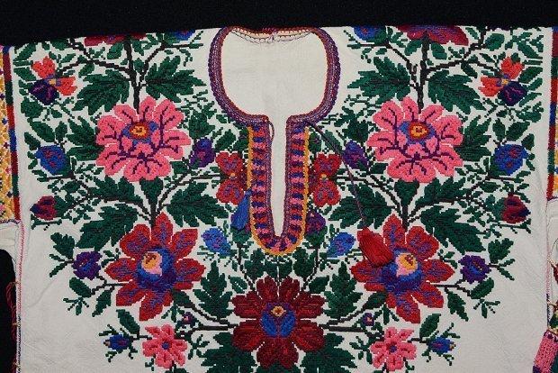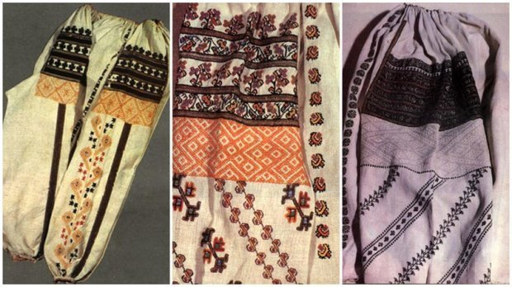

Embroidered shirt has sleeves with distinctive oblique stripes. Also, on the Chernovtsy region used the technique of smooth, small crochet and twisted seam. The ornaments were applied mainly with black and burgundy filaments, which were well placed on the background of a colorful outfit. Some people embroidered with silk threads. Beadwork, silver and gold thread, silk, wool and sequins were used for decoration. Also embroidered here are especially florid shirts.

Mykolaiv region
Women's shirts in this region of Ukraine were special. They were distinguished by a quadrangular neckline around the neck and loose, without assemblies in the bundle of sleeves. Strongly-styled vegetable motifs. These are pine trees, oak leaves and cones of hops, various flowers and flowering branches. It is interesting that such an element as a line used as a demarcation component of the embroidery was a symbol of the earth or the boundary between good and evil. No less popular were zoomorphic motives. Shirts of different cut had a variety of necks - with a narrow or wide collar-resistant, with the end of the rack with a picked up clip, with a collar and others. The peculiarity of the embroidered embroidery was a quadrangular neckline around the neck and sleeves, sewn straight with a free ending, without assemblies in the wrists. Colors - red, black and sometimes gray, gray-blue.

Volyn embroidery

Volyn embroidery has been famous for its geometric patterns, clear and simple in composition. Also, the old Polissya clothing is distinguished by the fact that the majority of embroideries in this region were cut with a knife, and the collars in such hangings were detailed. They were clipped with cufflinks (at the time - with keys, known from the Cossack era) of tin with glass or "veins" - woolen stripes of red or green color. The cut of men's and women's shirts did not differ fundamentally, but for drawing of the ornament it was possible to identify the young guys - the owners of embroidered clothes: their shirts embroidered on a collar, claws and covers. Women's shirts were long, than men: on the stones. Stretched inset, sleeves, sometimes collar and sinus
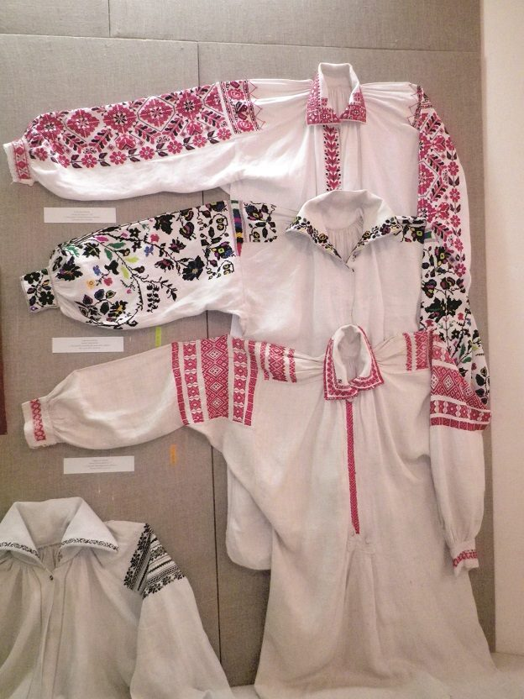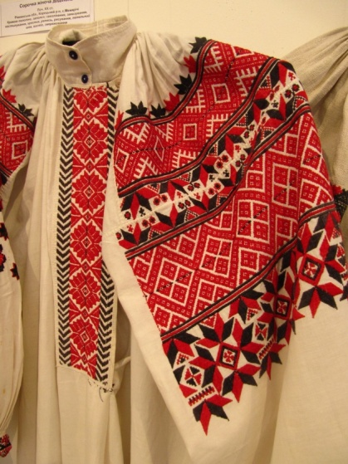

Kharkiv region
If we look at the shirts of the boundary of the XIX-XX centuries , we will see them mostly black and red colors (men's) and multicolored squares (women's). Both men and women wore embroidered shirts with collars. These garment details are necessarily decorated with patterns. Distinguishes the Kharkiv region from other regions that the embroidery ornaments were executed with a rough thread to create peculiar relief. Characteristic for the Kharkiv region is the motif of embroidery is a "Tree of Life". Under the motive of "Trees" there was either a zigzag-shaped ornament (meander), symbolizing underground water, or flowers flipped upside down, which symbolized the underworld.

Chernihiv region
This region is characterized by white embroidery. The geometric or plant ornament is embroidered with white threads or with an inlay of red and black. Executed with very small stitches resembling beaded embroidery, typical of Chernihiv shirts. Very thin threads were used, which required extraordinary craftsmanship from handkerchiefs. In order to enhance the overall expressiveness of the embroidery, two or more types of seams were used in it, for example, transparent with glider. Very popular was embroidery.
Embroidered sleeves with distinctive oblique stripes. Also, they used the technique of smooth, small crochet and twisted seam. The ornaments were applied mainly with black and burgundy filaments, which were well placed on the background of a colorful outfit. Some people embroidered with silk threads. Beadwork, silver and gold thread, silk, wool and sequins were used for decoration. Also embroidered here are especially flared shirts.

Picture

Zhytomyr region

The techniques that are used most often here are a snap and a small cross. From the colors - the combination of blue with red and black. Of the geometric figures, the most common were crosses, diamonds, circles, zigzags and especially sockets. These figures had a profound symbolic meaning, and the shirt decorated with them was intended to protect the host from negative influence. But equally popular in Zhytomyr region are floral and plant ornaments: the most ancient ones are daisies and birch trees, followed by hops, grapes, harps, apple, leaves, which were found on other subjects of folk art (for example, Easter eggs).

Transcarpathian region
Transcarpathian embroidery is a very colorful and dense embroidery - the traditional ones here were more than a dozen colors. Not every village here had its "favorite" gamma: from black-violet and cherry to green-blue. If red was combined with black - with one color obliged to stand out. The most widespread techniques are lean, curly stitches, straight and braid smooth ... The main figures are the rhombus adorned by other elements - and the so-called curvulki (zigzag). The oldest Transcarpathian embroidery is geometric shapes, but in the twentieth century vegetative motifs come in here.



