ДОДАТОК 1
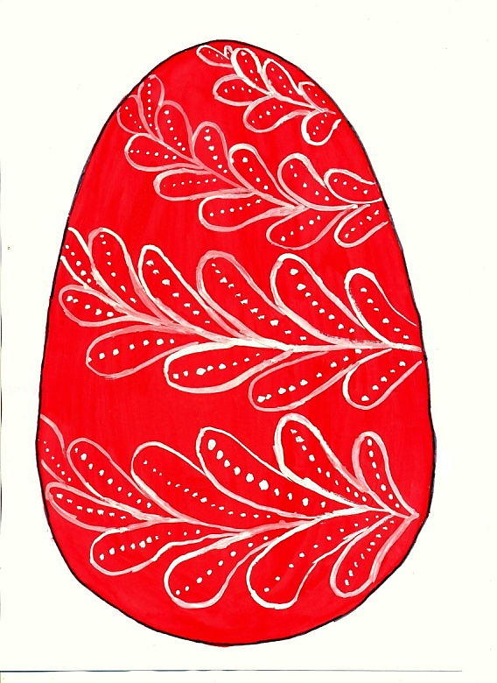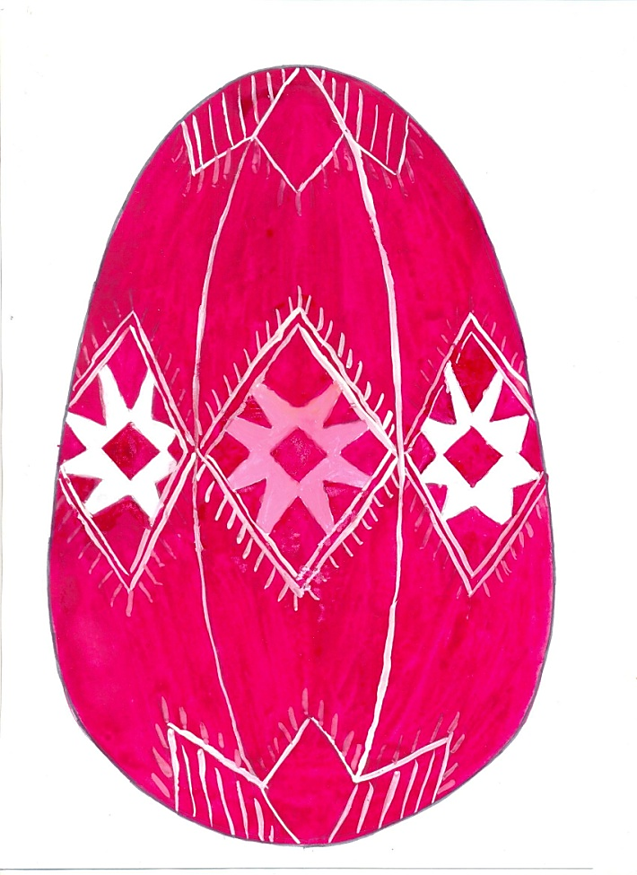
Fir branch Earth
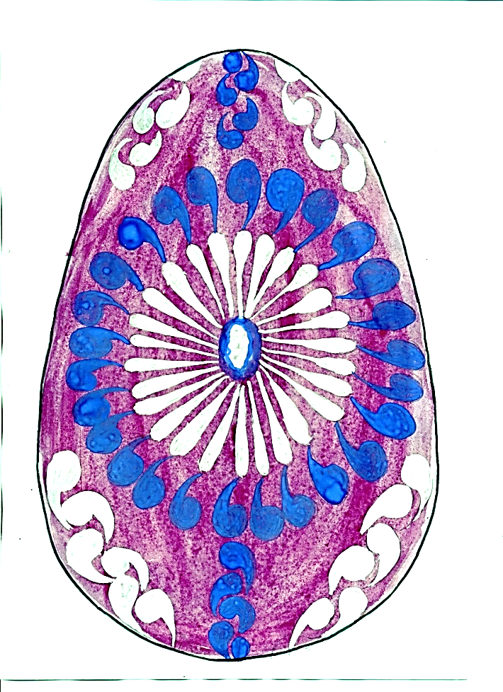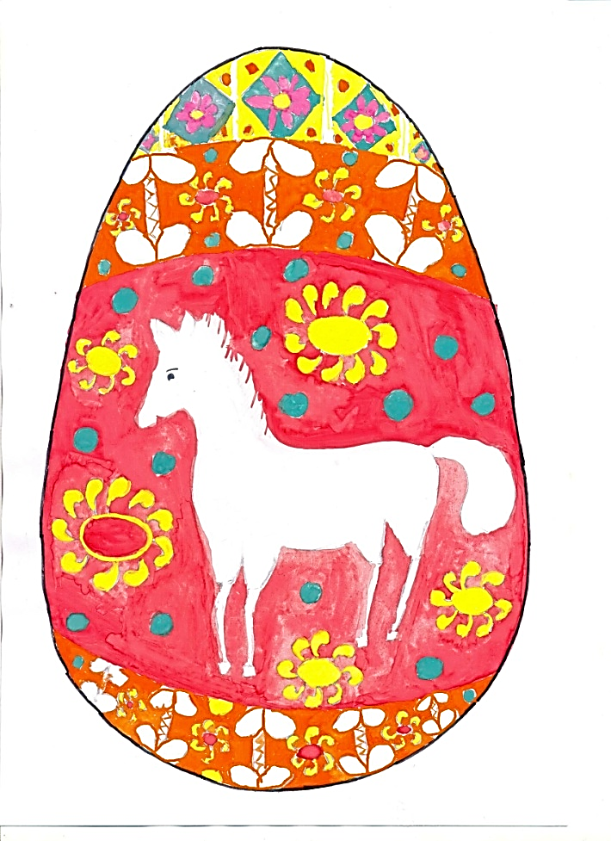
Flower Deer / Horse
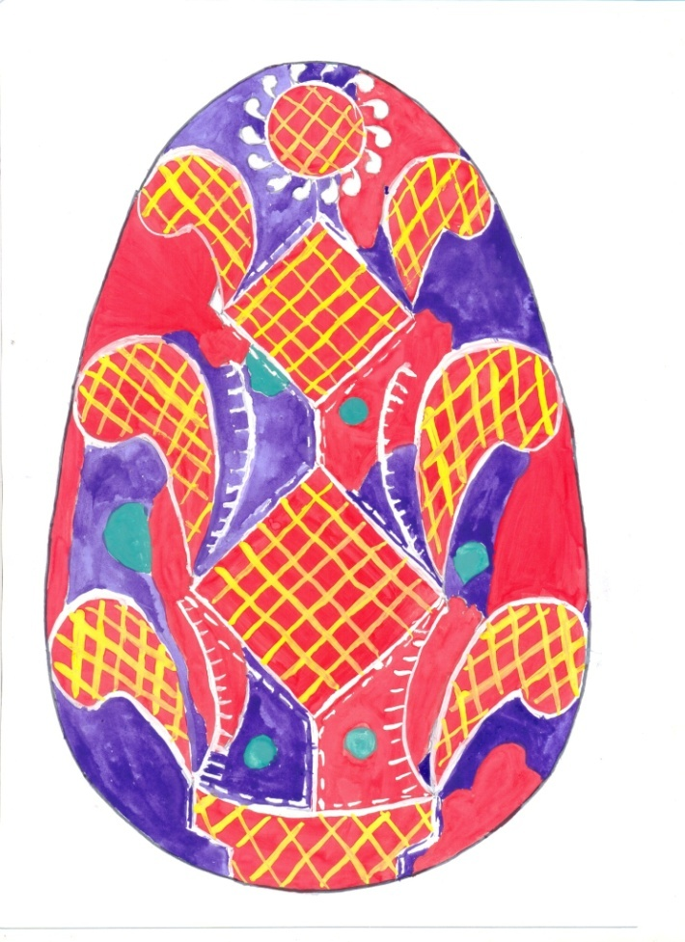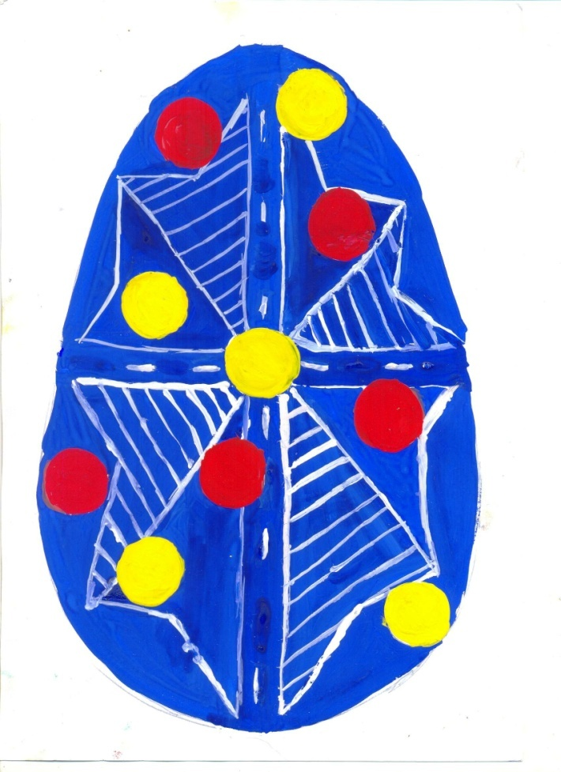
Berehynia Dots
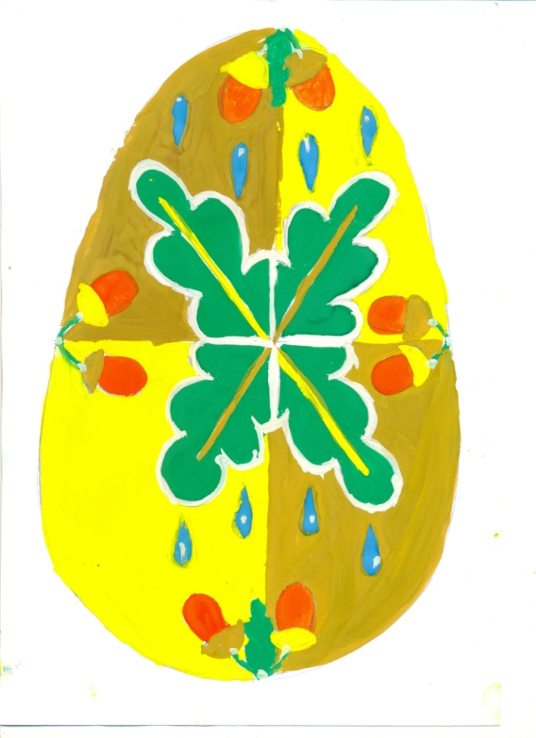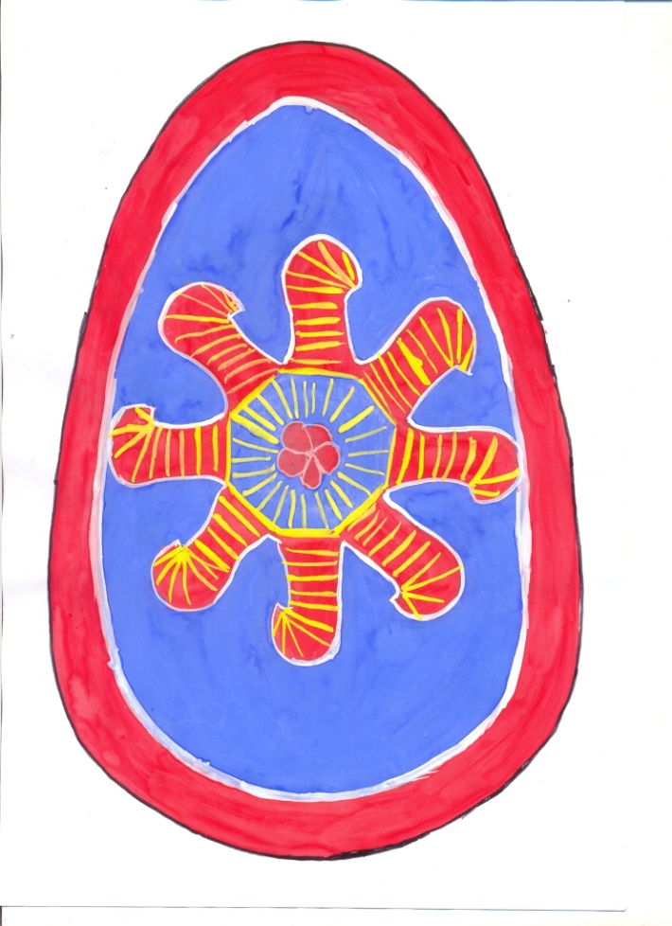
Oak Sun
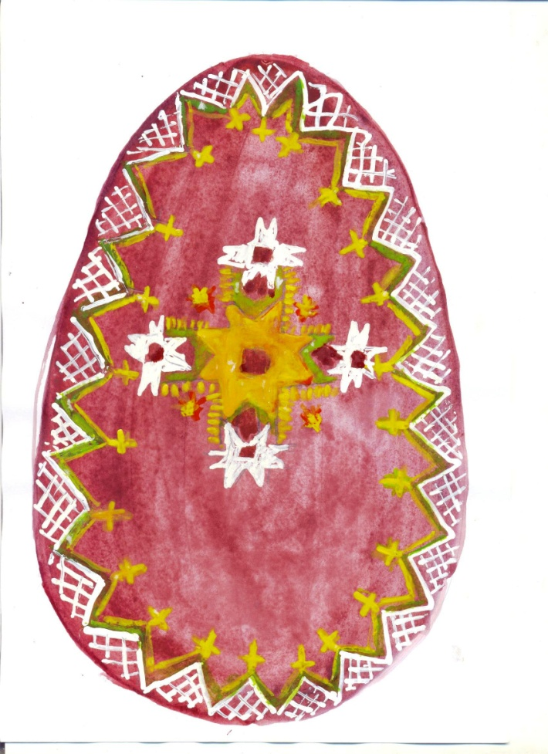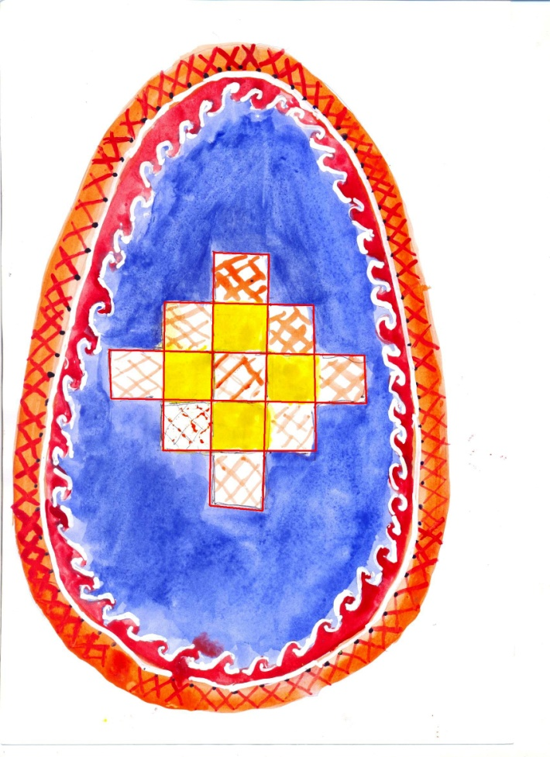
Church Water
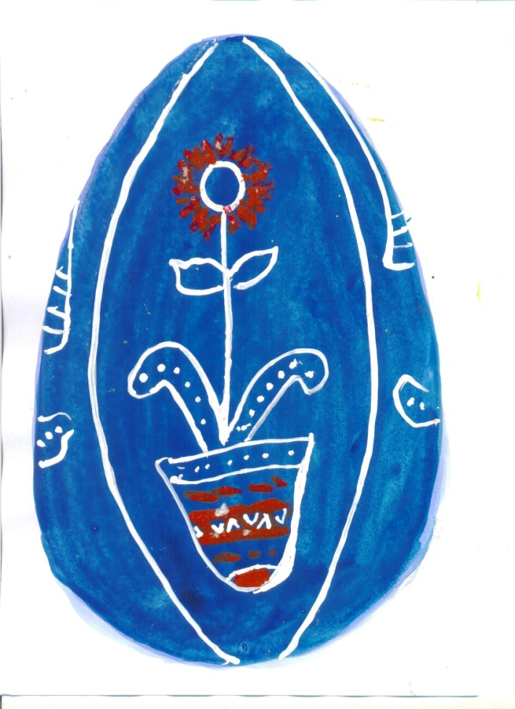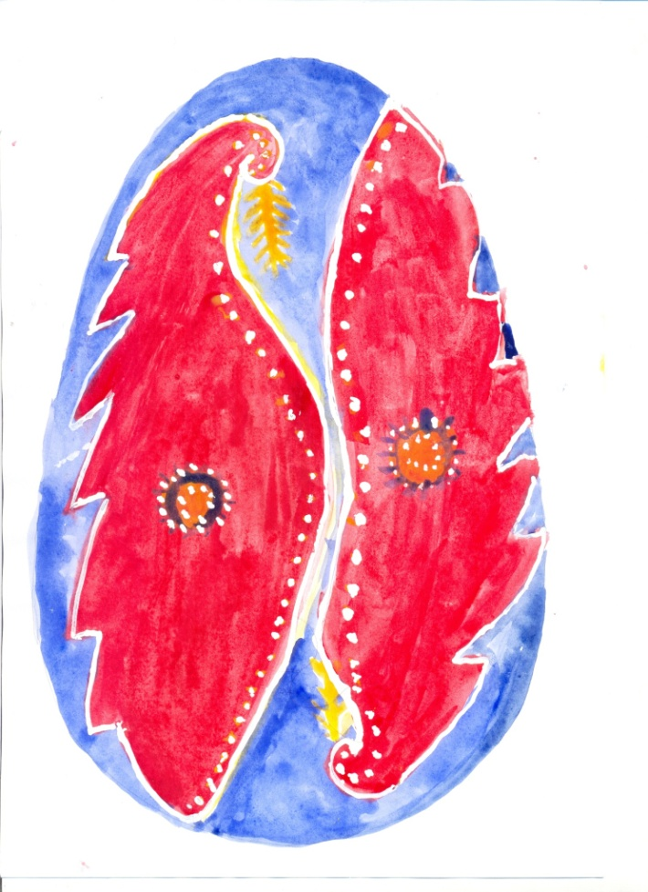
Plant Bird
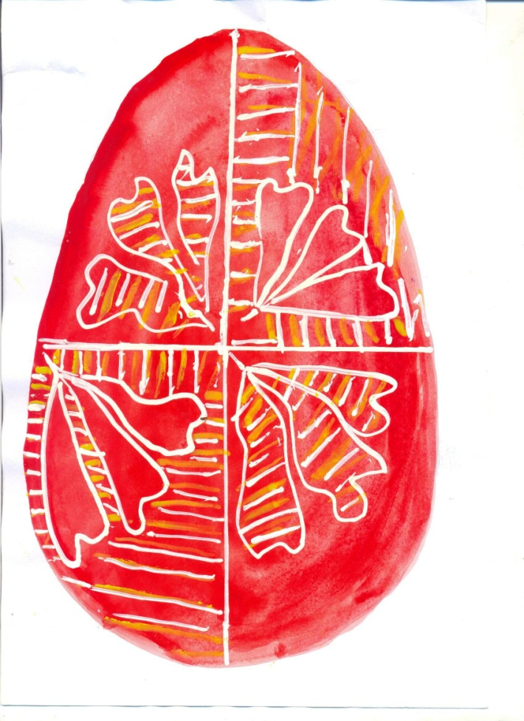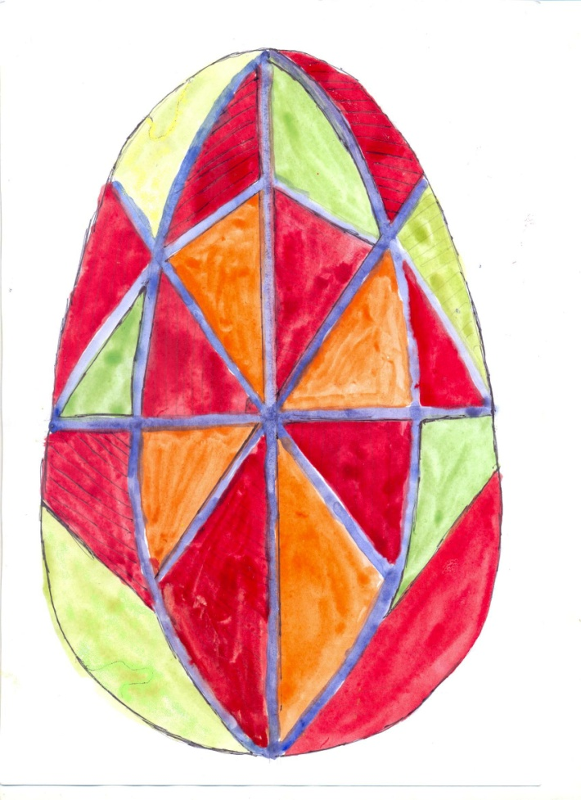
Trinity Forty gores
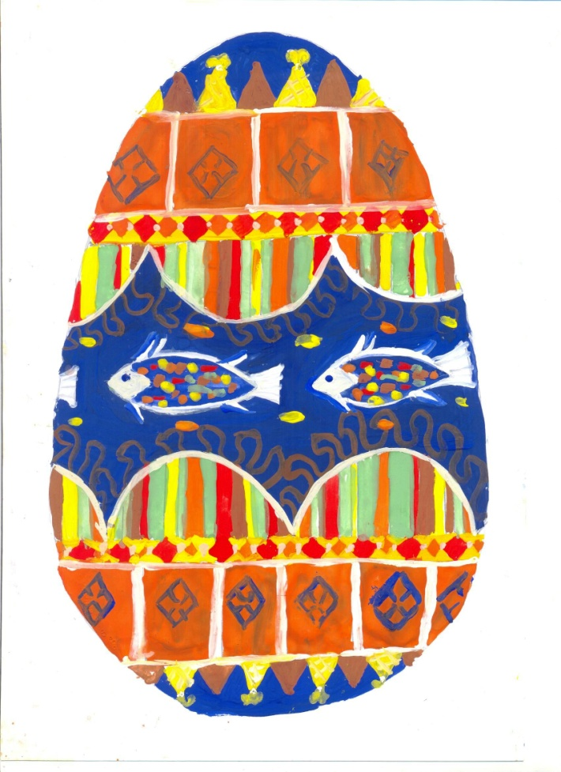
Fish
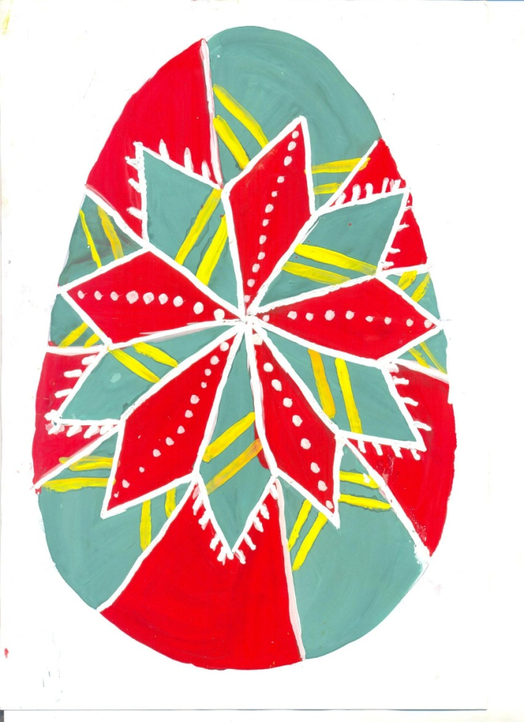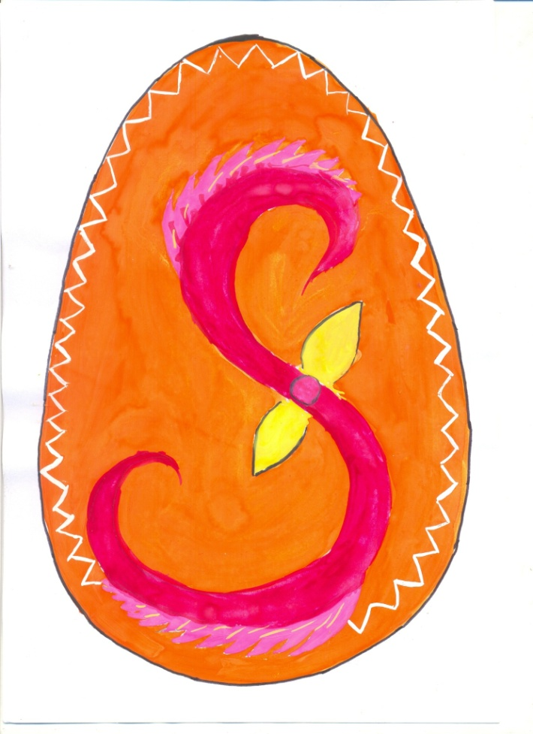
Star Endlessness
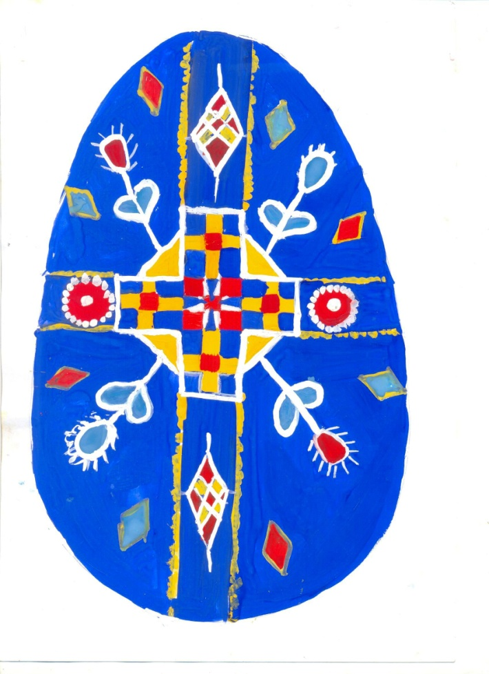
Cross
ДОДАТОК 2
Symbol | Main Meaning
Sun | Source of light, warmth, life; protection against ailments and the "evil eye".
Stars | Symbols of the Sun and Moon; in Christianity – Jesus Christ, eternity, salvation.
Water | Gives life to everything.
Cross | Unity of heaven (vertical) and earth (horizontal); beginning of new life; symbol of Jesus Christ.
Infinity | Eternal movement; cult of fertility; associated with the Sky Dragon.
Rhombus | Sign of the earth; a crossed rhombus – a cultivated, ploughed field.
Dots | Grain, seeds; sunlight; heavenly bodies; tears of the Virgin Mary.
"Forty Gores" | Prosperity, success in labor; in Christianity – 40 saints, 40 days of Lent.
Oak | Masculine strength, firmness, longevity.
"The Plant" (Tree) | Symbolic family tree; simplified image of Berehynya.
Flower | The human soul; symbol of recovery.
Fir Branch | Eternal life; earth fertilized by the spring sky; medicinal herbs.
Bird | The eternal, immortal soul; God's envoy.
Fish | Health (connected to water); in Christianity – symbol of Jesus Christ.
Deer | Prosperity and happiness in the family; connected with the cult of the sun.
Horse | Diligence, tenacity, strength.
Berehynya | A female figure with raised hands; queen of everything alive; prolongation of life.
"Chapels" / "Churches" | Structure of the universe (sky, earth, underworld); Holy Trinity.
Trinity (Earth, Water, Fire) | "Formula of life"; harmony (father, mother, child); Holy Trinity.

Color | Meaning
Red | Everlasting energy, life.
Yellow | Heavenly bodies (moon, stars); harvest, prosperity.
Green | Resurrection of nature.
Blue | Sky, water.
Brown | Earth, rich harvest.
Black | Earth; combination of all colors.

ДОДАТОК 3


