ESL STEAM Lesson Plan
on the topic

“Rethink What You Drink”

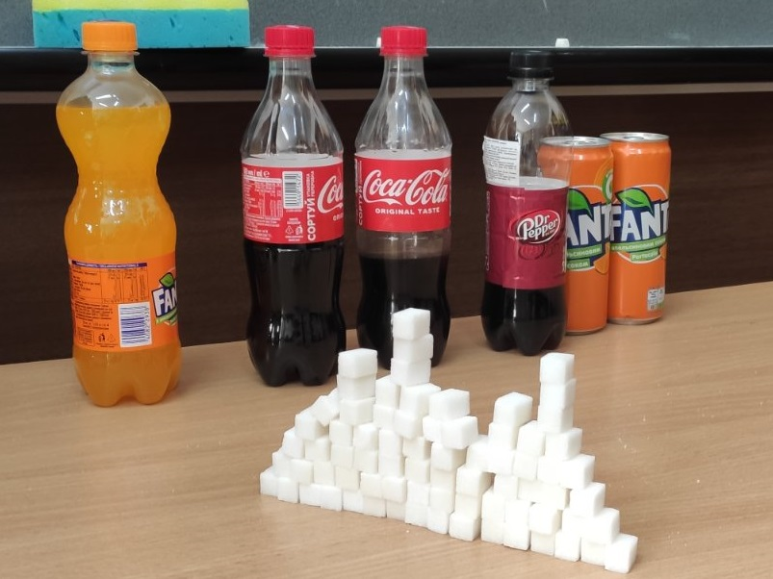

Grade 5

Objective:

To teach English as a Second Language (ESL) students new vocabulary related to sugary drinks
To practice listening, speaking, reading, and writing skills in the context of sugary drinks
To promote healthy drinking habits and raise awareness about the risks of consuming excessive sugar
To develop engineering and researching skills

Materials:

Visual aids (e.g. pictures or flashcards) showing different types of sugary drinks
Empty containers representing common drink sizes (e.g. soda cans, juice bottles)
Sugar cubes
Whiteboard or chalkboard
Markers or chalk
Handouts or worksheets
Procedure
https://www.baamboozle.com/game/1547366
https://wordwall.net/resource/55430822/sugary-drinks
https://www.youtube.com/watch?v=olK4mmJwP1c

Procedure
Warm-up (5 minutes):

Show pictures or flashcards of different types of drinks and ask students if they are familiar with them. Elicit the names of the drinks from the students and write them on the whiteboard or chalkboard.
Discuss with students what their favourite drinks are and why.

Vocabulary Building (10 minutes):
New vocabulary introduction (related to sugary drinks, such as "soda," "juice," "energy drink," "iced tea," "sports drink," "sweetened coffee," "smoothie," "milkshake," etc.) Visual aids to help students understand the meaning of the words or Bamboozle game is used
Practicing the new vocabulary with the students through activities such as Wordwall matching the words with the pictures and playing a vocabulary memory game.

Main Content (15-20 minutes)

Reading Comprehension

Pre-reading

Match the words to the pictures

Rot your teeth | 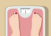
Burst of energy | 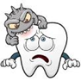
tooth decay | 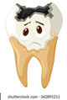
weight gain | 

While-reading
Mark the sentences True or False
Sugars can be added to food and drinks to make them taste sweeter. They can also occur naturally in fruit and these sugars are fine to eat, but do not have too much of them, especially in juice as this can rot your teeth! Sugar gives a short burst of energy, which can be great for athletes, but if you do not use the energy that sugar gives you it can lead to health problems including tooth decay and unhealthy weight gain. Children aged 7-10 years old can have 6 cubes (24 grams) of sugar per day at the most.

1.Sugars can be added to food and drinks to make them taste sweeter.
True

2.Sugars can occur naturally in fruits and are fine to eat.
True

3.Consuming too much sugar, especially in juice, can rot your teeth.
True

4.Sugar gives a short burst of energy, which can be great for athletes.
True

5. If you do not use the energy that sugar gives you, it can lead to health problems including tooth decay and unhealthy weight gain.
True

6. Children aged 7-10 years old can have 6 cubes (24 grams) of sugar per day at the most.
True

Post-reading
Choose the right option
1.What is the purpose of adding sugars to food and drinks?
a) To make them taste sour
b) To make them taste bitter
c) To make them taste sweeter
d) To make them taste salty

2.Where do naturally occurring sugars in fruits stand in terms of consumption?
a) They are fine to eat in any amount
b) They should be consumed in moderation
c) They should be avoided completely
d) They are harmful to health

3.What can be the consequence of consuming too much sugar, especially in juice?
a) Improved dental health
b) Increased energy levels
c) Tooth decay
d) Healthy weight gain

4.What is the effect of sugar on energy levels?
a) Sugar provides sustained energy throughout the day
b) Sugar has no effect on energy levels
c) Sugar gives a short burst of energy
d) Sugar causes a drop in energy levels

5.What are the potential health problems associated with unused sugar energy?
a) Improved dental health
b) Healthy weight loss
c) Tooth decay
d) Increased physical performance

6.What is the recommended daily sugar intake for children aged 7-10 years old?
a) No limit on sugar intake
b) 12 cubes (48 grams) of sugar per day
c) 6 cubes (24 grams) of sugar per day
d) 3 cubes (12 grams) of sugar per day

Listening and Speaking (15 minutes):
Students watch a video clip related to sugary drinks and complete the table.
https://www.youtube.com/watch?v=olK4mmJwP1c

Drinks | Grams of sugar
Cola
Sprite
Lemonade
Chocolate Drink
Water

After watching they fill in the chart(poster) on the board predicting the amount of sugar in other drinks presented.
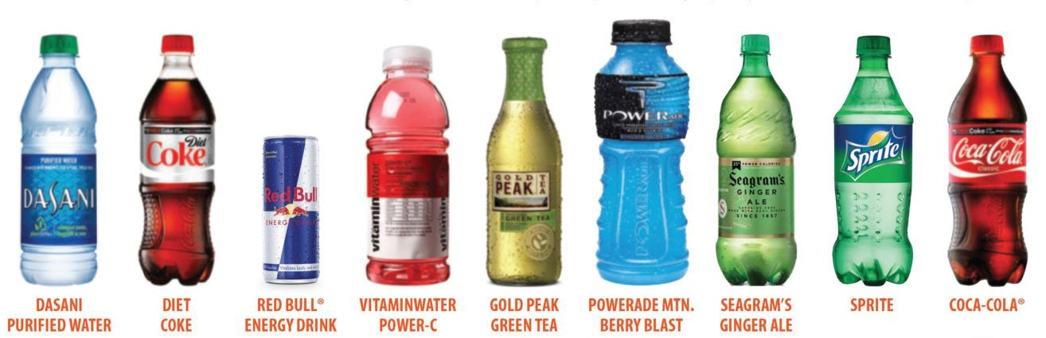

Group work
Students are divided into small groups and provided
with sugar cubes. They research their favourite drinks for amount of sugar, calculate (changing grams into cubes(1 cube- 4 grams)) and build the sugar cubes towers to visualize the amount of sugar they consume while drinking the most popular drinks among them.
Students present their works and reflect on the potential health consequences of consuming too much sugar.
Conclusion
Summarizing the main points discussed in the lesson and singing a rap song
Conclude the lesson by reinforcing the importance of making healthy drink choices and being mindful of the risks of consuming excessive sugar.

(Verse 1)
Yo, listen up, it's time to think,
Bout what you sip and what you link,
In your cup, don't let it sink,
Rethink what you drink, it's time to sync.

(Chorus)
Rethink what you drink, make a better choice,
Water or tea, that's the real voice,
No more sugary sodas, no more fizz,
Choose wisely, and stay in the biz.

(Verse 2)
Sweetened drinks, they may taste cool,
But they can harm you, that's the rule,
Tooth decay and unhealthy weight,
Time to change, don't take the bait.

(Chorus)
Rethink what you drink, make a better choice,
Water or tea, that's the real voice,
No more sugary sodas, no more fizz,
Choose wisely, and stay in the biz.

(Bridge)
It's time to break the habit, it's time to switch,
To healthier options, that'll enrich,
Your body and mind, make you feel great,
Rethink what you drink, it's not too late.

(Chorus)
Rethink what you drink, make a better choice,
Water or tea, that's the real voice,
No more sugary sodas, no more fizz,
Choose wisely, and stay in the biz.

(Outro)
So let's raise a glass, to a healthier you,
Make wise choices, stay true,
Rethink what you drink, every day,
It's a small step, but it's the only way!

Homework.
Encourage students to research the amount of sugar they eat with the lunch snacks and to write a short paragraph with the results of their researches.

