Розробка STEM-уроку «Видатні письменники»
(англійська мова, зарубіжна література, інформатика 6 клас)
Тема уроку: Видатні письменники.
Мета уроку: вчити учнів вживати лексичні одиниці на рівні понад фразової єдності, вдосконалювати граматичні знання учнів по темі “The Past Simple Tense”; розвивати кмітливість учнів, комунікативну компетентність учнів в рамках теми; розвивати соціальну та інформаційну компетентність; формувати навички пошукової діяльності, виховувати повагу один до одного, естетичні смаки.
Обладнання: інтерактивна дошка, програмне забезпечення, роздатковий матеріал.
ХІД УРОКУ
І. Організаційний етап уроку.
1. Вчитель: Hello, my dear students. Today I have met one of your teachers. I won’t tell you exactly who he/she is. You have to arrange the sentences of her request in the right order and then you will get to know the tasks of our today’s lesson.
2. Мотивація учнів.
Вчитель: So, if you arrange the sentences of the letter in the right order, you will get to know the tasks. I think, it will be exciting for you to do this task.
(На інтерактивній дошці висвітлюється лист від вчителя зарубіжної літератури, який учні повинні впорядкувати у правильній послідовності, щоб визначити мету уроку https://learningapps.org/watch?v=p7rt6y2bc21 ).
Робота учнів в групах: учні складають частини листа англійською мовою у відповідній послідовності для презентації їх змісту. Презентація одержаного листа :
Лист-прохання
Dear students,
I’m your teacher of Foreign Literature. I know that you adore English and we, teachers, decided to make your lessons more interesting and unusual.
Today you are going to speak about famous writers but in English. You will get to know some interesting facts about their life and ,of course, you are going to speak about their masterpieces.
By the way, I’m waiting for your letters containing the information about your favourite writers as a home task. Good luck.
Best wishes,
Your teacher
3. Презентація учнями листа англійською мовою.
4. Визначення завдань та мети уроку.
Вчитель: So, as you have understood, we have got an unusual lesson – at the same time we are going to combine three school subjects (English, Literature and ICT) and the topic of our lesson is “Great writers”. Our tasks are to revise the great authors’ biographies and describe their masterpieces; to practice using the Past Simple Tense. We will use the Internet and its resources for solving our tasks.
II. Основна частина уроку.
1. Вчитель: And now we have to match the names of the writers with the right pictures.
(на інтерактивній дошці розміщено імена видатних письменників. Учням потрібно співвіднести зображення авторів із відповідним іменем https://learningapps.org/watch?v=pnnwgx59521).
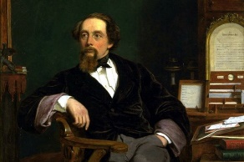 | 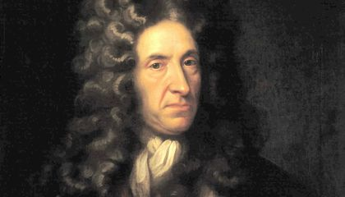 | 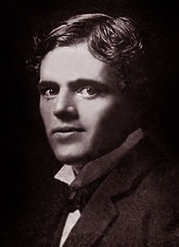 | 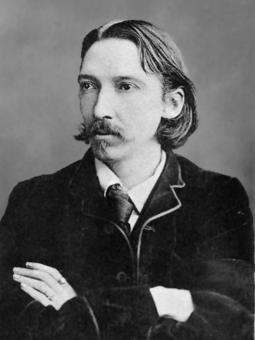 | 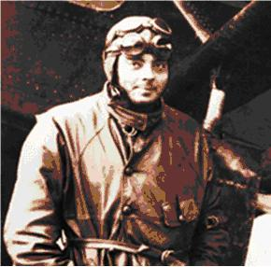
Charles Dickens | Daniel Defoe | Jack London | Robert Louis Stevenson | Antoine de Saint-Exupery

2. Вчитель: Your next task is to match some interesting facts of life with the right author.
(на інтерактивній дошці розміщено цікаві факти із життя відомих письменників. Учням потрібно здогадатися про кого йде мова https://learningapps.org/watch?v=po4b3b9i321).
Charles Dickens | He had to drop out of school and work as an office boy to contribute to his family’s income. As it turned out, the job became a launching point for his writing career.
Daniel Defoe | He was a famous writer of the 18 century. He wrote his famous novel when he was sixty. The story was based on real adventures of a sailor who lived for forty years on the desert island. When the book was published it became very popular. He didn't write stories for children. He is called "the father of English prose".
Jack London | He was born in 1876. His real name was John Griffit. His family was poor. He began to work at the age of 8. He spent a semester at the University of California. He published about 50 books. His novel ''The Sea Wolf'' was based on his experiences at sea. In 1910 he built his dream home.
Robert Louis Stevenson | One of the twenty six most widely translated authors in the world, he was a Scottish novelist, poet, essayist, but most widely celebrated as an adventure writer. He wrote a number of lesser known short stories, inspired by his worldly travels, as well as children's poems in his collection, A Child's Garden of Verses (1905).
Antoine de Saint-Exupery | He was born in Lyons on June 29, 1900. He flew for the first time at the age of twelve, at the Ambérieu airfield, and it was then that he became determined to be a pilot. He kept that ambition even after moving to a school in Switzerland.

3. Вчитель: And now your task is to match the authors with their masterpieces.
(на інтерактивній дошці розміщено назви художніх творів. Учням потрібно співвіднести назву твору із його автором https://learningapps.org/watch?v=p4n547j0521).
Charles Dickens | Daniel Defoe | Jack London | Robert Louis Stevenson | Antoine de Saint-Exupery
A Christmas Carol | Robinson Crusoe | Love of Life | Treasure Island | The Little Prince

4. Вчитель: As you remember, we are going to speak not only about great writers, but also about their masterpieces. And now your task is to match some parts of the stories with the appropriate titles.
(на інтерактивній дошці розміщено уривки із художніх творів. Учням потрібно співвіднести уривок із відповідною назвою художнього твору https://learningapps.org/watch?v=pnj4h29tn21)
...Nobody ever stopped him in the street to say, with gladsome looks, “My dear Scrooge, how are you? When will you come to see me?” No beggars implored him to bestow a trifle, no children asked him what it was o’clock, no man or woman ever once in all his life inquired the way to such and such a place, of Scrooge. | Now, as the waves were not so high as at first, being nearer land, I held my hold till the wave abated, and then fetched another run, which brought me so near the shore that the next wave, though it went over me, yet did not so swallow me up as to carry me away; and the next run I took, I got to the mainland, where, to my great comfort, I clambered up the cliffs of the shore and sat me down upon the grass, free from danger and quite out of the reach of the water. | Another day of fog. Half of his last blanket had gone into foot- wrappings. He failed to pick up Bill's trail. It did not matter. His hunger was driving him too compellingly - only - only he wondered if Bill, too, were lost. By midday the irk of his pack became too oppressive. Again he divided the gold, this time merely spilling half of it on the ground. In the afternoon he threw the rest of it away, there remaining to him only the half-blanket, the tin bucket, and the rifle. | It was one January morning, very early--a pinching, frosty morning--the cove all grey with hoar-frost, the ripple lapping softly on the stones, the sun still low and only touching the hilltops and shining far to seaward. The captain had risen earlier than usual and set out down the beach, his cutlass swinging under the broad skirts of the old blue coat, his brass telescope under his arm, his hat tilted back upon his head. I remember his breath hanging like smoke in his wake as he strode off, and the last sound I heard of him as he turned the big rock was a loud snort of indignation, as though his mind was still running upon Dr. Livesey. | "Just that," said the fox. "To me, you are still nothing more than a little boy who is just like a hundred thousand other little boys. And I have no need of you. And you, on your part, have no need of me. To you I am nothing more than a fox like a hundred thousand other foxes. But if you tame me, then we shall need each other. To me, you will be unique in all the world. To you, I shall be unique in all the world....
A Christmas Carol | Robinson Crusoe | Love of Life | Treasure Island | The Little Prince

5. Вчитель: All these writers lived a long time ago. Of course, you know when we talk about actions in the past we use the Past Simple Tense. Let’s practice in using this tense form.
(на дошці висвітлено гру типу “Хто хоче стати мільйонером?” на вживання минулого часу в англійській мові https://learningapps.org/watch?v=p3f5piqx221).

6 Вчитель: Your next task is work with the cards (writing).
HO 1
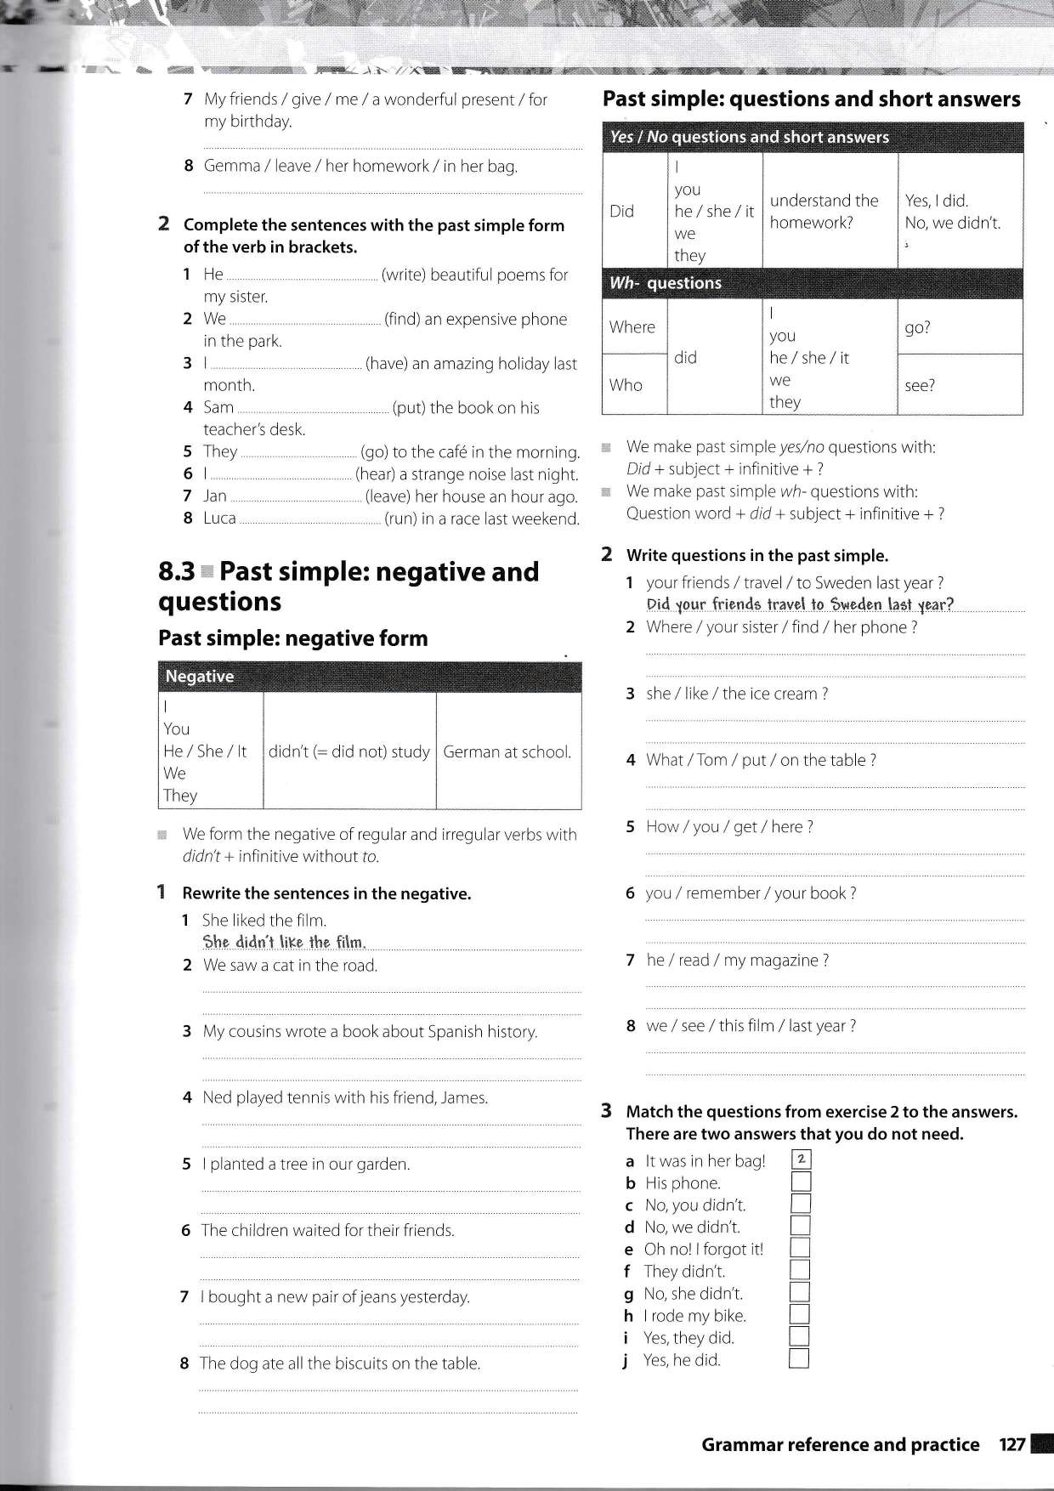

HO 2 HO 3

ІІІ. Заключний етап уроку.
1. Підведення підсумків уроку.
Вчитель: So, today we have done the great job and I am sure that you have got to know more about famous writers and their masterpieces.
2. Домашнє завдання.
Вчитель: Your task is to write a letter about your favourite writer and his/her story. Your teacher of Foreign Literature will be happy having got your letters.

