Тема : Amazing Astronomy
Мета:
очікуєтья сформувати комунікативні навички по темі « Amazing Astronomy»,
активізувати мовленнєву активність,
сформувати доброзичливе ставлення до опонента та навички толерантного спілкування, вміння аргументувати свій погляд, знаходити альтернативне рішення проблеми
очікуєтья, що урок сприятиме активізації навичок аудіювання , читання та письма,
будуть розвиватися вміння аналізувати отриману інформацію,
буде удосконалюватися монологічне мовлення з опорою на відео та аудіоматеріали,
планується розвивати креативність та критичне мислення та вміння співпрацювати під час групової роботи та розвивати навички наставництва
Хід уроку.
Teacher: Let`s revise the names of the planets. Repeat after me.
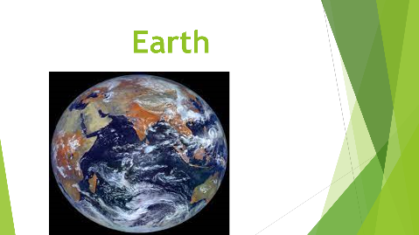
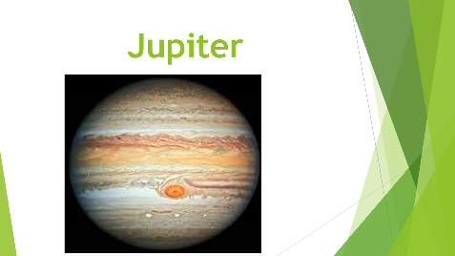
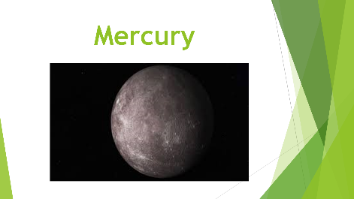
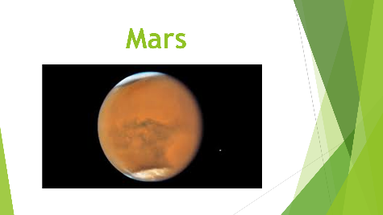
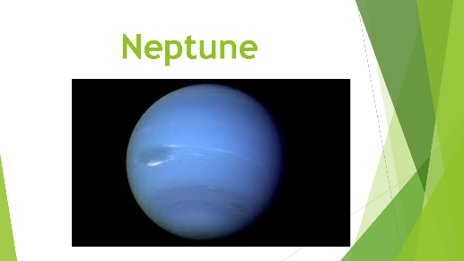
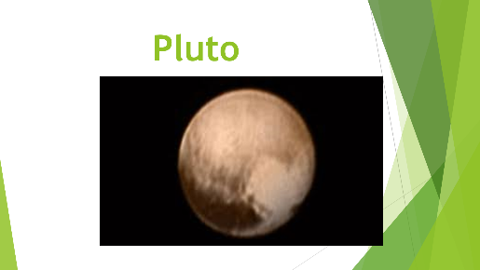

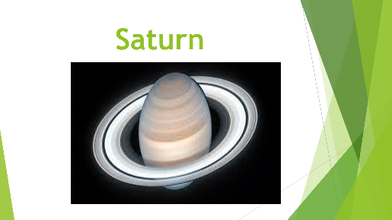
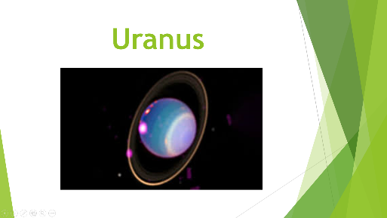
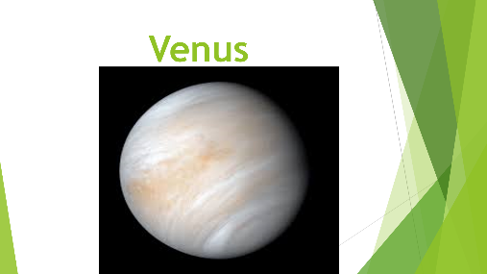
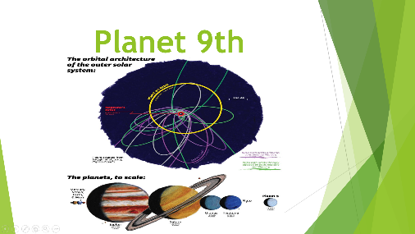
Teacher: Write the words that you`ve heard in the song which are connected with Astronomy. https://www.tricider.com/home
Students` own answers.
Teacher: Listen to the information about planets and answer the questions:
What is the closest planet to the Sun?
Which planet is the smallest?
What is the temperature of Mercury during the day?
What is the last discovery in Mercury?
What is the second planet from the Sun?
What does the surface of Venus have?
What kind of atmosphere is there?
What is the second planet from the Sun?
What does the surface of Venus have?
What kind of atmosphere is there?
Why is Mars red?
What landscape is there in Mars?
What is the largest planet in our solar system?
What is Jupiter like?
Which planet is the sixth in our solar system?
From what the rings are made of?
What is the smell in Uranus?
Why is Uranus blue?
What is the smell in Uranus?
Why is Uranus blue?
Is Pluto a planet?
Is it cold or hot in Pluto?
Have the scientists actually seen “Planet Nine”?
What is another name of “Planet Nine”?
Students` own answers.
Teacher: Join to virtual tour “Seven Great Galaxies”. Discuss the questions. Work in groups.
What is Galaxy?
What is Pinwheel?
What do you know about M53 galaxy?
What is the legend of M34 galaxy?
What is M83?
Students` own answers.
Teacher: Read the text and try to find the answers to this question: Why is there so little water left on Mars? (Клас ділиться на групи. Пропоную учасникам розрахуватися від 1 до 3.Кожен учасник отримує по одному уривку із тексту. Кожний працює зі своїм уривком – опрацьовує інформацію. Наступний етап – утворення нових груп ( в одній команді будуть всі ті, хто отримав уривок №1, у другій групі – ті, хто отримав уривок №2, у третій групі – ті, хто отримав уривок №3). Учні обмінюються своїми думками. Учасники за номером 1 переходять до наступної трійки за годинниковою стрілкою. Учасники за номером 2 переходять до наступної трійки проти годинникової стрілки. Учасники за номером 3 залишаються на місці.)

Mars is known for its thin atmosphere, where CO2 dominates and provides most of the atmospheric mass and pressure. In fact, the pressure is similar to that in the Earth’s stratosphere, which is a layer of the atmosphere, at more than 30km above the surface.
But what about water? Water on Mars is currently found on the surface as a layer of ice – several kilometres thick – at the north pole. It also appears as seasonal frost at the coldest times of the year, and in the atmosphere as vapour and ice. Nevertheless, the Martian atmosphere is extremely dry compared to Earth’s, with about 100 times less water. While precipitation on Earth results in water layers several centimetres thick, water that would precipitate on Mars would only form a thin film of less than a millimetre.
Water escapes from the Martian atmosphere?
The evidence suggests that Mars was not always the cold, arid planet we observe today. There is plenty of evidence of water on Mars’ surface in the distant past – about four billion years ago. At that time, liquid water flowed in great streams and stagnated in the form of pools or lakes, such as in the Jezero crater explored by the Perseverance rover, in search of traces of past life.
For liquid water to circulate and reside on the surface long enough to leave these marks, there must have been a radically different climate than the one we see today. Mars, Earth and Venus probably formed from the gradual accumulation of the same basic materials, which means that they must have had great similarities early in their history. But while Earth and Venus have retained most of their thick atmosphere, Mars, because of its small size and low gravity, has lost most of its atmosphere.

It is indeed this "loss of gas to space" that helps explain the current tenuousness of Mars’ atmosphere. This loss occurs very high in the atmosphere, above 200km, where molecules have already broken down into atoms and where the lightest ones, such as hydrogen, can be torn away from the weak gravity of Mars. Exposed to the energetic particles of the solar wind, Mars’ exosphere (the upper layer of the atmosphere) has allowed the equivalent of hundreds of present-day atmospheres to be lost to space.
Students` own answers.
Teacher: Now we revise mathematical calculations:
11 + 15 = 26
11 plus/ and 15 is/equals 26
15 – 11 = 4
15 minus/from 11 is/equals 4
2 * 6= 12
twice 6 is/equals 12 or
2 times 6 is/equals 12
12 : 6 = 2
12 divided by 6 is/equals 2
6 into 12 goes 2
Teacher: Solve mathematical problems:
Orbit of Mercury is 88 Earth days. Orbit of Venus is 225 Earth days. What is the difference between numbers?
The diameter of Mars is 6.787 km. The diameter of Jupiter is 86.881 km. How many times the diameter of Mars is larger than the diameter of Jupiter?
Students` own answers.
Teacher: Now we`ll dream a little bit. We created our mutual e-book. So, present your ideas.
Project: What do you think the future will be like? Would you like to travel into space? Why?
Will we have flying cars? Tell us your ideas.
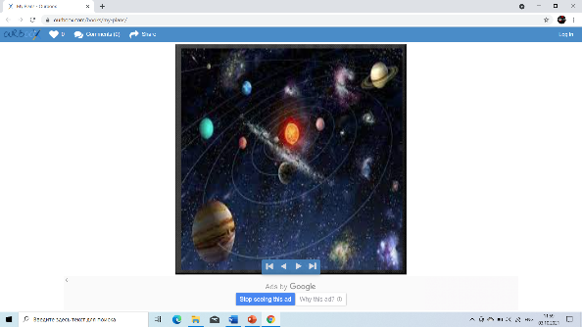
https://www.ourboox.com/books/my-plans/
Students` own answers.

