Тема уроку: Animals


Мета уроку:
Практична: систематизувати лексичний матеріал з теми; тренувати учнів у вживанні лексичного матеріалу.; практикувати учнів в читанні; вчити презентувати підготовлений матеріал.
Освітня: збагачувати знання учнів з теми.
Розвивальна: розвивати вміння висловлювати думки іноземною мовою; розвивати мовленнєву реакцію.
Виховна: виховувати бережливе ставлення до природи, тварин.
Обладнання: Підручник Click on 2 by Virginia Evans, текст, тест, ноутбук.

Animals
Introduction
Animals play a significant role in the stability of the environment, ecosystem, and our lives. They are excellent companions—especially the tiny mammals. The importance of animals cannot be stressed enough. Without them, our existence is not possible.
Warming-up!
Scientists sort the different types of animals in the world into categories based on certain characteristics.
Read the definitions and name animals for each type.
Birds - a creature with feathers and wings, usually able to fly
Mammals - any member of the group of vertebrate animals in which the young are nourished with milk
Reptile s- an animal that crawls or moves on its belly (such as a snake)
Insects - any small creature with six legs and a body divided into three parts.
Carnivores - an animal that feeds on other animals
Herbivores - an animal that feeds on plants.
Endangered species - a species of animal or plant that is seriously at risk of extinction
Wild - any animal living in a natural, undomesticated state.
Tame - an animal that is relatively tolerant of human presence.
Farm – animals that are raised on a farm

Main part

- In this exercise you have to match the animals to the types.

lion, eagle, deer, bull, lizard, caterpillar, fox, camel, shark, pig, butterfly, cat, snake, cow, wolf, sheep, ant, snail, rabbit, turtle, crocodile, mosquito, ladybird, ram, elephant, parrot, kangaroo, beetle, monkey

mammals
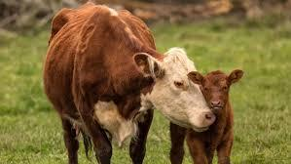

carnivores

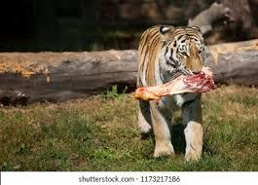

herbivores

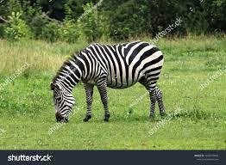

farm
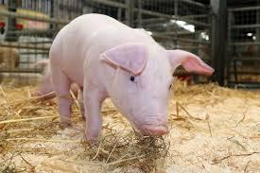

insects
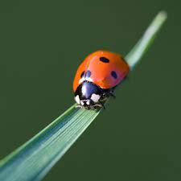

reptiles
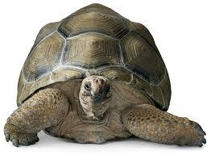

- Rebus Guess the animal

+k (monkey)


2=a
(kangaroo)

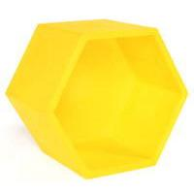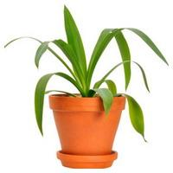
2=h

(elephant)

- Choose any animal you like and describe it.
Use the following vocabulary to describe animals.

Giraffe: long, tall, neck, brown spots, long legs, Africa, small horns, swim, herbivore, mammal
Kangaroo: a pouch for babies, shot, front legs, back legs, strong, tail, eyes, small, leaves, New Zealand, mammal, herbivore
Monkey: funny, hair, vegetarian, bananas, insects, tribes, steal, intelligent, amazing, mammal, omnivore
Fish: scales, fins, tail, eye, gills, swim, graceful, exotic, beautiful
Lion: ears, fur, tail, paws, whiskers, brown mane, strong, jaws, massive, mammal, carnivore
Shark: log fins, nose, teeth, scales, sharp, ocean, dangerous, wild, tough skin, carnivore
Elephant: huge, grey, long nose, two ivory tusks, wide, flat ears, leaves, branches, mammal, herbivore
Cat: fur, claw, tail, playful, whickers, curious, milk, fluffy, jump and climb, mammal, omnivore
Parrot: bright feather, sharp, curved beak, tail, long, fly, do tricks, wings, omnivore
- Do you have a pet? Sometimes they can cause trouble.
Match the viewpoints to the reasons. Which points are in favour of having a cat a pet? Which points are against?

They cause extra housework | If they don’t like you, they will scratch you
They can destroy furniture | they sit next to you and let you stroke them
They are friendly | they sharpen their claws on the furniture
They can be mean | they do funny things
They can destroy furniture | they can look after themselves
They are independent | they leave hairs everywhere

- Animals have different characteristics.
Fill in the gaps with the correct form (positive, comparative or superlative) of the adjectives/adverbs in brackets.
 |  | 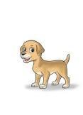

- The mouse is not as big as the dog.
- The elephant is………………………... (heavy) all.
- The dog is ………………………………...(noisy) the mouse.
- The dog can run ………………………. (fast) the elephant.
- The dog is …………………………………...(heavy) the mouse.
- The dog is ……………………………………(small) the elephant.
- Elephants live ……………………………. (long) dogs.
- The elephant is not ……………………. (friendly) the dog.

Home assignment: Write a short article on the topic “Cats make good pets.”

Олена Клименко
Урок для 7 класу

