FROM THE HISTORY OF LONDON
Form: 6
Done by Galyna Kotul
Aims: At the end of the lesson students will
- get new information about historical places of London;
- learn new words and phrases;
- revise words connected with history and past events;
- get knowledge about different types of texts;
- learn how to find necessary information in the text;
- tell about tourist attraction in the native country.
Equipment: students’ books and workbooks “NEXT MOVE 2” (PEARSON), Active Teach “NEXT MOVE 2” (PEARSON), Teacher’s Book, an interactive whiteboard, handouts.
Procedure
Warming-up. Revision
- Organize children in 3 groups using the puzzles of castles (HO1)

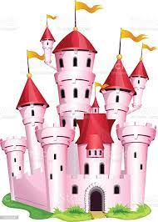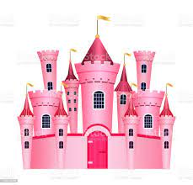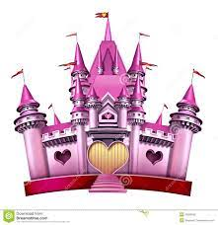
HO1. Pictures for puzzles

- Announce the topic and the aim of the lesson:
Teacher: Today we are going on learning about the history. So we are going to learn new words and develop your reading and speaking skills. To start our lesson revise the vocabulary from previous lesson.

- Group work.
Group 1. Create a history mind map.
Group 2. Create a history diagram using the word “century”.
Group 3. Create a history diagram using the word “history”
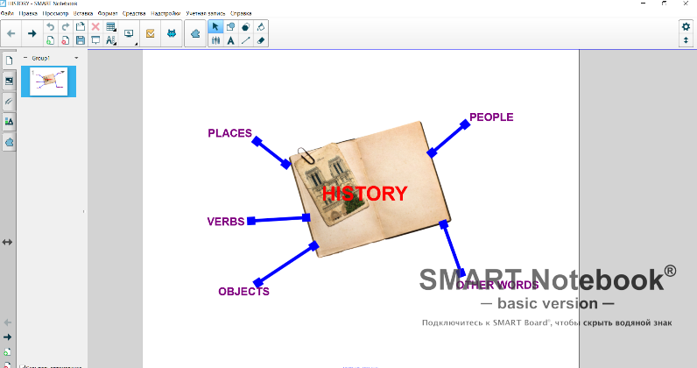
HO2. A history mind map

 |  |  |  |  | C | a | s | t | l | e
 |  |  |  | s | E | r | v | a | n | t
 |  |  | k | i | N | g
k | n | i | g | h | T
 |  |  |  | d | U | n | g | e | o | n
 |  |  | w | a | R
 |  | a | r | m | Y
HO3. A history diagram
Main part of the lesson
Pre-reading
- Look at the picture on page 31SB and answer the questions.
- What can you see in this picture? (a river, boats, a town, fire)
- Does this picture show past or modern time? (past)
- Where can we learn about historical events and past lives? (from books, in the museum, from excursions around towns)
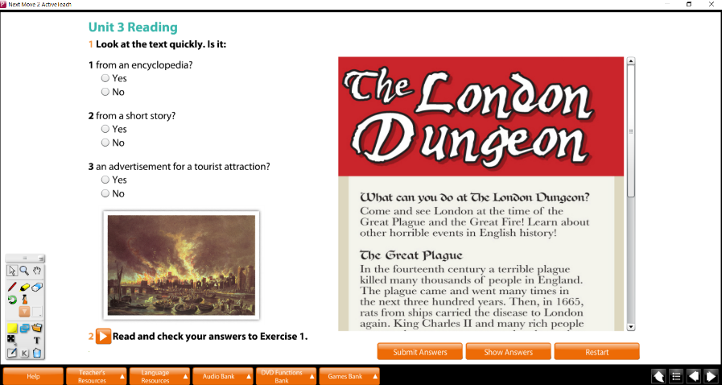
Picture 1. Active Teach Screen for pre-reading activity

- Read the task to exercise 1 page 31SB and answer the questions.
- What types of texts are called?
- What can you read about in these types of texts? (an encyclopedia – different facts about life; a short story – imaginary events and people; an advertisement – interesting information about real places or things)
- Read the text ‘The London Dungeon” quickly and decide what type of text it is. Explain your opinion. (An advertisement. In the first part of the text read:” What can you do at the London Dungeon? Come and see… Learn about…”

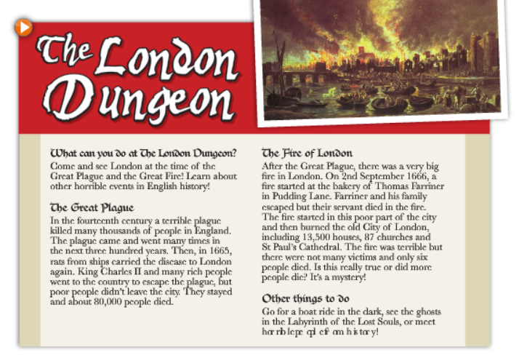
Picture 2. Text “The London Dungeon”

- Culture information about the tourist attraction of London “The London Dungeon”
- Variant 1. Read the information about the London Dungeon from the teacher’s book “NEXT MOVE 2” p.60
- Variant 2. Using an interactive white board read the information about the London Dungeon and look at real pictures of this place from Wikipedia (the link can be add to the active teach page) https://en.wikipedia.org/wiki/London_Dungeon
- Variant 3. In advance, ask one or two students to prepare a report about the London Dungeon.

While-reading
- Read the text and decide if the statements in exercise 3, page 31 SB are true or false (Discuss in groups and then in class. One student does the exercise on the interactive whiteboard)
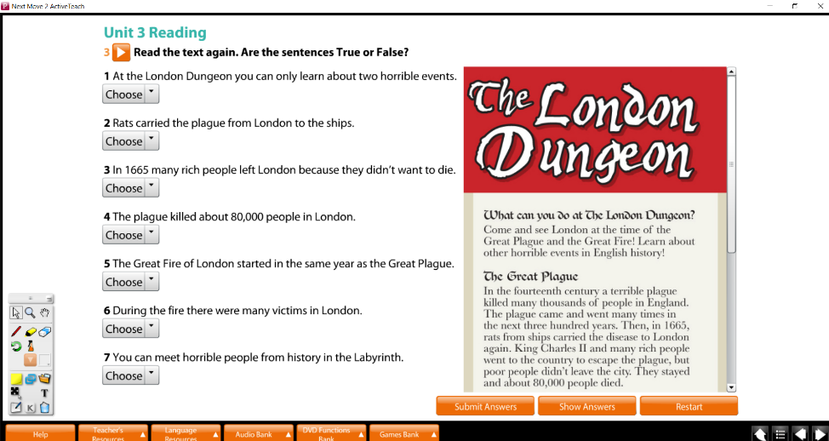
Picture 3. Active Teach Screen for while-reading activity
After-reading
- Find in the text extracts with the words and explain them.
- horrible (scared)
- rats (animals, big mice)
- escape (run away)
- burn (destroy by fire)
- victim (a person who was killed or died)
- ghost (unreal creature)
- soul (a spirit of a person)
- Extra activity. What do these numbers refer to?
- 6 (victims of the Great Fire of London)
- 87 (churches burnt in the Great Fire)
- 02.09.1666 (the date the Great Fire started)
- 80000 (people died because of plague)
- 1665 (the year when plague came to London)
- 13500 (houses were destroyed in the Great Fire)
Speaking
- Using the questions in exercise 4 page 31 SB tell about a tourist attraction in a native country.
- Variant 1. To help students suggest them some paper pictures of famous places in Ukraine, e.g. Baturyn
- Variant 2. Ask students to choose icons on the interactive whiteboard and open links with information about famous places in Ukraine https://uk.wikipedia.org/wiki/Батуринська_фортеця
https://en.wikipedia.org/wiki/Golden_Gate,_Kyiv
https://en.wikipedia.org/wiki/Vorontsov_Palace_(Alupka)

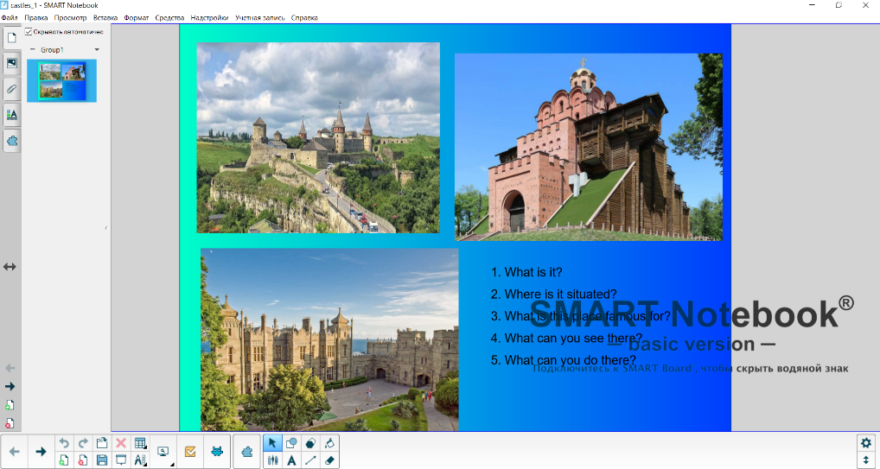
Picture 3. Smart Notebook Page for speaking activity
Summary
- Answer the questions.
- What place of London have we learned about?
- What new words have you learned?
- What type of text did you read?
- Have you learned how to tell about a tourist attraction?

- Explaining the home task.
- Do you know anything about King Arthur, Merlin or Lancelot? Read about them in your workbook.

