Topic: Genre of films.
Мета: -формування навичок вживання нових ЛО, вдосконалення навичок усного мовлення, аудіювання, читання та письма з опорою на лексико-граматичні структури, розвивати логічне мислення та пізнавальний інтерес до вивчення англійської мови, виховувати зацікавленість у розширенні своїх знань і повагу до культури інших народів.
Procedure
I. Warm-up.
Clap the hands if the following statements true. Correct the wrong statements.
- «Gone with the wind» is an action film.
- Matt Damon is an American actor.
- A composer prepares the music.
- Films are usually made by the ushers.
- A box office is the place where you buy tickets.
- Cast is the a group of musicians.
- Scary things are usually happens in comedies.
- Cartoons are films for adults.
- A movie about real life is an adventure film.
Key 1.F 2.T 3.F. 4. F. 5.T 6. F 7. F 8. F 9. F
II.Speaking
I. Answer for the questions.
1.What is your favourite genre of films?
2.What movies you don’t like to watch? Why?
3. Нow often do you go to the cinema?
4. What film have you seen recently?
5. Who is iyour favourite actor?
6. Who is your favourite actress?
7. What is the best film you have ever seen?
8. Which movies are more interesting for you modern or old?
II. Complete the sentences
I like to watch….because..
I don’t like to watch….because..
My friend (mother, I, classmates..) is (am,are) fond of (crazy about, interested in, excited about)…
I hates…
III.ex.2 p.83
III. Vocabulary practice.
- Practice the new vocabulary chorally.
A comedy, a horror film, an action, an adventure film, film about love (romance), a science fiction film, a thriller, a fantasy, a detective film, a history film, documentaries, a war film , biography, disaster film.
- Do ex.1 p. 82
- Match these words with the posters.
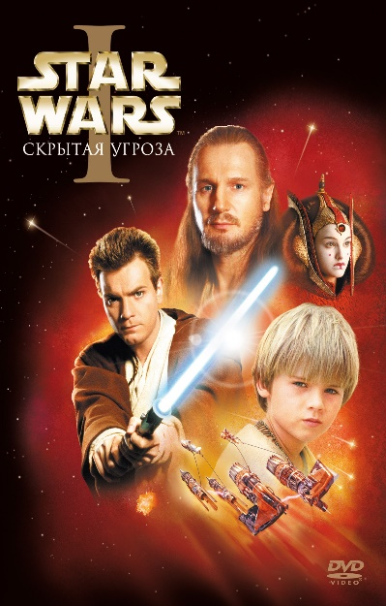
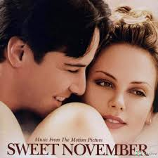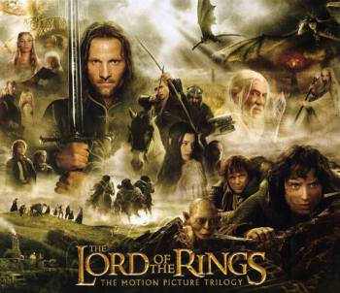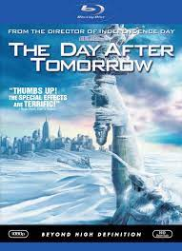
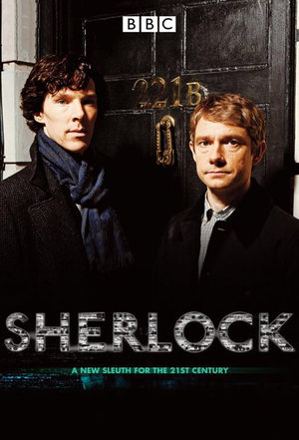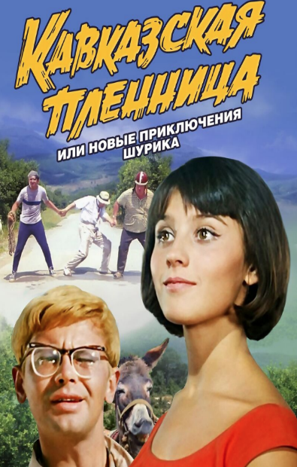

Key:
1. a science fiction film
2. an action
3. a horror film
4. film about love (romance)
5. disaster film
6. a fantasy
7. a detective film
8. comedy
9. an adventure film

- Listening

Jack: Do you like watching films?
Sue: Yes, I do. What about you?
Jack: Yes, of course. My favourite types of films are romantic drama, comedy, western and detective films.
Sue: Oh, I don’t really like detective stories. I prefer to watch historical films.
Jack: So, what is your favorite movie?
Sue: I think that the «Gladiator» is best movie for me. I can watch it million times. And Russell Crowe was believable in this role. On my opinion, it is the best role of Russell Crowe. Do you know the fact that Crowe lost 40 pounds before filming process?
Jack: Really? I have no idea. He worked hard.
Sue: Yes, I absolutely agree with you. And also in 2001 this historical drama became winner in five Academy Award nominations (is known as Oscar), for example as best picture and Russell was chosen as best actor in a leading role.
Task True or Falls
- Jack likes to watch different types of films.
- Sue likes detective films most of all.
- They both like historical films.
- Children are talking about Pirates of Caribbean
- Sues favorite movie is «Gladiator»
- Girl didn’t tell the boy about this film.
- Bruce Willis is a main star of this film
Key 1.T,2.F,3.F,4.F,5.T,6.F,7.F

V . Reading
Ex. 3,4 p.83
- Writing:
Write a dictation, use the new words (genres of movies)
1.Films that presents the real facts about a person, animals or events (a documentary)
2. An exciting, sensational, frightening film with strange creations ( a horror film)
3. An animated film made of funny drawings (a cartoon)
4. A film where we really can laugh (a comedy)
5. Films about future and space (a science-fiction)
6. Movies about history events ( a history film)
7.A film with detective investigations, crimes and mysteries
( detective films or thrillers)
8.Exciting movies with lots of guns and explosions ( an action
9. Romantic films ( romance)
10. Movies where actors sing songs and dance (musical)
11. Films about travelling and dangerous events (an adventure film)
12. Films where we can see imagine worlds, creations like dwarf and elves or wizards (a fantasy)
VII. Summary
Answer for the questions:
Ex.5 p.84.
Home work: ex.6 p.84, learn new words

