Тема: School
Підтема: School subjects
Мета: практикувати вживання лексичних одиниць з теми; звернути увагу учнів на вживання prepositions of time on, at, in; розвивати в учнів навики читання та усного мовлення; розвивати творчу уяву та мислення; формувати уміння колективної мовної взаємодії.
Обладнання: підручники, робочі зошити, роздатковий матеріал, ноутбук, відеоматеріали.
Очікувані результати: в кінці уроку учні учні навчаться вживати в своєму мовленні лексичні одиниці з теми; використовувати у своєму мовленні прийменники часу; писати невеликі нотатки про їхні улюблені предмети в школі.

PROCEDURE
- Introduction
T. Good morning. How are you today? What day is it today? What date is it today? Who is absent?
Aims of the lesson
T. You go to school every day and study different subjects here. Today we are going to talk about school. In our lesson we will try to find out what we are interesting in and give some tips to each other for ideal timetable.
- Listening
Look at the key words. Match the words with the pictures 1-9. Listen, check and repeat
https://www.youtube.com/watch?v=J0Ji8hXcD44

Key words
art, English, geography, maths, history, PE (physical education), science, music, physics
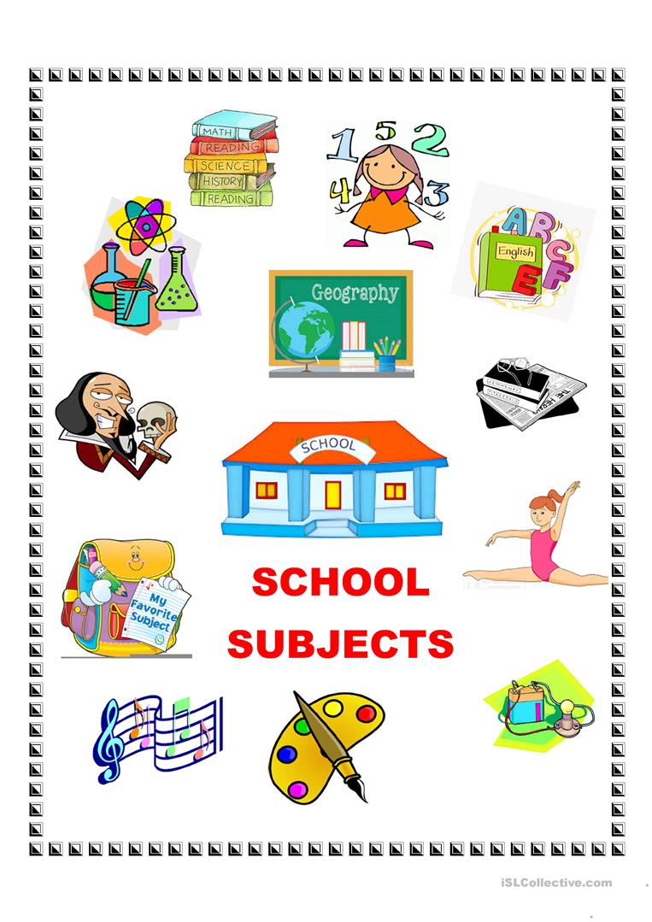
- Reading
T. You heard the names of different school subjects. Some of them you like more, another less. But all subjects are useful for you. Let's read Emma's letter to her friend about school.
Hi Melanie
How are you? I'm at my new school. I'm in Class 5 and my teacher's name is Mrs. Jackson. She is friendly and the students in my class are great.
My new classroom is fantastic but my timetable isn't great. On Mondays, it's science at 9 o'clock, maths at 9.50 and history at 11 o'clock in the morning. On Wednesdays, it's geography at 2.15 and PE at 3 o'clock in the afternoon. My favourite day is Friday. It's art in the morning. In the afternoon, it's English at 2.15 and IT at 3 o'clock.
And hours of homework in the evening and at weekends. Help!
What's it like at your new school? Email me soon.
Emma
- Post-reading activity
T. You read text. Are the following statements about the text true or false?
1. Melanie is in Class 5.
2. Her teacher's name is Mrs. Jackson.
3. Her timetable is fantastic.
4. Science is at 11 o'clock on Mondays.
5. Geography is on Tuesdays.
6. She likes Friday.
7. Melanie has art on Fridays.
She has English at 3 o'clock on Thursdays.
- Grammar time
T. We used many prepositions of time in our speaking. Today we are going to talk about such prepositions of time as on, at, in
Look at the table
Prepositions of time
on | on Mondays, on Tuesdays, on Wednesday,… on Sundays,  on 25 December
in | in the morning, in the afternoon, in the evening, in October
at | at six o'clock, at night, at weekends

6. Practice grammar
T. Complete the sentences with in, at, on
1. _____________the afternoon I study homework.
2. We aren't at school _______________weekends.
3. She usually gets up ____________7 o'clock.
4. My mum and dad are at home ______________the evening.
5. What's your favourite subject _____________Monday?
6. English is ________10.50 ______________Wednesday.
7. History is ________09.15 ___________the morning.
8. My favoutite lessons are ___________
9. The stars shine ____________night.
7. Speaking
T. Let's imagine your favourite timetable. Talk to your partner how do you see it.
- No lessons on Mondays.
- We study only _____________at school.
- On Tuesday it's PE all day.
- On Wednesday it's art all day.
- Your ideas.
8. Summing-up
T. Today we have learned names of school subjects and prepositions of time. As for me I liked all the school subjects. And you? (Pupils answer and explain their choice)
I like_________________
I don't like_____________
I can't stand____________
My favourite subject at school is___________
9. Home assignment
T. We have read Emma's letter about her timetable. Write your own timetable for the next time.

