Shopping for food
Мета: Ознайомити учнів з новими ЛО.
Повторити й активізувати лексику теми.
Продовжувати вдосконалювати техніку читання.
Розвивати вміння діалогічного та монологічного мовлення.
Практикувати учнів в аудіюванні та письмі.
Виховувати дбайливе ставлення до здоров'я.
Обладнання: Підручник, роздатковий матеріал, аудіодиск до підручника, , мультимедійна дошка, малюнки до теми «Їжа».
ХІД УРОКУ
І. ПІДГОТОВКА ДО СПРИЙНЯТТЯ ІНШОМОВНОГО МОВЛЕННЯ
1. Greeting. Привітання.
Т: Red and yellow, green and blue. Hello, pupils. How are you?
Ps: Red and yellow, green and blue. Hello, teacher. We are fine, thank you!
2. Aim. Повідомлення теми та мети уроку.
T: The theme of our lesson is “Shopping for food”. When you need to buy food, you go to the shop or supermarket. We go shopping practically every day. We cannot imagine our life without shops and shopping. Today at the lesson we’ll summarize and systematize your knowledge on the topic: talk about your likes and dislikes in food, develop your listening, reading, writing and speaking skills, and we`ll complete our cookbook with the recipes of national cuisine
3. Warming up. Уведення в іншомовну атмосферу.
a) Фонетична зарядка
Т: Let's prepare our tongues for our English lesson. Look at the screen and let's sing the song
b) Лексична розминка
And now we`ll use the dice and answer the questions. Please roll the dice
4.Checking on homework. Перевірка домашнього завдання
T: Your homework was to make presentations about the traditional food of different countries. After that we`ll put your recipes into the cookbook of national cuisines. Are you ready?
Doing the exercises during the lesson we will put different goods into the basket and at the end of the lesson we will be able to prepare Italian dish from these ingredients.
II. ОСНОВНА ЧАСТИНА УРОКУ
1. Vocabulary Practice. Відпрацювання лексичного матеріалу.
T: Let’s revise the food with the help of the game “Food Wheel”. Your task will be to spin the wheel and click the right words.
T: Well done! Lera , put this ingredient into the basket please and write down it into the recipe book! ( tomatoes)
2. Grammar. Interactive task. Повторення граматичного матеріалу.
And now we`ll remember the grammar rules of using countable ans uncountable nouns.
Countable nouns are things that you can count, they have a singular and plural form. For example: one apple, two apples, three apples. Uncountable nouns are things that you can’t count and they have only a singular form: cheese, meat, milk, water...
Interactive task
https://wordwall.net/uk/resource/592439/uncountable-and-countable-nouns
T: Excellent! Sofia, put this ingredient to our basket please and write down it into the recipe book!! (olives)
3. Work in pair. Writing. Робота в парах. Виконання завдання на картках
There is, there are не перекладаються українською, але сповіщають про наявність чогось / когось у певному місці.
There is вживається в однині та з незлічуваними іменниками.
There are вживається у множині зі злічуваними іменниками.
Some \ any
Займенники any / some використовуються, коли мова йде про невизначеність у кількостях, числах, в тих випадках, коли точна кількість або число не важливі. Головним чином, some використовується в ствердних реченнях, а any – в питальних і заперечних.
And now let`s work in groups. Each group has a task to complete the sentences with some or any. For this task you`ll have 2 minutes

T: Complete the sentences with “ some” and “any” ( in writing)
There are some eggs.
There isn’t any milk.

1. There are______ apples.
2. There aren’t _____ oranges.
3. There isn’t _____ soup.
4. There’s _____ cheese.
5. There aren’t_____ hamburgers.
6. There’s_____ water.

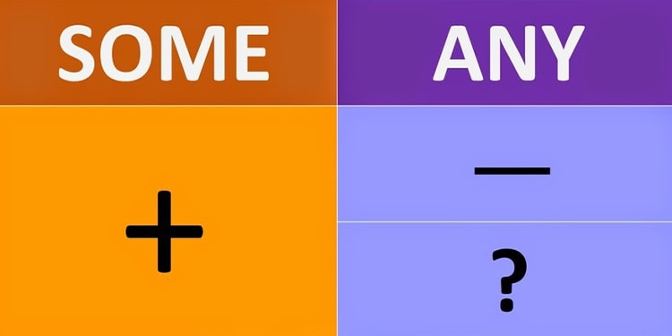
- ?
any

+
some
T: O’k , have a look at the screen , here are right answers.
Good job! Sofia, put this ingredient to our basket please and write down it into the recipe book!! (ham)
4. Listening Comprehension. Аудіювання.
1) Етап підготовки до аудіювання.
a) Т: And now we are going to listen to the text. But first answer my questions.
- Do you eat healthy food? (Yes, I do. I always try to eat healthy food.)
- What healthy food do you often eat? (I often eat milk, cheese, fish, fruit and vegetables.)
b) T: Now I’d like to explain all unknown for you words from the text you are going to listen to. Repeat after me.
аn aisle [ən aɪl] ряд
to sigh [saɪ] зітхати
checkout [ˈʧəkˈaʊt] каса
to scowl [skaʊl] хмуритися
to shrug [ʃrʌɡ] знизувати плечима
2) Етап аудіювання.
T: Listen to the text.
Учні слухають текст.
3) Етап перевірки розуміння змісту тексту.
T: Open your exercise books, write down the date. Your task will be to write down letter T if the sentences are true, and letter F if the sentences are false. For this task you`ll have 2 minutes
1. Mom read the shopping list.
2. Harry put apples into a bag.
3. Mom got broccoli and potatoes.
4. “I don`t like fruit!” said Oliver.
5. Candy is not good for you.

T: O’k , have a look at the screen , here are right answers.
Good job! Sofia, put this ingredient to our basket please and write down it into the recipe book!! (cheese)
5. Rest for your eyes. Гімнастика для очей
6. Reading. Читання.
a) Pre-Reading Activity. Етап підготовки до читання.
T: And now we’ll read the dialogue, exercise 1, page 51. But before reading answer my question
Do you like going shopping?
Vocabulary:
1. anything [ˈɛniθɪŋ] будь що, щось
2. altogether [ɔltəˈɡɛðə˞] загалом
3. change [ˈtʃeɪndʒ] решта, дрібні гроші
b) While-Reading Activity. Читання.
Exercise 1, page 51.
T: Let’s read the dialogue in pairs
Physical warm-up
с) Post-Reading Activity. Етап розуміння змісту тексту.
T: Open your exercise books, your task will be to complete the sentences with the missing words
1. Can I have a ___________ and fries, please ?
2. Yes, a ___________________, please.
3. How __________ is that?
4. 3.90 ___________ altogether, please.
T: O’k , have a look at the screen , here are right answers.
Good job! Stepan, put this ingredient to our basket please and write down it into the recipe book!! (mushrooms)
7. Role play

T: Well done. It`s high time for you to go shopping. One of you is a shop assistant, the others are customers. Your task is to make up a dialogue. The example of a dialogue is on a screen. Of course you can add the necessary information And show your creativity. I give you some minutes.
S-shop assistant
C-customer
S: Hello. Can I help you?
C: Yes, please. I would like…
S: How much/many… would you like?
C: I would like…
S: Ok. Anything else?
C: No, thanks. How much is it?
S: That is…. pounds
C: Here you are.
S: Thank you. Good bye.
T: Great! Illia, put the last ingredient to our basket please and write down it into the recipe book!! (pepper). Now we have all the ingredients. What tasty food can we prepare of these ingredients? It`s pizza. And this recipe we`ll put into our recipe book.
8. Vocabulary Practice. Відпрацювання лексичного матеріалу.
T: Let’s make up the cinquain .
Line 1: one word( the title).
Line 2: two words( describing the title).
Line 3: three words( describing an action or containing three present participles). Line 4: four words( expressing a feeling).
Line 5: one word( a synonym for the title).

III. ЗАКЛЮЧНА ЧАСТИНА УРОКУ.
1. Homework. Домашнє завдання.
T: Write down your homework.
Write about what you eat every day.
2. Summarizing. Підведення підсумків уроку.
T: We have done a lot of work today. We have spoken about healthy and unhealthy food. What healthy food do you eat? What unhealthy food do you like?
You have worked excellent today.
Our lesson is over. You may be free.

Ukrainian borshch

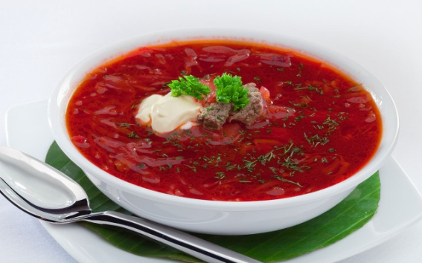
Cook the meat.

Wash and peel some potatoes, carrots, beetroots, onions.

Chop the onion and greens. Slice potatoes and cabbage.

Put all the vegetables into the saucepan. Add tomato sauce, spices and don`t forget to salt.

When borshch is ready, add some sour cream into your plate.

Enjoy your meal!
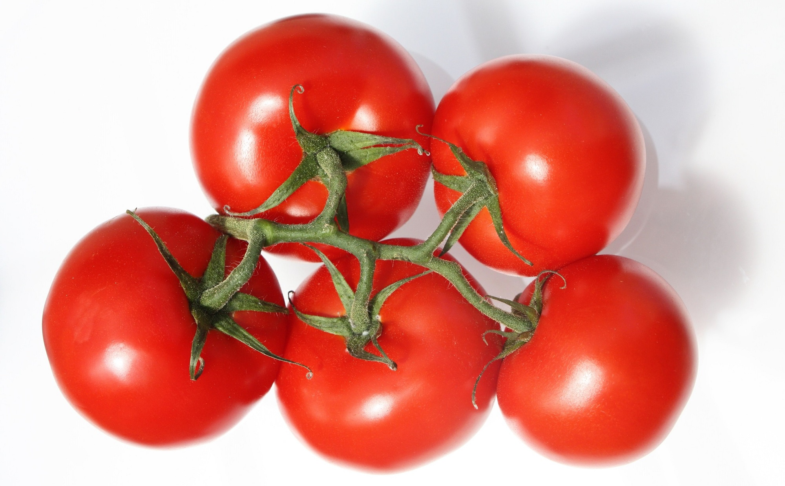
tomatoes
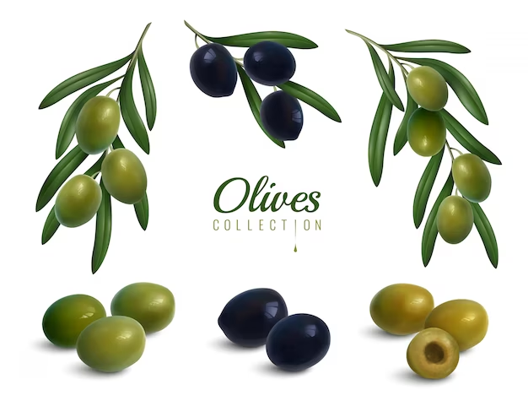
olives
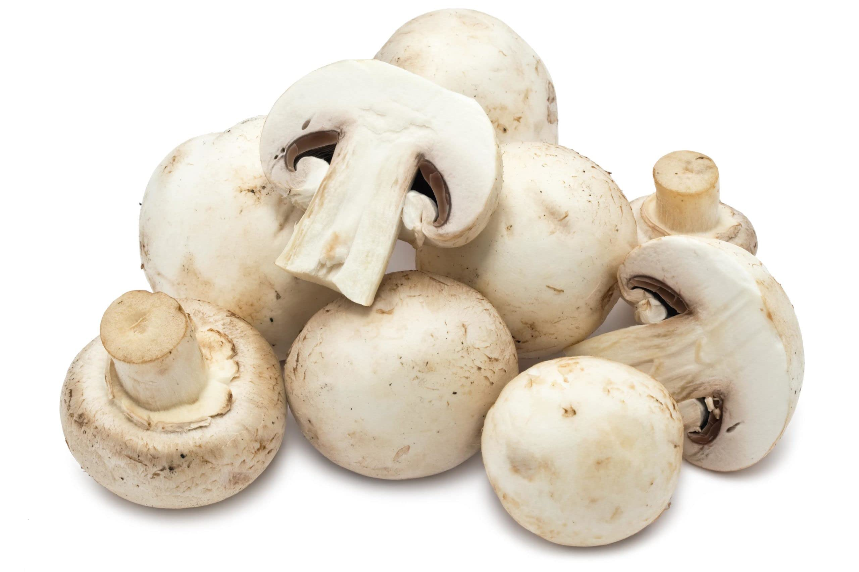
mushrooms
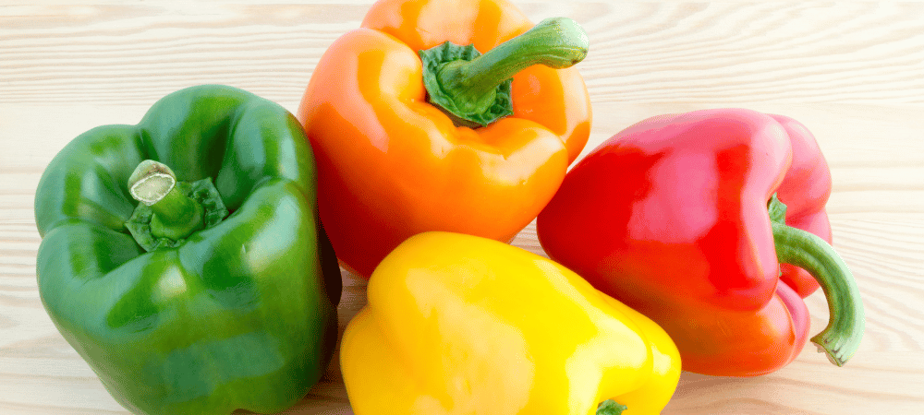
peppers
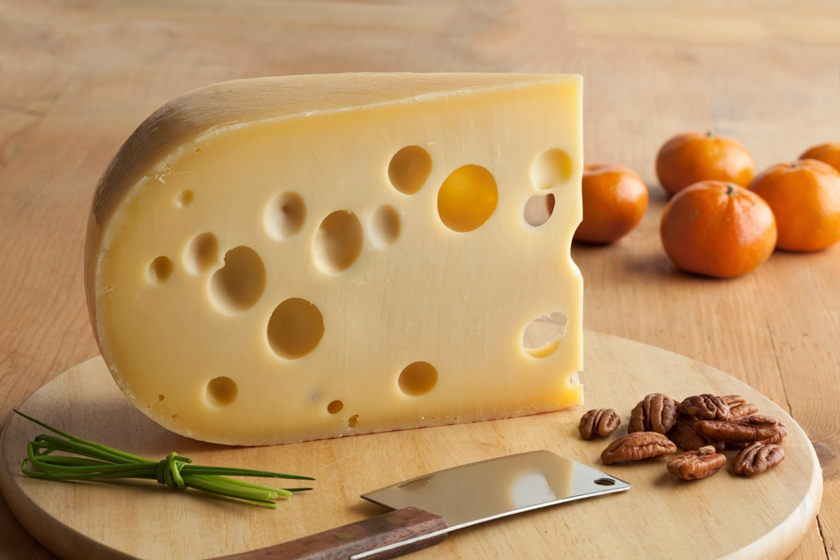
cheese
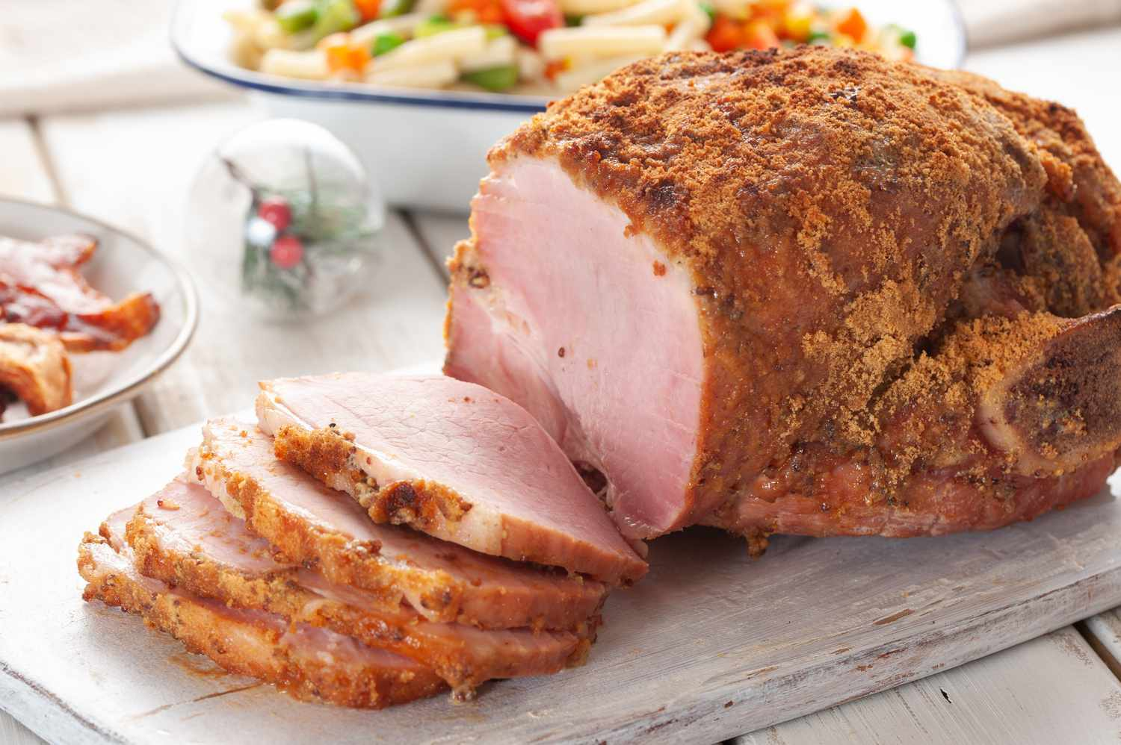
ham

