Тема уроку: Shopping
Мета уроку: повторити та закріпити лексичні навички до теми; поглибити знання учнів з теми Shopping; удосконалити навички вживання ступенів порівняння прикметників; розвивати мовленнєві здібності; розвивати соціокультурну компетенцію учнів; позитивне ставлення до іноземної мови; розвивати навики роботи над проектом.
Тип уроку: узагальнення і систематизація вивченого матеріалу.
Обладнання: картки, підручник, аркуші А4, олівці.

Хід уроку
І Вступна частина уроку
1. Welcome.
- Welcome to our shopping centre. Let’s repeat the names of the shops.
bakery – bookshop – butcher’s – clothes shop – florist’s - greengrocer’s – newsagent’s – pharmacy – shoe shop
- What can you buy at the bakery? (bookshop – butcher’s – clothes shop – florist’s - greengrocer’s – newsagent’s – pharmacy – shoe shop)
ІІ Основна частина уроку
1. Project work
- We’d like to visit your shops. (Students introduce their shops. They choose their own way to speak about the shop: text, dialogue, video, presentation)
For example:
A bakery is an establishment that produces and sells flour-based food baked in an oven such as bread, cookies, cakes, doughnuts, bagels, pastries, and pies.
A bookstore is a store that sells books, and where people can buy them. A used bookstore or second-hand bookshop sells and often buys used books.
Butchers prepare and sell meat and meat products. Butchers prepare meat for customers by boning, tying, grinding, cutting and trimming meat. They clean, cut, weigh, package and label products to meet customer satisfaction.
A clothes shop or clothes store is any shop which sells items of ready-made clothing. A small shop which sells expensive or designer clothing may be called a boutique. A shop that sells clothes for a narrowly restricted market such as school uniforms or outdoor sports may be called an outfitter.
Florists, or floral designers, sell flowers and floral arrangements to customers. They cut and arrange flowers and greenery to make decorative displays. Florists are part of the industry called floriculture. Growers produce vast amounts of flowers for the wholesale market.
The greengrocer sells fresh produce which is grown by a farmer. Some greengrocers specialize in offering organic produce which is grown without the use of artificial pesticides. Grocers offer fresh produce in season, but may also have imports that are in demand. These usually cost more.
A newsagent's shop or simply newsagent's or paper shop is a business that sells newspapers, magazines, cigarettes, snacks and often items of local interest. Newsagents typically operate in busy public places like city streets, railway stations and airports. Racks for newspapers and magazines can also be found in convenience stores, bookstores and supermarkets.
A shoe shop is a shop that sells shoes. Shoe salesmen and women work in retail establishments, helping clients select shoes that will make them happy in terms of overall fit, style and their budget.
2. Design your own shopping centre
- Tell us about your favourite shop. What is the most important and the least important in your shopping centre.
Number the facilities in order of importance (1 = most important, 12 = least important).
free parking
good choice of shops
lots of places to eat
multi-screen cinema
escalators
electric doors
fountains
children’s play areas
comfortable seats
art gallery
lots of plants and trees
clean toilets
3. Draw an advertisement.
Advert – advertisement – advertising
Create an advert for your shopping centre. Give your shopping centre a name and make it sound as attractive as possible. Add pictures. (Students can do it at home before the lesson as a project)
4. Listening
- Where do you like to go shopping?
(Watching a video about Shopping in London. Video from Wider World 2, Unit 6)
5. Shopping List
- If you don’t want to spend a lot of money you need a shopping list.
Find words in the word search to complete the shopping list.
S H A M B U N C H E
O I M E A T S A N A
F P A C K E T N U P
L O A N E D T O M P
O G B A R E J O A L
W E L T Y A A K T E
E M O H G T R A C S
R E A E A E Y T H O
S O F A M B E R E T
P H A R M A C Y S E

Shopping list
* a bottle of shampoo from the 1_________________
* a 2______ of bread from the 3___________
* a bag of 4 _________ from the greengrocer’s
* a 5 _________of chocolate, a 6 _________ of lemonade,
*a 7__________ of crisps and a box of 8______ from the newsagent’s
* some 9 _______from the butcher’s
* a 10______ of coffee from the supermarket
* a 11______ of 12_______ from the florist’s
Answers: 1 pharmacy 2 loaf 3 bakery 4 apples 5 bar 6 can 7 packet 8 matches 9 meat 10 jar 11 bunch 12 flowers
6. Money
- If we do shopping we need money. Listen and repeat new words.
piggy bank
pocket money
price
purse
sales
wallet
borrow – take something from someone else and give it back later
lend – give something to someone for some time
get some pocket money
earn money
save money
spend money
pay back
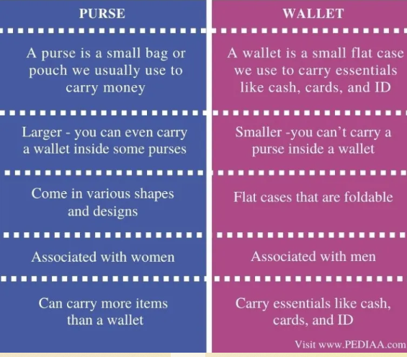

7. Sing a song.
Song “Money,money,money….” , ABBA
(use the link https://www.youtube.com/watch?v=wWgTxgmAIug)
8. Currency
REMEMBER: pay cash , pay by card
England
Unit | pound
Plural | pounds
Symbol | £
subunit
1⁄100 | penny
Plural
penny | pence
Symbol
penny | p
Ukraine
Unit
Plural | hryvni (nom. pl.), hryven (gen. pl.)
Symbol | ₴ or грн
Subunit
1⁄100 | kopiyka (копійка)
Plural
kopiyka (копійка) | kopiyky (nom. pl.), kopiyok (gen. pl.)

9. Grammar
comparatives of adjectives adj+er, more adj
superlatives of adjectives the adj+est, the most adj
Read the sentences about the mobile phones. Complete the table with the information below.
1 The cheapest phone is the Mokini.
2 The Nelson is lighter than the Mokini.
3 The Nelson is the oldest phone.
4 The best phone is the Escucha.
5 The thinnest phone is the Escucha.
6 The Nelson isn’t as expensive as the Escucha.
7 The Escucha is newer than the Mokini.
8 The Escucha is heavier than the Mokini.
9 The worst phone isn’t the lightest.
10 The Mokini isn’t as thin as the Nelson.
6mm £ 38 7/10 2012 4mm 500g
8/10 300g 2015 £104 10/10 £212
7mm 2016 400g
 | Mokini | Nelson | Escucha
price
weight
how thin
date
review score
Answers: 38,104,212; 400,300,500; 7,6,4; 2015,2012,2016; 7/10,8/10,10/10
10. Pair work.
Student ‘A’
Discuss the questions below with your partner.
1. When was the last time you went shopping? What did you buy? Why?
2. Do you enjoy shopping? Why? / Why not?
3. How often do you go shopping?
4. Do you ever spend too much money when you go shopping? Why? / Why not?
5. Where is your favorite place to go shopping for groceries? Why do you like it?
6. Are you saving your money to buy something expensive (for example, a TV or a car)?.
7. Is it a good idea for stores to open 24 hours a day, 7 days a week? Why? / Why not?
8. In your family, who usually goes shopping the most often? Why?
9. How can you save money (spend less) when you go shopping?
10. What is the worst thing you ever bought? Why was it so bad?
Student ‘B’
Discuss the questions below with your partner.
1. Are you going to buy anything after class? What?
2. Where is your favorite place to go shopping for clothes? Why do you like it?
3. Is it better to use cash or a credit card? Why?
4. Tell me about something you bought that was very expensive.
5. Why do many people enjoy window shopping?
6. Which stores or shopping malls do you dislike in your town or city? Why?
7. Would you like to work in a store? Why? / Why not?
8. In your classroom, who usually goes shopping the most often? (guess)
9. Do you prefer to shop alone or with another person? Who? Why?
10. What is the best thing you ever bought? Why was it so good?
ІІІ Підсумкова частина уроку
1. Summary
•What did you buy the last time you went shopping? Why?
• Are you going to go shopping after class?
• How often do you go shopping?
• Is it better to use cash or credit cards? Why?
• Did you ever buy something very expensive? If ‘yes’, what?
• What is your favorite store or shopping mall?
• Which is better: saving money or spending money? Why?
• Which is better: shopping alone or with family or friends? Why?
• Does shopping make you feel happy? Why? / Why not?
• Do you ever spend too much money when you go shopping?
• Would you like to work in a store? Why? / Why not?
• Should stores be open 24 hours a day? Why? / Why not?
• Would you like to own a store? Why? / Why not?
• Are there any stores in your town that you don’t like? Why?
• Do you plan to buy something expensive soon? What?
• Is on-line shopping a good idea? Why? / Why not?

