План-конспект уроку
з англійської мови
підготувала
Кочерга Наталія Леонідівна

2021-2022 н. р.

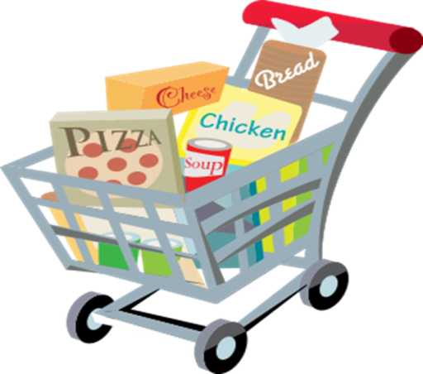

Aims:
practical - to involve students into communicative activity; to revise the words to the themes: “SHOPS”, “FOOD”, “CLOTHES”, to understand their meanings and use them discussing the topic; to watch videos for the main ideas and specific information; to do the tasks on the cards; to solve the crossword; to carry on a conversation about shops and shopping, making up dialogues;
developmental – to develop creative and logical thinking, to develop skills of speaking, reading, listening and writing, to teach learners to analyze and make conclusions;
educational – to widen pupils’ knowledge about shopping;
cultural – to promote positive attitude towards each other’s opinion.
.
Equipment: PowerPoint presentation, video, audio, idioms.
Lesson type: lesson of revising learned material

Procedure

I. Introduction. Greeting. Warming up.
Hello everyone! I am very glad to see you today. Hope you’re in a good mood and will be hard-working and active at the lesson. What are we going to speak about? Look at the board! You have to solve the crossword to find out the theme of our lesson.

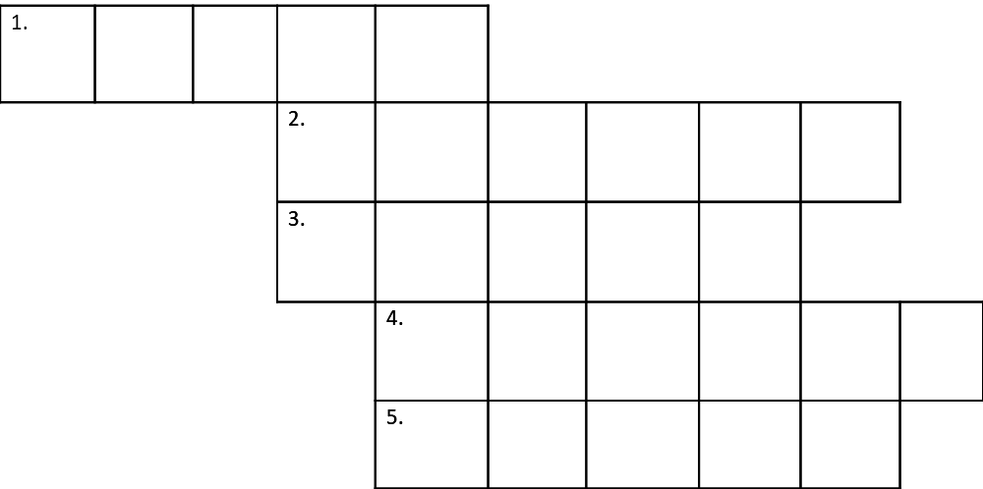
Riddles
1) Women and girls like to wear it. Boys can't put it on. (Answer: DRESS)
2) You smile when you name it. The mouse likes it very much.
(Answer: CHEESE)
3) If you give them to the shop-assistant you can buy smth. (Answer: MONEY)
4) I am a vegetable,
I am not very big,
I am not small
I am brown.
I have many eyes on my body
I live in the kitchen garden.
What am I? (Answer: A POTATO)
5) Clean, but not water,
White, but not snow,
Sweet, but not ice-cream,
What is it? (Answer: SUGAR)
T: Well done. So the theme of our lesson is "Shops And Shopping". And today we'll revise the words to the themes: “SHOPS”, “FOOD”, “CLOTHES”; understand their meanings and use them discussing the topic; watch video for the main ideas and specific information; do some tasks; carry on a conversation about shops and shopping.

II. Main part.

Speaking skill development
T: Look at the pictures of different shops and tell me what we can buy there?
(Possible answers)
- The Newsagent's (newspapers, magazines, books, copybooks and pens)
- The Chemist's (medicines, toothpaste, shampoo and bars of soap)
- The Greengrocery (fruit and vegetables)
- The Baker's (bread, buns, rolls, pies)
-The Butcher's (meat, chickens and sausages)
-The Toy Shop (balls, dolls, toy cars, trains, planes)
-The Fishmonger's (fish, seafood, shrimps)
- The Dairy (milk, butter, cheese, cream and curds)
-Clothes Shop (different clothes for men and women)
-The grocer’s shop (a variety of foodstuffs, such as flour, butter, eggs, biscuits, jams, cheese, sugar, spices, tinned and frozen foods)
-The Sports Shop (sport clothes, trainers and sport equipments)
-The confectioner's (sweets, bars of chocolate, biscuits and cakes)
Pupils name goods.
Practice in vocabulary
T: Let's practice in vocabulary
- match names of the shops with goods.
(Pupils match the words.)

MATCH:
newsagent’s bread
chemist’s sweets
super-market dress
confectioner's medicine
clothes shop all you need
dairy books
baker's butter

- and continue the sentences using names of the shops.
They sell meat at the butcher’s
They sell newspapers at _________
You can buy T-shirts at _________
They sell shampoo at ___________
When we run out of bread we go to the __________________
You can buy trousers at _________
When we run out of sugar we go to _____________________
They sell trainers at _____________

Watching the video
T: Very well. So let's watch how we can go shopping on practice using English.
Pupils watch the vidio "A Visit to the Shop".
T: Well now answer the questions:
- What did a girl buy?( 1 loaf of white bread, dozen of eggs, small bottle of olive oil, small bag of flour, 2 cartons ok milk.)
- Did she buy white or brown bread? (white)
- How many cartons of milk did she buy? (2)
- Did she buy a big or a small bottle of oil?(small)
- How much did she pay?(23 dollars)

Making the shopping list
T: After visiting the shop you have to learn how to make the shopping list before you go to the shop.
(Pupils match pictures with the words)
-a bottle of milk
-a jar of jam
-a jug of water
-a packet of sugar
-a bar of chocolate
-a piece of cheese
-a carton of tea
-a cup of cocoa
-a loaf of bread
-a glass of juice

Workout
Listening
T: And now we'll visit a shop and imagine how to buy smth not knowing the language.
(Pupils listen audio recording)
Post-listening activity
T: I hope that you have understood this story and may answer the questions.
- Where was an Englishman? (In Spain)
- Where did he go? (He went to a little shop)
- What did he want to buy? (A bottle of milk)
- What did he draw on a piece of paper? (A cow)
- What did the shop assistant bring him? (A kilo of meat)

Speaking skill development

T: And what about you? Can you go shopping? Make your own dialogues “At the shop”
(Pupils make their own dialogues )

Writing and reading skills development
T: Complete the sentences and read where we go when we want to buy different things.
(Pupils complete the sentences with the words given below in a written form on the cards, read them and translate)
A Shopping Day
Today is Saturday. This is the day when we do the shopping.
First we buy some milk, butter, sour cream and cheese. So we go ______________________ After that we buy meat, sausages, ham or bacon___________________. Then we buy fruit and vegetables ____________________________. I always ask my mum for a new toy or a puzzle _____________________. This shop is the best. At the end we buy some bread, cakes and pies _________________________
at the baker's , at the dairy, at the greengrocer’s, at the butcher's, in the toy shop.

GRAMMAR
How much is it?
How much are they?
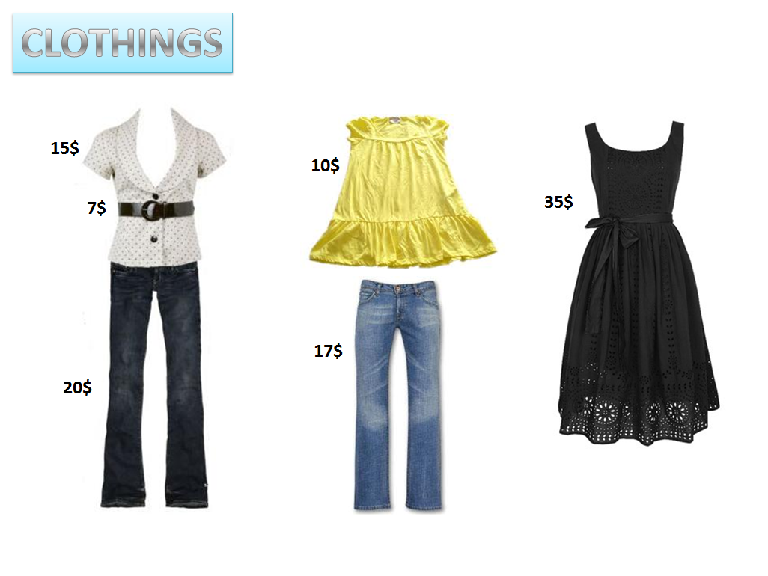
Pupils make the questions and answer them.
Acquaintance with English Idioms
(Pupils read the examples and try to understand the meaning)
1. bring home the bacon - to earn a living for the family
For example:
"He felt it was his responsibility to bring home the bacon."
2 .to sell like hot cakes - to sell quickly or rapidly
For example:
"The new Spice Girls' album was sold like hot cakes."
3 .as cool as a cucumber - to remain calm under pressure
For example:
"Although he was driving at 110 mph James Bond was as cool as a cucumber."
4 .to know your onions - to know a lot about a particular subject
For example:
"When it comes to computers he really knows his onions."
5. like a fish out of water - to be uncomfortable in a particular situation
For example:
When she started talking about her personal problems, he looked like a fish out of water.

III. Summing-up.
Conclusions of the lesson
Homework:
Ex. 5. P. 40.

