Тема: «Шкільне життя. Мій улюблений предмет»
Мета:
Забезпечувати активну усвідомлену комунікативну діяльність школярів з теми «Шкільне життя. Мій улюблений урок» та формувати здатність застосовувати необхідний для цього лексико-граматичний інвентар у реальних життєвих ситуаціях через використання ІКТ. Розвивати та удосконалювати комунікативну компетентність учнів відповідно до тематики спілкування, стимулюючи їх навчально-пізнавальну діяльність через виконання різноманітних інтерактивних вправ та завдань.
Сприяти мотивації учнів до вивчення англійської мови та інтересу до навчання, усвідомленню важливості освіти в житті людини.
Очікувані результати:
учні вмітимуть висловлюватися в діалогічному та монологічному мовленні і виявляти готовність до комунікації з теми; сприймати текст, виходячи на комунікацію; розширять словниковий запас та поглиблять знання з теми.
Обладнання:
комп’ютерна презентація, відеофільм, флешкартки, загадки про навчальні предмети, інтерактивна вправи

Topic: School is Cool! My Favourite Subject.
Objectives:
- to solve the riddles (school subjects);
- to read children’s opinions about school subjects;
- to complete the sentences;
- to talk about what makes a school subject interesting or boring;
- to develop students’ communicative competence;
- to activate thinking;
- to develop self-esteem and a sense of respect for others;
- to promote positive attitude through studying the language.
Outcomes: by the end of the lesson the students will be able to talk about their favourite school subjects.
Materials: Flashcards “School subjects”, Riddles “School subjects”, Power Point Presentation, Student’s Book, a song “What is your favourite subject”
https://youtu.be/AnZxeX_8mVk
https://youtu.be/AnZxeX_8mVk
https://youtu.be/nijiuBgWi4Q

Plan
I. Introduction:
- Greeting.
Good morning, dear friends! Pleased to see you again! Today we’ll sum up our knowledge about school and speak about your different subjects. We listen, read and discuss many different children’s opinions about their school subjects and at the end of the lesson you’ll answer the questions:
What is your favourite subject? Why?
What subject is boring for you
Today we are going:
- to solve the riddles (school subjects);
- to name all your school subjects
- to sing a song “What is your favourite subject?”
- to listen and read children’s opinions about school subjects;
- to complete the sentences;
- to say why they prefer some subjects to other subjects
- to speak what makes a school subject interesting or boring, using the scheme
2. Warm-up:
The icons of the lesson are:
- Listening;
- Writing;
- Speaking;
- Grammar;
- Vocabulary.
According to the Chinese proverb
When I hear – I forget
When I see – I remember
When I do – I understand
So, let’s practice. Practice makes effort. Let’s begin.
- What new subjects do you study in the sixth form?
- Have you got new teachers? Who are they?
- What subjects are your favourite?
- What days do you have English lessons?
- Why is learning English important for you?
- Why do you learn English?

- Name the school subjects with the help of the flashcards.
- Sing a song “What is your favourite subject?”
- School subjects. Solve the riddles:

- The study of numbers, shapes and space using reasons and usually a special system of symbols and rules for organizing them. (Maths)
- An activity such as weaving, carving or pottery that involves making things skilfully with your hands. (Craft).
- The study of past events, particularly in human affairs. (History).
- The use of any computers, storage, networking and other physical devices to create, process, store, secure and exchange all forms of electronic data. (IT).
- The study of the systems and processes involved in the world’s weather, mountains, seas, lakes, etc. (Geography).
- Pre-activity:
Vocabulary Box. Listen and repeat.
To yawn – позіхати;
To learn by heart - вчити напам’ять;
A nonsense - нісенітниця.
- Main activity:
- Work with Student’s Book. a) Read some different children’s opinions about their school subjects and say which of them they like and don’t like. (Ex.5, p.63)
Read some different children’s opinions about their school subjects.
- The last lessons of the day are History and Maths. History is really boring, lots of reading and writing, of course. I don’t like History, but Maths is really great! – Аlison
- The last lessons of the day are History and Maths. History is really boring, lots of reading and writing, of course. I don’t like History, but Maths is really great! – Ted
- The last lessons of the day are History and Maths. History is really boring, lots of reading and writing, of course. I don’t like History, but Maths is really great! – George
- Today, in the middle of the boring Mathematics lesson I started yawning. Miss Walsh looked at me just at that moment. What did she do? She told me to learn one page from our Maths book by heart! And I wasted three hours on that nonsense. - Andrew

Say which of them they like and don’t like.
Alison likes Maths.
Alison doesn’t like History.
Ted likes Geography, History and Maths.
George likes doing lots of interesting experiments.
George doesn’t like school at all.
Andrew doesn’t like Mathematics lesson
- Do the task:
“Match the subjects”: https://learningapps.org/watch?v=pg2rc7qu322
“Guess the subjects”: https://learningapps.org/watch?v=ph2xghqf322

- Work with Student’s Book. b) Read the children’s opinions again and complete the sentences. (Ex.5, p.64)
Read the children’s opinions again and complete the sentences.
- Work with Student’s Book. c) Complete the sentences to say why they prefer some subjects to other subjects. (Ex.5, p.64)
Complete the sentences to say why they prefer some subjects to other subjects.

- Practice:
Work with Student’s Book. In groups, speak about what makes a school subject interesting or boring. Use the scheme below. (Ex.6, p.64)
In groups, speak about what makes a school subject interesting or boring.
It is … if…
… it’s useful for my future profession.
… the textbook is nice.
… the teacher is good.
… there are a lot of experiments.
… we read (learn) about …
… it helps me in …
… we work with computers.
… homework isn’t large.
… there is a lot of reading and writing.
… there is a lot to learn by heart.
- Assessment and evaluation:
Ending of the lesson. Summarizing.
Now you can answer the questions:
What is your favourite subject? Why?
What subject is boring for you?
Many students say that their favourite subject is English. It will help them in their future education and future job. Today we speak about the importance of learning English. Nowadays English has become the world’s most important and the most universal language. It is the official language in over forty countries and the most used language in international business, science, medicine, trade and culture relations. In order to understand the world around us we have to study English. English is the passport to the world. Studying abroad is really a good experience.
Our lesson has come to the end. I want to thank you for your work and hope you have enjoyed our lesson. Your homework is to make a poster on “My School”. You must collect photos of your school and classmates. Find out interesting information about your school days, then use the photos and the writing to design a poster. The last step is to display your poster in class.
And now answer my questions:
Did you like this lesson?
How did you work in class today?
Was it interesting for you today?
Please write in the chat the colour of your emotion.
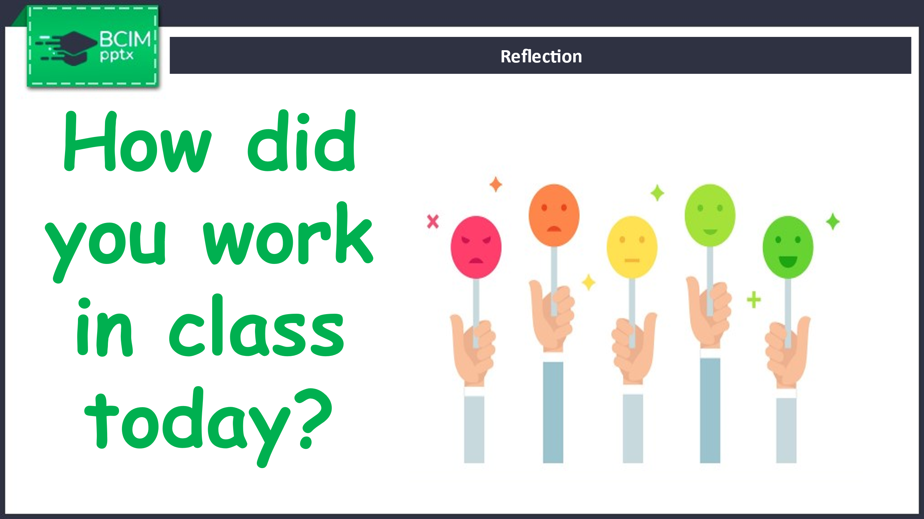

Say “Goodbye!”

