Form : 6
Theme: Weather Forecast. Future Simple
Мета: активізувати лексичний матеріал з теми «Weather. Nature»; формувати в учнів навички читання, усного мовлення, аудіювання; розвивати комунікативні навички, мовну здогадку, пам’ять, увагу; розвивати вміння працювати самостійно; практикувати вживання допоміжного слова «will» для утворення майбутнього
Очікувані результати: в кінці уроку учні навчаться вживати лексичні одиниці з теми; використовувати у своєму мовленні майбутній час; писати невеликі репортажі про прогноз погоди на наступний тиждень.
Обладнання: роздатковий матеріал, підручник, робочі зошити, відеоматеріали, ноутбук.
Procedure of the Lesson
- Preparation for foreign speech
- Greeting
- Good day children. Nice to meet you.
- Today we will learn new vocabulary to the topic and using of Future Simple Tense. We will listen to the video and make many interesting exercises.
- Warm – up
- How are you today?
- What day is it today?
- What month is now?
- What the date is it today?
- What is the weather like today?

- The poem
- Let's read the poem, mind your sounds and intonation please.
The sun is shining
And I am smiling,
The weather is bad
And I am sad.
- Phonetic exercise
Students revise sounds [Ө] and [/∂/]. The teacher gives pupils the cards with the table. Students have to listen and tick the right sound, then check them.

 | /Ө/ | /∂/ |  | /Ө/ | /∂/
seventh |  |  | that
this |  |  | author
theatre |  |  | these
the |  |  | think
thin |  |  | those

- The Basic Part of the Lesson
- Vocabulary
Sunny, rainy, foggy, warm, cold, frosty, snowy, cloudy, partly cloudy, windy, temperature, forecast, degree,
- Listen to the video.
- Repeat after it.
- Match words with pictures
https://www.youtube.com/watch?v=CXKj7bm4Ops

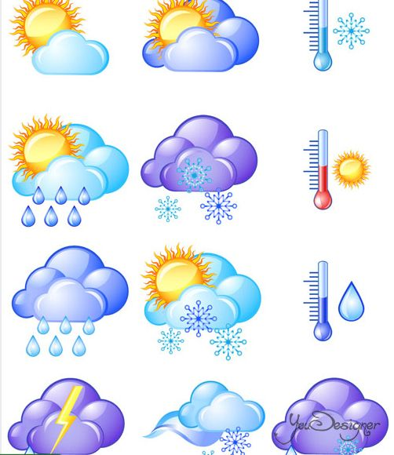
- Test " Nature"
- Divide these words into two groups good weather and bad weather
- cold, windy, rainy, cloudy, snowy, partly cloudy, foggy, and frosty.

- Grammar Time
- Today we'll talk about the weather forecast, but for this exercise we need to get acquainted with the new time form – Future Simple
- Let’s watch the video. Be attentive, please.
https://www.youtube.com/watch?v=j0VEbjHyTYc

- When we use the Future Simple?
- What is the main word in this tense?
- Who can make a sentence in the Future Simple?
- 1. I (to do) home exercises.
2. He (to work) at a factory. .
3. We (to work) at the weeekends.
4. They (to visit) their aunt tomorrow .
5. Mike (to be) a student.
6. Helen (to buy) a car.
7. It (to be) cloudy on Monday.
8. You (to have) birthday party on Sunday.
- Weather forecast
- I read you weather forecast for the next days. Let's listen to it. Be attentive.
- Hello, my name is Thomas. I want to tell you about the weather fot the next days. On Wednesday it will be snowy and windy. The temperature will be 5 degrees below zero. But on Thursday the weather will change for the better. It will be sunny and frosty. The sky will be blue and cloudless. So, you will be able to enjoy real winter weather. Have a nice day!

- Were you attentive? Let's check. If the sentence is correct you put the letter T, if the sentence is wrong you put the letter F.

1. Speaker's name is Frank.
2. It will be snowy and cloudy on Wednesday.
3. The temperature will be 5 degrees above zero.
4. It will be sunny on Thursday.
5. The sky will be blue and cloudless.

- Relaxation
The teachers makes movements with pupils
- Stand up, clap, clap.
Arms up, clap, clap.
Arms down, step, step.
Clap, clap, sit down.
- The Final Part of the Lesson
- Homework – write the weather forecast for the next week.
- Summarizing
- You have learned vocabulary to the topic “Weather.Nature” and got acquainted with the new time form – Future Simple

- Ok, today we read, listened, did exercises. You were great. You all get good marks.

