Topic: Going to the cinema. My favourite film.
Objectives:
- to systematize lexical materials on the topic;
- to practice the active vocabulary of the topic;
- to develop speaking, reading, listening skills through various activities;
- to develop pupils’ thinking, memory, imagination, attention and creativeness.

Procedure
1.Introduction
What do we usually do in our free time? Well, yes, we read books and magazines, listen to music, walk with our friends and watch TV.
So, out lesson will be connected with TV programs, especially with films. We’ll speak about types of films, work over some texts, do different tasks, speak about your favourite films and present your project works.

II. Warming-up
1. Practicing Vocabulary
Repeat some words:
Історичне минуле, сцена, театр, кінотеатр, завіса, актор, актриса, глядач, анімаційні технології, спец ефекти, каса, хол,афіша, реконструкція….
T: Let’s check your knowledge of the vocabulary on the topic “Kinds of films”
(computer presentation “Watching Films”(in Power Point). Look at the slides and name the various kinds of films: a comedy, a western, a war film, an adventure film, a cartoon, a feature film, a science fiction film, etc.

Thank you very much. Now I want you to guess what style is the film. Look at the blackboard and write correct numbers near the words.

- A film about space travel or life in an imaginary future.  - A film about criminals and detectives.  - A film with lots of music and dance.  - A film about cowboys and life in the Wild West.  - A funny film with happy ending.  - A film in which mysterious and frightening things happen. | musical  a western  a comedy  a science fiction film  a crime film  a horror film

ІІІ. Presentation ( Homework)
T: Let’s check up your hometask. You’ve prepared projects about your favourite actors, actresses, films. Give some information about them. (pupils’ answers).

ІV. Speaking
Складіть діалог за зразком (учні вчаться вживати розділові запитання в зв’язному діалогічному мовленні)
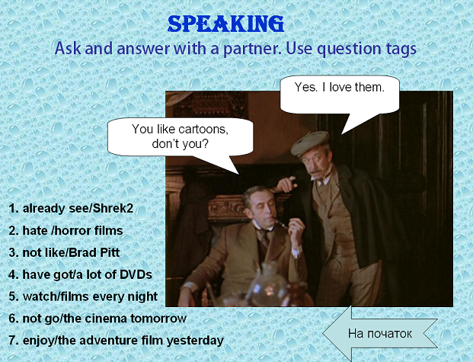

IV. New Material. (Пояснення нового матеріалу)
На уроці учні вивчать нову лексику з теми (1) та розширять знання з утворення та вживання прикметників (2)
1. Нова лексика.
а) Введення нової лексики (новий матеріал 1)
Назви професію (використовуючи мовну здогадку учні підбирають слова зі списку професій, пов’язаних з кіно до відповідних малюнків, повторюють за вчителем).

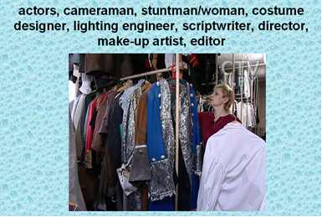
b) Закріплення нового матеріалу (закріплення 1)
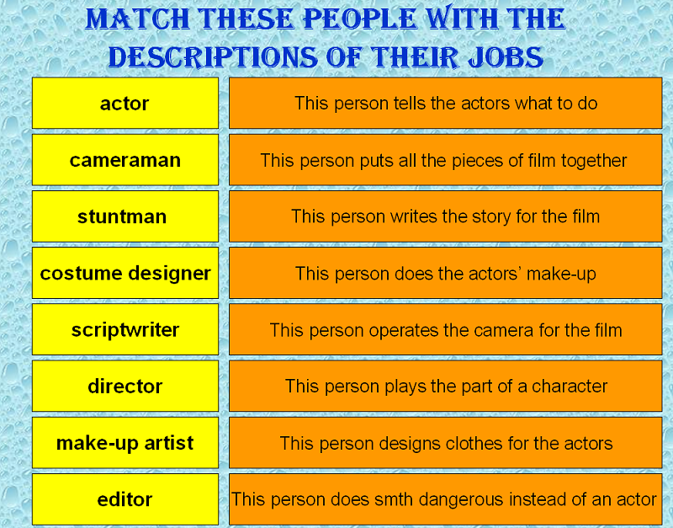
Робота в групах (читаючи опис професій учні називають її)

с) Формування практичних навичок (практичне використання 3)
Заповніть пропуски (учні вживають нову лексику у зв’язному тексті, читають, перекладають)
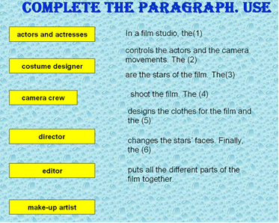
- 2. Новий граматичний матеріал.
Which adjectives we use to say about our emotions, our opinion for smth? Let’s divide these words into two columns: which we like and which we don’t like.
like
favourite, exciting, amazing, funny, relaxing, interesting, amusing, useful, good, romantic, unusual, kind
dislike
terrible, boring, sad, scary, depressing, frightened, horrible, bad
а) Пояснення нового матеріалу (новий матеріал 2)
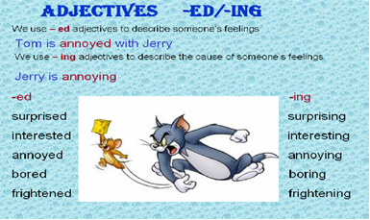
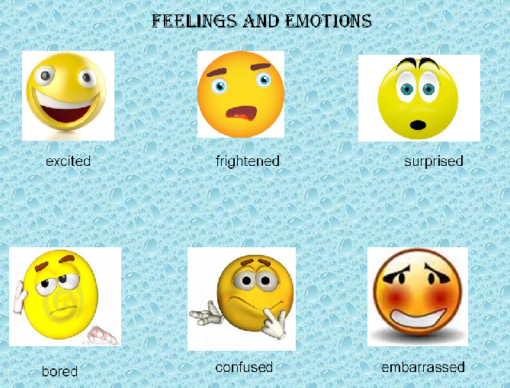
- Прикметники, які закінчуються на –ed, означають емоції.
Приклади (слайд Feelings and Emotions)

Приклади (слайд Reasons of emotions)
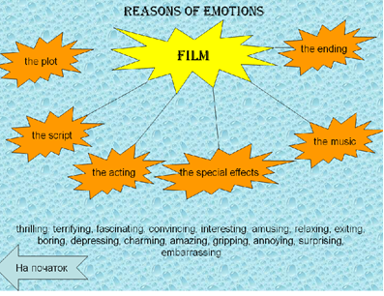
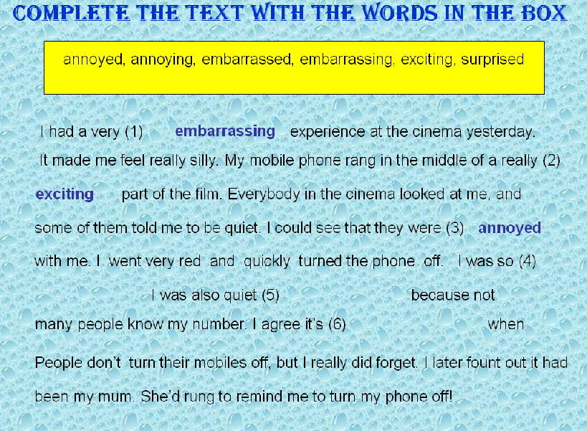
b) Закріплення (закріплення 2)
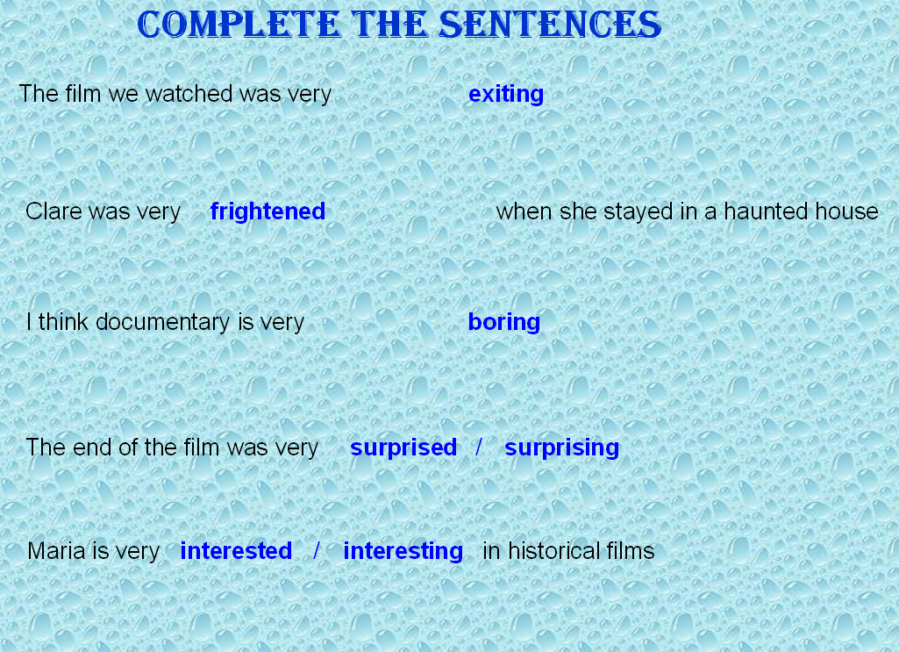
Виберіть правильне слово (учні вибирають відповідне слово)
Заповніть пропуски словами з таблиці ( учні використовують відповідні прикметники у зв’язному тексті)

V. Reading
1) Pre-Reading task
T: By the way, do you feel like playing a game now? You are to name as many star actors as possible! The winner will get the highest award of the American Cinema Academy “Oscar”.
2) While-reading task.
T: Read the text about a famous actor George Clooney. Be ready to cope with true-false task.

George Clooney worked for many years in TV before he became famous as a film star. He was born in Kentucky in 1961 and his first television appearance was on his father’s chat show when he was only five. As a young man, he was more interested in baseball than anything else, so he didn’t start acting until he was twenty-one.
For years he worked in TV programs which were not very successful. Then
came the TV series E.R. (Emergency Room). The series, in which he played
a doctor, was very popular in the USA and all over the world and George Clooney
became famous. He started his acting career in Hollywood where he soon became
a major star.
Clooney starred in “One Fine Day” with Michelle Pfeiffer, who also produced the film. Then, in 1997, he took the star role in “Batman and Robin”, which was a Hollywood blockbuster.

3) Past-Reading task (computer test on text about “George Clooney”- true-false)
T: Decide if the sentences are true or false
1) George Clooney was first seen on TV in 1966.
2) When he was a student, he played baseball and went to acting classes.
3) If he hadn’t been in Emergency Room he wouldn’t have become famous.
4) He produced the film “One Fine Day”.
5) His greatest success was in “Batman and Robin”.

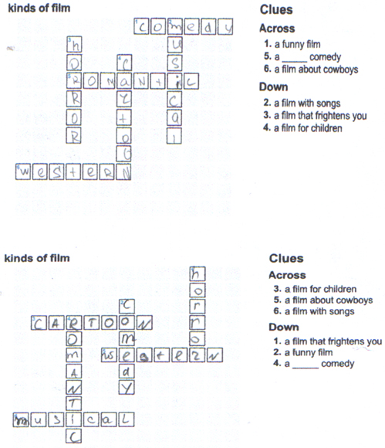

VI.Summing-up

Now tell me what you learnt on our lesson, what problems we solved. Did we realize our aim?
I want to thank everybody who took an active part in our work. The best of you get the highest marks:… Our work was good and we’ll continue it in our next lessons.

