Тема: Healthy Living
Мета уроку
Навчальна:
- ознайомити учнів із лексикою з теми Healthy Living;
- формувати навички вживання кількісних визначників much, many, few, a few, little, a little;
- розвивати навички говоріння та письма на тему здорового способу життя, харчування, фізичної активності.

Розвивальна:
- розвивати критичне мислення через аналіз корисних і шкідливих звичок;
- формувати вміння висловлювати власну думку, аргументувати позицію.

Виховна:
- виховувати відповідальне ставлення до власного здоров’я;
- заохочувати дотримання здорового способу життя та раціонального харчування.

Матеріали
- картки з лексикою (healthy food, junk food, daily routine, habits);
- таблиця з граматикою (much/many/few/a few/little/a little);
- робочі аркуші з вправами;
- фото або коротке відео про здорове харчування
- плакат “Healthy plate”.

Хід уроку
- Організаційний момент

Привітання.
T: Good morning! Today we’ll talk about healthy living — what makes us strong and full of energy, and what can harm our health.

- Введення в іншомовну атмосферу

Запитання до учнів:
- Do you eat healthy food every day?
- What do you usually have for breakfast?
- Do you do any sports?

- Повторення лексики

Healthy food: vegetables, fruit, porridge, nuts, eggs, fish, salad, water, milk, yoghurt.
Unhealthy (junk) food: chips, sweets, burgers, pizza, fizzy drinks, fast food, fried food, chocolate bars.
3.1. Вправа “Sorting game”
Учні розподіляють слова на дві колонки — Healthy / Unhealthy.
Потім складають по 2–3 речення з кожної категорії:
- Vegetables are healthy because they have a lot of vitamins.
- Chips are unhealthy because they contain too much fat.

3.2. Обговорення
T: How does food affect our body?
Р: Too much sugar makes us tired. Fresh fruit gives us energy.
Запитання для обговорення:
- Do you think you have healthy habits?
- What food do you eat every day?
- Do you do any sports?

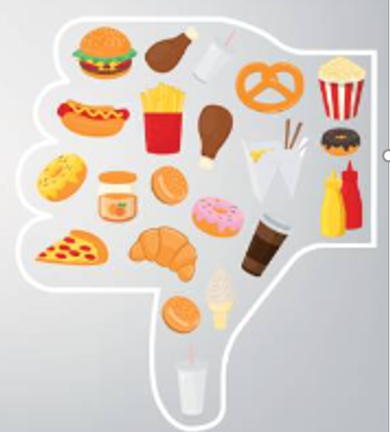
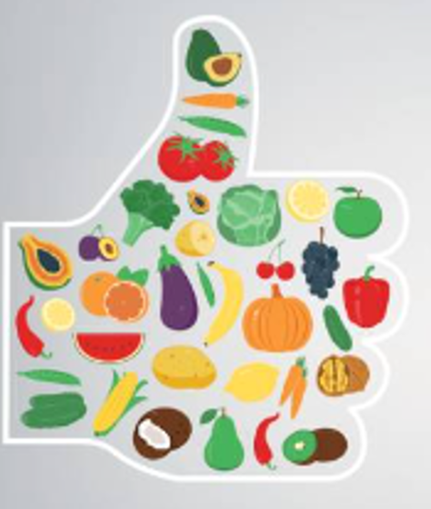
Healthy habits | Unhealthy habits
eating fresh fruits and vegetables | eating fast food too often
drinking enough water | drinking fizzy drinks
sleeping 8 hours a night | going to bed late
exercising regularly | avoiding physical activity
having breakfast every morning | skipping breakfast
walking instead of driving | sitting too long
spending time outdoors | spending too much time online
thinking positively | stressing all the time
keeping personal hygiene | smoking or drinking alcohol
eating small portions | overeating or eating at night
Disscussing:
What healthy habits do you have?
- Які здорові звички ви маєте?
What habits should you change?
- Які звички справа варто змінити?
Учні утворюють речення:
I drink a lot of water and walk every day.
I sometimes eat fast food, but I try to avoid it.
4. Watching the video
T: Let`s watch the video”How Does Junk Food Affect Your Brain”
https://youtu.be/qqSXiVRjUok?si=hbZL1WyJN-i3GvLa

Pre-watching tasks
- Discussion:
  - What does the term “junk food” mean?
  - What examples of junk food can you name?
  - How do you think junk food affects not only our body but also our brain and mood?
- Pair work:
  - How often do you eat junk food during the week?
  - Do you notice any changes in your mood, energy, or concentration after eating it?
- Vocabulary preparation:
Look at these key words from the video:
brain, reward system, dopamine, memory, inflammation, processed food, sugar, fat, hippocampus, learning, behaviour.
T: Discuss what you think each word means and how it might be related to the topic of food and the brain.

While-watching tasks
- Active listening:
While watching the video, mark when you hear or see information about:
  - how junk food affects the brain (memory, learning, behaviour);
  - which brain chemicals or parts are mentioned (dopamine, hippocampus, inflammation);
  - examples of unhealthy foods or habits;
  - suggested ways to improve eating habits.
- Fill in the blanks:
Complete the sentences while watching:
  - When we eat a lot of junk food, the brain’s _______ system gets activated and releases _______.
  - The part of the brain called the _______ is important for memory and learning.
  - Too much _______ and _______ can cause problems with the brain’s ability to focus and remember.
- Key facts:
After watching, write down three main facts you learned from the video and one question you still have.

After-watching tasks
- Group discussion:
  - What did you find most surprising or interesting in the video?
  - In what ways can junk food affect our brain and behaviour?
  - What small changes could you make in your daily diet to stay healthier?
- Writing task:
Write a short paragraph (150–200 words) titled “If I were my brain, what would I do when attacked by chips, chocolate, and soda?”
Include at least two facts from the video and suggest one or two ways to eat or live more healthily.
- Research task (homework):
Find one scientific fact or short article about the connection between nutrition and the brain (for example, how food affects memory or concentration).
Prepare a short 2–3 slide presentation to share your findings with the class.
- Creative task (optional):
Design a poster or infographic titled “How Food Affects the Brain.”
Use facts from the video and your own ideas. Present or display it in class

5. Граматичний блок: Much / Many / Few / A few / Little / A little

5.1. Пояснення
Визначник | Використання | Приклад
much | незлічувані іменники | I don’t drink much coffee.
many | злічувані іменники (множина) | How many apples do you eat every day?
few | мало (злічувані) — негативне значення | Few people eat enough vegetables.
a few | кілька, достатньо (злічувані) | I have a few bananas for breakfast.
little | мало (недостатньо, незлічувані) | There is little sugar in this tea.
a little | трохи, достатньо (незлічувані) | I drink a little milk every morning.

5.2. Приклади з теми “Healthy living”
- There isn’t much salt in my soup.
- Many teenagers eat too many sweets.
- Few students drink enough water.
- A little exercise every day can make a big difference.
- There are a few apples in the fridge.

6. Практичні вправи

Вправа 1. Choose the correct option
- There isn’t ___ sugar in green tea. (much / many)
- How ___ vegetables do you eat daily? (much / many)
- He drinks ___ milk every morning. (little / a little)
- Only ___ people avoid fast food. (few / a few)
- We eat ___ fruits and nuts when we go hiking. (few / a few)

Вправа 2. Fill in with your ideas
- I don’t eat much ___ because it’s unhealthy.
- A few ___ every day make me feel good.
- There is little ___ in my diet.
- Many ___ drink coffee in the morning.

Вправа 3. Speaking (Pair work): “How healthy are you?”
Учні ставлять одне одному запитання, використовуючи конструкції з How much / How many:
- How much water do you drink a day?
- How many hours do you sleep?
- How many times a week do you do sport?
Учні відповідають і коротко обговорюють результати.
Виконання інтерактивної вправи на платформі «Liveworksheets»
https://www.liveworksheets.com/c?a=s&t=uu157u360u3&sr=n&l=ps&i=xnsunxu&r=ar&f=dzdfuzdz&ms=uz&cd=pxx783x012x0lhpmlpxlmxdsngnexgngxg&mw=hs

7. Підсумок уроку

T: What does it mean to be healthy? What habits help you stay fit? What`s the difference between few / a few and little / a little?
Рефлексія:
- Today I learned that…
- Now I can talk about…

8. Домашнє завдання
- Написати коротке есе: “Healthy lifestyle – my choice”
(використати лексику та граматику з уроку).
- Підготувати усну міні-презентацію: “My daily habits for good health” (5 речень із much/many/few/little).

