Objectives: expand students' knowledge about the historical origins of St.Valentine's day, explore cultural its significance, encourage students to express their emotions creatively by engaging in activities like writing heartfelt messages, poetry or creating handmade cards, emphasize the importance of showing love and gratitude to friends or family
Dear children and guests! Today we have a party "Be my Valentine!" Valentine's day is celebrated on 14th February.
It's a special day to celebrate love and friendship. Children may organize small classroom parties with sweet treats. People often exchange cards, gifts or flowers. They share kindness with friends and family. Let's remember St. Valentine's day celebration, it's traditions, sing songs, do quizzes, recite poems!

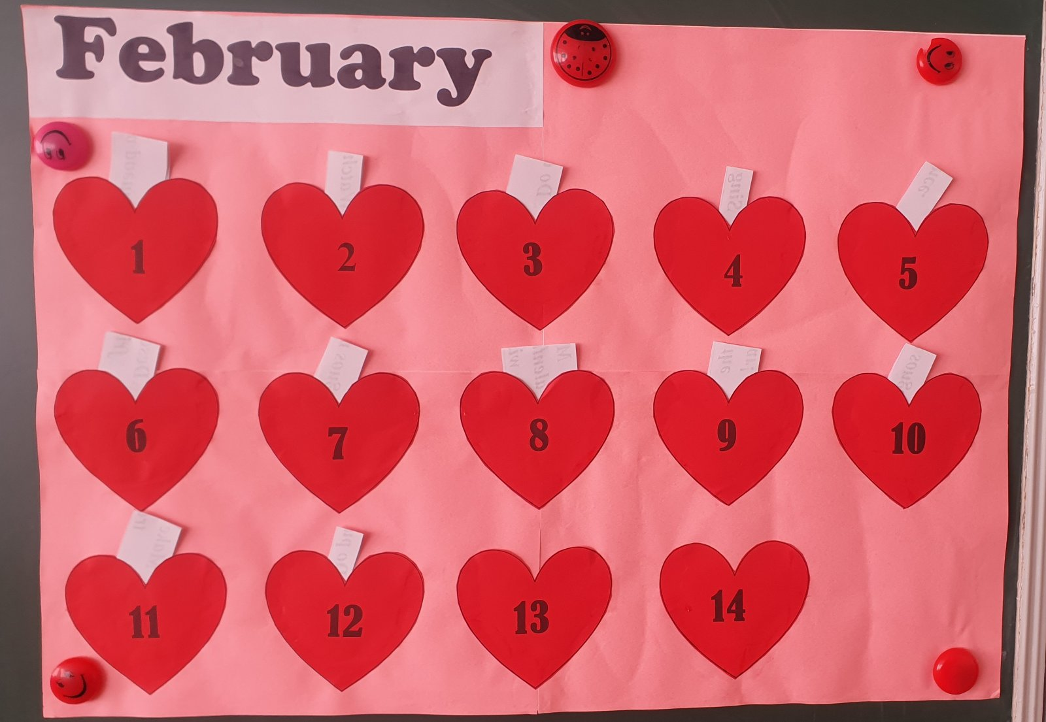

- Recite a poem.

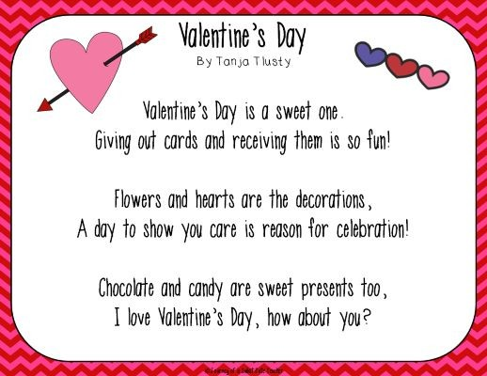



- Watch a video and remember some facts about St.Valentine's day celebration.
https://www.youtube.com/watch?v=nRXT2csSNEk
- Do a quiz. Choose the correct letter.
https://www.youtube.com/watch?v=DKJ5gU7Z0-Y

- What are the traditional colors of Valentine's Day?

- purple and blue
- orange and green
- red and pink
- red and pink

- What do we celebrate on Valentine's Day?

- pets
- Thanksgiving
- love
- love

- Which flower is traditionally given on Valentine's Day?

- red rose
- yellow daffodil
- purple lavender
- red rose

- Which organ in the body is used as a
symbol for love?

- lungs
- heart
- kidney
- heart

- Saint Valentine is the patron saint of
love and what else?

- beekeepers
- animals
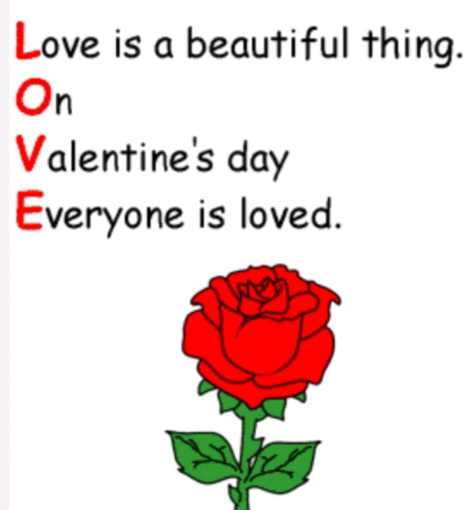
- music
- beekeepers

- In which language does tiamo
mean I love you?

- German
- French
- Italian
- Italian

- What date is Saint
Valentine's Day?

- 14th February
- 24th February
- 1st March
- 14th February

- Sing a song.
https://www.youtube.com/watch?v=XLu_UkihByY

- Dance.
https://www.youtube.com/watch?v=iIn7ktx8xao


6. Describe a friend.
V valuable
A amazing
L lovely
E exciting
N nice
T true
I important
N needed
E easy – going
- Sing a song
https://www.youtube.com/watch?v=4BxqEzEzUx4

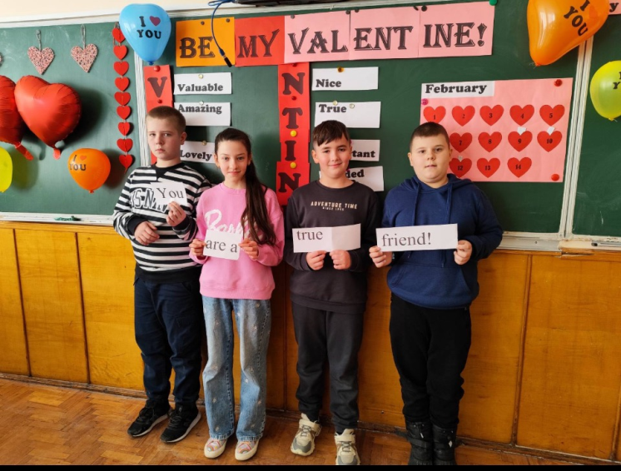
8. Make Valentine's day wishes.
Be Valentine! my
Be my Valentine!
me make You smile!
You make me smile!
friend! a true You are
You are a true friend!
9. Play the guitar.
10. Sing a song.
https://www.youtube.com/watch?v=myMSIarv7IA

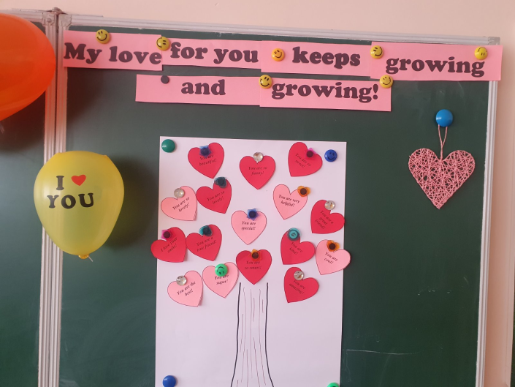
11. Make a love tree. Read the wishes and put them on the blackboard.
І love your smile!
You are kind!
You are beautiful!
You are so funny!
You are so smart!
You are a great friend!
You are cool!
You are special!
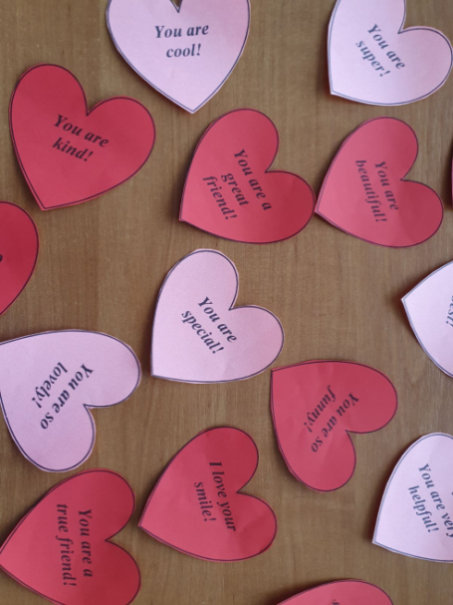
You are very helpful!
You are the best!
You are super!
You are so lovely!
You are amazing!
You are so lovely!
You are a true friend!
You are so sweet!
A friend like you is dream come true!
You warm my heart!
12. Do a puzzle.
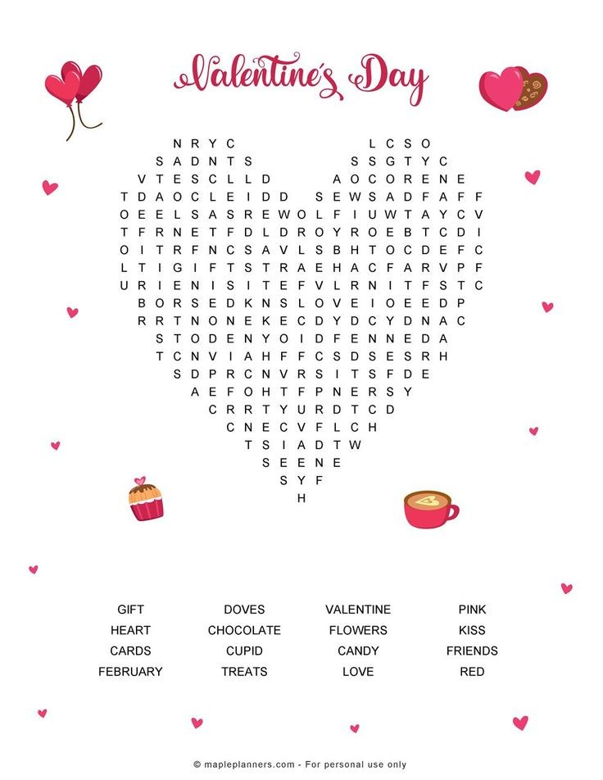

Everything seems bright and beautiful with love. Love makes people better, we can see and realize more. Love makes wonders. Our party is finished. Thanks for your attention!



