Topic: My school is cool!
Objectives: expand students' knowledge of the history of the institution, develop listening, reading and speaking skills, train memory, attention, foster students' creativity, self-organization, teamwork, collaboration, encourage to participate in various activities
Hello, dear pupils and guests! As you know, this year our school is 30 years old. Today we have a party "Our school is cool!" We will sing songs, play games, dance and celebrate the 30th school anniversary. Our school is the best school in the town. It's a place, where you learn and grow together
- Sing a song "Hello"
https://www.youtube.com/watch?v=gghDRJVxFxU
- Let's revise, what school rules do you know?
https://wordwall.net/ru/resource/9604268/school-rules-must-mustnt

A pupil ... go to school.
- must b) mustn`t
A pupil ... listen to teachers.
A pupil ... be late for school.
A pupil ... do homework.
A pupil ... be polite to people.
A pupil ... be rude to friends.
A pupil ... help parents.
A pupil ... throw rubbish.
A pupil ... run in class.
A pupil ... go to bed late.
A pupil ... write on the desk.
A pupil ... wear school uniform.
A pupil ... fight.
A pupil ... say bad words.
A pupil ... say "Hello" and "Goodbye" to teachers.
A pupil ... raise a hand to speak.

- Sing a song " If you're happy back to school "
https://www.youtube.com/watch?v=AyszvetYZps
- Listen to the poem
I am School

I am cool
I am full
Of many girls and boys,
Who make much noise
But have a choice
To play all time
Or learn a rhyme,
Or read a book,
To sew or cook.
We love school all
And wait for fall
To meet together here,
To teach and study near.

- What words do you know, associated with school?
( classmates, teacher, pupil, bag, break, lessons, homework...)
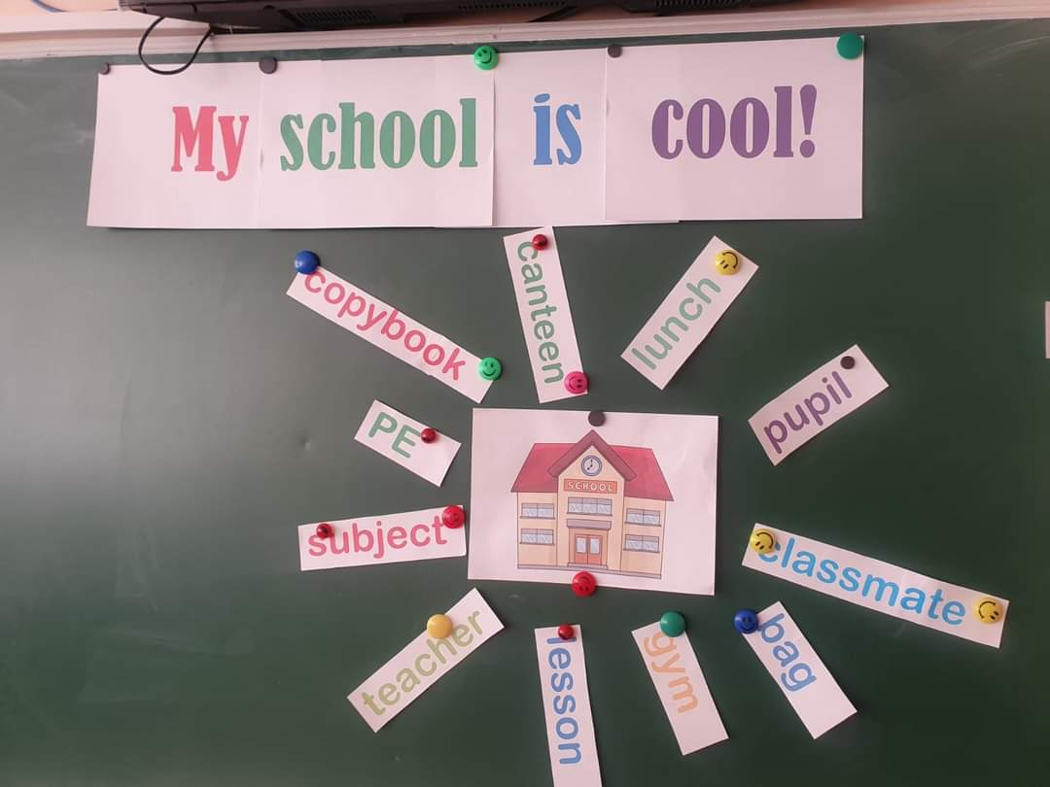
- There are talented pupils at our school and they are going to show a dance!
https://www.youtube.com/watch?v=gQlMMD8auMs
- Sing a song " My school"
https://www.youtube.com/watch?v=7i211NeJZRQ
- Let's guess some places at our school. Read definitions and look on the pictures.
https://naurok.com.ua/prezentaciya-my-school-402274.html
You can read books here
- Library
You can play football or volleyball here
- Gym
You have IT classes here
- Computer science classroom
You can buy pens and copybooks here
- Stationary store
You can eat here
- Canteen
A very large room, a place for performances
- Assembly hall
Teachers work here
- Teacher’s room
We go there, when the air alarm sounds
- Shelter

- What subjects have you got at school? Watch a video and revise!
https://www.youtube.com/watch?v=AnZxeX_8mVk&t=32s
10. Let's play "A Subject Game!" Take some things from the bag and guess the names of the school subjects.
Students' book or dictionary - English
A ball - PE
A globe - Geography
A calculator - Maths
A laptop - ICT
11. Sing a song "School is cool"
https://www.youtube.com/watch?v=xsXQODsATK0
12. Pupils say all together "Happy Birthday, dear school!"
13. Our party is finished. Thanks for your attention!



