The theme of the Lesson “Shopping. Units of Money”
Type of the lesson: combined
The purposes of the lesson:
1)To refresh the vocabulary of the theme “Shopping”.
2)To familiarize with the new vocabulary of the theme “ Money. The
Units of Money. Currency”.
3)To learn and find out everything about money and money units of other countries.
4)To refresh the grammar themes Past Simple and Past Cintinuous.
5)To do a lot of interactive exercises.

Lesson Progress
- Organizational Moment
  - Greeting.
T: Good morning, dear students!
1.2 Checking the presence of students. (Let’s call over)
Let’s start our lesson with talking about emotions because they play a very important role in our life. And our lesson will also depend on your emotions. So, let’s watch the video and say how are you felling now.
(watching the video https://youtu.be/QRyvCe09_Yc)
T: Are you happy (sad, tired, bored…)
S: Yes, I’m happy (sad, angry…)
2. Actualization and correction of basic knowledge. Checking homework.
3.1 T: Tell me, please Why do we need money?
S: We pay money for some services.
Т.: Last year we learnt the theme “Shopping” and your home task was to refresh the names of stores.

1. bakery – a place where bread and cakes are baked, or a shop where they are sold
2. barber – a shop where men can have their hair cut
3. café – a small restaurant where you can buy drinks and simple meals
4. market – a time when people buy and sell goods, food, … or the place, usually outside or in a large building, where this happens
5. bookshop – a shop that sells books
6. candy shop – a happy place where innocent little children go to buy candy
7. clothes shop – a shop selling clothes
8. boutique – a small shop that sells fashionable clothes or other objects
9. computer shop – a store that sells computers to the small businessperson or personal user
10. butcher’s – a shop where you can buy meat
11. delicatessen – a shop that sells high quality cheeses, salads, cooked meats, …
12. grocery – a retail store that primarily sells food
13. greengrocer’s – a shop where fresh fruit and vegetables are sold.
14. hardware store – a place to buy household hardware
15. newsagent’s – a business that sells newspapers, magazines, cigarettes, snacks and often items of local interest
16. jewellery store – a retail business establishment, that specializes in selling jewellery and watches
17. fishmonger’s – a shop that sells fish
18. supermarket – a very large shop that sells food, drinks, and things that people need regularly in their homes
19. pet shop – a retail business which sells different kinds of animals to the public
20. shoe shop – a type of retailer that specializes in selling shoes

T: Now let’s do some exercises to refresh the vocabulary on the topic “Shopping”.

Ex. 1 https://learningapps.org/display?v=pq94suvw223 (video choose the correct answer)
Ex. 2 https://learningapps.org/26820444 (names of shops) ----
Ex. 3 https://wordwall.net/uk/resource/49412499 (you need get into the zone containing a correct answer and avoid enemies at the same time)
T: We can buy things in different shops. For example, where can we buy bread, buns, pies…? (clothes, medicines, trousers…)
Ex. 4 https://www.liveworksheets.com/nk8323sh (put the words into the correct boxes) -----
Ex. 5 https://wordwall.net/uk/resource/49400067 (pop the ballons so that the keywords fall on the definitions that correspond to them)
T: Now let’s do listening exercises. You should listen to the sentences, then do some tasks.
Ex. 6 https://learningapps.org/display?v=p8n4ywgoj23 (video choose the correct answer)
Ex. 7 https://www.liveworksheets.com/co1405743qj (listening) -----

Microphone Method

T: 1. I’d like to know what shops do you often go to?
- What do you buy there?
- Do you buy your clothes by yourself or with your mother?
- What types of fashion style do you prefer?
- What clothes size do you wear?
- What shoe size do you wear?

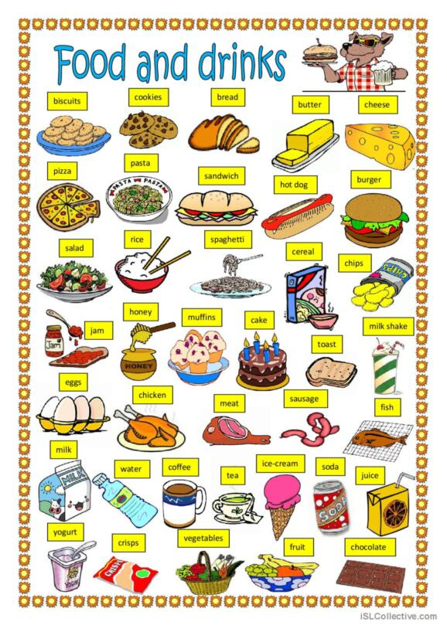
- What shops do you like visiting? What do you usually buy there?
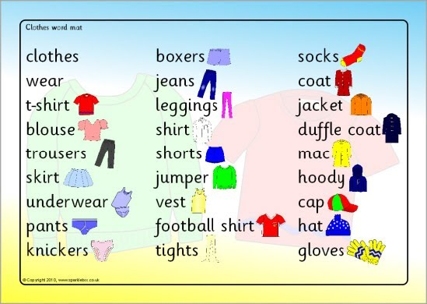
3. Notification of the theme, content and sequence of learning new material.

T: The theme of our lesson is “Money. Currency.” We are speaking about the importance of money in our life. Why do we need money.
You’ll learn new vocabulary on this theme and learn to use the words and word expressions in everyday speech. You’ll learn to express your own opinion, give convincing arguments and discuss them using active vocabulary on the topic. So our aims are:
1)To learn the new vocabulary of the theme “ Money. The Units of Money. Currency”.
2) To learn and find out everything about money and money units of other countries.
3) To refresh the grammar themes Past Simple and Past Cintinuous.
4) To do a lot of interactive exercises.

First, let’s get acquainted with the vocabulary.
accountant бухгалтер
bank банк
bank account банківський рахунок
bankrupt банкрут
bank teller касир банку
borrow позичати (в когось)
buy купувати
cash готівка
cashier касир
cent цент
cheap дешевий
check чек
​check book чекова книжка
​coin монета
cost коштувати
cost of living вартість проживання
credit кредит
credit card кредитна карта
currency валюта
customer покупець, клієнт
debt борг
deposit вклад
dollar долар
donate пожертвувати
dime монета в 10 центів
earn заробляти
exchange office обмінний пункт
exchange rate обмінний курс
​expensive дорогий
euro євро
foreign іноземний
​currency валюта
gold золото
income прибуток
​income tax податок на прибуток
inflation інфляція
interest відсоток
invest інвестувати
investment інвестиція
investor інвестор
lend позичати (комусь)
lottery лотерея
millionaire мільйонер
​nickel монета в 5 центів
notes паперові гроші
​owe заборгувати
own володіти
penny копійка
pound фунт
price ціна
quarter чверть
receipt чек, квитанція
recession відмова
salary зарплатня
sale продаж
save заощаджувати
savings заощадження
​sell продавати
​spend витрачати
steal красти
stock market фондовий ринок
tax податок
tip чайові
wealth багатство, добробут
wealthy багатий
welfare добробут
withdraw вилучити
yen ієна
​
( listening these words and phrases)

Work with vocabulary. (How to say in English…?)
Use the new vocabulary in sentences.
1)Її сестра – бухгалтер.
2)Вона любить витрачати гроші.
3)Де ти заробляєш гроші?
4)Він не заощаджує гроші.
5)Яка ціна цього пальто?
6)Ви отримали зарплатню вчора?
7)Дивись! Той чоловік викрадає твій велосипед!
8)Скільки євро вона має?
9)Ми купили дорогий автомобіль.
10)Я думаю, що обмінний курс буде високим.

Doing the interactive exercises.
Ex. 8 https://learningapps.org/display?v=pktquh8ft23 (match the words with their translations)
Ex.9https://www.educaplay.com/learning-resources/13809426-money_currency.html (frog)
Ex. 10 https://learningapps.org/display?v=p0uv87pek23 (crossword)
Ex. 11 https://www.liveworksheets.com/nv1376739er (money verbs)
Ex.12https://www.educaplay.com/game/13814674-money_currency.html%22%3E (match phrases with pictures)
Ex.13 https://www.liveworksheets.com/zd1705548nc (different tasks)

T: There are a lot of contries in the world and each country has its currency.
What is the currency of Great Britain? (America, Ukraine).
What are the richest countries in the world? (Luxembourg, Switzerland, Norway, Austria and Iceland. These countries have the highest GDP (gross domestic product) per capita in the world. Europe has the highest per capita GDP as a continent because a lot of countries are economically strong, while the other continents have a large proportions of poor countries.)
Do you know what is the currency of Luxembourg (euro) (Switzerland (Swiss frank), Norway, Austria, Iceland (Icelandic krona))?
Austria European euro
Belgium European euro
Bulgaria Bulgarian lev [lef]
Cyprus Europian euro
Czechia Czech koruna [kɒrˈuː.nə]
Denmark Danish krone [ˈkrəʊ.nə]
Estonia European euro
Finland European euro
France Eropean euro
Hungary Hungarian forint
Norway Norwegian krone
Poland Polish Zloty [ˈzlɒt.i]
Romania Romanian leu [ˈleuː]
Sweden Swedish krona [ˈkrəʊ.nə]
Switzerland Swiss franc

(listening https://youtu.be/q8ApwZOGbPM)

Ex. 14 https://learningapps.org/display?v=pvm10cqsk23 (match the countries and their currencies)
Ex. 15 https://wordwall.net/uk/resource/48755927
Ex. 16 https://wordwall.net/uk/resource/51714109 \ (wheel)

Grammar. Refreshing the grammar themes.

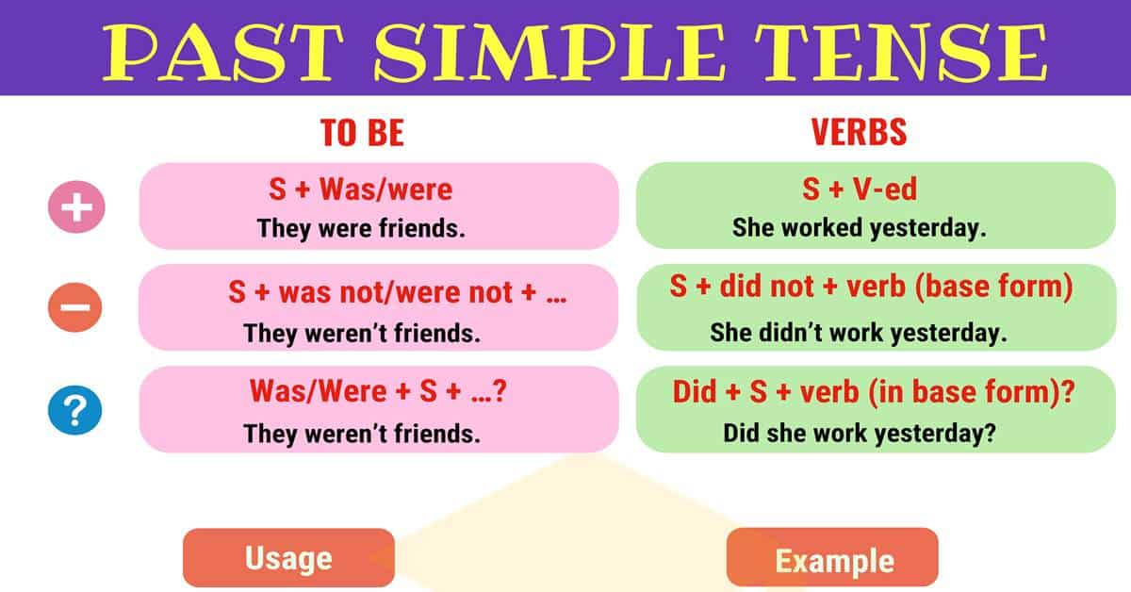
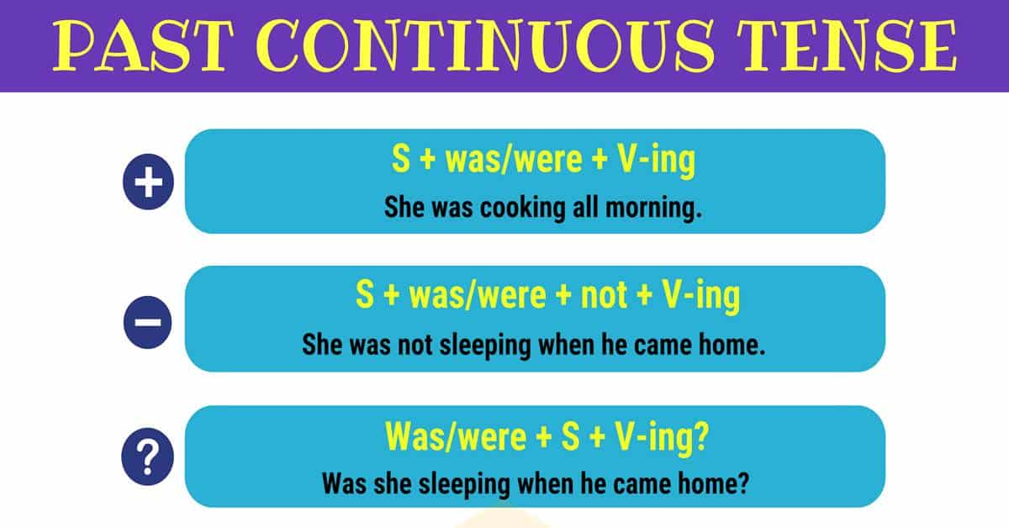

Doing the interactive grammar exercises.
Ex.16
https://learningapps.org/display?v=pw2zugffc23
Ex. 17 https://learningapps.org/display?v=p0jcm2e3t23
4. Generalization and systematization of knowledge.

Method “Brainstorming”.
- Do you like to spend money?
- What sum of money do you need every day?
- Is money very important in your life? Why?
- What is the best way to earn money?
- Want is the difference between the mottoes: “Money is for life” and “Life is for
money”?
- Which of them do you support? Why?
- Is it possible to have too much money?
- Would you prefer fame or fortune?
- If you could buy yourself a skill, talent or change in your appearance, what would it be?
- Is there something you own that’s worth a fortune?
- Do you agree that having a lot of money makes you free?
- Do you agree that all the millionaires are miserable people?
- What can’t money buy?
- Do you agree with the proverb “Much will have more?”
- Is a person really rich “ that has few wants”?
- Why do many rich people suffer from nervous breakdowns or drugs and alcohol problems?

Lesson Summary.
T.: You have worked very well today, your marks are excellent.
There were some mistakes in your answers, your marks are…
You were not very active today, so your marks are…

Homework.
T: Your home task is to choose three gifts for your birthday, which you think are the most important or useful.
Good health, plenty of money, a nice house, a brilliant mind, an attractive face, lots offriends, a good job, a fast car, a long life,an artistic talent
Thank you very much for your work. The lesson is over. Good-bye.

Do you think it’s difficult to write poems? Let’s do it together.
If the weather isn’t sunny, So you’ve got too little...(money).
When you travel England around, Then you need not hryvnia, but...(pound).
If you fly to system solar, You will surely need...(a dollar)

Answer the questions
- Is it possible to have too much money?
- Would you prefer fame or fortune?
- If you could buy yourself a skill, talent or change in your appearance, what would it be?
- Is there something you own that’s worth a fortune?
- Do you agree that having a lot of money makes you free?
- Do you agree that all the millionaires are miserable people?
- What can’t money buy?
- Do you agree with the proverb “Much will have more?”
- Is a person really rich “ that has few wants”?
- Why do many rich people suffer from nervous breakdowns or drugs and alcohol problems?

advantages
You can buy whatever you want
You can travel all over the world You have a lot of free time
You needn’t go to work People are interested in your opinion
You don’t have to worry about your education or finding a good job
You can always help your relatives and friends

disadvantages
People are jealous of your wealth
You are afraid to lose your money
Everybody asks you to lend some money
You can never be sure if people like you or your money
It is difficult to find real friends
You are in constant danger of the wrong attention.
You need a bodyguard It is difficult to know who to trust

Choose three gifts for your birthday, which you think are the most important or useful
good health;
plenty of money;
a nice house;
a brilliant mind;
an attractive face;
lots of adventure;
lots of friends;
a good job;
a fast car;
a happy marriage;
a long life;
an artistic talent.

- Take care of the pence and the pounds will take care of themselves.
2. Money burns a hole in the pocket.
3. Money has no smell. 4. Money is a good servant but a bad master.
5. Money often unmakes the men who make it.
6. Poverty is in want of much, avarice of everything.
7. A great fortune is a great slavery.
9. Lend your money and lose you friend.
8. Muck and money go together.
10. A friend in court is better than a penny in purse.
11. A penny saved is a penny gained.
12. A light purse makes a heavy heart.
13. A bargain is a bargain.
14. Time is money.
15. Money makes the world go round.
16. A good name is better than riches.
17. Money spent on the brain is never spent in vain.
18. A heavy purse makes a light heart.

