Topic: Welcome to Ukraine
Objectives: revise vocabulary on topic Ukraine;
develop pupils' knowledge about their Motherland, Ukrainian customs and traditions
teach them to work in groups, make them interested in learning English
Dear quests and children! Today we have a performance on topic "Welcome to Ukraine". We are going to watch a video about Ukraine, answer the questions, do a quiz. Let's start!
- Watch a video and answer the questions, get a heart for the correct answers:
https://www.youtube.com/watch?v=zBzXSRf3iSE&feature=youtu.be

- What symbols of Ukraine do you know? (trident, anthem, flag);
- What colours is Ukrainian flag? (blue and yellow);
- Where is Ukraine situated? (in the centre of Europe);
- What language do Ukrainians speak? (Ukrainian language);
- Is Ukraine the largest country in Europe? (Yes, it is)

- Let’s continue! Use the letters to name our Motherland and say some words about Ukrainian people according to the letters.
Are the Ukrainians united? Are the Ukrainians kind? Are the Ukrainians independent?

U - united
K - kind
R - rich
A - amazing
I - independent
N - nice
E- educated

- Recite a poem "My native land"

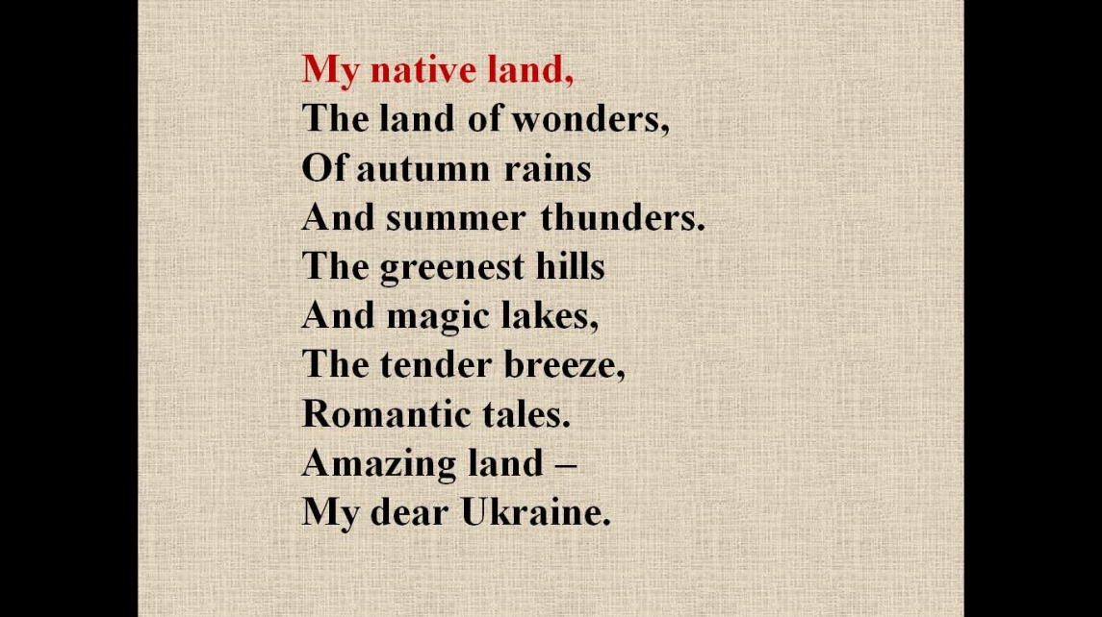

- Your next task is to place the cities in the correct order on the map. You have got 5-10 minutes.
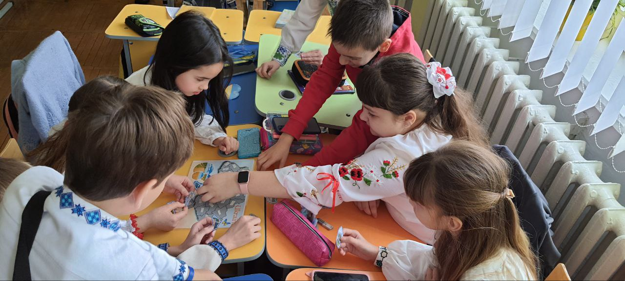

The winners will be those, who complete the task first.

- Let's have a little break and dance.
https://www.youtube.com/watch?v=P5cNYlsVpOA

- Watch the presentation and revise some information about Ukraine and then do a quiz.

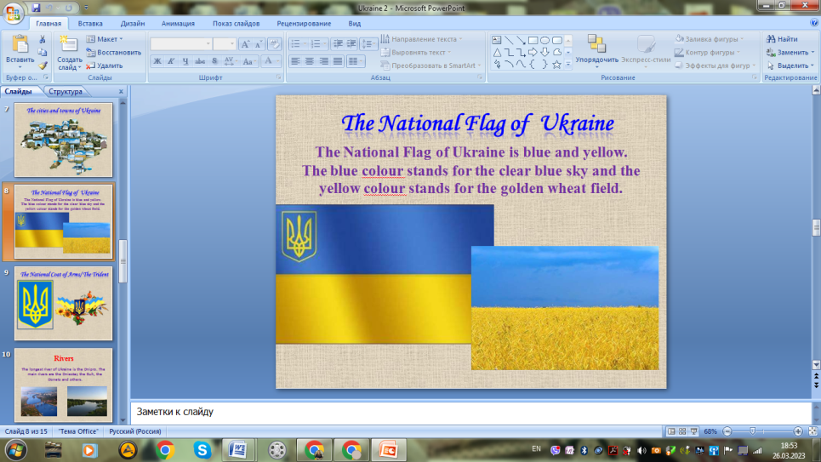

- Do a quiz, choose the correct answers and get a heart.

https://wordwall.net/uk/resource/39699079/ukraine

1. On which continent is Ukraine located?
a) Asia b) Europe c) Australia ( Europe )
2. What is the highest point in Ukraine?
a) Hoverla b) Crimean mountains c) Motherland ( Hoverla )
3. What is the national food in Ukraine?
a) pizza b) borshch c) syrnyky
( Borshch )
4. What is the area of Ukraine?
a) 674.163 km. b) 603.549 km. c) 601.896 km.
( 603.549 km )
5. Is Ukraine bigger than France?
a) Yes b) No
( Yes )
6. What is the capital of Ukraine?
a) Lviv b) Kyiv c) Odessa
( Kyiv )
7. Who is the president of Ukraine?
a) Petro Poroshenko b) Volodymyr Zelenskyi c) Joe Biden
( Volodymyr Zelenskyi )
8. When did Ukraine become independent?
a) 1990 b) 1998 c) 1991
( 1991 )
9. What is the longest musical instrument invented in Ukraine?
a) harp b) guitar c) trembita
( Trembita )
10. What is the most famous poet of Ukraine?
a) Ivan Franko b) Taras Shevchenko c) Lesia Ukrainka
( Taras Shevchenko )
11. What seas wash Ukraine?
a) Mediterranean Sea b) Black Sea c) Black Sea, Sea of Azov
( Black Sea, Sea of Azov )
12. What is the name of one of the largest deserts in Europe, located in Ukraine?
a) Olesky Sands b) Sahara d) Sonora
( Olesky sands )

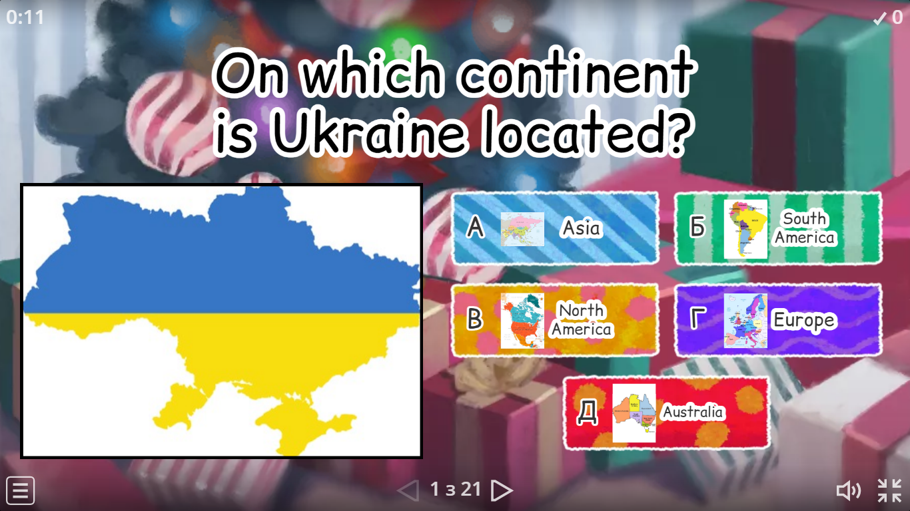
- Stick the hearts with wishes on the board.

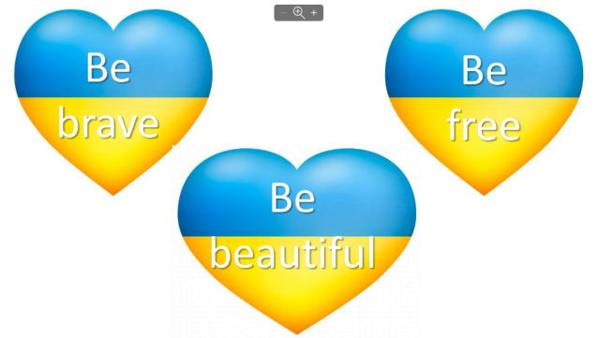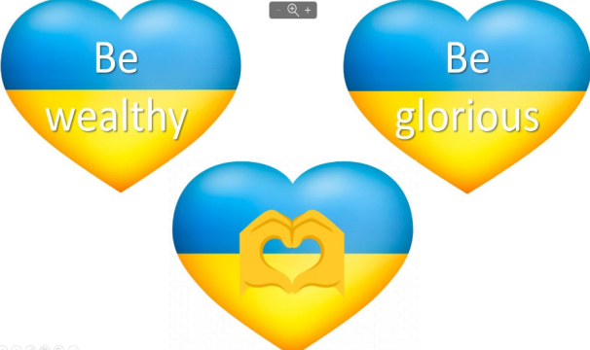
- Our performance came to the end. You were active and great today! I hope, you had a lot of fun! Our guests also get hearts with wishes.


