Позакласний захід з англійської мови на тему:
«Who knows the USA better?»

Мета:
Практична: удосконалювати навики усного мовлення;
Освітня: продовжити знайомити студентів з особливостями життя США та визначними місцями країни; розширити кругозір студентів;
Розвиваюча: розвивати пам'ять та логіку, розумові та мовленнєві здібності студентів; розвиток міжкультурної компетенції;
Виховна: виховувати повагу до культури країн, мова яких вивчається; виховувати інтерес до вивчення іноземної мови.

Обладнання: мультимедійний комплекс, матеріал для презентації, картки з запитаннями, ручки та папір для нотаток, бейджики з іменами учасників.

Good afternoon dear students and our guests. I am glad to see you here at our meeting. As you have already guessed we’ll speak about the United States of America. What do we know about it? A lot of everything including the popular symbols of America, Statue of Liberty, New York and Los Angeles and, of course, Hollywood. But preparing this program we decided to show this country from different sides.
I hope we are ready to start.

ROUND 1

So we star our first round.
I’ll ask you questions and you will answer them one after the other in turn. There are 4 variants of answers on the screen and your task is to choose the correct variant.

1. What do the Englishmen say to be taken a photo?
a) hello b) good morning
c) cheese d) ham
2. According to the English proverb when you don’t know what to speak about, speak about
a) politics b) music
c) weather d) love
3. Smog is
a) an American blazer b) a man’s hat
c) heavy rain d) thick fog
4. How many stars are there on the American flag?
a) 48 b) 49
c) 50 d) 51
5. What is the capital of the state of Georgia?
a) Atlanta b) San Francisco
c) Los Angeles d) Washington
6. How many stars were there on the American flag originally?
a) 50 b) 15
c) 48 d) 13
7. How many stripes were there on the American flag originally?
a) 12 b) 13
c) 15 d) 50
8. Washington D.C. is a
a) state b) district
c) country d) city
9. To what city do these parts belong: Harlem, Manhattan, Brooklyn?
a) New York b) Washington D.C.
c) Los Angeles d) San Francisco
10. What is Washington?
a) a country b) a district
c) a city d) a state
11. What is Moscow in the USA?
a) a mount b) a river
c) a state d) a town
12. What is the national symbol of America?
a) the rose b) the Cherokee rose
c) the Statue of Liberty d) the bald eagle
13. Who wrote the Declaration of Independence?
a) Abraham Lincoln b) Thomas Jefferson
c) George Washington d) Bill Clinton
4. In the north the USA is bordered by
a) Mexico b) Alaska
c) Canada d) France
14. What is the highest skyscraper in New York?
a) the Capitol b) the Sears Tower
c) the Washington Memorial d) the Empire State Building
15. What is soccer?
a) football b) hockey
c) squash d) boat racing
16. It speaks about the annual income of a family:
a) a number of cars b) a number of the houses
c) a number of the children d) a number of the bedrooms in the house
17. The sittings of the American Congress take place in
a) the White House b) the Capitol
c) the Pentagon d) the Library of Congress
18. The original name of this city was New Amsterdam. Today this city is called
a) Philadelphia b) Gettysburg
c) Pittsburg d) New York
19. The Golden Gate Bridge is the symbol of
a) San Francisco b) Seattle
c) Vancouver d) New York
20. The American Congress consists of the Senate and
a) the House of Lords b) the House of Commons
c) the House of Representatives d) the Council of Federation
21. This building is 555 feet high:
a) the Jefferson Memorial b) the Capitol
c) The Washington Monument d) the White House
22. This city was built on the banks on the Potomac river:
a) New York b) Los Angeles
c) Washington D.C. d) Salt Lake City
23. The symbol of the USA is
a) Union Jack b) Uncle Sam
c) Big Ben d) Pall Mall
24. New England is
a) a country b) a part of Great Britain
c) a part of the USA d) an island near the USA
25. What is the name of “007”?
a) Henry Bond b) James Bond
c) Thomas Bond d) William Bond
26. John Steinbeck is a famous American
a) writer b)actor
c) composer d) cosmonaut
27. You can see the famous slogan “In God we trust”
a) on the White House b) in the President’s office
c) on the money d) in the streets
28. The oldest and the youngest US presidents elected were respectively
- Ronald Reagan and John F. Kennedy
- Ronald Reagan and Theodore Roosevelt
- George Washington and Bill Clinton
- George Washington and Abraham Lincoln
29. The first person to introduce paper currency in the USA was
a) George Washington b) Thomas Jefferson
c) Benjamin Franklin d) Ulysses Grant
30. Santa Barbara is situated
a) in California b) Florida
c) Arizona d) Texas

Let’s look at the results. Dear jury, will you tell us the results of the first round, please?

Round 2. Blitz quiz about the USA.

So, there are some questions for you. They can help us to check your knowledge about the USA. The student who will give the correct answer to the question first will get 1 point.

- What famous sight can be seen both, in Canada and the USA? (Niagara Fall)
- Who and when discovered America? (Columbus in 1492)
- Who is the President of the USA now? (Joseph Biden)
- How do they call an American flag? (Stars and Stripes)
- How many stripes are there on the US flag? (13)
- What ocean doesn’t wash the USA? (The Indian Ocean)
- Where is the Statue of Liberty situated? ( New York)
- When is Thanksgiving Day celebrated in America? (4th Thursday in November)
- Which state joined the USA last? ( Hawaii)
- Which of the Kennedy brothers, John or Robert, became the US president? (John Kennedy)
- Name the famous American writer, author of Tom Sawyer Adventures. (Mark Twain)
- When did the United States declare its independence? (July, 4, 1776)
- What is the tallest building in Washington? (The Capitol)
- What state was named after American president? ( Washington)
- What is the biggest state among 50 states in the USA? ( Alaska)
- What mountains are not situated on the territory of the USA: the Cordilleras, the Rocky Mountains, the Cumbrian Mountains? (the Cumbrian Mountains)
- What was the name of the famous ship which took first colonists from England to America in 1620? (“Mayflower”)
- What is the Statue of Liberty by nationality? ( the French)
- What is the population of the USA: about 300 mln, 250 mln, 52mln? (300mln)
- What city is the biggest by population: Los Angeles, Chicago, Washington or Detroit? ( Los Angeles )

Dear jury, will you tell us the results of the second round?

Round 3. Sights

On the screen you will see the pictures of some sights of the USA and at the bottom you can see their names. Your task is to match the pictures and their names. You will get 1 point for each correct matching. The student, who will do the task first, will get 3 points more.
You have 2 minutes.

(1-Golden Gate Bridge,2- Grand Canyon, 3- The Washington Monument, 4- The White House, 5- Disneyland Park, 6- The Lincoln Memorial, 7- The United States Capitol, 8-Death Valley, 9-Niagara Fall)

Round 4. Culture. Holidays.
Look at the pictures on the screen. What holidays are they connected with? You will get 1 point for each correct answer. If you write the date when this holiday is celebrated in the USA, you will get one more point for each holiday. The student who will do the task first, will get 3 points more.

For this task you have 5 minutes.

1-Independence Day, July, 4th
2- Memorial Day, last Monday in May
3-Thanksgiving Day, fourth Thursday in November
4- Boxing Day, December 26th
5- Easter (moving),
6- Halloween, October, 31st
7- Flag Day, June, 14th
8- Veterans’ Day, November, 11th
9- Columbus Day, October 12th

Round 5. Famous People
You will listen to some pieces of information about famous people of the USA. If you guess the name of the person after the first prompt, you will get 5 points, after the second prompt – 3 points, after the third one – 1 point.

№1 (Lincoln)
- He was born in the family of a poor farmer and had to work much. He become a lawyer and always tried to use the law to defend people. In 1846 he was elected to Congress.
- In 1860 he became the president of the USA. In 1864 he was elected the President again. But a year later he was killed by his enemies in a theatre in Washington.
- This name was given to a brand of Motor Company. It had a long history of providing official state limousines for the U.S. President. The first car specially built for Presidential use was called the "Sunshine Special" used by Franklin Roosevelt.

№ 2 (Einstein)
- He is one of the brilliant and the most famous physicists. He was born in Germany. He attended a Munich elementary school where he showed an interest in science and mathematics but did bad in other subjects. He finished high school and Technical College in Switzerland. In 1940 he became an American citizen.
- In 1916 he published his general theory of relativity. Television and other inventions are practical applications of his discoveries. In 1922 he was awarded the 1921 Nobel Prize in Physics.
- He published over 300 scientific works and over 150 non-scientific works. He presented his famous formula E=m$c^{2}$, known as the energy-mass relation.
№3 (Britney Spears)
- She was only 17 when she reached #1 on the U.S. pop music charts with her 1999 debut album. She is one of America's biggest pop stars, and she became a near-constant presence on MTV, radio broadcasts and magazine covers around the world.
- She married Kevin Federline, a professional dancer. They had two sons. But she filed for divorce in November of 2006. During 2007 she was in the gossip columns on a weekly basis and made headlines by shaving her head, entering rehab and, after repeated missteps with the courts.
- Her second album, Oops...I Did It Again, was released in May of 2000 and went gold in its first week.

№ 4 (Angelina Jolly)
- She was born in the family of actors. And in 1999 she won an Oscar for her supporting role as a troubled mental patient.
- She has become famous for her charitable impulses: she was named a goodwill ambassador for the United Nations High Commissioner on Refugees in 2001. She adopted a Cambodian boy, Maddox (in 2002), a daughter born in Ethiopia (in 2005), and a boy from Vietnam, (in 2007).
- She sealed her international fame by playing the video game heroine Lara Croft in Tomb Raider (2001) and Tomb Raider: Cradle of Life (2003). She and Brad Pitt starred in the action film Mr. & Mrs. Smith in 2005.

№ 5 (Michael Jordan)
- He is a famous sportsman. His deal with Nike led to the creation of the popular athletic shoes…He starred with Bugs Bunny in the 1996 feature film Space Jam... In October of 1993 he stunned his fans by retiring from basketball and beginning a professional baseball career.
- He wore uniform number 23... With him, the Chicago Bulls won three more championships in 1996, 1997 and 1998. He retired and returned to basketball several times.
- He was the dominant basketball player in the world during the 1990s. He won the NBA's Most Valuable Player award five times, and six times led the Chicago Bulls to the league championship.

Thank all of you! Let’s count the points our competitors have gotten and name the winner!

Presentation Materials
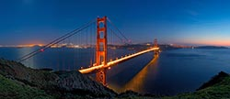
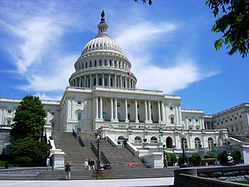
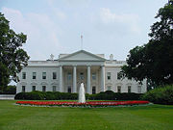
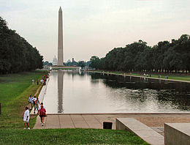
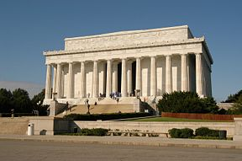
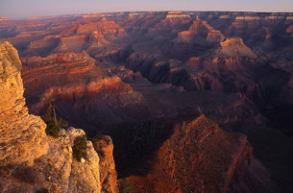
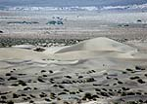
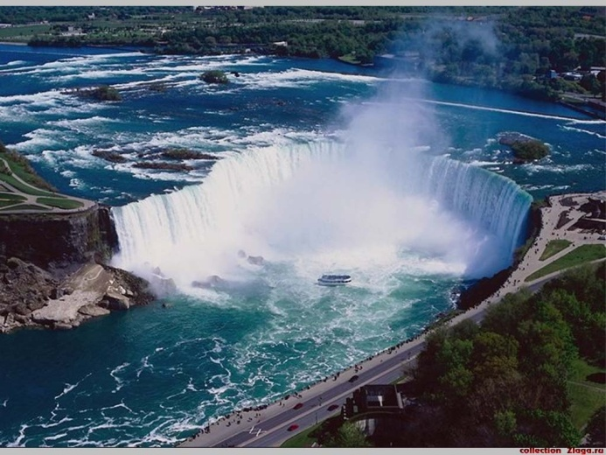
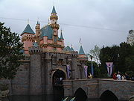
To Round 3
1
2
4
5
6
7
3
9
8
The United States Capitol, Golden Gate Bridge, The White House, The Washington Monument, The Lincoln Memorial, Grand Canyon, Death Valley, Niagara Fall, Disneyland Park
To Round 4
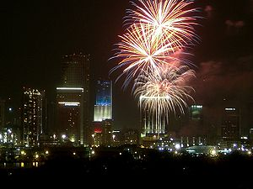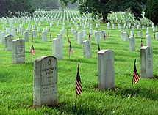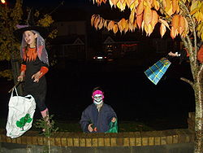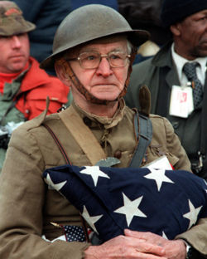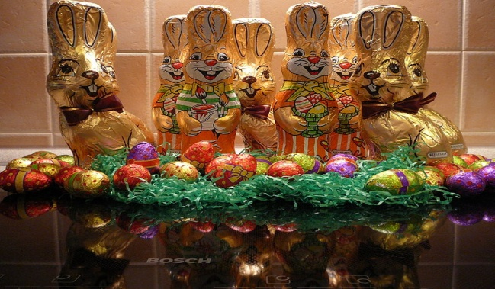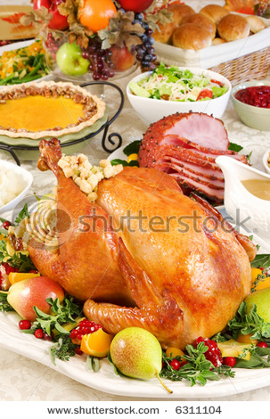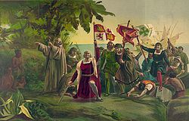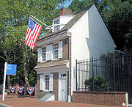
9
HOLIDAYS OF THE USA
1
2
3
4
5
6
7
8
9

