
St. Patrick’s Day Celebration
I.Video clip
https://www.youtube.com/watch?v=2YAa6NjFVjk
II.A sweet melody is played, spring and flowers appear on the stage and they dance to the music.
https://www.youtube.com/watch?v=ryUxrFUk6MY
Spring: Glad to meet you, my dear flowers! How are you after the long winter sleep?

Flower 1: Glad to meet you, sister Spring. We are fine. But we missed you so much.

Spring: Oh, dear, I missed you too. I missed the warmth and the sun, and the light breeze.

Flower 2: I am so happy that
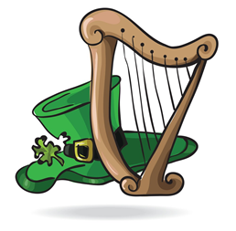
Nature is awaking,
Birds are singing,
The sun is shining
The bright day is ringing.

Flower 3: The birds are returning,
Their songs you can hear,
The meadows are smiling
With spring flowers here.

Spring: Yes, this is my season
When snowdrops bloom,
When nobody likes to stay in the room.

III.SONG «Spring is Here» https://www.youtube.com/watch?v=DobrRgD5aOU

Flower 4: Look! Sister Spring! What country shall we go for a holiday this year?
Oh, I know! Let’s go to Australia, it’s always warm there.

Flower 5: Australia? What are you talking about! Don’t you know that it’s autumn in Australia now. There are no flowers there.

Flower 6: Right you are! I know where to go. Let’s go to Egypt. It’s always hot in this country.

Flower 7: Well, I think it’s too hot there. It’s not good to have a holiday in Egypt now.

Spring: So, what to do? Where to celebrate a spring holiday this year?

Flower 8: I know the country where to go. It’s the greenest country in the world. Everything is green there: the trees are green, the grass is green, the clothes are green and the nose is green.

Flower 9: Yes, everything is green on March 17! I know this country. This is Ireland.

Spring: Ireland, my dear? Let’s have a look at this country. My magic stick will help us. One, two, three! Look at the screen!

IV.Presentation

Irish 1: We are from Ireland, a beautiful country in the north of Europe. It is situated on the island very close to Great Britain.

Irish 2: Our country is famous for its gorgeous mountains, deep lakes with crystal clear water, thick green forests, sweet meadows, sea swept coastlines, cliffs that climb up the sky and pastoral countryside.

Irish 3: Our national symbol is shamrock and our national colour is green, our patron Saint is Patrick and our national holiday is in March 17.

Irish 4: We are very famous for our national spirit and we are very proud to be Irish.

Irish 5: Today is the day for the wearing of green.
Today is the day when Irish are seen.
Today is St. Patrick’s Day, so if you are Irish, my lad,
Join the celebration for the greatest time to be held.

Irish 6: St. Patrick’s Day is with us,
The day when all that’s seen
To right and left and everywhere
Is green, and green, and green.
The Irish tunes we whistle
And Irish songs we sing.
Today each Irish lad walks out
As proud as the king.

V.IRISH DANCE
https://www.youtube.com/watch?v=FoHlrQScWl0

Irish 7: Today is St. Patrick’s Day. They say that on this day Saint Patrick comes to Ireland and blesses the people. Look, it seems that he is coming here.

St. Patrick: Good afternoon to everyone! I am Patrick, the patron saint of Ireland. I lived more than 2 thousand years ago. I loved this country and did many nice things for the people of Ireland. I showed them the way to Christianity and taught to be kind, generous, patient and to love God. I used shamrock as the symbol of holy trinity. And now let’s join our hearts in blessing for the country of Ireland and the Irish:
VI.Irish Blessing

Irish 8: I wish you not a pride
Devoid of clouds,
Nor a life on a bed of roses

Irish 9: Not that you might never need regret,
Nor that you should never feel pain.
No, that is not my wish for you.

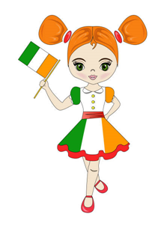
Irish 1: My wish for you is
That you might be brave in times of trial,
When others lay crosses upon your shoulders.

Irish 2: When mountains must be climbed
And chasms are to be crossed;

Irish 3: When hope scarce can shine through
That every gift God gave you
Must grow along with you.

Irish 4: And let you give the gift of joy
To all who care for you.

Irish 5: That you always have a friend
That is worth that name,
Whom you can trust,
And who helps you in times of sadness.

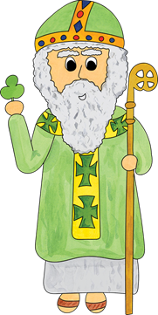
Irish 6: Who will defy the storms of daily life at your side.

Irish 7: One more wish I have for you:
That in every hour of joy and pain
You will feel God close to you.

St. Patrick: This is my wish for you
And for all who care for you.
This is my hope for you
Now and forever.

(St. Patrick leaves the stage)

Irish 8: But don’t you know, my friends, that St. Patrick’s Day is impossible without the leprechauns!
Irish 9: Yes, you are right. I saw a leprechaun hiding in a tree,
I saw a leprechaun and he saw me.
I said, «I’ve never seen a leprechaun before! »
He said, «You probably won’t see him anymore! »
VII.Leprechauns appear dancing

https://www.youtube.com/watch?v=rrxzG0we9t4

Leprechaun 1: Near a misty stream in Ireland
In the hollow of a tree
Live mystical magical leprechauns
As clever as can be.

Leprechaun 2: With their pointed ears and turned up toes
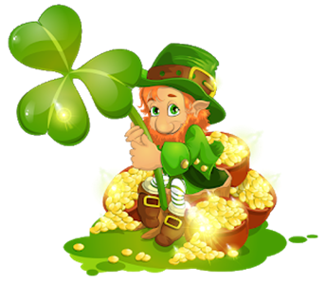
And little coat of green
The leprechauns busily make their shoes
And try hard not to be seen.

Leprechaun 3: Only those who really believe
Have seen these little elves
And if you are all believers
You can surely see for yourselves.

Leprechaun 4: I am a little leprechaun
That lives on a tree,
I am a cunning leprechaun
Nobody catches me.

Leprechaun 5: I am a lucky leprechaun
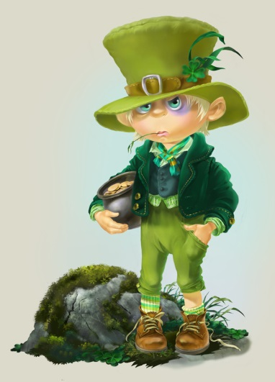
My treasure’s with me.
I am a happy leprechaun
As happy as can be.

Leprechaun 6: I love to be a leprechaun
Hiding in the flowers
And playing tricks on people
For hours and hours.

Leprechaun 7: They say in good old Ireland
If a leprechaun you hold
You’ll go to the end of the rainbow
To his treasure pot of gold.

VIII. Song « Have You Ever Seen A Leprechaun».

https://www.youtube.com/watch?v=2k-ht4lJJN4

Leprechaun 8: Happy St. Patrick’s Day, the people of Ireland and the people of Ukraine! Well, gentlemen, let us check if everyone here is wearing green. Come on pinching!

IX. They start pinching the audience, the Irish melody is played

Flower 1: St. Patrick’s Day is here, you see.
We’ll pick some shamrocks, one, two, three.
We’ll count the leaves and look them over,
And maybe find a four-leafed clover.

Flower 2: I’ll sew green buttons on my vest,
Green for St. Patrick is the best.
I’ll wear a green hat, very high,
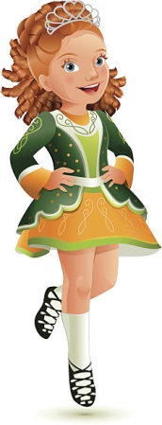
And dance a jig – at least I’ll try!

X.SONG IRISH JIG

https://www.youtube.com/watch?v=So1qiyLaypk

Have You Ever Seen A Leprechaun
LYRICS:
Have you ever seen a leprechaun
Little green hat and boots so brown
Have you ever seen a leprechaun
Can you catch one sneakin' around

He's got a secret pot of gold
Hiding at the end of a rainbow
And you can try to find it but you'll never win
Get a four leaf clover and try again

Have you ever seen a leprechaun
Tiny little trickster from Ireland
Have you ever seen a leprechaun
Maybe just maybe you can make him your friend

