Конспект уроку до підручника “Prepare 5”
Form 5
Theme: Ukraine
Aims: тренувати учнів у говорінні, розвивати комунікативні навички та читацькі вміння, розширювати кругозір та творче мислення учнів, виховувати любов до Батьківщини, формувати патріотичні риси характеру
- Greeting
- Setting topic and aids
Today we are going to speak about the best country in the world. If you look at the blackboard, you will see the topic of our lesson. You can read it-«Ukraine is my Motherland». So, we are to talk about our country, do a lot of tasks, learn new words, revise grammar.
- Warming up
Let us start our lesson with some phonetic exercises
Read and sing the chant:
I was born in Ukraine
and I live here.
My family and friends
are also near.
I love my country.
I love Ukraine.
It is my homeland
My native land!

And now answer my questions:
-Where are you from?
-Where do you live?
-Do you love your country?
4. Watching a video
Watch a video about Ukraine and make a mind-map “Ukraine is …”
Strong, independent, beautiful, large, famous, wonderful, friendly, modern
Ukraine

- Pre-reading
Look at the Globe and find Ukraine on it and then on the World Map!
-Is it large?
-Is it in Europe?
-Are there big cities in Ukraine?
-What big cities do you know?
Exercise 1,2 page 20
And now read the text and do some tasks
Exercise 3 page 20
Post –reading activity
Exercise 4 page 21
- Break (a song If you are happy…)
- Listening
Exercise 5 page 21
- Speaking
Tell about Ukraine using the structures There is a …There are ….in Ukraine.
- Writing
Complete.
I’m proud of being Ukrainian.
My name is …. I’m from… I’m …. Ukraine is a country in the heart of …. The national language is …. Ukrainian flag is… and .... …is the capital city of my country. The longest river of Ukraine is…. Ukrainian national dishes are ….
- Creative task
You know that Ukraine is in danger. There is a war in our country. That”s why:
Draw a peace dove and write words which I wish Ukraine ….
peace-мир, victory-перемога ,strength-сила ,success-успіх, luck-удача ,glory-слава, rise-підйом, joy-радість, happiness-щастя ,protection-захист
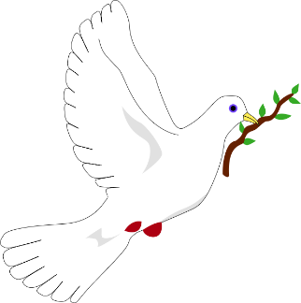
- Summing up
So, today we have done a lot:
Learnt new words, discussed the topic, revised the grammar material, read, sang and spoke about Ukraine. Your marks for the lesson are…
- Homework


