Хід
1.Початок,організація
T:11,12,13,14,15,16,17,18,19,20.Begin!
Привітання
Т: Listen children! Please stand up!
Go to the blackboard! Circle please!
Say and wave hello, review after me!
(Діти в колі , по черзі, повторюють за вчителем).
T:Good morning!
P:Good morning!
T:How are you? How do you do?
Р:I'm well/fine.
T:Nice to meet you.
P:I am glad to see you.
T:You look well today.
P:You look well today too.
T:Listen children! Please sit down!
And answer my questions, please!
Актуалізація опорних знань. Бесіда-повторення про пору року.
Т:What day is it today?
P:It's Monday/Tuesday/Wednesday…
T:What season is it?
P:It's spring.
T:Great! Look at the picture '' Spring '', say about it.

P:March is too cold and wet.
April comes with rain showers.
May is the month when Daddy
Brings our Granny flowers .
T: Well! Name the spring months.
P: They are March, April, May.
T: Wow! Let's play the clapping game '' Spring ''. Clap, when it's right.
1 March is a winter month.
2 The days get longer in spring.
3 It's warm in spring.
4 The sky is grey.
5 April showers bring May flowers.
II. Основна частина. Ознайомлення з темою уроку, цілями
T: Spring is sunny
Spring is fun….
Let's have ”Fun time”: we play the ABC games, remember: Where is…? It's on/under/in/next to… . (Where's the radio? It's on the table). Do the Zoo trail.
Повторення алфавіту
T: Do you remember the ABC? Yes, we do. Listen to the song ”The ABC”. Then sing and clap.
Повторення голосних
T: Well done! Go to the blackboard, take the vowel letter ”a” (”e”, ”i”, ”o”, ”u”), name it, fix on the blackboard. And say with others.

Гра з голосними літерами
T: Wow! I have a surprise for you. It`s a game. Listen to the rules: match the vowel letter ”a” (”e”, ”i”, ”o”, ”u”) and the card (”a” apple, ”e” egg, ”i” insect, ”o” orange, ”u” umbrella).
Письмо
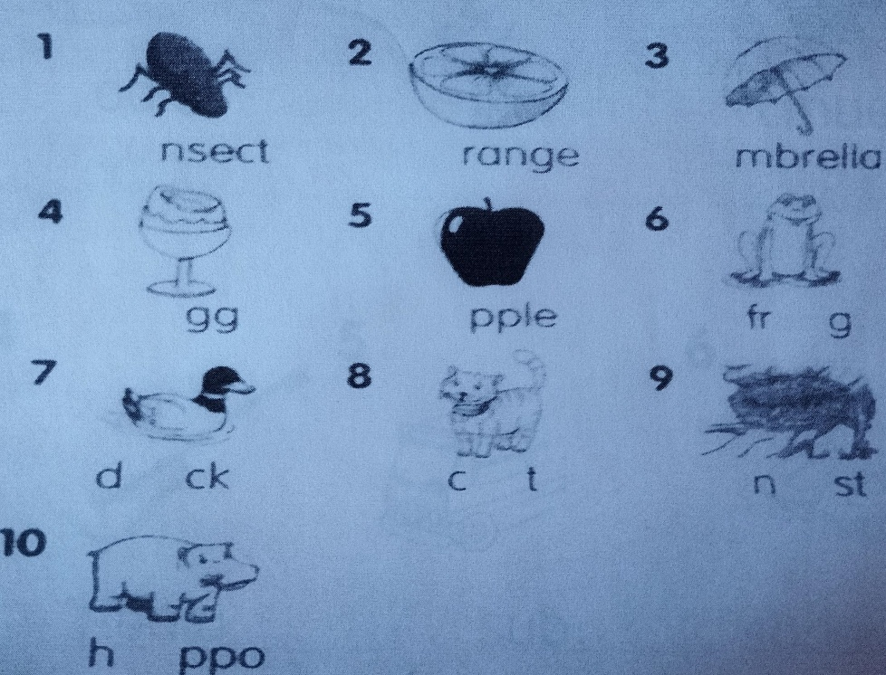
T: Good of you. One more task for you. Listen and write. Then repeat.
T: Look at the blackboard and correct. Great!
Зарядка
T: Are you tired? Let`s stand up! Act!
Clap your hands and turn around
Stomp your feet and touch the ground
Clap your hands and turn around
Stomp your feet and sit down!

Аудіювання
T: Listen to the chant, follow in your books. Then say it all.
Black cats. Eggs in a nest. Pink insects. Orange frogs. Mum and an umbrella.
T: Listen to the CD. Say the chant with it. Then repeat in pairs.
(Діти працюють в парах)
Гра - повторення лексики
T: Well! Let`s have fun. It`s time to play. Rules: draw and put the letters in order by yourself.
T: Look at the blackboard and correct.
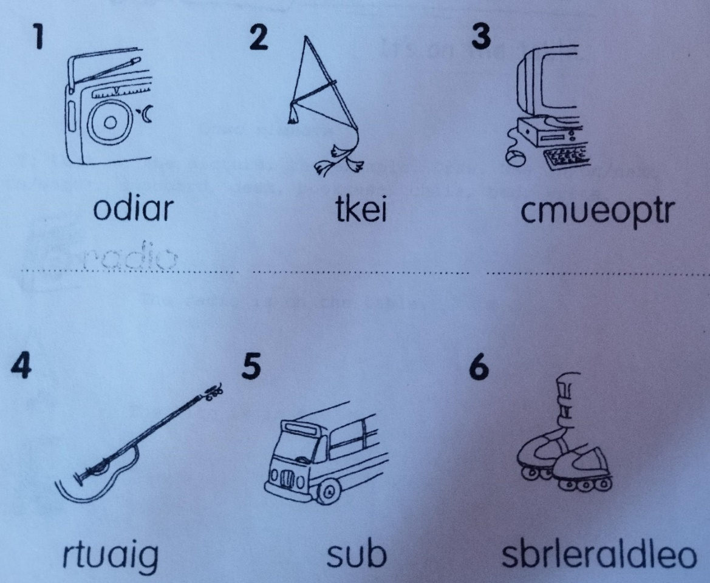

Гра - повторення Where's…?
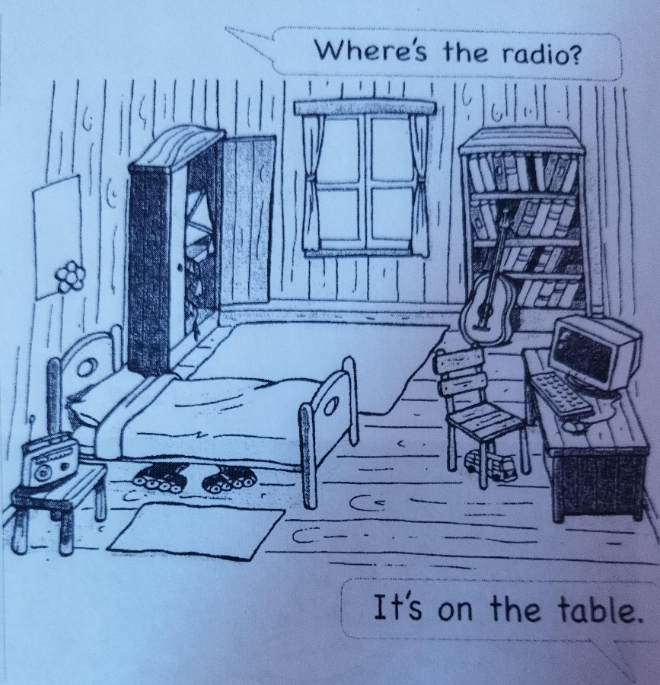
T: Now, I give you pictures and listen to the task: find all items in the room and circle. The first is the winner and start asking the questions with the help. (Діти роблять цю вправу в ланцюжку).

Опис кімнати
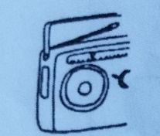
T: Cool! Let`s draw and write looking at the picture, the example - sentence. Use in/on/next to/under; cupboard, desk, bookcase, chair, bed. Begin.

The radio is on the table.
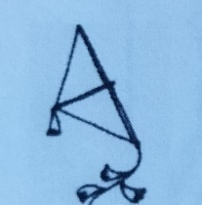
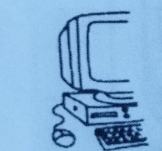
The kite is in the….
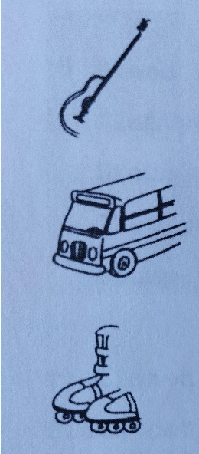
T: Stop! Your time is up! Let`s read and correct. (Діти по черзі читають речення).
Повторення Do...? питань, Yes, they do./No, they don't
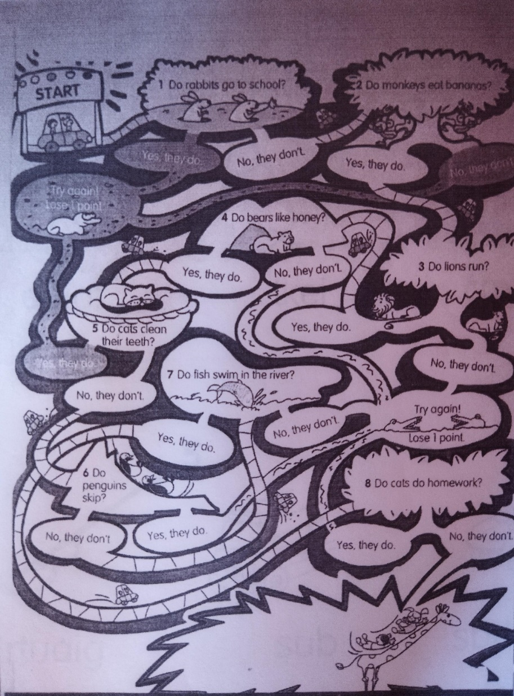
T: It`s fun time. Do the Zoo Trail in pairs.
T: Finish! Well done!
Завершення уроку. Прощання.Вербальне оцінювання
Т: Listen children! Please stand up!
Go to the blackboard! Circle please!
And wave goodbye to me, to fun time
And to each other!
T: Fantastic! Well done!

