Тема програми : Дозвілля і спорт.
Тема: Види спорту. Обладнання для спорту.
Мета уроку: (формувати компетентності):
предметні: активізувати вживання лексики за темою, формувати навички усного мовлення, читання, письма і аудіювання, практикувати навички вживання дієслів go, do, play з різними видами спорту, вчити здобувачів освіти висловлювати свою точку зору щодо ставлення до спорту, формувати лексично-граматичні навички у форматі ЗНО, вчити здобувачів освіти сприймати іноземну мову на слух, розвивати мовну здогадку, розвивати критичне мислення.
ключові компетентності:
уміння вчитися: допомогти здобувачам освіти самоорганізовуватися до навчальної діяльності, самостійно визначати і використовувати необхідну інформацію;
екологічну грамотність і здорове життя: пропагувати здоровий спосіб життя засобами іноземної мови, розвивати екологічне мислення під час опрацювання тем, текстів, новин, комунікативних ситуацій, аудіо-та відеоматеріалів;
інформаційно-цифрову: вивчати іноземну мову з використанням спеціальних програмних засобів, інтерактивних вправ, розвивати цифрову грамотність для пошуку, обробки, аналізу та підготовки інформації відповідно до поставлених завдань;
ініціативність і підприємливість: ініціювати усну, писемну, зокрема онлайн взаємодію іноземною мовою для розв’язання конкретної життєвої проблеми;
соціальну та громадянську: обговорювати позитивні та негативні наслідки технічного прогресу; оцінювати вплив навколишнього середовища на здоров’я людей.
Тип уроку : формування компетентностей.
Методи навчання, прийоми: колективна робота, індивідуальна робота, робота з підручником, таблицями, робота з картками, тестами, QR-кодами, інтерактивними аркушами.
Основні терміни і поняття: Sport and Games, go in for sport, stadiums, swimming pools, basketball courts and skating- rinks, pitch’ or ‘field’, court, rink, table, course, field, ring, pitch, board, track, ring, field, pool, to play rugby, an achievement, a coach, a contest, a participant, a referee, to achieve, to draw, to hit, to lose, to score, to play draughts, to win.
Міжпредметні зв’язки: фізичне виховання
Наочність: «Англійська мова. 10 клас» авт. О. Карп’юк, роздатковий матеріал.
Технічні засоби навчання: комп'ютер, слайдова презентація.
Procedure
ХІД УРОКУ
І. ПОЧАТОК УРОКУ.
1. Greetings.
Привітання.
- Good morning my dear friends. I’m glad to come into your friendly group, and look into your clever eyes. I know: you are genius and talented. I hope you are all healthy.
2. Aims.
Повідомлення теми та завдань уроку.
Different people spend their free time in different ways. Some like travelling,
reading books, some listening to music, some enjoy going to the theatres and

cinemas. I like jogging so much. I am full of beans after it. Don’t you understand me? “Full of beans” is an idiom. People create some very interesting phrases using their experience. They may sound interesting and they may mean also interesting things. So it is an idiom. Take a look. Let’s watch the video. It helps you to understand this English idiom.
https://www.youtube.com/watch?v=qUqlDaQBy9M
- And when are you full of beans?
- What is your favourite activity?
- How fit are you?
- Do you like quiet or noisy games?
- What can you do well?
- Do you watch sport channels?
- Do you look forward to attending your Physical Education class?
- Have you ever taken part in a sport competition? Do you always win?
Really and truly this lesson we`ll start a new topic “Sport and leisure”, and we`ll revise the names of different sports and games and discuss the importance of sports in our everyday life.
3.Warming-up activity.
Мовленнєва зарядка
(введення в комунікативну ситуацію)
Mind-map “Guess the sport”

Listen to the description of different kinds of sport and try to guess what kind of sport is each text about and name the place for this sport.
Sport in which 2 teams using skates try to hit goals in the gate.
(hockey/rink)
- You need a small ball, 2 rackets and a net for this game. Two players take part in the game.
(tennis/court)

- A game in which two baskets are on the walls, each team try to throw the ball into the other team’s basket.
(basketball/field)

- A kind of sport where 2 men fight with one another with the help of gloves.
(boxing/ring)
- People need sport suit and sport shoes for this sport. They can do it everywhere.
(running/ park, street, gym)

- A dangerous kind of sport where you need a racing car.
(motor racing/track)
-It's a game played by two teams of eleven players who try to kick a ball into the other team's gate.
(football(UK)/soccer(US) – field/pitch)
-It is a sort of swimming under the water using a special equipment .
(diving/pool)

II. Main Part
- Vocabulary presentation
https://quizlet.com/_a24n8l?x=1qqt&i=3t20vc
- Vocabulary links
You WIN a match, competition, medal.
You BEAT another team or person.

- Develop your vocabulary
https://quizlet.com/609959740/complete-the-sentences-flash-cards/?x=1qqt
- Grammar point.
DO, PLAY OR GO WITH VARIOUS SPORTS
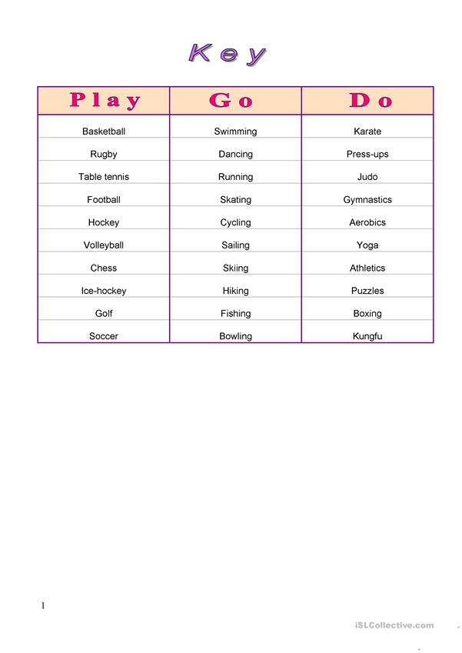
Use “play” with any competitive game that you can play, “go” with activities that can be done alone, and “do” with groups of related activities.
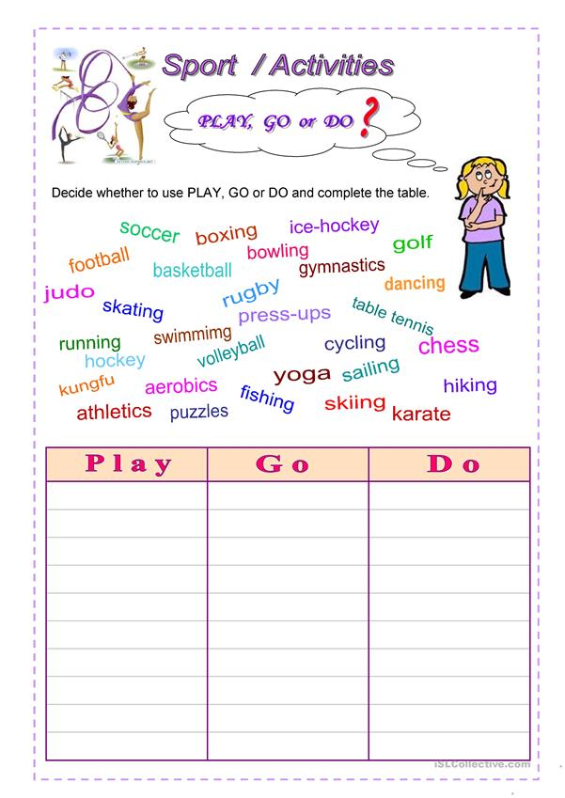

- Word-formation
And now I can also give you advice how to enrich your vocabulary. You won’t have to memorize a great number of words if you remember the rulers of word-formation. Now, let’s do two exercises: еxercise 1, page 202 and еxercise 2, page 202.
- Reading Activity
- Read the young people’s opinions and complete them with the suitable final sentences ( A - D).
A I know it’s only a dream at the moment. But maybe it’ll come true.
B This and reading the sports pages in the papers are my kinds of sport.
C How can you stay fit when you body is under pressure all the time?
D For example, last year some of us went on a big holiday trip to Italy, which was great fun. Anyway, sport keeps you fit and healthy, doesn’t it?
A I know it’s only a dream at the moment. But maybe it’ll come true.
B This and reading the sports pages in the papers are my kinds of sport.
C How can you stay fit when you body is under pressure all the time?
D For example, last year some of us went on a big holiday trip to Italy, which was great fun. Anyway, sport keeps you fit and healthy, doesn’t it?

Bill, 22
Well. I Consider myself an armchair sportsman. I enjoy sports most when I’m at home watching the Grandstand on TV. It’s cricket that I like in particular. I could watch it for hours on end. I even stopped fixing my motorbike last week to watch England playing Jamaica. And I love my motorbike ! You see, it’s not that I’m not interested in sports. I’m just too lazy to drag myself to the football ground to kick the ball round. I’d rather meet my mates in the pub and discuss the weekend’s football results with them.( 1) __________________________________________________________________
__________________________________________________________________
Mark 20
Oh, I love it. I’m very active in sports. I’ve always been like that. I remember spending my days running through the woods and climbing up trees when I was a little boy. Now I go jogging every week, and besides that, I play tennis every now and then. My favorite sport , however, is football. My life would be boring without it. I think, I love it, because it’s a team game and you need all skills. You must be fit, you must keep on eye on what your team – mates do, and you need a quick brain. I am a member of our local football team. You see , that’s the other thing I like about sports : you make new friends, it gives you a felling of been part of something. We even do a lot of things together besides football.
(2) ________________________________________________________________________________________________________________________________________________________________________
Liz ,17
Well, sport is fun, isn’t it? I couldn’t imagine a life without sport, could I? Only Maths, English and History – how dull would that be! I love riding, playing volleyball and selling. It’s wonderful to be in the open and to enjoy the fresh air and the sun. But it’s tennis that I really interested in. My sport teacher told me that I had a skill for playing tennis and that I should practice it more. That’s way I stopped sailing and riding, and tennis takes up all my free time now. It would be great if I made it big as a tennis professional. Just think of the money you could earn. It would be fantastic to travel round the world, to meet people in business and to be interviewed by TV reporters .
(3) ____________________________________________________________________________________________________________________________________
Suzie, 21
Thanks goodness people never try and talk sport to me! I hate sports. What is an endless boring tennis match to a good film – nothing, it just a waste of time! I think English people’s attitude to sport is so childish. Hundreds of thousands of them listen to cricket commentaries on their radio for five days. It so stupid.. They think that the big stars in the business lead a wonderful life. What a load of rubbish! In my opinion, these people are poor devils living out of a suitcase. How can hey are any social life when they are always away from home? I don’t believe that these professionals are really interested in their sports. Besides, nobody ever mentions the dangers of sport. Just think of the injuries…
(4) ____________________________________________________________________________________________________________________________________
7. Speaking.
Group working
-Now we are going to work in a groups. The first group must think and write the advantages of sport and the second one its disadvantages.
Advantages | Disadvantages.
People go in for sport because it is fashion.  It helps you to be healthy, keep fit.  Going in for sports makes people more organized and better disciplined  Sportsmen are famous all over the world.  Sport takes extra energy | Sport is dangerous because brings injures.  It takes a lot of time.  You have no friends only regards.  Famous sportsmen are in public all the time and theirs funs fallow everywhere.
-As you see there are much more advantages of sport than its disadvantages. And what is your attitude to sport?
- What sports are popular in our country?
- And do you know what sports are popular in Britain?
8. Listening Activity.
Listen to the text and do the tests.
https://learnenglishteens.britishcouncil.org/uk-now/video-uk/extreme-sports

III. ЗАКЛЮЧНА ЧАСТИНА УРОКУ.
- SUMMARY
Заключна частина уроку
Підсумки уроку
Our lesson is coming to the end and I hope it was useful for you.
2. HOME ASSIGNMENT
Повідомлення домашнього завдання
Your homework for the next lesson is
- Complete the text with the words in the box at p. 208 ex. 7.

- Fill in the worksheet using this QR code.

