Слов’янська гімназія

Урок на тему:
«Дорога до школи»
(4 клас)

Виконала: Савченко В.Д.

Київ -2016
Урок на тему: Дорога до школи
( 4 клас )
Практична мета:
- Навчити вживати прийменники напрямку руху з опорою на мапу.
- Формувати навички монологічного мовлення з використанням прийменників напрямку руху з опорою на малюнки.
- Удосконалювати навички вживання дієслів у Рast Simple.
Освітня мета:
- Сформувати уявлення учнів про граматичне явище” прийменники напрямків руху”.
Розвивальна мета:
- Розвивати вміння працювати в різних режимах навчання і контролю.
- Розвивати вміння логічно викладати свої думки.
Виховна мета:
- Виховувати почуття ввічливості у стосунках з товаришами.
Обладнання:
Екран з проектором, підручник, малюнки дітей, листочки з завданнями.

Зміст уроку:
Початок уроку:
- Hello, children! Sit down, please. I’m very glad to see you again. Today at the lesson we continue to work with the prepositions of movement, we’ll repeat some verbs in Past Simple and we will do lots of interesting exercises in English. Are you ready? Great!
Фонетична зарядка:
- Do you like riding bikes? Have you got bikes? Let’s remember a boy on the bike and a poem about him
Look at the screen and recite the poem (Додаток1)
Введення в мовну атмосферу:
- Do you remember prepositions of movement? Look at the screen. You can see some pictures. Describe them using the prepositions of movement (Додаток2)
Контроль домашнього завдання:
- I know you live not far from school. Your hometask for today’s lesson was to draw a rote to school .
- Сьогодні на уроці унас присутня репортер нашої шкільної газети. Вона хоче поставити вам кілька запитань.
- (Учениця): Hello, everybody! My name is Masha and I’m doing a questionnaire for our school newspaper. I’ve got two questions for you: how do you get to school and how much time does it take you to get to school.
- ( Кілька учнів біля дошки розповідають як вони добираються до школи, демонструючи свої малюнки)
Аудіювання:
-Do you remember Claudia and Magnus? They stole Toto the toucan from the zoo. They are in a town now and want to find a pet shop to buy some food for Toto. Let’s listen to their dialogue and match their rote in your books. Then be ready to retell the dialogue.
Письмо:
-You have got the sheets of papers on your desks. You have to do the first exercise. Choose the right words and put them in the sentences.
- Now change your works with your partner and check them. You can even put the marks. Exercise two is your hometask for the next lesson. (Додаток3)
Фізкультхвилинка:
- I see you’re a bit tired. Stand up , look at the screen and do the exercises (Додаток4)
Читання:
- I think everybody knows a lot of interesting stories about himself or about his friends. Let’s read a funny story about Ben. Be ready to choose the right preposition of movement(Додаток5)
- Let’s find the verbs in Past Simple in the text. Find and count regular verbs then irregular verbs. Be ready to say them in Present Simple.
Усне мовлення:
- I have found a very interesting exercise for you. Look at the screen(Додаток5). The story is about a cow and the title of the story is “ A runaway cow “. Let’s describe the pictures and then let’s think up the beginning of the story. It may be scary or funny. I begin:
- When the cow saw Claudia and Magnus on the farm it ran out of the field…
- When the cow didn’t find any food on the farm it….
Підбиття підсумків:
- The lesson is coming to the end. You worked great and you got excellent marks. Ви працювали чудово. Ви сьогодні навчились використовувати прийменники напрямків руху в усному та писемному мовленні, описувати малюнки, придумувати цікаві історії, використовуючи вивчений матеріал, правильно вживати минулий час дієслів. На наступних уроках ми продовжимо використовувати вивчений матеріал.
- Now the lesson is over. Good bye, children. See you soon!

Додаток 1
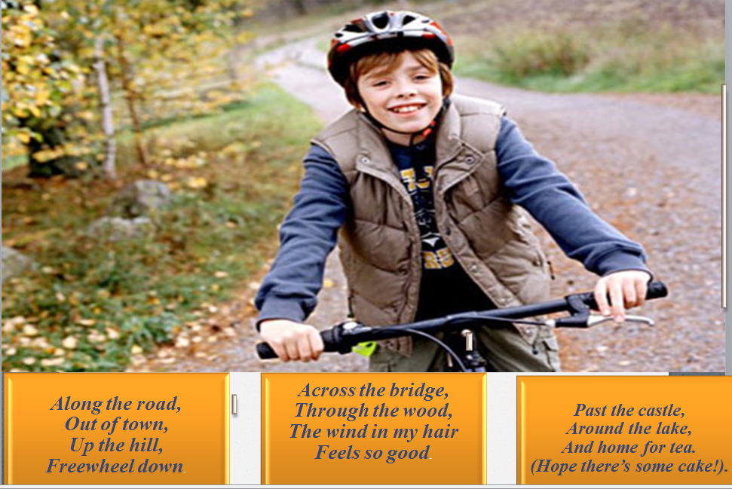

Додаток 2
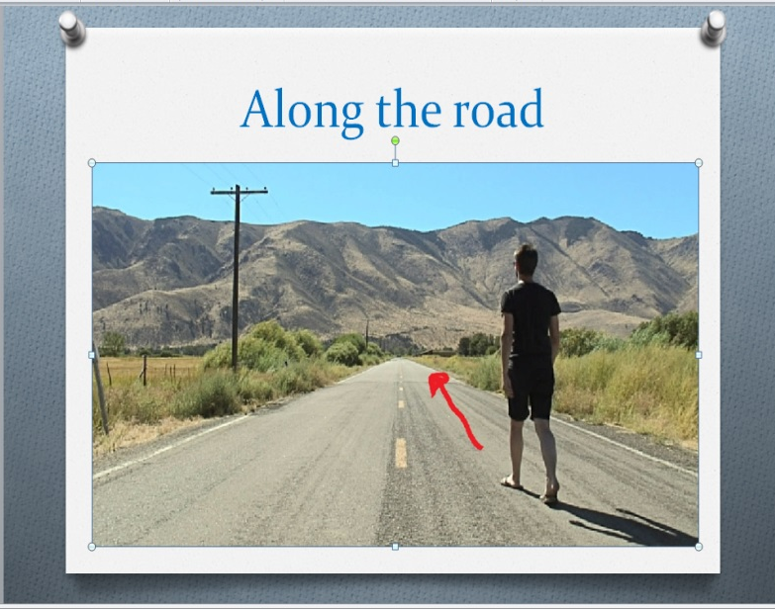
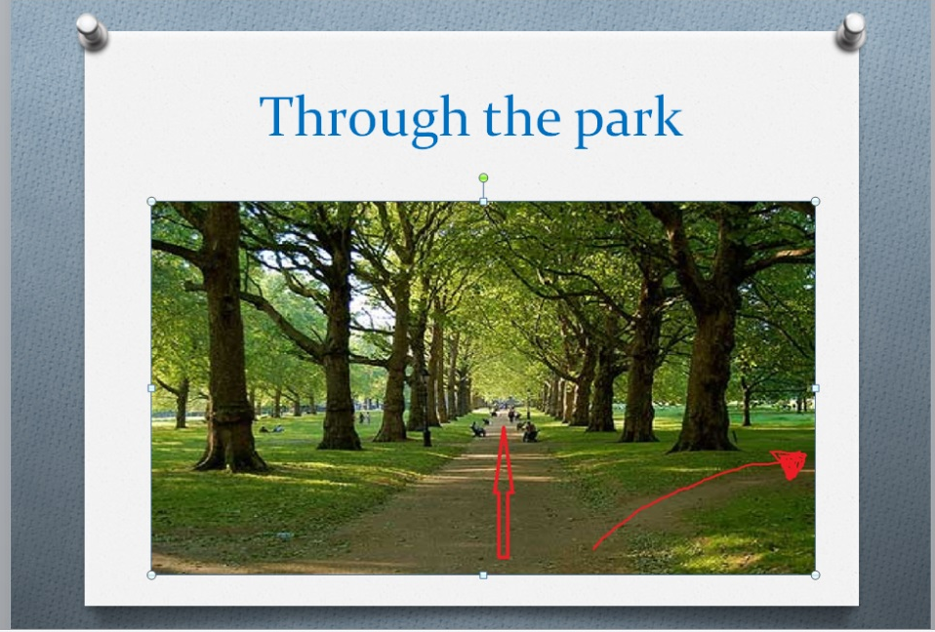
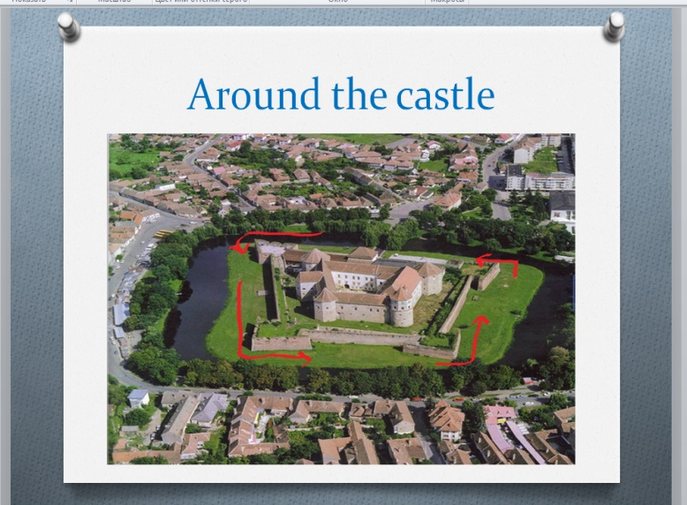
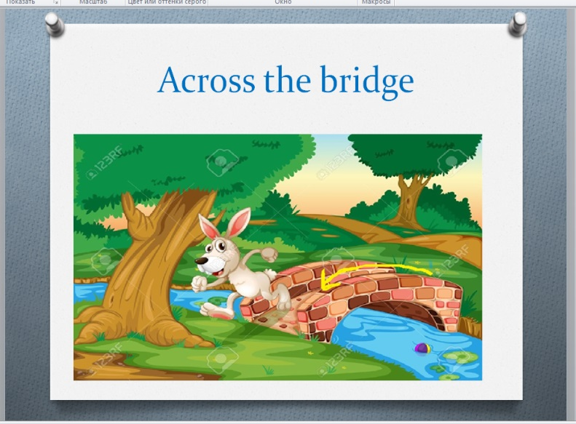
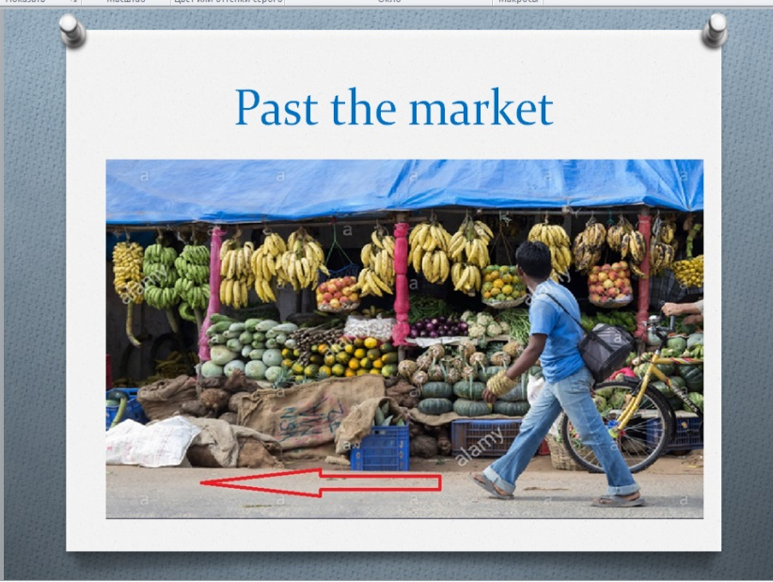

Додаток 3
І. Read, choose and write
- We walked_________ the hill and had a picnic at the top.
a down b up c along

- We went ________ the museum but we didn’t go inside.
a into b through c past

- They walked _________ the park. It was very nice.
a on b through c in front of

- She went _________ the café and bought an ice cream.
A up b into c down
- Be careful when you walk_________ the road.
a across b through c around
6. They ran ________ the tree.
a around b into c along
7. He drove __________ the tunnel.
a up b across c through
8. She walked _________ the river.
a through b along c under
9. I always look for cars before I walk_________ the street.
a across b around c past
10. They stopped talking when the teacher came______ the room.
a up b into c down
11. We go _______ the sweet shop every morning but never go in.
a past b across c under

ІІ. Translate the phrases :
Tom and Maria walk to school every day. Tom leaves his house and walks ( вздовж дороги)___________. He goes ( повз залізничну станцію)___________________ and ( через міст)____________. He goes (через парк)_________ and then he is at school.
Maria leaves her house and she walks ( через дорогу)__________. She goes ( повз супермаркет)___________ and ( вздовж річки)__________. She goes ( навколо замку)___________ and then she is at school.
Додаток 4
https://www.youtube.com/watch?v=6XyRIpP1Qkw

Додаток 5
Read the text. Choose the right prepositions of movement
Ben’s night adventure
At ten o’clock last night I was in bed. I heard a noise outside and I was very scared. I got up and opened my bedroom door. I walked past / up my mum and dad’s room and then I went slowly through / down the stairs to the hall. I quietly walked around / along the kitchen. I opened the kitchen door and I looked around / along the room. Just then, my cat jumped across / through the kitchen window. I laughed happily and I went up / down the stairs to bed again.
Додаток 6


