Авторська розробка уроку
На тему: «Free Time»
В 3 класі
За підручником Fly High 3
By Jeanne Perret and Charlotte Corill
(Pearson Longman)

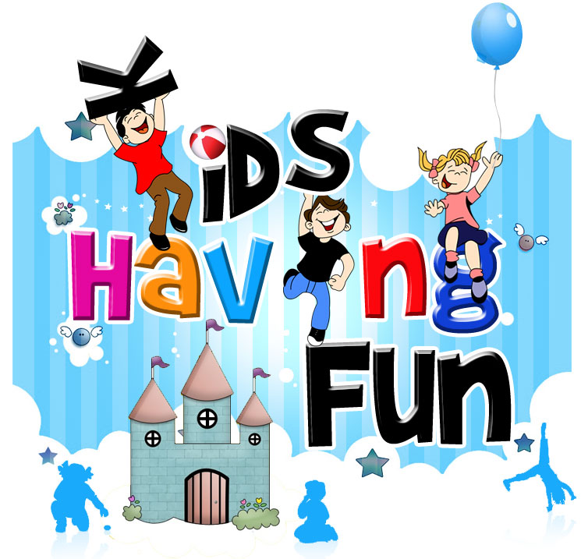
Вчитель вищої категорії
Панчук М.М
Theme: Free Time
Objectives:
1) to develop communicative approach in speaking.
2) to exercise all kinds of language skills.
3) to practice the construction you can…
4) to expand students outlook & enrich their knowledge through collaborative work.
5) to encourage students creative skills.
6) to develop memory, imagination, logical thinking.

Equipment: a CD player, Class CD, multimedia-projector, student`s projects, Fly high 3 SB, flashcards.
Procedure
slide 1
1) Greeting

T: Good morning, children!
Ps: Good morning, good Morning,
Good morning to you!
Good morning, good morning
I am glad to see you!

T: How Are You Today?
Ps: We Are Fine, Thank You.

T: So, let`s work hard & remember our motto:
Ps: Good, bettеr, best,
Never rest
Till good be better
And better best.

2) Aim: Look at the pictures. What is the theme of our lesson?
( Free time)

3) Warm up:
Right you are. And what do you like to do in your free time? Let`s recite the poem.

What do you like?
I like many things.
Which do you like best?
Try to guess!
You like birthdays, celebrations, holidays & rest.
Right! And what about you?
Just the same I guess.

4) Vocabulary.
a) Words connected with free time.
T:There is an English proverb «All work and no play makes Jack a dull boy». It means that people should have fun after hard work or they become both bored & boring. There are a lot of places to go & have fun.
Look at the blackboard & match the words with the pictures.
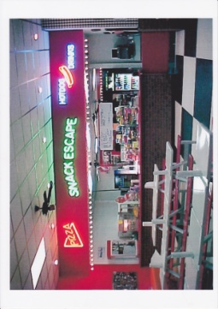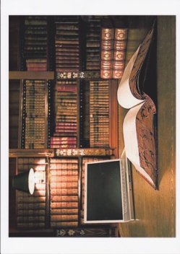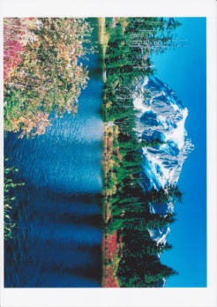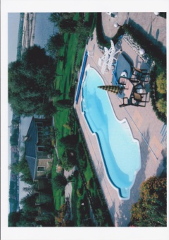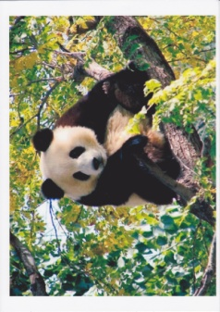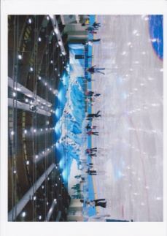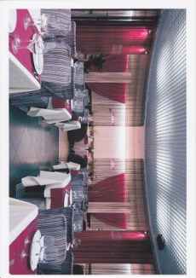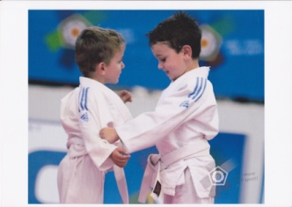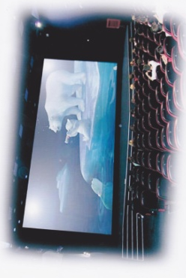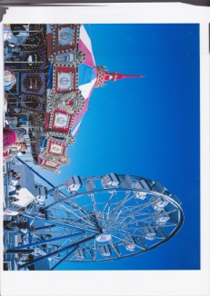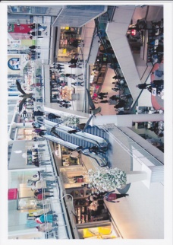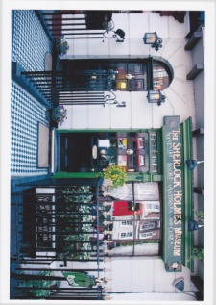

Library Ice rink Zoo
Cinema Skateboard park
Shopping mall Sports centre
Swimming pool Restaurant
Amusement park Mountains
Museum Snack bar

b) Quick filler. Riddle. Now you can see there`s one more picture here. Try to guess what it is
slide 2
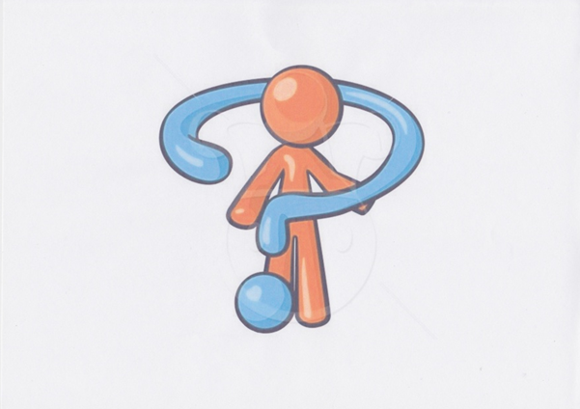

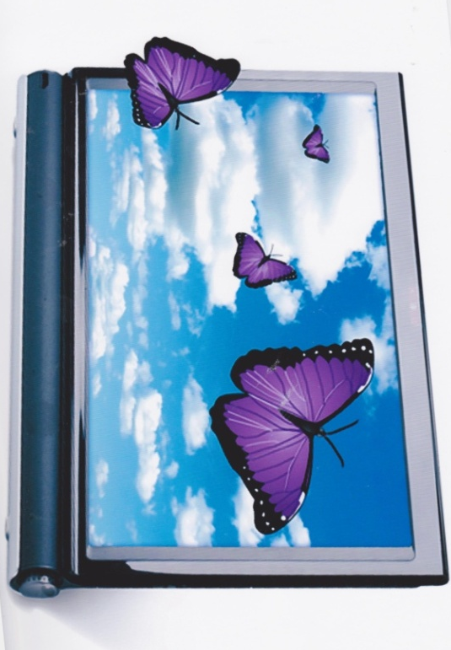
I can`t sing but you can listen to music on me. Slide 3
I can`t take photos but you can look at photos on me.
I can`t watch films but you can watch DVDs on me. I can`t write but you can write e-mails on me.What Am I? (A Computer) T: Right. It`s a computer. Do you like playing computer games?

C) The odd words out.
What Are The Odd Words Out?
A) Ice Rink B) Sports Centre C) Computer D) Skateboard Park
A) Museum B) Cinema C) Amusement Park D) Shopping Mall
A) Café B) Restaurant C) Mountains D) Snack Bar
A) Swim B) Do Homework C) Play Football D) Rollerblade
A) Read Books B) Watch TV C) Ski D) Play Computer Games
A) a book B)a bike C)skis D) A skateboard

5. Listening.
Listen To Three Dialogues. Where Are The People?
Tapescript
One
A: It's beautiful.
B: Yes, it's got fantastic eyes.
A: And really strong legs.
B: Yes, I wouldn't like to meet that in the jungle.
A: No way.
B: Hey, it's nearly five o'clock. The dolphin show starts at half past.
A: Okay, let's go.
Two
A: So what do you want to see?
B: I don't know.
A: What about Screen 3?
B: No .. . I don't like Orlando Bloom.
A: Oh, I think he's lovely. What about Screen 6?
B: Dracula? No, I don't like horror films ... Maybe a comedy?
A: Screen 4 ... Eddie Murphy. He's funny.
B: No, I hate Eddie Murphy ... maybe we ...
Three
A: Come on.
B: No, I can 't do this.
A: Yes, you can. Here, hold my hand.
B: It's okay for you, you go to classes.
A: Come on. Okay?
B: Well, yeah, yeah, it's quite easy really…. ah!
A: Are you okay?
B: Yeah, I'm okay. Wow, this ice is cold. Can we stop for a moment?
Answers: 1 zoo 2 cinema 3 ice rink.
6. Speaking. Pair work.
T: You see there are a lot of places to go and things to do in your free time.
Listen to your friends, choose places for the situations & give each other advice.
Example. T: I like shopping! Where should I go? Ps: Go to the supermarket.

P1: I love reading. - P2: Go to the library.
P3: I`m into films. - P4: Go to the cinema.
P5: I like paintings & statues - P6: Go to the museum.
P7: I love swimming - P8: Go to the swimming pool.
P9: I`m bored. - P10: Go to the amusement park.
P11: I like skating - P12: Go to the ice rink.
P13: I`m into skateboarding - P1: Go to the skateboard park.
P2: I like rock climbing - P3: Go to the mountains.
P4: It`s my mother`s birthday. - P5: Go to the restaurant.
P6: I`m into sport & exercise - P7: Go to the sports centre.
P8: I need some food for a picnic. - P9: Go to the shopping mall.
P10: I`m hungry - P11: Go to the snack bar.
P12: I like animals - P13: Go to the zoo.

7. Relaxing pause
slide 4
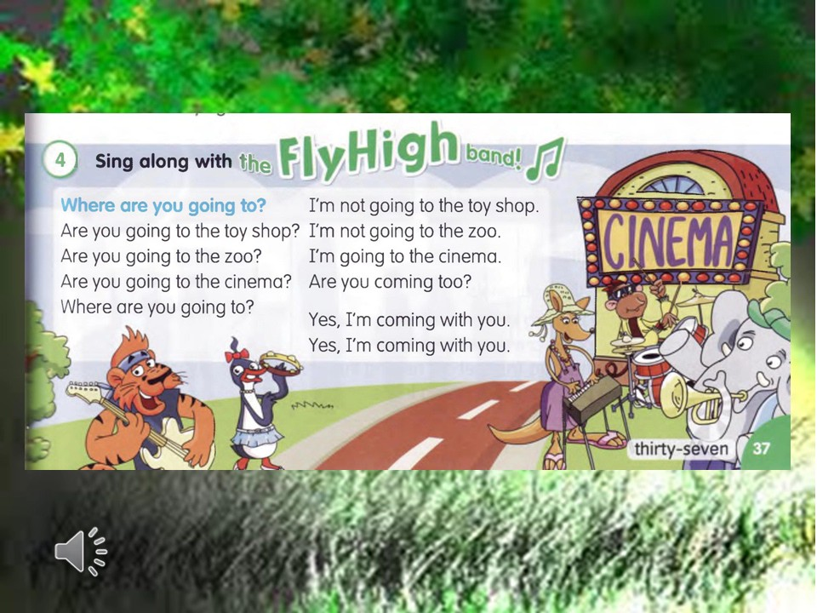

8. Reading « A Weekend in Britain». People spend their free time in different ways. Now let`s learn what people in Britain do at weekends. Text p98 Slide 5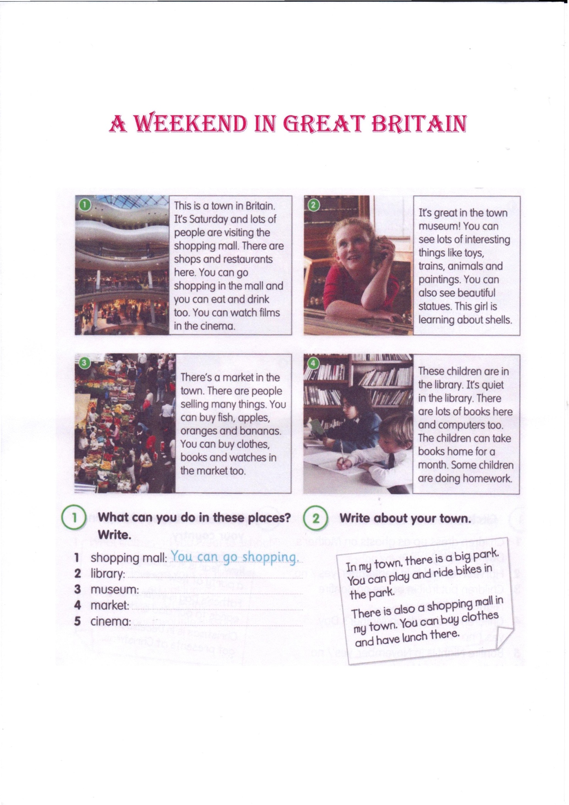

Pre-reading activity:
Look at the pictures & say what you can see in each one?
While-reading activity:
Listen and read the text.
Post-reading activity:
Answer the questions.
What are people doing on Saturday?
Where can you watch films?
What can you see in the museum?
What are beautiful?
Name three things you can buy at the market.
Where is it quiet?
What is in the library?
9. Writing.
What can you do in these places? Write.
1 shopping mall: You can go shopping
2 library:
3 museum:
4 market:
5 cinema:

10. Presentation of the students` projects.
Pupil 1 : My name is Dasha.
I love winter sports. I like tobogganing.
I`m very good at it.
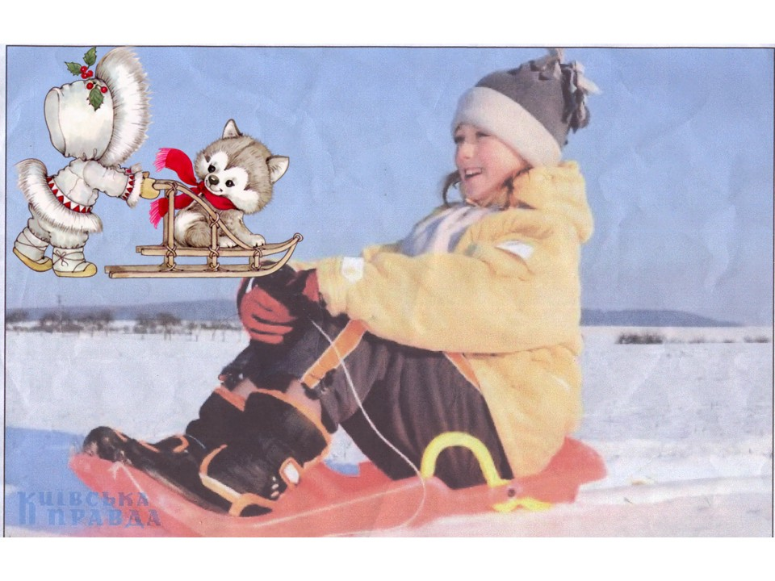
slide 6
Pupil 2: My name is Masha. I like travelling and visiting museums.
I learn lots of new things. I can see many interesting toys, animals, paintings and statues. It`s great.
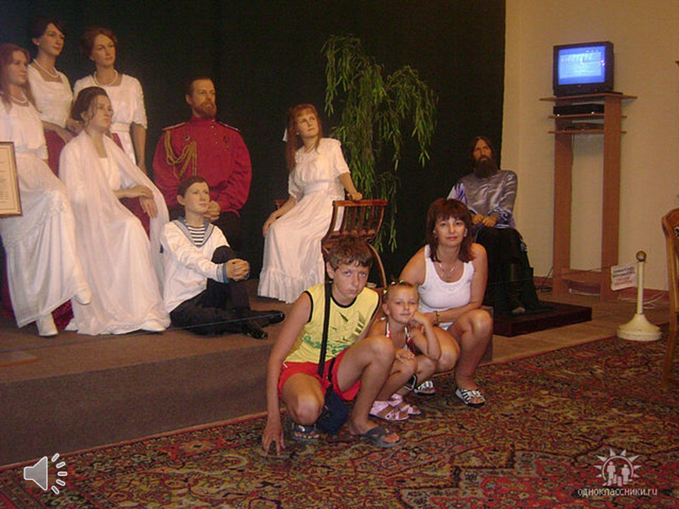
slide 7

Pupil 3: My name is Valeria.
I love ice skating and skiing.
I sometimes go to the ice rink on Saturday.
In winter I go to the village and ski with my friends.
I`m very good at skating and skiing. It`s good fun.
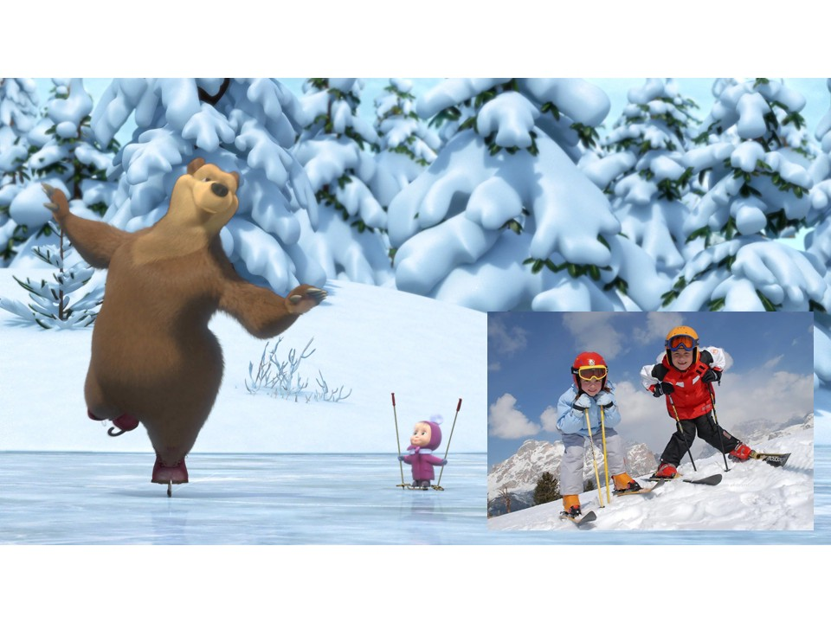
slide 8

Pupil 4: My name is Vlad. I like riding a bike, skateboarding and rollerblading. It`s fun. Summer is the time to play.
I`m fond of playing computer games. It`s cool.

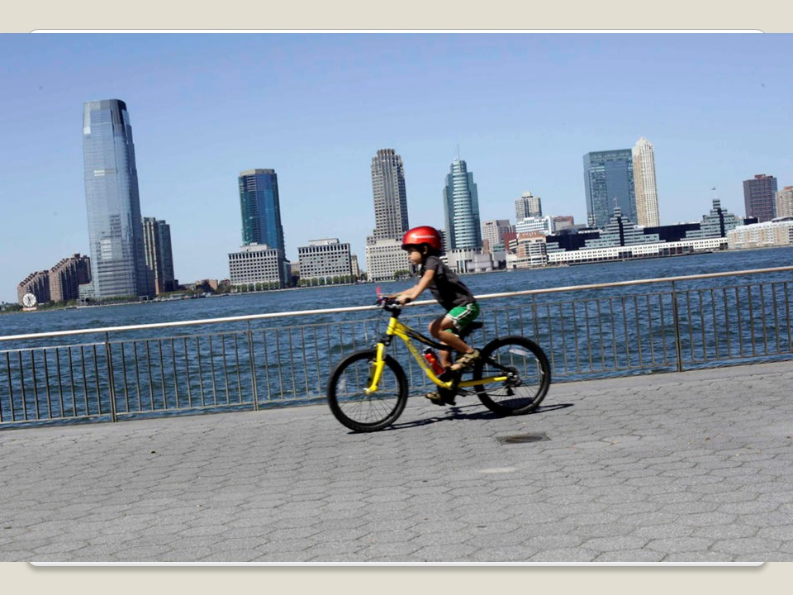
slide 9
Pupil 5: My name is Angelina. I`m fond of swimming. In summer I go to the cinema with my mum. We go to the beach and to the mountains. It`s good to get lots of fresh air.
slide 10
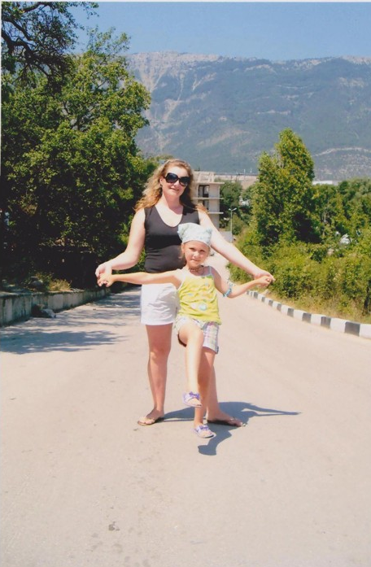

Pupil 6: My name is Dasha. I`m into skiing. I`m happy then I`m doing it. In summer my family likes having a picnic. We go to the park, take lots of food and then play games.
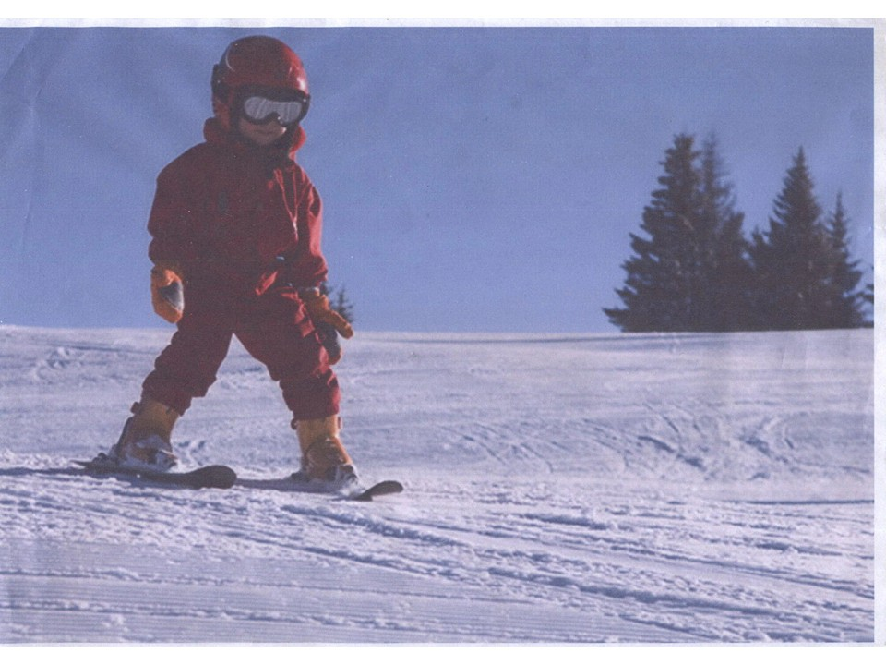
slide 11

Pupil 7: My name is Maksym. I like cycling and fishing. At the weekend my dad and I go to the river & fish.
In summer we go to the mountains. I like climbing too.
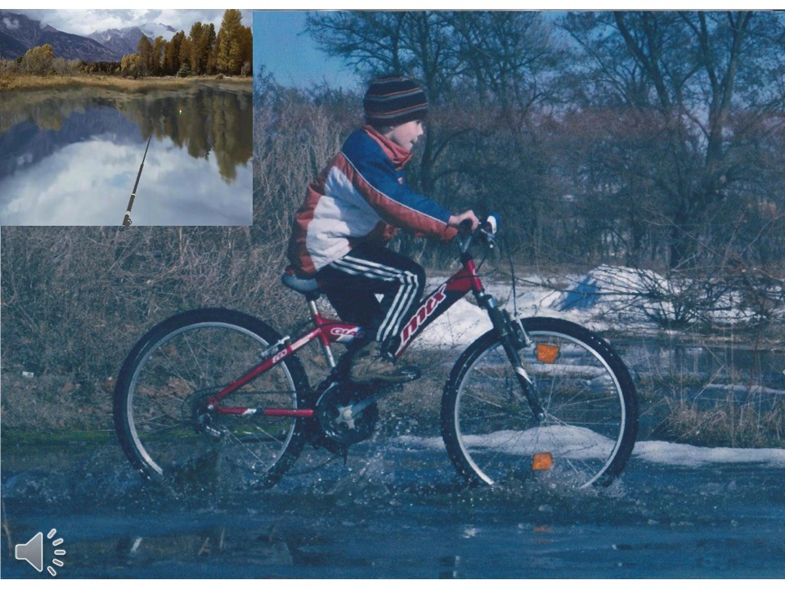
slide 12

11. Group work. Reading and Writing
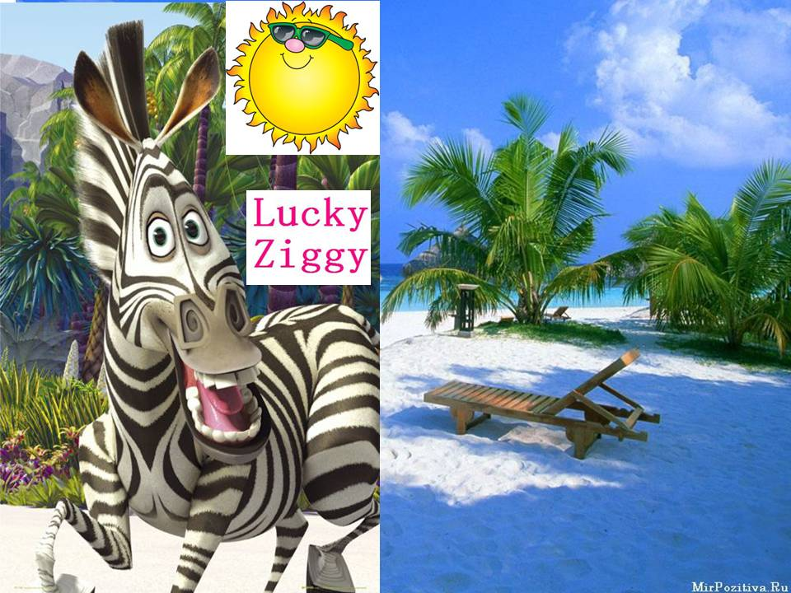
slide 13
T:Who is this?
Where is Ziggy now?
Ziggy wanted to ring us but he dropped his mobile phone into the Black Sea. So he sent us a message in the bottle.
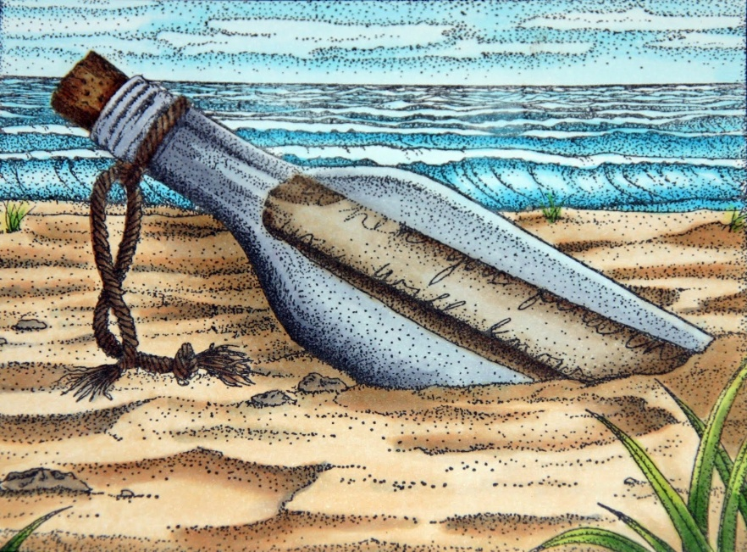
slide 14
Some words are not clear because sea water spoilt them. Try to read the message and fill in the missing information.
Work in groups, then read the message.
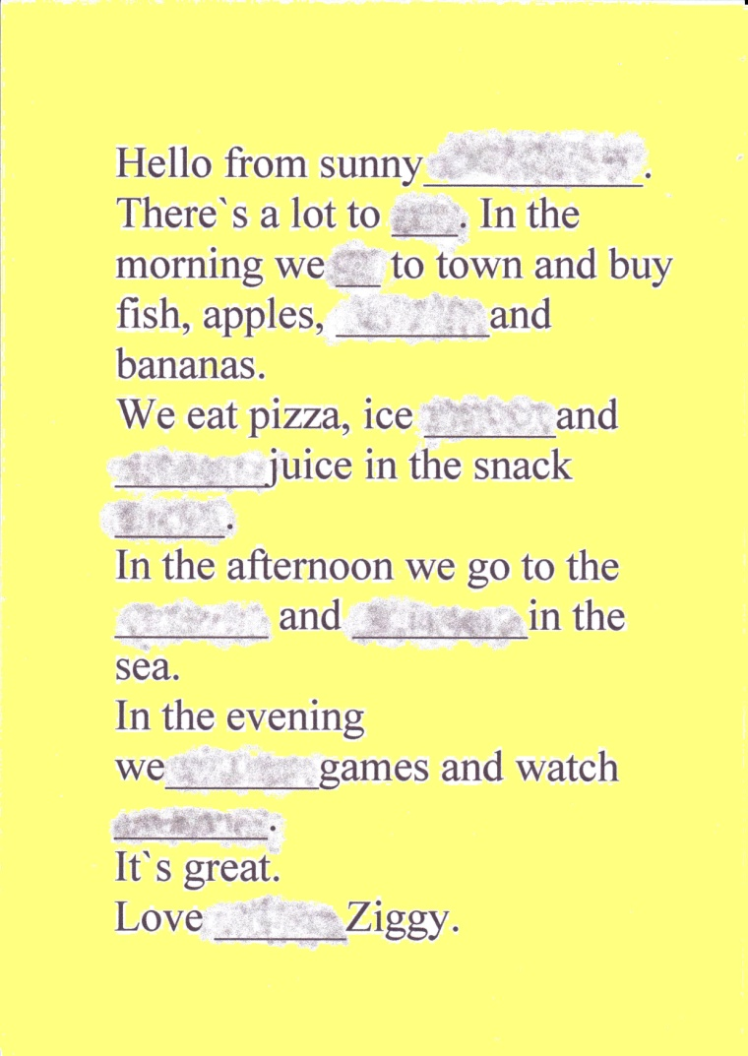
slide 15
T: Is Ziggy lucky?
12. Song «Lucky Ziggy».
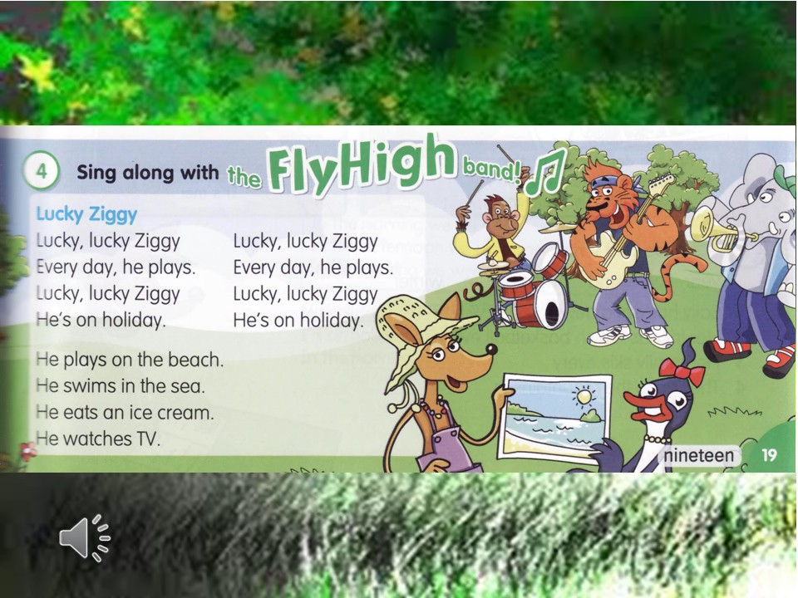
slide 16

13.Homework: Ex. 2 p 98.
14. Summing-up:
I`m pleased with your work. You are active, hard-working and bright. Your marks are…
Our friend Ziggy is lucky , because he is on holiday , and you are lucky too, because you weekend starts today. Goodbye, children. Have a nice weekend!
Slide 17


