МІНІСТЕРСТВО ОСВІТИ ТА НАУКИ УКРАЇНИ
УПРАВЛІННЯ ЧЕРНІГІВСЬКОЇ МІСЬКОЇ РАДИ
НАУКОВО-МЕТОДИЧНИЙ ЦЕНТР

План-конспект уроку
в 4 класах з теми:
«Що ти знаєш про лелек?»

Підготувала:
вчитель англійської першої категорії
Замерлова А. В.

Чернігівський ліцей № 22
2017
Date:
Teacher: Zamerlova A. V.
Form: 4
Theme: What do you know about storks?
Aim: to teach children to tell what stork is and to give general information about them
Objectives:
- To present and practice new vocabulary
- To develop listening, reading and speaking skills
- To practice using to be and to have got in context
Outcome: students can tell what stork is and give general information about them
Equipment:
- Multimedia board
- Power Point presentation
- Demonstrative materials and handouts
- Video materials
https://www.youtube.com/watch?v=B85CcbPsQsU
https://www.youtube.com/watch?v=8BMp9HykJqk

Дата:
Вчитель: Замерлова А. В.
Клас: 4
Тема: Що ти знаєш про лелек?
Мета:
- Ознайомити, тренувати та практикувати ЛО у мовленні та при читанні;
- Тренувати та практикувати вживання дієслів to be та to have got у мовленнєвих ситуаціях;
- Практикувати учнів у читанні та усному мовленні (висловлювання на рівні фрази та речення);
- Розвивати навички аудіювання;
- Розвивати світогляд учнів;
- Виховувати пізнавальний інтерес та бережне ставлення до птахів і природи.
Очікувані результати: учні можуть сказати, що таке лелека та дати загальну інформацію про лелек.
Обладнання:
    - Мультимедійна дошка
    - Презентація у Power Point
    - Демонстраційний та роздатковий матеріал
    - відеоматеріал:
https://www.youtube.com/watch?v=B85CcbPsQsU
https://www.youtube.com/watch?v=8BMp9HykJqk

What do you know about storks?
- Warming up
- – Good afternoon dear children
- I’m glad to see you
- Are you fine?
- Let’s start our lesson
- Look, (Fly High 4)
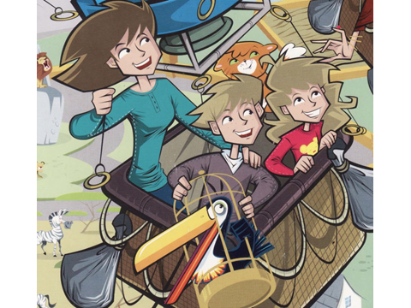
- Who are they?
- Who is Sophie Wild for children?
- Who’s Jack for Aunt Sophie?
- Who’s Kelly for her?
- What is Dr. Wild? (What’s her job?)
- What does she do?
- Who is missing from the zoo?
Read about Toto
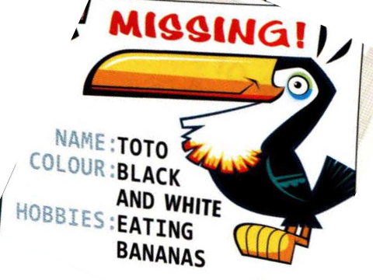What does Toto look like?
- Toto has got a cousin in Ukraine. And it’s also missing.
Look, what bird is this?
Read the theme: What do you know about storks?
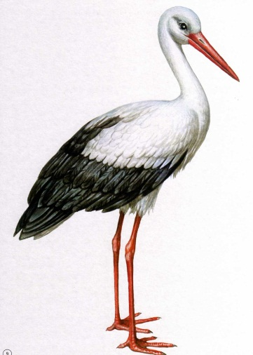
- Main part
- Phonetic:
- Look and repeat
- Read the sound: [o:]
- Read the tongue-twister:
A stork can walk but it can’t talk.
(all together, only girls, only boys)
- Vocabulary:
- Look and repeat
- Is it a_____?
- What’s this?
- Guess (I show quickly)
- Read the words
Stork [sto:k] лелека
Feathers [feðəs] пір’я
Wings [wiŋs] крила
Legs – ноги
Beak [bi:k] клюв
Up to – до
In pairs [peəs] в парах
Nest – гніздечко
Bring [briŋ] приносити

- Story:
- Read the story and say: “What are the storks?”
Storks are large birds. They’ve got white and black feathers. The storks have got big wings, long red legs and long red beak. They live up to 10 years. The storks live in pairs. They’ve got big nests on the houses. Their favourite food is frogs, snakes, fish and small birds. The storks can fly and walk. People say that storks bring happiness to the families.

4. Work in pairs. Read and match:
1. large d) birds
2. white and black a) feathers
3. big g) wings
4. long red f) legs and beaks
5. live up b) to 10
6. live in e) pairs
7. nests h) on the houses
8. favourite c) food
9. can j) fly and walk
10. bring i) happiness
- Let’s check

Let’s have a rest with song “ We’ve got the whole world in our hands”
https://www.youtube.com/watch?v=8BMp9HykJqk

5. Work in pairs. Write a missing card about stork.
- What is its name?
- What colour is it?
- Where is it from?
- What are its hobbies?
Ask and answer
- Watch the video:
“Stork”
https://www.youtube.com/watch?v=B85CcbPsQsU

7. Answer the questions:
1. What bird is it?
2. Are storks small or large birds?
3. What feathers have they got?
4. What do they look like?
5. How long do they live?
6. Who do they live with?
7. Where do they have nests?
8. What is their favourite food?
9. What can they do?
10. What do people say about storks?

8. Look at the pictures and tell about storks
(Children’s sayings)

- Summing up
- Read the quote
Quote:
Can a sparrow know how a stork feels?
- What does it mean? (We don’t know what other people feel and we should be kind to each other)

