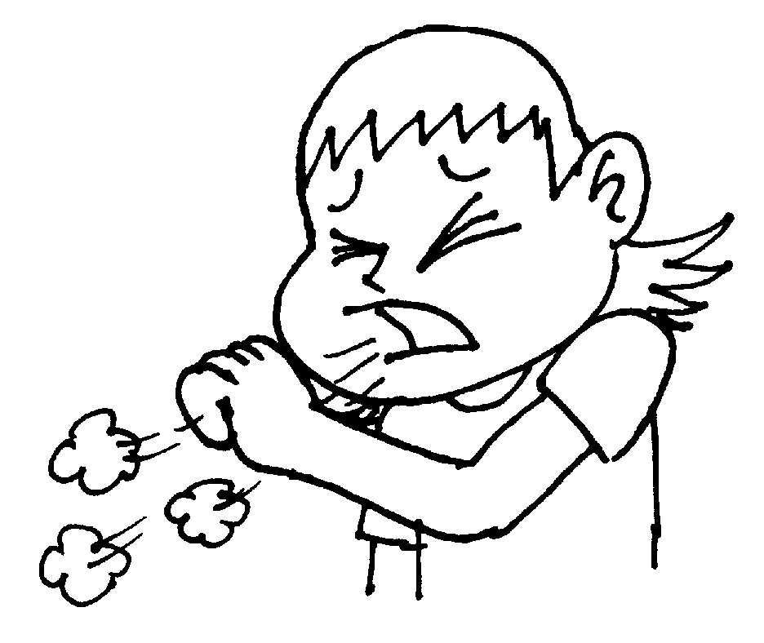
Lesson Topic: At the Doctor’s
Unit Title [Welcome 2]: I’ve got a sore throat!
Grammar Subject: modal verb should / shouldn’t
Objectives: to revise vocabulary through brainstorming and games; to activate knowledge in the topic; to develop listening skills; to practise grammar; to develop speaking skills; to develop collaborative work skills; to develop pupils’ ability to explain their health problems to a doctor or to give the right piece of advice to an ill friend.
Lesson Equipment: cards ‘At Hospital...’ Ranok, copies ‘I’m too ill’, laptop and the Internet, pieces of paper, plates, some medical instruments from a toy set.
The Procedure of the Lesson
1. Preliminaries. Greeting
T: Good afternoon, dear children!
P_{s}: Good afternoon, our teacher!
T: I’m glad to see you!
P_{s}: We are glad to see you, too!
T: Sit down, please.
T: Today we are going to continue our topic ‘I’ve got a sore throat!’
Imagine that you are in Great Britain. You have got problems with your health and you will be able to explain your illness. Or a friend of yours is ill and you can give the right piece of advice.
I believe that at the end of the lesson you will be able to do this.
2. Lexical Warming-Up
• Brainstorming
T: First let’s revise all illnesses and symptoms that you know and can tell the doctor
P_{s}: sore throat, cough, headache, toothache, stomachache, cold, temperature, hurt, sneeze, runny nose, flu, bump, bruise, cut, fracture, earache, backache, heart pain.
• Poor Teddy
T: Not only people can be ill, but animals too. Tell me please who helps people when they are ill?
P_{s}: A doctor.
T: And who helps animals?
P_{s}: A vet.
T: Who wants to be a doctor? ... And a vet? ...
Now imagine that you are vets. Tell me what Teddy has got and why. (Cards with ill Teddy) [attached pictures as examples]
T: What has Teddy got?
P₁: He’s got a headache.
T: Why?
P₁: Because he’s ill.
Illness / Symptom | Approximate Reason
sore throat  cough  earache  backache  stomach (tummy) ache  toothache  heart pain  runny nose  cut  bruise  bump | … he eats too much ice cream.  … he doesn’t wear warm clothes in winter.  … it’s cold and windy outside.  … he does too many exercises.  … he eats a lot of mushrooms.  … he likes eating sweets.  … he is in love.  … it’s cold and raining outside.  … he cooks.  … he likes fighting.  … he climbs the tree.

T: I think you can become good vets.
3. Practice
• Matching
T: Now can you match the illnesses that you know to the pictures? Take your xerocopies and do the first exercise. [attached copy ‘I’m too ill’]
Pupils do the task
T: Let’s check.

• Listening
T: There’s a boy who lives far away. And he is ill. Now you will watch/listen to the story about this boy and his father who wanted to help him. Which of the symptoms from Exercise 1 are mentioned in the video? [http://learnenglishkids.britishcouncil.org/en/short-stories/im-too-ill]
Pupils do the task. Checking.
T: Let’s watch/listen to the story one more time and do the second task. But first, look through the exercise. [attached copy ‘I’m too ill’]
T: Now watch/listen to the story and fill in the gaps.
Pupils do the task. Checking.
• True / False
T: I’ve watched/listened to the story but I didn’t catch some information. Can you help me? Listen to the statements I read you and say whether they are true or false. If a sentence is false, correct it.
F 1) Siriwat’s Dad is ill. (Siriwat)
T 2) Siriwat said ‘Ouch, it hurts. I’m too ill to drink.’
F 3) Siriwat had a toothache. (sore throat)
T 4) Dad said ‘Here is some medicine.’
T 5) Next morning he had a headache.
F 6) By mid-day Siriwat had a backache. (tummy ache)
T 7) By evening he had earache.
F 8) Dad said ‘I’m calling your mother.’ (the doctor)
T 9) The doctor said ‘High temperature.’
F 10) The next day Siriwat said ‘I feel much worse now.’ (better)
• Matching
T: Let’s help Siriwat and give some advice. So, do the third exercise. Match the illnesses to the pieces of advice. [attached copy ‘I’m too ill’]
Pupils do the task. Checking.
4. Break
• Game ‘Young Doctors’
T: Imagine that some of you are ill and others are doctors.
T divides the class in two teams.
Step 1. Each pupil from A-team writes an illness on a piece of paper.
Each pupil from B-team writes a piece of advice.
T: Then you must fold your pieces of paper and put on your plate.
Step 2. Now change the plates. A pupil from B-team takes and reads an illness and a pupil from A-team takes and reads a piece of advice. If it is correct you say ‘Right’, if not you say ‘Wrong’ and give your advice.
P_{B}: I’ve got a sore throat.
P_{A}: You shouldn’t eat too many sweets.
P_{s}: Wrong! You should take some medicine.
5. Speaking
• At the Doctor’s
T: Now you can show us what you know: how to give advice or tell your problems to a doctor.
P₁: Good morning!
P₂: Good morning, Dr White!
P₁: What’s the matter?
P₂: I feel terrible. I’ve got a cold.
P₁: You should take some medicine. You should stay in bed. You should eat some soup.
P₂: Thank you, Doctor. Good-bye!
P₁: Good-bye!
6. Summing-Up. Homework
T: Well, dear children, I can see that you know a lot. Please, put your hand up who can give advice to an ill friend or a relative now. And put your hand up who can explain the illness to a doctor.
H/t: 1) Pb [Welcome 2] ex.7, p.61

Ill Teddy Pictures


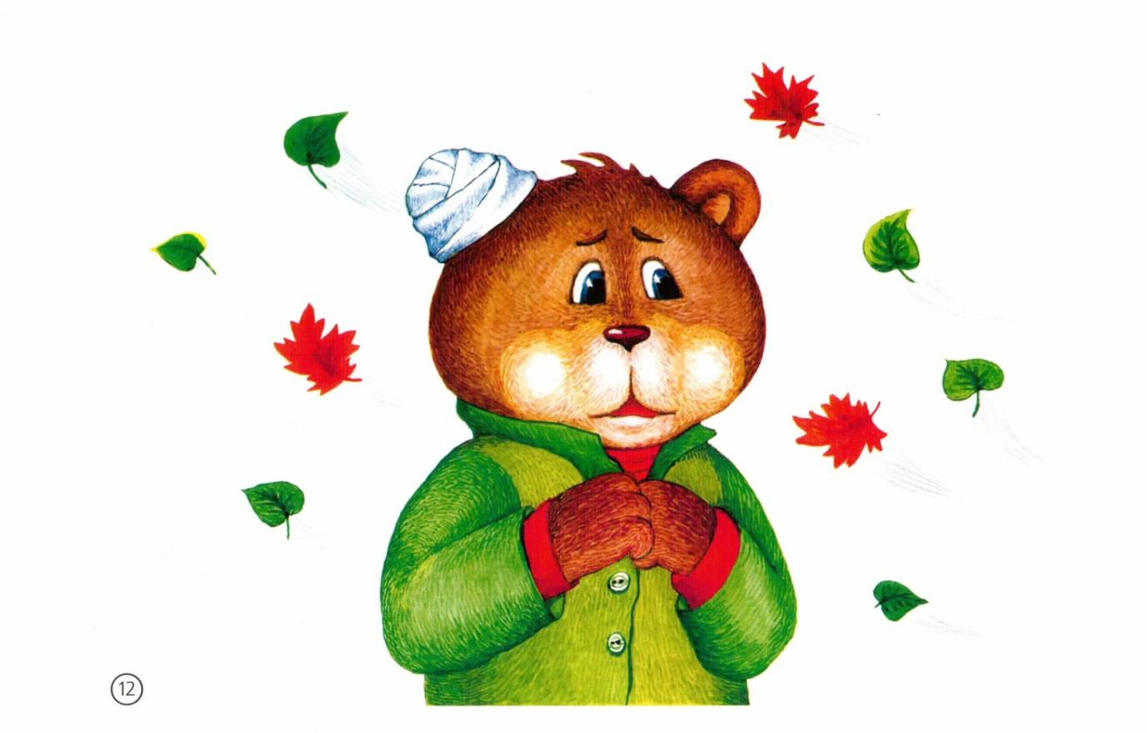

I’m too ill!
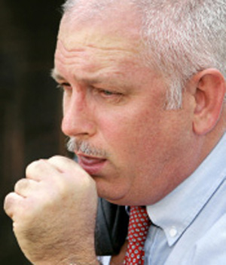

1. Match them up !

Backache

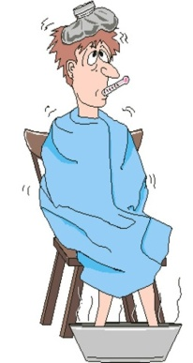
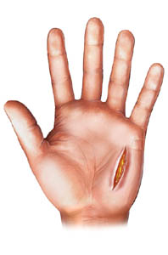
Bruise

Bump

Cough


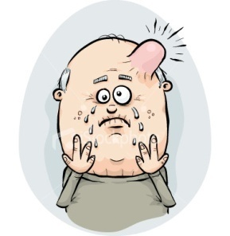
Cut

Earache

Flu


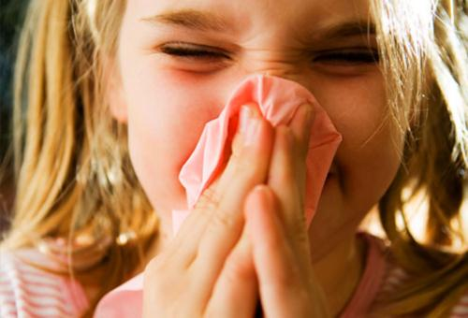
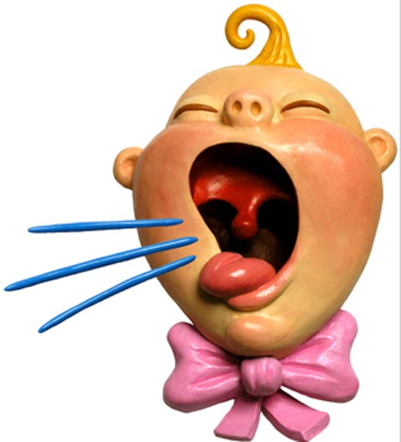
Fracture

Headache


Runny nose
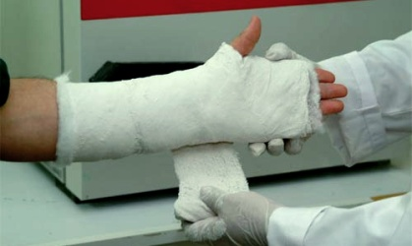
Sneeze

Sore throat


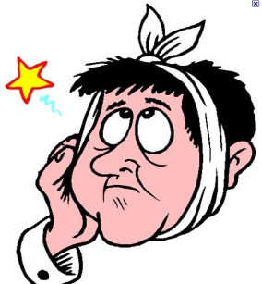
Stomachache/Tummy ache

Toothache

2. Fill it in ! Write the missing words in the sentences
better, doctor, earache, headache, high temperature, hurts, ill, medicine, sleep, sore throat, tummy ache

1
2
3
4
5
6
7
8
9
10
11
3. Match them up ! What should you do ? Match the illness to the advice !

Tapescript for Listening

