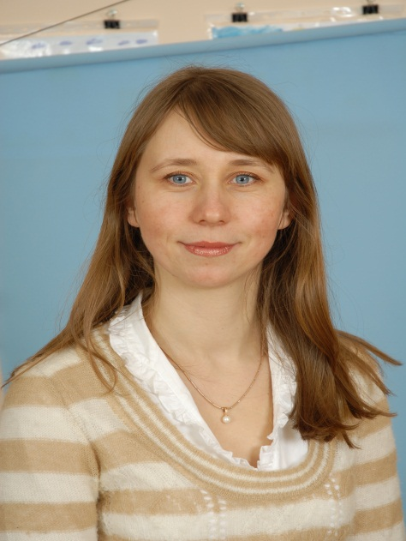
Урок з використанням мультимедійної дошки у 4 класі Suggested level –A1+ FAMOUS ARTISTS Objectives:-to get acquaintance with famous artists and the topic related- vocabulary;
-to broaden pupils’ knowledge about art;
-to develop pupils’ skills in reading, listening and speaking;
-to bring up interest in learning English through art.
Teacher :Voziian Olga Volodymyrivna
Equipment: portraits of famous artists, a tape recorder, vocabulary cards, cards with letters and sounds, textbook “Excellent-3”, a smart board.
PROCEDURE
I.INTRODUCTION
T: Good morning, pupils. Nice to meet you. Today we are going to learn many interesting facts about art and famous artists. So the topic of our today’s lesson is “Famous artists”. Let’s revise the words to our topic and get acquainted with artists and their paintings.
II.MAIN PART
- TEACHING VOCABULARY
T: Let’s play a game “The best listener”
(Teacher shows the words on the cards and reads them; pupils listen to and repeat. Then each pupil tries to name all the words)
New vocabulary: art, artist, paint, painting, picture, colourful, the biggest, the oldest, the newest, the smallest, was born, die, sky, cloud.
T: Well, look at the board. There are three pictures on it: the baby, the adult next to the place, the old person. Each of them has a name and a year over the top. Read the sentences: Kate was born in 1997. Tom lived in London in 1993. John died in 1995. Now you are going to write your own sentences in your copy-books.
- LISTENING
T: Look at the paintings and say the dates: 2001,1690,1890,1950.
T: Listen and point to the paintings in your books.

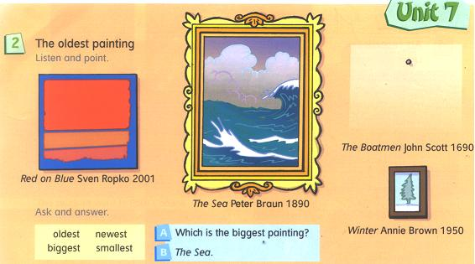

After listening
T: Work in pairs and practice asking and answering questions.
Examples of pupils’ dialogues
P1: Which is the newest painting?
P2: Red on Blue.
P1: Which is the smallest painting?
P2: Winter.
- WRITING
T: Look at the tables on the board and fill in the gaps (degrees of comparisons of adjectives).
Small
New
Great
Clever

Noisy
Scary
Happy
Funny

Fat
Hot
Thin
Big

Good
Bad
Little
Far
4. RELAXATION
The Hockey-Pockey
You put your right foot in
You put your right foot out
You put your right foot in and
You shake it all about.
You do the hockey-pockey
And you turn yourself around
And that’s what it all about
Left foot
Right hand
Left hand

- READING
T: Before reading the text look at the paintings and answer the questions:
-Do you know these paintings?
-Do you know the artists, the people who painted them?
-Which painting do you like best?
T: Look at the board. There are portraits of famous artists with each artist’s name, the dates and the place where each artist lived. Now listen then read.
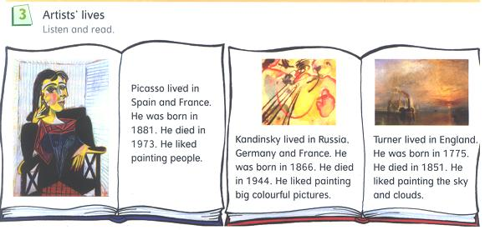
- SPEAKING
T: Make up your own dialogues. Work in pairs.
Examples of pupils’ dialogues
Dialogue 1 Dialogue2
P1: When was Picasso born? P1: When was Kandinsky born?
P2: In 1881. P2: In 1866.
P1: When did he die? P1: When did he die?
P2: In 1973. P2: In 1944.
P1: Where did he live? P1: Where did he live?
P2: In Spain and France. P2: In Russia, Germany and France.
P1: What did he like painting? P1: What did he like painting?
P2: People. P2: Big colourful pictures.
III.SUMMING-UP
T: We have learnt a lot of interesting facts about famous artists and their paintings. Thank you children. I like your work. You were brilliant and worked hard. Your marks are… I’d like you to look for more information about art and artists.

