Natalia Kompanichenko, a teacher of English, Muzykivka lyceum Bilozerka district Kherson region

Suggested level - Beginner

FOOD
Objectives: by the end of the lesson students will be able to:
- revise and practice vocabulary on the topic «FOOD»;
- enrich their vocabulary on the given topic;
- revise grammar material;
- teach to use the gained knowledge and information in speech;
- develop skills in listening, reading, speaking and writing;
- develop communicative skills;
- foster their creative skills.
The equipment of the lesson: Pupil’s book Fly High 3, Activity book Fly High 3, a laptop, worksheets, a blackboard, posters, handouts.

Procedure
І Introductions
1. Greetings
Т: Good morning, dear pupils! I’m glad to see you! I hope you are fine! Let’s begin our lesson. Today we speak about food. By the end of the lesson you'll be able to tell about your favourite food. Let’s start our lesson!

II. Main part
1. Phonetic drill
T: Our first task is «Phonetic drill for breakfast». Listen to me and say after me:
[æ] cabbage, apple, sandwich, jam
[ı] fish, chips, biscuit
[e] bread, egg, lemon
[i:] tea, meat, beans, meal
[aı] rice, ice cream, pie.

- Warming-up
Ok. We have already warmed up our tongues, let’s warm up our brains. You’ve got 12 letters. Haw many words can make from these letters?

b | e | a | d | r | t | f | s | i | h | c | m
Key: tea, bread, fish, meat, rice.

- Checking homework.
T: OK. Your task was to read the text «Food in Britain», exercise 1, page 99. Open your books, read the sentences and answer my questions.
- What do people in Britain like to eat?
- What have they got for breakfast (Sunday lunch)?
- Do they like eating cereal for breakfast or lunch?

- Development of grammar skills.
T: Thank you. It’s time for our next task. Revise a grammar rule (countable uncountable nouns). Look at the screen.
1. Here you will see a list of words. Write the words in the correct box and explain your answers, please:
potatoes, eggs, sausages, nuts, fish, sweets, onions, lemons, oranges, carrots, mushrooms, tomatoes, apples, bananas, cucumbers, pasta, spaghetti, bread, milk, yoghurt, cheese, meat, cereal, fruit, rice, butter, chocolate, oil, honey, peaches.

Countable nouns | Uncountable nouns
There are some …… | There is some …….

2) Fill in How much or How many:
1. ………………………. bread do you want?
2. ………………………. eggs are there in the fridge?
3. ………………………. biscuits have you got?
4. ………………………. milk do you want?
5. ………………………. butter is there on the plate?
6. ………………………...glasses are there on the table?

- Let’s play a game «What am I»
Listen to attentively and guess these items of food:
1. I can be red, green or yellow, I grow in the tree in the garden. I am tasty in autumn and in winter. What am I? (apple)
2. I am very small. I am red. I grow in the orchard. I ripe in summer. My first letter is “C” Children like jam with me. What am I? (Cherry)
3. We are very tasty when we are green. People like to eat us with tomatoes in salads. What am I? (Cucumber)
4. I am tasty if you boil or fry me. Don’t forget to peel me. I’ll be white then and clean. You like me with meat, fish, salad. You eat me every day. What I am? (Potatoes).
Look at the screen and check your answers, please.

Thank you very much. I’ve got one more task for you. You are to fill in this crossword and read the correct words.
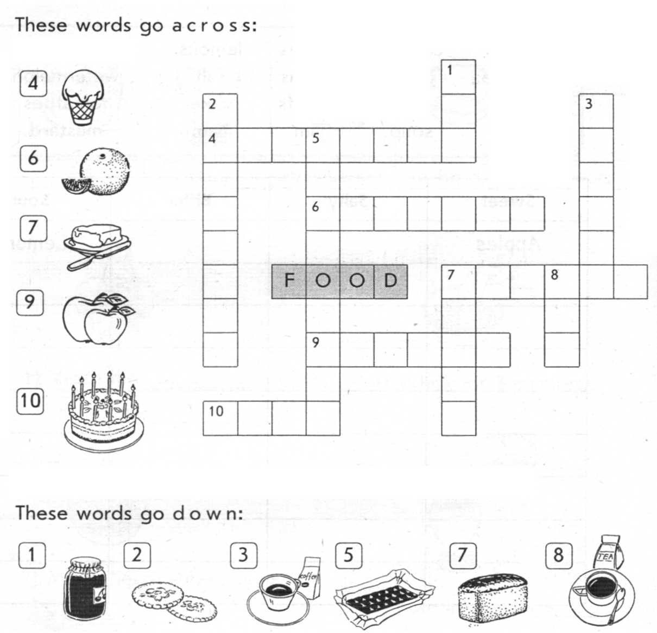

- Relaxation
T: Very nice. I see you are smart children. You work very hard. It’s time to relax a little bit. Look at the screen. Let’s sing the song «Fruit song for kids» (Children sing the song).

- Writing
Open your Activity Books at page 51. Write about what you eat every day. You can draw pictures.
I eat three meals every day.
For breakfast ____________________
For lunch_______________________
For dinner_______________________
On my birthday__________________
My favourite food is______________
I don’t eat ______________________

- Speaking
Our last task is a Game «Our lunch box». Imagine that we have a very big lunch box. So I’ll start the sentence and you have to repeat it and add your own word, your favourite food. Be attentive. Are you ready? Let’s start.
T: In my lunch box I put an apple and….
Ps: In my lunch box I put an apple, a banana and ...
T: … repeat, please and say your own word.

- Homework.
T: Now open your day-books and write down your hometask – make a food poster, page 55 (Pupil’s book). Your marks will depend on your creativity. You can draw the picture and tell us about your favourite dish.

III. Summing-up
T: The lesson is over. I have only one questions – Do you like the lesson? If you like our lesson, please smile. Thank you for your attention and activities!
Have a nice day! Goodbye, pupils!

