Form: 2 A
Topic: At the zoo
Date: 02.11.2022
Time: 25-30 minutes

Objectives: to review and practice zoo animals, to practice spelling, to practice structures I like/ I don’t like, to practice reading for specific information, to practice solving math problems , to practice drawing animals.
Target vocabulary: zoo, lion, tiger, zebra, monkey, elephant, giraffe, panda, bear, snake, flamingo, hippo.
Structures:
“Let’s go to …”
“How many …can you see?”
“I can see …”
“Do you like…?”
“I like…/ I don’t like…”

Outcomes:
By the end of the lesson students will be able to:
- identify and name the zoo animals
- express their preferences by using I like/ I don’t like
- to solve math problems
- to draw a panda
- to work in pairs

Materials:
PowerPoint presentation, e-Worksheets (source: Liveworksheets), e-Flashcards (source: Quizlet), Riddles (source: Wordwall)

- Greeting (Slide 1) (2-3min)
Greet the students by saying “Hi, hello, dear boys and girls!. Then teacher can check the students attendance by calling their name one by one and waving hands. Asks and do the feeling gestures asks them “How are you today? Are you happy, sad, angry, hungry or sleepy. After their answers, teacher say “Don’t be sad because today we will have fun together”.

- Lead-in (Slide 2)
- T.: Look at the rebus and guess the topic of the lesson. ( Zoo) (1min)
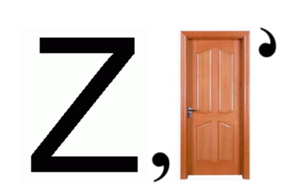

T.: Today we are going to speak about zoo and zoo animals.

2. Vocabulary activities (Slide 3)
Review zoo animals vocabulary. (2-3 min)
Prepare e-flashcards with scrambled letters, students come up with the words , check them with correct answers and pronounce them correctly.
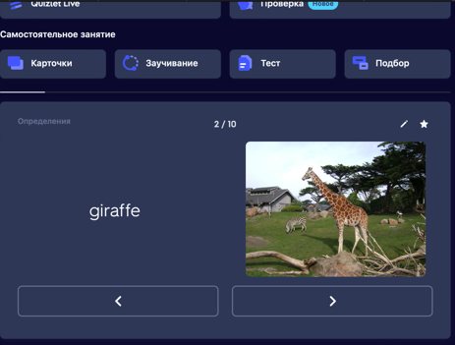

2. Riddles (Slide 4) (3-4min)
Students in order choose the riddles and match them with the proper zoo animals.
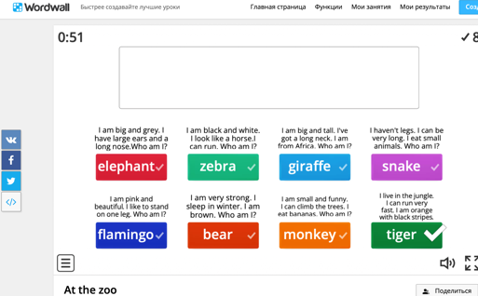

3. Spelling (2 min)
The teacher checks the spelling by using zoom chat. Students type the words (zoo animals) in to the chat, check and correct the spelling.

- Main activity
Reading (Slide 5) (4-5 min)
Pre- reading task. (Slide 6)
T.: Look at the picture and answer the question:
What place is this?
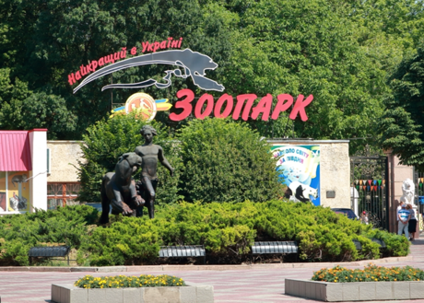

- This is Askaniia nova
- Dzharylhach island
- Mykolaiv zoo (correct answer)

What animals can you see in Mykolaiv zoo?

While –reading
T.: This story is about the boy, Nazar. Read the story and find out: What is Nazar’s favourite zoo animal? You have to work individually, when you finish drop plus + in to the chat.
Teacher gathers the answers and highlights the sentence with the right answer.

At the Zoo
Nazar likes animals. He lives in Mykolaiv and visits the zoo every month.
We can see lots of animals in the zoo. We can see a crocodile. He’s name is Vasia. He is very old and big. He likes to eat meat.
You can see two tigers. They are black and orange. They are very fast.
We can see twenty monkeys. They can climb the trees. Nasar gives them bananas.
Two tall giraffes live in the zoo too. The giraffes are very tall. They are beautiful. Nazar’s favourite animal is an elephant.

Post reading –reading
T.: Find out :
How many tigers are in the zoo? (2)
How many monkeys are in the zoo?(20)
How many crocodiles are in the zoo? (1)
Let’s add these numbers. Two + twenty +one = twenty three

- Pair practice

Pair –work (Slide 7) (3-4min)

T.: Work in pairs and solve these math problems. Follow the link. You ‘ve got 4 minutes for this task. Teacher splits students into pairs. (T. uses breakouts room option in the zoom conference). Students present the answers in pairs. ( the worksheest included)



- Art time (Slide 8) (3-4min)
The teacher involves students to the following task by asking: ”How many pandas can you see? Do you like pandas? Can you draw it? Let’s do it together.”


The teacher shows the video and give students some instructions. (Slide 9,10) Students follow the instructions and draw a panda. After that, they show their pictures and teacher makes a screenshot.
Optional activity: (Slide 11) (2 min)
- Send students the link with the ‘True or False’ task.

- Some students follow the link and do it.

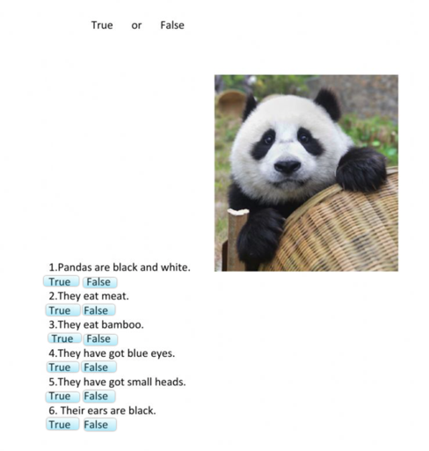

VI. Summary: (2min)
- Reflection. (Slide 13)
Students use zoom emoji to express their feelings about the lesson.

2. Saying goodbye
Fun way:
Teacher: Take care, polar bears
Children: See you soon, baboon

Resources:

https://wordwall.net/ru/resource/34174854 Wordwall
https://www.liveworksheets.com/7-gv187128mr Liveworksheets
https://quizlet.com/_chpzmb?x=1jqt&i=4uqa87 Quizlet

