Date Form: 2
Topic: At the zoo\ У зоопарку
Lesson: My favorite animal. Моя улюблена тварина. Розвиток навичок говоріння.
Objectives: to revise the names of some pets, to present and practice language structures: «I like/I don’t», to revise prepositions of place «in», «on», «under», to practice asking and answering questions: «What is your favorite animal?», to sing a song and play a game with a class revising and practising prepositions and animals using the language structure «Where is a dog ?», «It’s on/in/under the box».
Цілі: повторити назви тварин, презентувати та використовувати у мовленні структури «I like/I don’t», повторити вживання прийменників місця «in», «on», «under» будуючи запитання та відповіді до них, ознайомити з запитанням «What is your favorite animal?» та відповіддю на запитання.
Learning outcomes: By the end of the lesson learners will be able to
- express preferences using like and don’t like;
- ask and answer questions using language structure «I like cats.
- What about you? »;
- say where things or animals are using in,on,under;
- use plural nouns by counting animals;
- imitate animal movements;
- to play a game with the class.
Language
New language: What is your favorite animals? , plural nouns, animals
Basic competences
Language competence: Pupils express preferences using like and don’t like
Social and civic competences: Pupils work together to ask and answer about likes and dislikes
Materials: 4 Cards«Like/don’t like» toy buckets with on/in/under on them, figures of animals, bag, video song toy do, phonics cards, lesson procedure (Microsoft Power Point presentation).

PROCEDURE
I. Introduction
1. Greeting
T: Hello, children!
P: Hello,
T: How are you today?
P: We are fine, thank you.
T: Are you happy today?
P: We are happy today.
T: Great! It’s time to start our lesson.
Pronunciation Drill
T: Let’s train our tongues to speak English. Repeat after me.
A lion says [ m m m] meat,
a monkey says [a: a: a:] banana,
a hippo says [æ æ æ] apple,
a zebra says [g g g] grass.
Warm-up
- Game «What animals is this? »
https://wordwall.net/uk/resource/24568555/quick-minds-2-unit-2-test
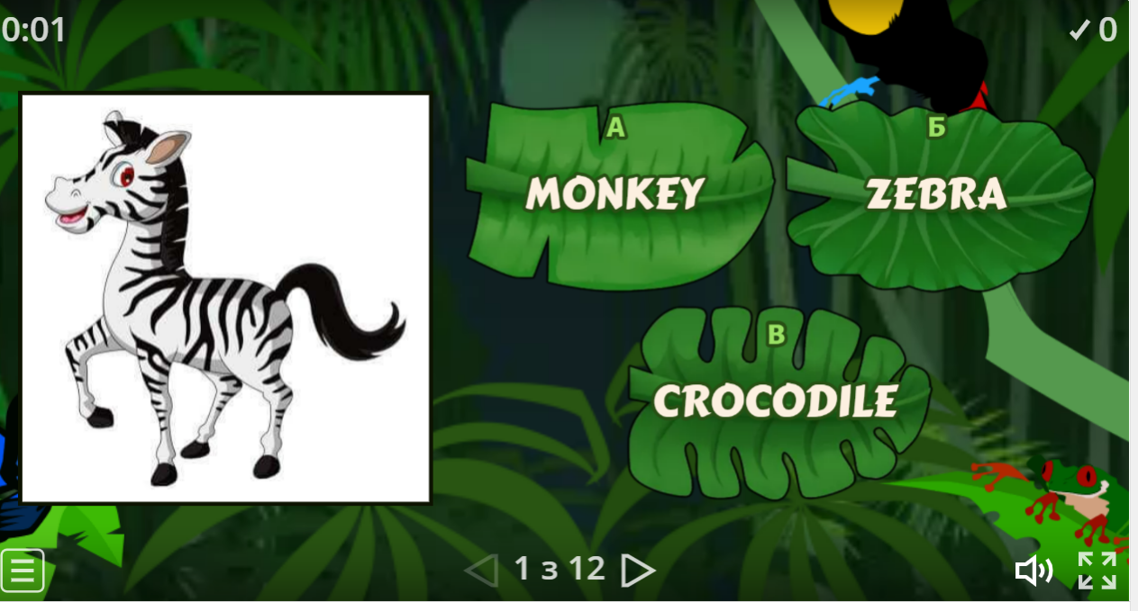
- Listening and recognizing the animal sounds
T: Listen to the animal sounds and guess the animals ( Track U5 L 1-2 from the course book) Which animal is it?
(Answers: elephant, lion, parrot, monkey, snake)
II. Main part of the lesson
As you guess today we shell speak about animals, your favorite animals. At the end of the lesson you well be able express preferences using like and don’t like;
- ask and answer questions using language structure «I like cats.
- What about you? »;
- say where things or animals are using in,on,under;
- use plural nouns by counting animals;
- imitate animal movements;
- to play a game with the class.
- Grammar game. Prepositions of place: in, on ,under
https://www.youtube.com/watch?v=__WRcIFso04
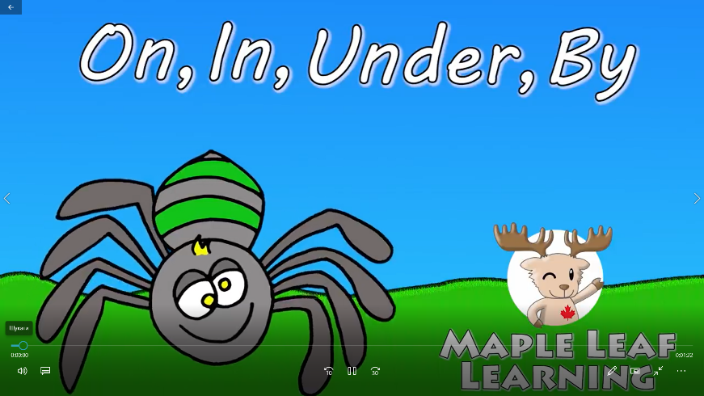

There is a box and a spider on the desk. Teacher takes a dog, place it in, on, under the desk asking pupils: «Where is the spider?».
3.2 Group work
- Teacher divides children into three teams by counting to four. Each group gets card and must write on in under.
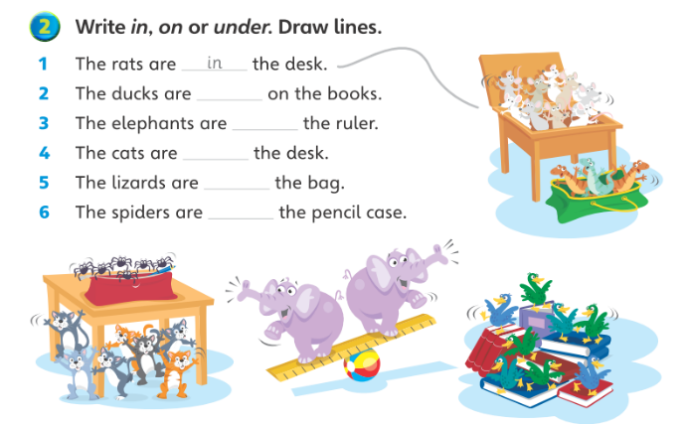

- Relaxing minute
Good job! Now it’s time to watch a song and do the actions. Repeat all the like actions with a happy face and dislike ones with a sad face.(video song «Pet song for kids»)
- Description of favourite animals.
  - Speaking
What is your favorite animals?- I like ….
Plan
I like….
It’s name is…….
It is (colour)……..
- Speaking Practice
Look at the picture in the book and make up a question
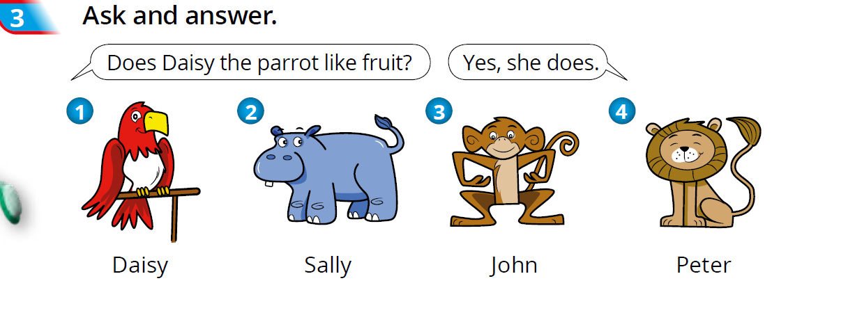

- Ball Game
Teacher takes a ball and throws it to any pupil in the class saying: I like dogs. What about you? Pupil: I like dogs too. Pupil continues the game throwing a ball to another pupil and asking the same question

Summing up.
T: Good job, boys and girls! We have done a lot of work today!
Let’s summaries our lesson. Let’s work with “Magic bag”- take one thing from the bag and say What is it?
What are your impressions after the lesson?
What are your wishes?
Have you got any questions?
( Children take separate stripes and finish the sentences)
T: Well done, pupils! The lesson is over. Thanks. See you at the next lesson.

