2 form Game ‘Now I Can…’
Цілі: повторити літери алфавіту, кольори та числівники, тренувати вміння використовувати структури «Is it a…?» та «It is a….»; вміти підбирати звуки англійського алфавіту, розвивати навички сприймання на слух; виховувати любов до однокласників
Good morning, children! Today we are going to have a game ‘Now I can’. Your answer should be right, loud, expressive and artistic. Good luck! Please sit down and let me see if you know the ABC.
1. DO YOU KNOW THE LETTERS?
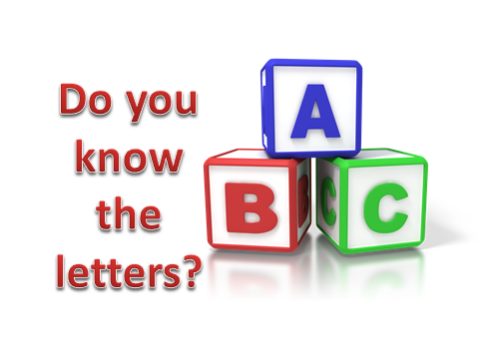
Look at the board and name the letters you see
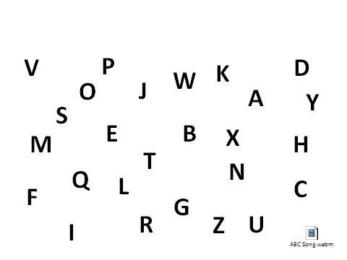
And now let’s sing the song (https://www.youtube.com/watch?v=B7dAerwRq1U)
2. MATCH THE LETTER AND THE SOUND
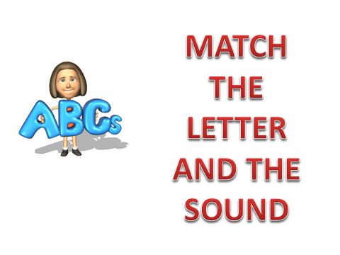
And now we’ll check the knowledge of letters and sounds. You should match the letter and the sound.
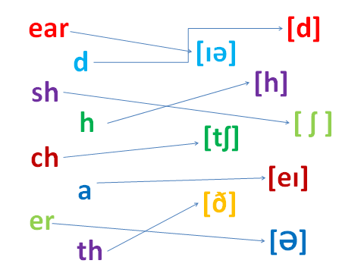
3. LET’S COUNT
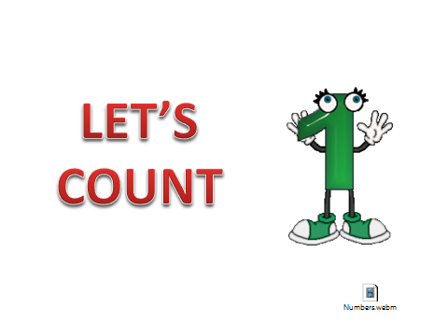
I see you know letters well. And now it’s time to remember the number. Who can do it better? So, let’s sing count song. (https://www.youtube.com/watch?v=DR-cfDsHCGA)
And now look at the board and name and translate the numbers
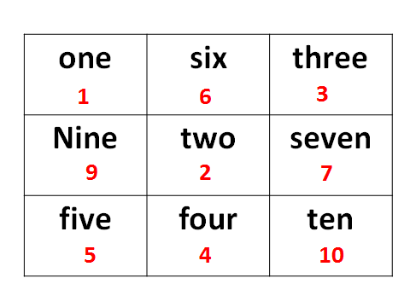
4. ASSEMBLE THE MOSAIC
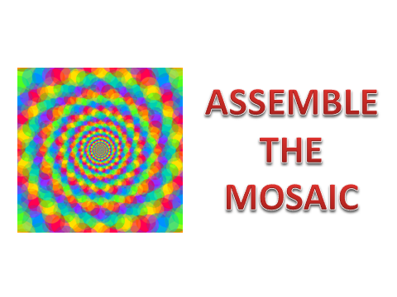
So, we’ve already remembered letters and numbers. It’s time to remember the colours. And the next task is to assemble the mosaic. You should name the colours.
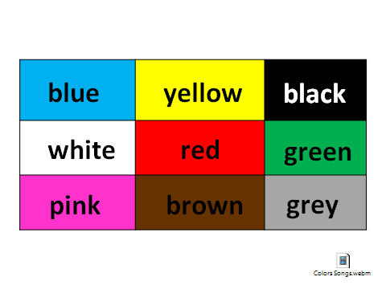
(https://www.youtube.com/watch?v=w_Yp5_QP46U)
5. WHAT ANIMAL IS IT?
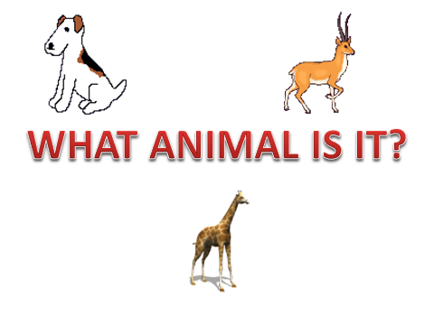
Look at the board and name the animal. Use It’s a…..
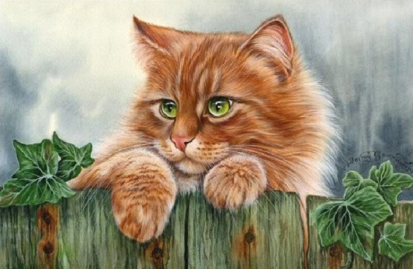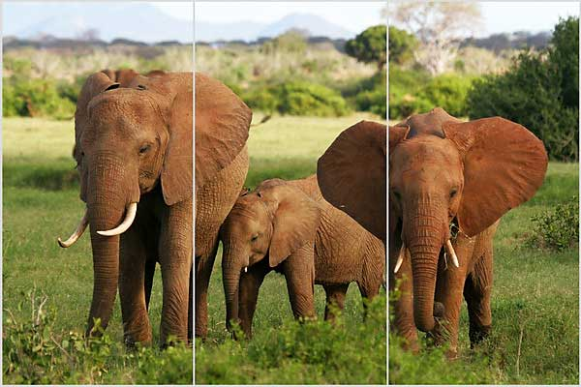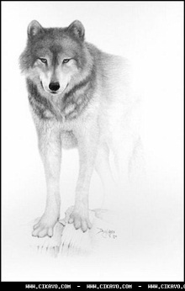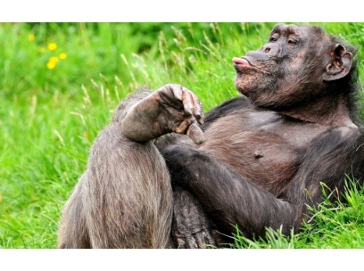
And let’s remember some animals and sing song (https://www.youtube.com/watch?v=a53DkiJ5HDc)
Let’s dance (https://www.youtube.com/watch?v=YQLmX2hMlho)
6. GUESS THE ANIMAL
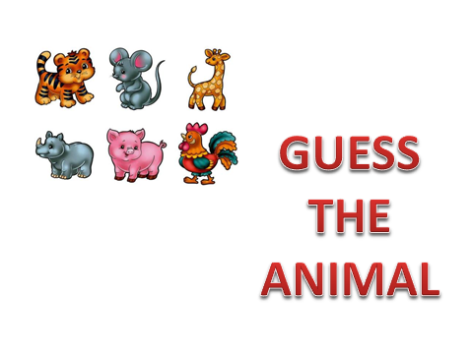
One of you must show (illustrate) the animal without saying a word but only by helping of hands and legs. And you should guess the animal. Ask ‘Is it…?’
(monkey, rabbit, bear, cat)
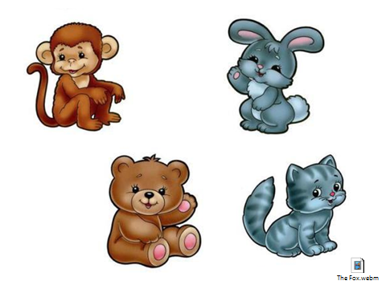
Let’s dance (https://www.youtube.com/watch?v=UU0AtBzAlYY)

