Позакласний захід
Театралізована вистава
“Wild West Show”

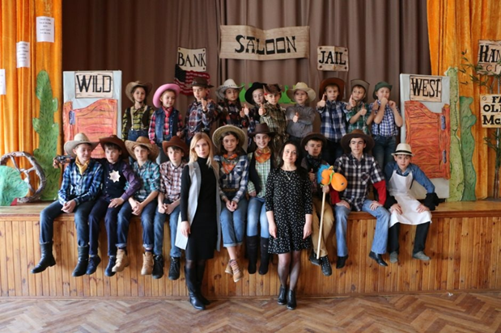

(Виставу було показано учням школи, батькам та колегам-вчителям
в рамках місячника англійської мови у 2017році)

Вчителі вищої категорії, Вітковська Л.В., Рубанік Т.М., спеціалізована школа №173, м.Київ

Мета:
Підтримувати лінгвістично обдарованих і здібних учнів; сприяти розкриттю інтелектуальних, мовленнєвих і творчих здібностей школярів та формуванню їх позитивної мотивації до вивчення англійської мови, використовуючи автентичні краєзнавчі матеріали

Хід заходу
(Звучить музика. Трек: Геннадій Гладков “Далека дорога твоя” з кінофільму “Людина з бульвару Капуцинів”. На сцені з’являється ковбой)
Cowboy | It was many years ago, in the wild, wild west. Cowboy Harry was on his way home. He spent a lot of time far from his home town driving the cattle and he missed much the saloon, the friends and a glass of whisky, but most of all he missed his girlfriend Susanna. He made a lot of money and was going to marry the girl of his dream. When at last he saw the sign with the name of his town he became excited.

(В цей час на коні в напрямку сцени рухається Гаррі, головний герой. Музика лунає голосніше. Чути звуки бійки. Вилітає капелюх. Гаррі бере його в руки та уважно розглядає.)
Harry  Bo | It seems to me I know whose hat it is. (Вилітає ковбой. Гаррі одягає йому на голову капелюха) Hi, Bo. Nice to meet you.  Is that you, Harry? Haven’t seen you for ages. Back home at last?

Bo | Yea, hope so.
Bo Sounds good. Let’s have a drink.
(Гаррі та Бо входять в салон, в якому все ще триває бійка).
Harry (Звертається в зал) Oh, nothing gonna change here.
( Дістає наган та стріляє у повітря, щоб привернути їх увагу).
Sorry to interrupt your friendly talk, gentlemen, but I wanted to say “Hello”.
(Бійка припиняється. Ковбої здивовано дивляться на Гаррі, вони раді його бачити.)
Cowboy 1 Is that you, old man?
Cowboy 2 Nice hat, Harry!
Cowboy 3 Plan on staying here long, Harry?
Harry None of your business. Johnny, whisky to my friends.
( Ковбої співають пісню “Ten Green Bottles”)

Ten Green Bottles
Ten green bottles hanging on the wall
Ten green bottles hanging on the wall
And if one green bottle should accidentally fall,
There'll be nine green bottles hanging on the wall.
One green bottle hanging on the wall,
One green bottle hanging on the wall,
And if that green bottle should accidentally fall,
There'll be no more bottles hanging on the wall.
(This pattern continues until the number of bottles reaches zero)
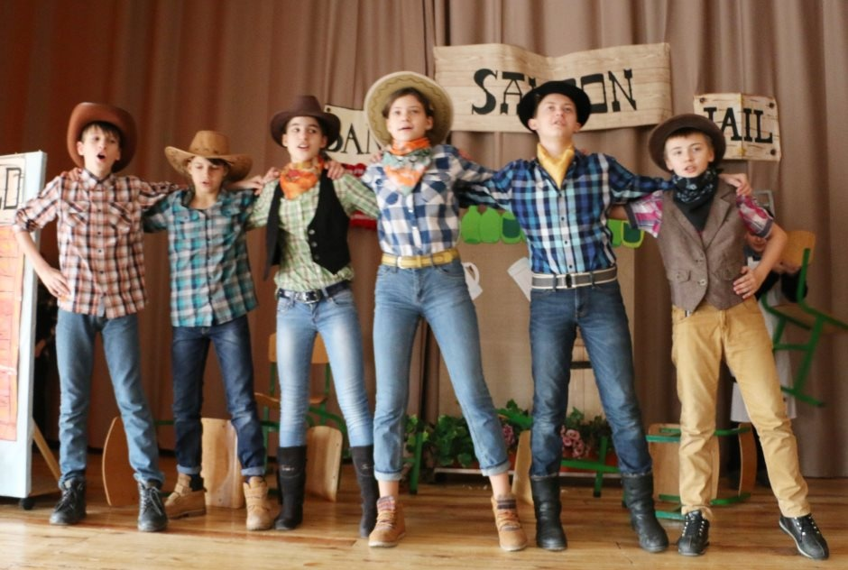

Cowboy 4 How is your old horse?
Cowboy 2 Heard about Susanna?
Harry Oh, Susanna. I like that name, Susanna.
(Ковбої співають пісню “Oh, Susanna”, сидячи на стільцях як на конях).
Oh! Susanna!
I come from Alabama with my banjo on my knee,
I’m going to Louisiana my true love to see.
It rained all night the day I left,
The weather, it was dry,
The sun was hot and I froze to death,
Susanna don’t you cry.
Chorus
Oh! Susanna, oh! Don’t you cry for me,
I come from Alabama with my banjo on my knee.

I had a dream the other night,
When everything was still.
I thought I saw Susanna, coming down the hill.
A cake was in her mouth, a tear was in her eye,
But I’m coming from the south,
So Susanna don’t you cry.
Chorus
Oh! Susanna, oh! Don’t you cry for me,
I’ve come from Alabama with my banjo on my knee!

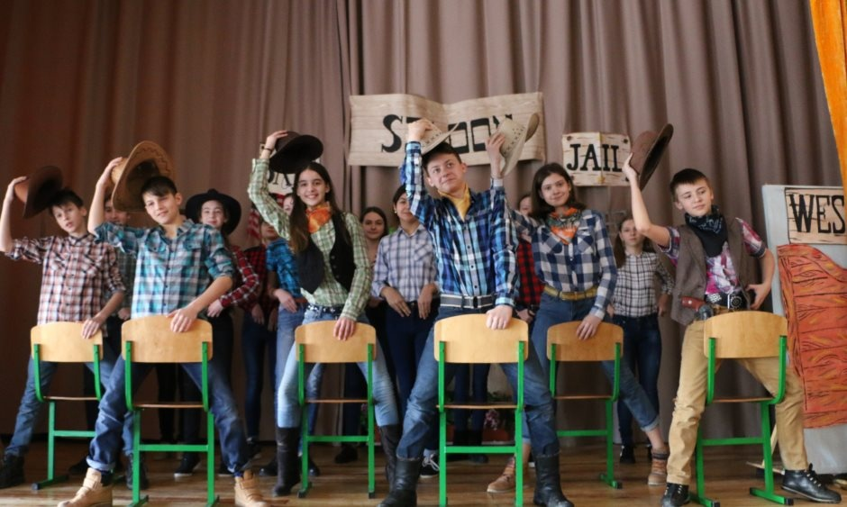

Harry Have you ever been in love?
(Входить шериф Pat)
Cowboy 4 Hello, Pat. Any bad news?
Pat | Yes, men. We’ve got a great problem. Again this Billy the Kid- the most dangerous bandit of the Wild West.

(Шериф вішає плакат”Wanted”. Всі підходять до плакату і читають вголос інформацію).

WANTED DEAD OR ALIVE
BILLY THE KID
Billy the kid is young but very dangerous.
His face is thin and his hair is short and dark.
His eyes are brown and his nose is small.
He wears a white hat and a yellow scarf.
REWARD; $ 5, 000

Cowboy 1 It’ s a great sum of money.
Cowboy 2 It would be nice to get it.
Cowboy 3 Don’t even dream. He is number one. It’s impossible.
(Ковбої виконують вірш “Billy the Kid”)
Billy the Kid
This is a story about Billy the kid.
This is the story of things that he did.
In the Wild West a long time ago
He lived and he robbed down in old Mexico.
Billy the kid, Billy the kid! Poor Billy the kid!
Pat Garret , the sheriff, searched Billy the kid.
And he put him in prison for the things that he did.
But Billy escaped and started to run.
He said: “ No one can catch me now,
I’m number one!”
Billy the kid, Billy the kid! Poor Billy the kid!
\

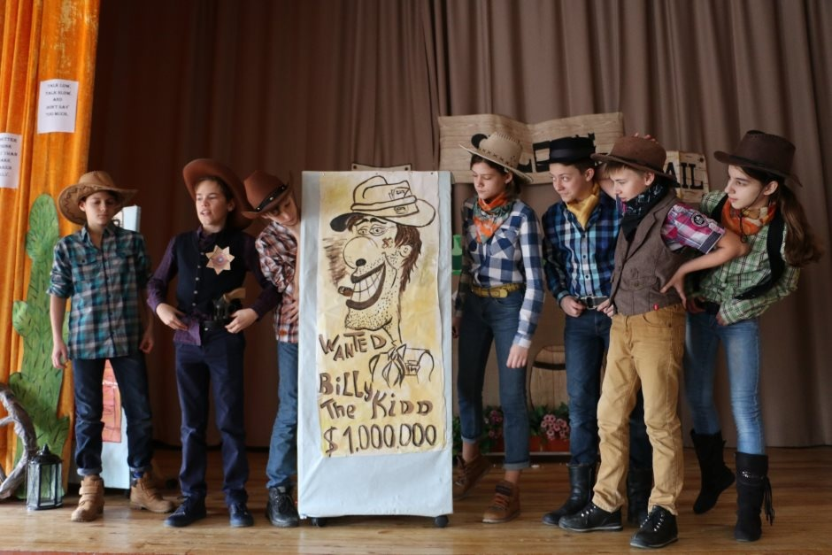

(Несподівано з’являється Billy з пістолетом)

Billy | You are absolutely right, gentlemen. Don’t move. Put down your guns. Money, and be quick. You know I’m not kidding.

Cowboy 1 It seems to me I know this guy.
Cowboy 2 So do I. It’s famous Billy the Kid himself.
Billy Too much talk, gentlemen. I gonna take your horses.
Harry Not this time, Billy.
(Гаррі стріляє в Біллі та ранить його. Шериф арештовує бандита та веде його геть).
Billy Oh, no. Again to prison!
Pat This time you won’t escape.
(Всі кричать: “Hurrah. Harry – the hero!” Звучить канкан, дівчата танцюють).
\
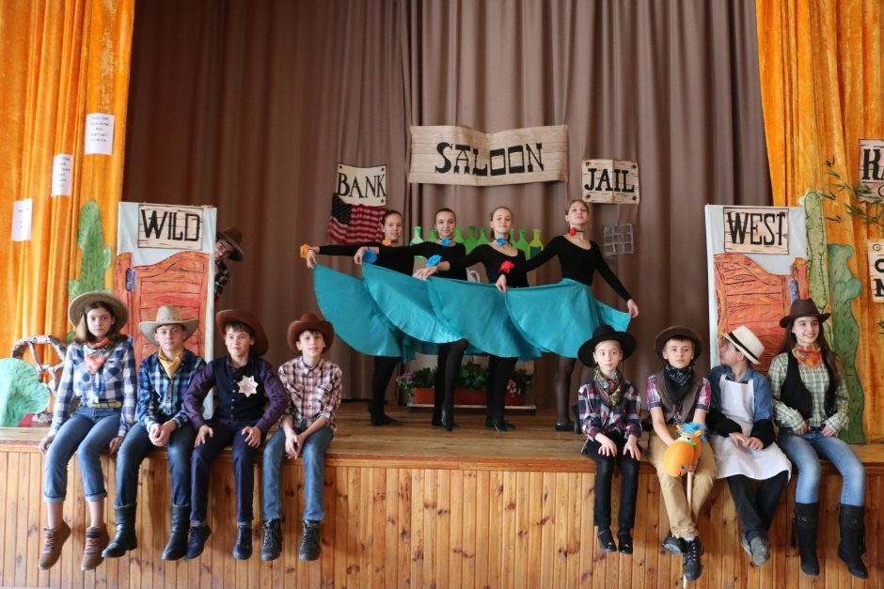

Cowboy 3 | You are very rich now, boy. It’s high time to go to the old farmer MacDonald, if you want to marry his daughter Susanna.

Cowboy 1 Heard? MacDonald wanted his daughter to marry Butch Cassidy.
Harry | I’ll never let it happen. Her Pa said I could have her if I had…..$. and I have…$ now.

Cowboy 4 If Susanna’s Pa keeps his promise we’ll dance at your wedding.
Harry If he doesn’t I’ll take her from under his nose. Let’s go to Old MacDonald.

(Звучить пісня “Old MacDonald Had a Farm”)
Old MacDonald had a farm
Old MACDONALD had a farm  E-I-E-I-O  And on his farm he had a cow  E-I-E-I-O  With a moo moo here  And a moo moo there  Here a moo, there a moo  Everywhere a moo moo  Old MacDonald had a farm  E-I-E-I-O  Old MACDONALD had a farm  E-I-E-I-O  And on his farm he had a pig  E-I-E-I-O  With a oink oink here  And a oink oink there  Here a oink, there a oink  Everywhere a oink oink  Old MacDonald had a farm  E-I-E-I-O  Old MACDONALD had a farm  E-I-E-I-O  And on his farm he had a duck  E-I-E-I-O  With a quack quack here  And a quack quack there  Here a quack, there a quack  Everywhere a quack quack  Old MacDonald had a farm  E-I-E-I-O  Old MACDONALD had a farm  E-I-E-I-O  And on his farm he had a horse  E-I-E-I-O  With a neigh neigh here  And a neigh neigh there  Here a neigh, there a neigh  Everywhere a neigh neigh  Old MacDonald had a farm  E-I-E-I-O | Old MACDONALD had a farm  E-I-E-I-O  And on his farm he had a lamb  E-I-E-I-O  With a baa baa here  And a baa baa there  Here a baa, there a baa  Everywhere a baa baa  Old MacDonald had a farm  E-I-E-I-O  Old MACDONALD had a farm  E-I-E-I-O  And on his farm he had some chickens  E-I-E-I-O  With a cluck cluck here  And a cluck cluck there  Here a cluck, there a cluck  Everywhere a cluck cluck  With a baa baa here  And a baa baa there  Here a baa, there a baa  Everywhere a baa baa  With a neigh neigh here  And a neigh neigh there  Here a neigh, there a neigh  Everywhere a neigh neigh  With a quack quack here  And a quack quack there  Here a quack, there a quack  Everywhere a quack quack  With a oink oink here  And a oink oink there  Here a oink, there a oink  Everywhere a oink oink  With a moo moo here  And a moo moo there  Here a moo, there a moo  Everywhere a moo moo  Old MacDonald had a farm  E-I-E-I-OOOOOOO.........

MacDonald Hello, cowboy!
Harry I did pretty good. I won prize money. And I’m back to marry your daughter.
MacDonald | Let’s ask her, if she wants to marry you, guy. Susanna, come here! Where are you hiding , my little girl? Don’t you see Harry is back?

(З’являється Сюзанна, співаючи пісню ” The Wagoner's Lad’’)
The Wagoner's Lad
Oh hard is the fortune of all womankind
They're always controlled, they're always confined
Confined by their parents until they are wives
Then slaves to their husbands for the rest of their lives
Oh I am a poor girl, my fortune is sad
I've always been courted by the Wagoner's Lad
He's courted me daily, by night and by day
And now he is loaded and going away
"Your parents don't like me because I am poor
They say I'm not worthy of entering your door
But I work for a living, my money's my own
And if they don't like it, they can leave me alone"
"Your horses are hungry, go feed them some hay
Come sit down beside me as long as you stay"
"My horses ain't hungry, they won't eat your hay
So fare thee well darling I'll be on my way"
Oh hard is the fortune of all womankind
They're always controlled, they're always confined
Confined by their parents until they are wives
Then slaves to their husbands for the rest of their lives
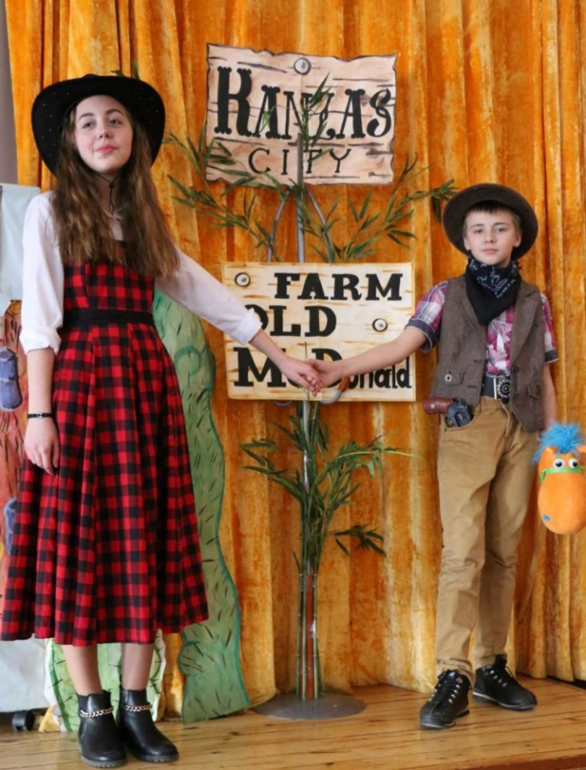

\

Harry | I heard you changed the plans, Susanna. People say you are with Butch Cassidy now.

Susanna I’ll better run away from home than marry him. You know it, Harry.

Harry | Then your Pa must keep his word. Mr MacDonald, you promised to let Susanna marry me. It’s high time to make the wedding.

MacDonald There is nothing like my daughter’s happiness.
(Всі кричать”Hurrah”. Актори виконують фінальну пісню “Singing the Blues” by Guy Mitchel)
Singing the Blues
Well, I never felt more like singin' the blues
'Cause I never thought that I'd ever lose
Your love dear, why'd you do me this way?
Well, I never felt more like cryin' all night
'cause everythin's wrong, and nothin' ain't right
Without you, you got me singin' the blues
The moon and stars no longer shine
The dream is gone I thought was mine
There's nothin' left for me to do
But cry-why-why-why over you (cry over you)
Well, I never felt more like runnin' away
But why should I go 'cause I couldn't stay
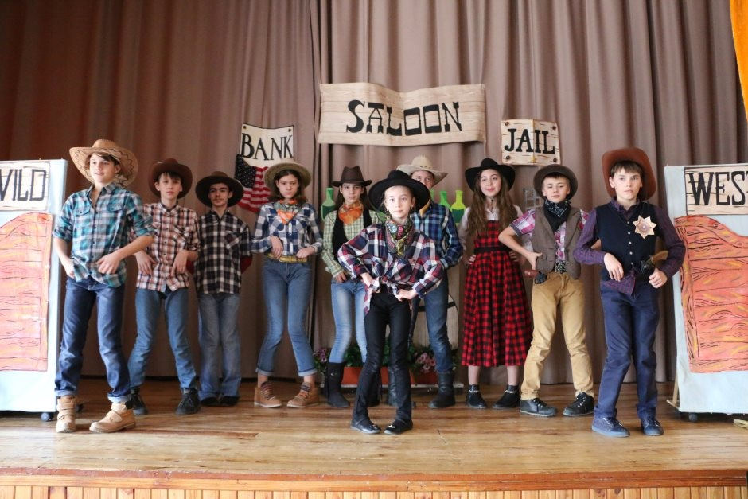
Without you, you got me singin' the blues

