КЗЛОР «Самбірський педагогічний коледж імені Івана Филипчака»

Оксана Зубрицька

Позакласний захід з англійської мови
Carols Chiming Everywhere!
Christmas Party.

для студентів спеціальності 013 «Початкова освіта» з дисципліни «Іноземна мова» (англійська мова)

Самбір
2017
Carols Chiming Everywhere!
Christmas Party.
Subject: “Christmas traditions in English speaking countries.”
Objectives:
- to acquaint students with Christmas traditions in English speaking countries, like cooking, carols, poetry and symbols;
- to develop respect towards traditions of other countries;
- to widen students’ outlook;
The equipment: a projector, a slide presentation, a notebook, Christmas decorations, booklets with carols, homemade mince pies, video recording of a fireplace, the recordings of carols and Christmas music.
Script.
Setting: A fireplace is being projected on the wall. Some Christmas carols are being played. Two students meeting guests at the door are giving them the booklets with carols and showing them their seats. When all are settled in the shape of a semicircle the party begins.
The music is going down….
The host of the holiday: - Welcome to the party. Christmas season is the most charming period of the year. It’s full of family warmth, carols delicious snacks and presents. We hope that today all of you will sense it. Also you’ll take the challenge in the competitions, carol singing and if you are active you’ll get some presents from Santa. Do you like singing? – yes! Do you like snacks? – Yes! Do you like challenge! – Yes!!! (2min.)
The music is going up and in a moment down. STUDENT 1 comes out with a poem: (1min.)
It’s Christmas! It’s Snowing!
It’s Christmas! It’s Snowing!
Oh my, what a delight,
A true, loving Christmas
All covered in white.
I hear people singing
As they travel our street,
I hope they come hear
For my family to greet.
Oh, Christmas! I love thee!
The joy that you bring,
And now we must welcome
The Baby Jesus…our King.
Students sing “SILENT NIGHT” (guitar accompaniment 2min.57sec.)

Silent Night
Silent night, holy night!
All is calm, all is bright.
Round yon Virgin, Mother and Child.
Holy infant so tender and mild,
Sleep in heavenly peace,
Sleep in heavenly peace
Silent night, holy night!
Shepherds quake at the sight.
Glories stream from heaven afar
Heavenly hosts sing Alleluia,
Christ the Savior is born!
Christ the Savior is born
Silent night, holy night!
Son of God love's pure light.
Radiant beams from Thy holy face
With dawn of redeeming grace,
Jesus Lord, at Thy birth
Jesus Lord, at Thy birth

STUDENT 2 recites a poem: (1 min)
Remembering at Christmas.
When Christmas comes around this year,
It makes me think of friends;
Of all the pleasures that they bring,
Of how their love transcends.
Our faith in God, the hope we have,
And caring more each year
Keeps friendship strong inside my heart
For those I hold so dear.
How special just to be with them
And share each other’s lives-
Oh, how I like remembering When Christmastime arrives.
Students sing “Let It Snow Let It Snow Let It Snow.” (1min. 52sec.)

Let It Snow Let It Snow Let It Snow
Oh, the weather outside is frightful
But the fire is so delightful
And since we've no place to go
Let it snow, let it snow, let it snow
Man it doesn't show signs of stoppin'
And I brought some corn for poppin'
The lights are turned way down low
Let it snow, let it snow, let it snow
When we finally kiss good-night
How I'll hate going out in the storm
But if you really hold me tight
All the way home I'll be warm
And the fire is slowly dying
And, my dear, we're still good-bye-ing
But as long as you love me so
Let it snow, let it snow, and snow
When we finally kiss good-night
How I'll hate going out in the storm
But if you really grab me tight
All the way home I'll be warm
Oh the fire is slowly dying
And, my dear, we're still good-bye-ing
But as long as you love me so
Let it snow, let it snow, let it snow

Three students come out one by one, with poems. (2min 50 sec)
STUDENT 3
We celebrate!
We trim a tree and wrap up gifts
With festive colours bright,
We gather round a cozy fire to sing “O Holy Night.”
We cook a juicy turkey
And make big, fancy pies,
And plan to find some special ways
To strengthen family ties.
STUDENT 4
Merry Christmas!
Isn’t it fun
To say “Merry Christmas!”
To everyone?
Time for a party
And presents and things
That make children happy
And give their hearts wings.
STUDENT 5 Comes out holding a big silver bubble in his/her hands looking at it and reciting a poem.
The funniest face looked out at me
From a silver ball
On the Christmas tree!
At first I thought
It was Santa’s elf,
But I looked again and
It was just myself!
Students sing “Deck the hall.” (1min 20sec) Two students sing the main verse and the whole group sing the chorus.
Deck the halls with boughs of holly
Fa-la-la-la-la, la-la-la-la
'Tis the season to be jolly
Fa-la-la-la-la, la-la-la-la
Don we now our gay apparel
Fa-la-la, la-la-la, la-la-la.
Troll the ancient Yule tide carol
Fa-la-la-la-la, la-la-la-la.

See the blazing Yule before us.
Fa-la-la-la-la, la-la-la-la
Strike the harp and join the chorus.
Fa-la-la-la-la, la-la-la-la
Follow me in merry measure.
Fa-la-la-la-la, la-la-la-la
While I tell of Yule-tide treasure.
Fa-la-la-la-la, la-la-la-la

Fast away the old year passes.
Fa-la-la-la-la, la-la-la-la
Hail the new year, lads and lasses
Fa-la-la-la-la, la-la-la-la
Sing we joyous, all together.
Fa-la-la-la-la, la-la-la-la
heedless of the wind and weather.
Fa-la-la-la-la, la-la-la-la

STUDENT 6 QUEST (Slides 1-23 10min) - And now it’s high time for a QUEST. Are you ready for a challenge? Some prizes are waiting for you! Let’s check how well you know Christmas symbols. The slides of Christmas symbols are being projected and students call out their names. The first to call out the word gets a sweet. In the end of the activity the winner is announced.
-Well done!!! You were so smart. And now let’s sing the carol without which we can’t imagine Christmas.
Students sing “Jingle Bells” (1min 50sec)
Dashing through the snow
In a one horse open sleigh
O'er the fields we go
Laughing all the way
Bells on bob tails ring
Making spirits bright
What fun it is to laugh and sing
A sleighing song tonight

Oh, jingle bells, jingle bells
Jingle all the way
Oh, what fun it is to ride
In a one horse open sleigh
Jingle bells, jingle bells
Jingle all the way
Oh, what fun it is to ride
In a one horse open sleigh
The Host tells about Christmas desserts in English speaking countries.(10min) Do you like desserts? Of course all of us adore them. And what do people in English speaking countries have for dessert? Let’s have a look. (Slides 25-32)
Chocolate yule log
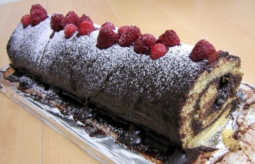
Is a traditional dessert served near Christmas. Made of sponge cake to resemble a miniature actual Yule log, it is a form of sweet roulade. The original "Yule log" recipe emerged during the 19th century. The most common combination is basic yellow sponge cake and chocolate buttercream. “Yule logs” are often served with one end cut off and set atop the cake, or protruding from its side to resemble a chopped off branch. A bark-like texture is often produced by dragging a fork through the icing, and powdered sugarsprinkled to resemble snow. Other cake decorations may include actual tree branches, fresh berries, and mushrooms made of marzipan.
Christmas cake
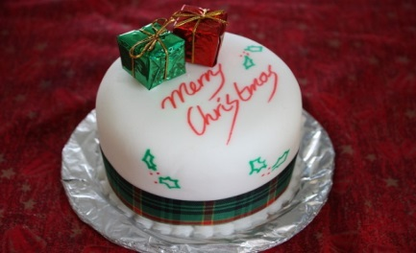
A Christmas cake may be light or dark, crumbly-moist to sticky-wet, spongy to heavy, shaped round, square with marzipan, icing, glazing, dusting with icing sugar, or plain. If a Christmas cake is covered in icing, it is quite common for it to be decorated - models of houses, of fir trees or of Santa Claus may be in the array of decorations.
A particular favourite of many is the traditional Scottish Christmas cake, the Whisky Dundee. As the name implies, the cake originated in Dundee and is made with Scotch whisky. It is a light and crumbly cake, and light on fruit and candied peel—only currants, raisins, sultanas and cherries. This Christmas cake is particularly good for people who don't like very rich and moist cakes.

Christmas pudding
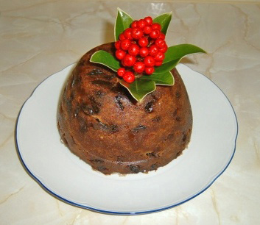
Christmas pudding is a type of pudding traditionally served as part of the Christmas dinner in the UK, Ireland and in other countries where it has been brought by British emigrants. It has its origins in medieval England, and is sometimes known as plum pudding or just "pud", though this can also refer to other kinds of boiled pudding involving dried fruit. Despite the name "plum pudding," the pudding contains no actual plums due to the pre-Victorian use of the word "plums" as a term for raisins. The pudding is composed of many dried fruits held together by egg and suet, sometimes moistened by treacle or molasses and flavoured with cinnamon, nutmeg, cloves, ginger, and other spices. The pudding is usually aged for a month or more, or even a year; the high alcohol content of the pudding prevents it from spoiling during this time.

Dundee cake (traditional Scottish fruit cake)
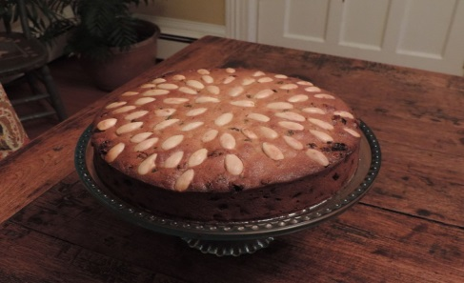
Dundee cake is a famous traditional Scottish fruit cake with a rich flavour.
The cake is often made with currants, sultanas and almonds; sometimes, fruit peel may be added to it. The cake originated in nineteenth-century Scotland, and was originally made as a mass-produced cake by the marmalade company called Keiller's. Keiller's marmalade company first mass-produced the cake commercially and have been claimed to be the originators of the term "Dundee cake". However, similar fruit cakes were produced across Scotland. A popular story is that Mary Queen of Scots did not like glace cherries in her cakes, so the cake was first made for her, as a fruit cake that used blanched almonds and not cherries. The top of the cake is typically decorated with concentric circles of almonds. Today, the cakes are often sold in supermarkets throughout the United Kingdom.
Trifle
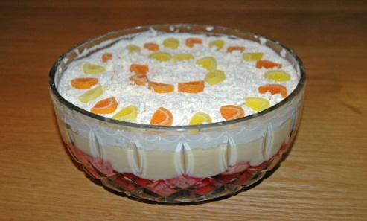
Trifle in English cuisine is a dessert made with fruit, a thin layer of sponge fingers soaked in sherry or another fortified wine, and custard. It can be topped with whipped cream. The fruit and sponge layers may be suspended in fruit-flavoured jelly, and these ingredients are usually arranged to produce three or four layers.
Gingerbread
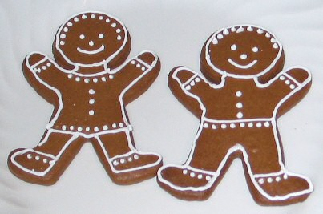
Gingerbread refers to a broad category of baked goods, typically flavored with ginger, cloves, nutmeg or cinnamon and sweetened with honey, sugar or molasses. Gingerbread foods vary, ranging from a soft, moist loaf cake to something close to a ginger biscuit. Originally, the term gingerbread (from Latin zingiber via Old French gingebras) referred to preserved ginger. It then referred to a confection made with honey and spices.
Hot chocolate
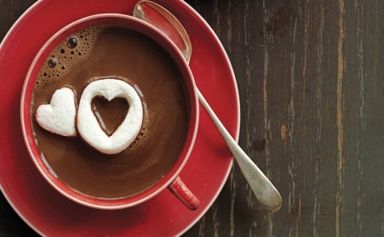
Hot chocolate, also known as hot cocoa, drinking chocolate or just cocoa is a heated beverage consisting of shaved chocolate, melted chocolate or cocoa powder, heated milk or water, and usually a sweetener. Hot chocolate may be topped with whipped cream. Hot chocolate made with melted chocolate is sometimes called drinking chocolate, characterized by less sweetness and a thicker consistency.
The first chocolate beverage is believed to have been created by the Mayans around 2,500-3,000 years ago
Mince pies
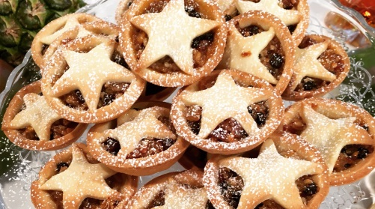
A mince pie is a sweet pie of British origin, filled with a mixture of dried fruits and spices called "mincemeat", that is traditionally served during the Christmas season in the English-speaking world. Its ingredients are traceable to the 13th century, when returning European crusaders brought with them Middle Eastern recipes containing meats, fruits and spices.
The early mince pie was known by several names, including "mutton pie", "shrid pie" and "Christmas pie". Typically its ingredients were a mixture of minced meat, suet, a range of fruits, and spices such as cinnamon, cloves and nutmeg.

The Host: We’ve prepared for you one of the traditional dishes so help yourself and guess the ingredients. (Students help themselves with mince pies.)

STUDENT 7 (50sec)
May Christmas spirit,
In all of its joy.
Touch the depths of your soul with delight,
And may blessings in bushels,
Abundant and rich,
Light every path of your life.
Students sing: “We wish you a Merry Christmas!” (52 sec)
We Wish You A Merry Christmas
We wish you a Merry Christmas
We wish you a Merry Christmas
We wish you a Merry Christmas
And a Happy New Year
Good tidings to you wherever you are
Good tidings for Christmas and a Happy New Year
We wish you a Merry Christmas
We wish you a Merry Christmas
We wish you a Merry Christmas
And a Happy New Year
Oh, bring us a figgy pudding
Oh, bring us a figgy pudding
Oh, bring us a figgy pudding
And a cup of good cheer
Good tidings to you wherever you are
Good tidings for Christmas and a Happy New Year
We wish you a Merry Christmas
We wish you a Merry Christmas
We wish you a Merry Christmas
And a Happy New Year
The host of the holiday: You’ve been great today and Santa left some presents for you. Look under the Christmas tree and help yourself. Thank you for being with us!
Total Time (35 – 40 min)

