Christmas Party. Методична розробка виховного заходу з англійської мови.

Тема заходу: Christmas Party

Мета заходу:
- розвивати навички усного мовлення та синхронного перекладу
- навчити учнів логічно та послідовно викладати свої думки;
- виховувати бажання вивчати англійську мову;
- збагачувати знання про традиції англомовних країн та українського народу.

Обладнання:
- мультимедійний проектор та екран;
- презентації;
- аудіозапис;
- відеозапис “Ukraine Christmas Traditions”
Хід виховного заходу
І. Організаційний момент.
Т: Glad to see you at our party dedicated to Christmas and New Year! Let’s start with Christmas in Ukraine. Перегляд відео “Ukraine Christmas Traditions”. (https://www.youtube.com/watch?v=782905thjzA)
ІІ. Основна частина.
P: Christmas is the most beloved festivals among Ukrainians when the family gathers for a Holy supper of 12 symbolic dishes.
The beginning of the Holy supper is signaled by the first star. Christmas Eve is really a family celebration. Traditionally the father brings in the “snip” a handpicked wheat sheaf that represents the spirit of ancestors. The father sets it in a place of honour in the dining room before the table is set. Whet flour and bread are important to Ukrainians.
P: “Kutia” is a dish of honey popy seeds and wheat kernels boiled in pure rainwater. Christmas Eve supper begins with the lighting of the beeswax candle.
After a carol and the Lord”s player the the kutia is passed and everyone takes a spoonful .But nobody eats yet. The head of the family raises his spoonful and greets the family with “ Khrystos Rozhdaietsia” (Christ is born).
The family answers : “ Slavym yoho!” (Glory,praise him!). That’s the signal to start the meal. The meal is traditionally meatless and milk-free and features fish.
The most well known dishes are “holubtsi” and varenyky or pyrohy.
Carols usually end the evening and signal the start of a joyous season of visiting.
Колядка “ БОГ СЯ РОЖДАЄ”
T: Christmas is a family holiday,but unfortunately not all people can be at home on Holy Supper. Especially it applies to our warriors who defend our country on the east. Lets listen to the poem from the diary of a soldier.
Сторінка із щоденника солдата

Нарешті стало тихо. Хлопці сплять,
на каремати впали від утоми.
А я пишу. Бо мушу дописать,
як на Святвечір я хотів додому.
Ревіли «буки», замість коляди,
в найбільше свято нечисть не дрімає.
А я в думках летів, летів туди,
де мама стіл обрусом накриває.
Гриміли «гради», падали дощем,
чи було страшно? Хто це пам’ятає…
А в хаті тато курить ялівцем
і першу зіроньку родина виглядає.
І я шукав очима ту зорю,
вона у вечір той була одна-єдина.
На мить так добре стало, як в раю.
У тім раю, що зветься – Україна.
T: Christmas is a Time for Love ,isn’t it?
Christmas is a time for Love; a time for Joy and Peace;
A time to rain the Christmas Tree and a time to stuff the geese.
It`s a time when we can come together, however far on near;
To shed a little hope into a world of sorrow and fear.
To give a gift of Hope to one who otherwise has none;
To be a Friend to somebody whom everyone else has shun.
To be Forgiving of our faults, and of our sisters and our brothers;
To live in Peace and Harmony with ourselves and with each other.
T:We want you to learn more about Christmas and New Year celebration in Great Britain.
Let’s start with one of the most popular songs in the world “Jingle Bells”
Song “Jingle Bells”. 1) Dashing through the snow, in one-horse open sleigh,
O’er the fields we go, laughing all the way.
Bells on Bobtail ring, making spirits bright, What fun it is to ride and sing a sleighing song tonight! Chorus: Jingle bells, jingle bells, jingle all the way Oh! What fun it is to ride in a one-horse open sleigh! Jingle bells, jingle bells, jingle all the way Oh! What fun it is to ride in a one-horse open sleigh! 2) A day two ago, I thought I’d take a ride, And soon Miss Fannie Bright was sitting by my side. The horse was learn and lank, misfortune was his lot. He got into a snowdrift bank – and we? We got upsot! 3) So now the moon is bright, enjoy it while you’re young. Invite your friends tonight to sing this sleighing song. Just get a bob-tailed nag and give him extra feed. Then hitch him to an open sleigh – and crack! You’ll take the lead!
T :Some pupils prepared an interesting messages about New Year’s celebration in GB. Let’s listen to them.
P :In England the New Year is not as widely observed as Christmas. Some people ignore it completely and go to bed at the same as usual. Many others however celebrate it. The way of celebration varies very much according to the local custom and family tradition.
The most common way of celebration is a New Year party which usually begins at about eight o’clock p.m. and goes on until the early hours of the morning . There is usually an informal supper of cold meat pies sandwiches cakes and some drinks . At midnight the radio set is turned on so that everyone can hear the chimes of Big Ben. Then the party goes on.
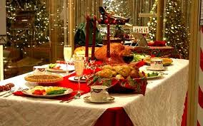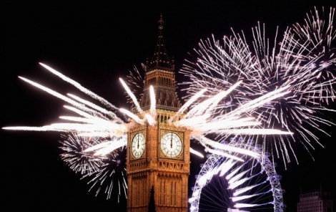

P :Another popular way of celebrating the New Year is to go to a New Year's dance. Most hotels and dance halls hold a special dance on New Year's Eve. The hall is decorated, there are several different bands and the atmosphere is very gay.



P: The most famous celebration is in London at Piccadilly Circus where crowds gather and sing and welcome the New Year. In Trafalgar Square there is also a big crowd and someone usually falls into the fountain.

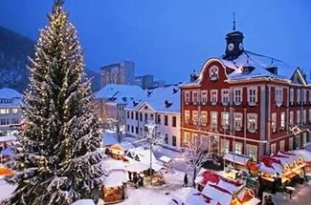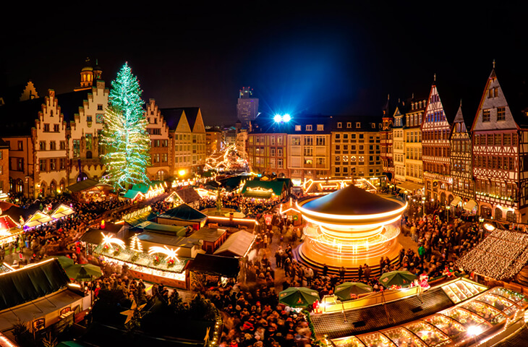

P: In Scotland most traditional ceremonies are connected with the New Year . There’s a New Year’s Eve Fire Festival in each city; men parade with blazing tar barrels then throw them into a great bonfire.

In Scotland it’s considered lucky if a dark-haired man is the first to set foot in the house after midnight on New Year’s Eve bringing a coin a piece of bread or a lump of coal as a symbol of plenty for the coming year .

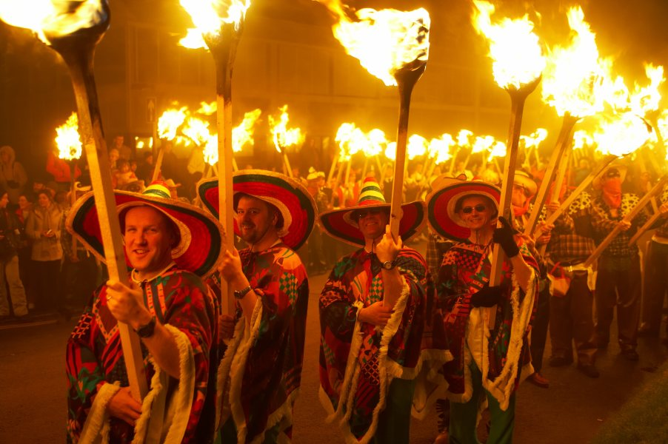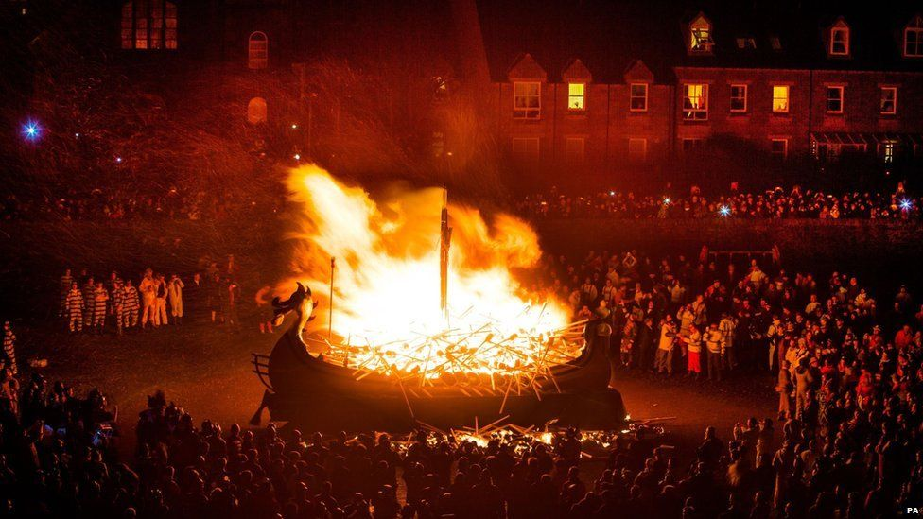
P: Centuries ago it was the custom to put an ivy leaf in water on New Year’s Eve and leave it there until Twelfth Night (the 6th of January). If the leaf remained fresh and green it foretold a good healthy year ; if black spots appeared on it this meant illness and death in the family.
Song “Happy New Year”. No more champagne
And the fireworks are through
Here we are, me and you
Feeling lost and feeling blue
It's the end of the party
And the morning seems so grey
So unlike yesterday
Now's the time for us to say
Happy New Year
Happy New Year May we all have a vision now and then
Of a world where every neighbor is a friend
Happy New Year
Happy New Year
May we all have our hopes, our will to try
If we don't we might as well lay down and die
You and I.
Sometimes I see
How the brave new world arrives
And I see how it thrives
In the ashes of our lives
Oh yes, man is a fool
And he thinks he'll be okay
Dragging on, feet of clay
Never knowing he's astray
Keeps on going anyway.
T : Let’s return to Christmas celebration
Christmas and New Year traditions.
Each country has its own customs, traditions, holidays, and important days in its history. Talking of holidays in Ukraine we can’t but tell about everybody’s favourite New Year Holiday. People think that at night on New Year’s eve the old year with all its troubles leaves us forever and the new year with all our hopes and expectations knocks at our doors. People decorate the Christmas tree, have New Year parties and prepare presents for their relatives and friends.
On the eve of January the 7th Ukrainians start celebrating Christmas. It’s the day of Jesus Christ’s birthday and it is widely celebrated all over Ukraine. People sing carols, cook a traditional Ukrainian Christmas dish named “kutya” which all the family eats together. Then people go to church to listen to the Christmas sermon.
The Christmas season is the most festive time of the year in Britain. Students at school and colleges usually have a two weeks vacation. Although no one knows exactly when Jesus born, Christians everywhere in the world celebrate his birthday on December 25. This day was a festival long before Christianity because ancient people believed this was the time when the sun god started his journey back to earth and it was a custom to give presents to each other.
Every year the people of Norway give the city of London a present. It’s a big Christmas tree and it stands in the Trafalgar Square.
Before Christmas, groups of singers go from house to house. They collect money for charities and sing carols, traditional Christmas songs.
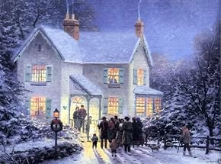
Колядка –HOLY NIGHT
The most important part of English Christmas is, of course, the gala dinner. For many centuries people of Britain have served turkey, the plum-porridge or plum-pudding for this night. It’s a special dish from oatmeal boiled in broth and served with raisins, almonds, prunes and honey. Traditionally, there were four objects hidden in this pudding - a coin, a thimble, a button and a ring.
A coin meant wealth, a button and a thimble meant bachelorhood and unmarried life, while a ring predicted a marriage for young girls. A turkey is a traditional Christmas bird. People eat it on Christmas Day.

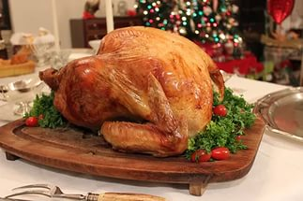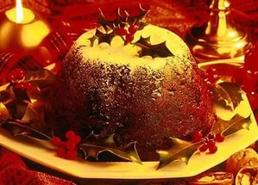

After Christmas dinner families may watch the Queen on television as she delivers her traditional congratulations to the United Kingdom.
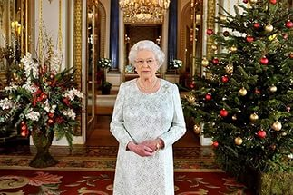
The children are told that Santa Claus Father Christmas comes down the chimney during the night and fills the stockings by the fireplace with toys and sweets.
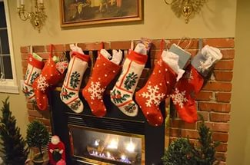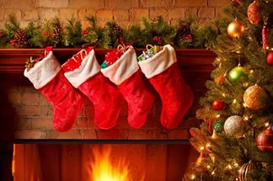

Christmas is a family holiday. All the family usually meets for the big Christmas dinner of turkey and pudding. The 26 (th) of December, Boxing Day, is an extra holiday after Christmas. It’s the time to visit friends and relatives.
New Year day is less favourite in Britain than Christmas.

T :What’s Christmas without greetings?
. Wish you a Merry Christmas and may this festival bring abundant joy and happiness in your life!
. May this Christmas be so special that you never ever feel lonely again and be surrounded by loved ones throughout!
. Here’s wishing you all the joys of the season. Wish you and your family a Merry Christmas!
. May joy and happiness snow on you, may the bells jingle for you and may Santa be good to you! Merry Christmas!
. May this Christmas be bright and cheerful and may the New Year begin on a prosperous note!
. Love, Peace and Joy came down on earth on Christmas day to make you happy and cheer in your lives!
. Sending the warmest Christmas wishes to you and your family. May God showers his choicest blessings on you and your family this Christmas.
. May all your days be merry and bright and may your Christmas be white! Merry Christmas!
T: Now look at the screen, please. Here you can see the presentation with questions about Christmas symbols and traditions.
Questions:
When is Christmas celebrated?
Does Santa Claus in England and in America
come through the window or down the chimney?
Where do people put the presents?
What is traditional Christmas food?
When do people in England put up their Christmas trees and decorations?
How do we call traditional Christmas songs?
What do they wish their relatives and friends?
What are traditional Christmas colours?
What is traditional Christmas song?
Song “We wish you a Merry Christmas”

1) We wish you a Merry Christmas 2) Let’s all do a little clapping We wish you a Merry Christmas Let’s all do a little clapping We wish you a Merry Christmas Let’s all do a little clapping And a Happy New Year. And spread Christmas Cheers.
3) We wish you a Merry Christmas 4) Let’s all do a little jumping We wish you a Merry Christmas Let’s all do a little jumping We wish you a Merry Christmas Let’s all do a little jumping And a Happy New Year. And spread Christmas Cheers.
5) We wish you a Merry Christmas 6) Let’s all do a little laughing We wish you a Merry Christmas Let’s all do a little laughing We wish you a Merry Christmas Let’s all do a little laughing And a Happy New Year. And spread Christmas Cheers.
7) We wish you a Merry Christmas 8) Let’s all do a little dancing We wish you a Merry Christmas Let’s all do a little dancing We wish you a Merry Christmas Let’s all do a little dancing And a Happy New Year. And spread Christmas Cheers.
9) We wish you a Merry Christmas 10) Let’s all do a little stocking We wish you a Merry Christmas Let’s all do a little stocking We wish you a Merry Christmas Let’s all do a little stocking And a Happy New Year. And spread Christmas Cheers.
11) We wish you a Merry Christmas 12) Let’s all wave Good-bye to Santa We wish you a Merry Christmas Let’s all wave Good-bye to Santa We wish you a Merry Christmas Let’s all wave Good-bye to Santa And a Happy New Year. And spread Christmas Cheers.



