МІНІСТЕРСТВО ОСВІТИ І НАУКИ УКРАЇНИ
ДЕРЖАВНИЙ ВИЩИЙ НАВЧАЛЬНИЙ ЗАКЛАД
«ПРИАЗОВСЬКИЙ ДЕРЖАВНИЙ ТЕХНІЧНИЙ УНІВЕРСИТЕТ»
МАРІУПОЛЬСЬКИЙ МЕХАНІКО – МЕТАЛУРГІЙНИЙ КОЛЕДЖ

МЕТОДИЧНА РОЗРОБКА
відкритого виховного заходу
“The Age of Shakespeare”
з дисципліни: Іноземна мова

Маріуполь

Методична розробка відкритого виховного заходу з дисципліни «Іноземна мова» за темою:“The Age of Shakespeare”.
Підготувала Горлова Я.В.- викладач кваліфікаційної категорії «Спеціаліст І категорії»
Маріупольського механіко-металургійного коледжу ДВНЗ «ПДТУ»

Викладено методику проведення відкритого виховного заходу, спрямованого на удосконалення лексико-граматичних навичок за темою, розвиток творчих здібностей студентів, естетичних смаків, самостійності та акторської майстерності.

Для викладачів іноземної мови вищих навчальних закладів І-ІІ рівнів акредитації

Мета: виховувати та підтримувати мотивацію студентів до оволодіння
іноземною мовою;
розширити знання про історію та культуру Великобританії;
розвивати навички усного мовлення;
формувати лінгвокраїнознавчу компетенцію студентів.

Обладнання: мультимедійний проектор, комп`ютер,
відеоматеріали: відео презентації,
англомовні фрагменти екранізованих творів,
виставка творчих робіт студентів із зображенням В Шекспіра
та героїв його творів

Учасники: студенти І-ІІІ курсу
Місце проведення: Читальна зала.

Хід позакласного заходу.
І. Організаційна частина.
а) Greeting. Good afternoon dear friends, students, colleagues and guests.
Викладач: The Year of English is coming to an end? But our love and respect
Teacher : to this international languages have no end.
I wish you all creative enthusiasm.
Let this year bring us still more zeal in learning English.
Відеопрезентація №1.
(на екран проектується портрет У. Шекспіра.)
Student:
Ведучий: Hello dear guests, members of the teaching staff, students and
lovers of English!
Our party is dedicated to the greatest and the most famous of
English writers and probably, the greatest playwright who has
ever lived, William Shakespeare.
The last half of the 16th and the beginning of the 17th centuries
are known as the Golden Age of English literature.
It was the time of the English Renaissance and it is even called
“The Age of Shakespeare”.
Today we offer the excursion which will acquaint you with the
Epoch of Shakespeare.
b) Reciting the sonnet: Let out students recite the wonderful sonnet:
Декламування сонетів.
Student 1- Student 2 –recites The Sonnet 91
recites The Sonnet 91 In English in Russian
Some glory in their birth, some in their skill,  Some in their wealth, some in their bodies’ force;  Some in their garments, though new- fangled ill;  Some in their hawks and hounds, some in their horse;  And every humour hath his adjunct pleasure  Wherein it finds a joy above the rest.  But these particulars are not my measure;  All these I better in one general best.  Thy love is better than high birth to me,  Richer than wealth, prouder than garments’ cost,  Of more delight than hawks or horses be,  And having thee, of all men’s pride I boast;  Wretched in this alone, that thou mayst take  All this away, and me most wretched make. | Кто хвалится родством своим со знатью,  Кто силой, кто блестящим галуном,  Кто кошельком, кто пряжками на платье,  Кто соколом, собакой, скакуном.  Есть у людей различные пристрастья,  Но каждому милей всего одно.  А у меня особенное счастье-  В нём остальное всё заключено.  Твоя любовь, мой друг, дороже клада,  Почётнее короны королей,  Наряднее богатого наряда,  Охоты соколиной веселей.  Ты можешь всё отнять, чем я владею,  И в этот миг я сразу обеднею.
And I’d like to recite the translation of the sonnet by Marshak:

II. Уведення в іншомовну атмосферу.
Відеопрезентація №2
Student 3:
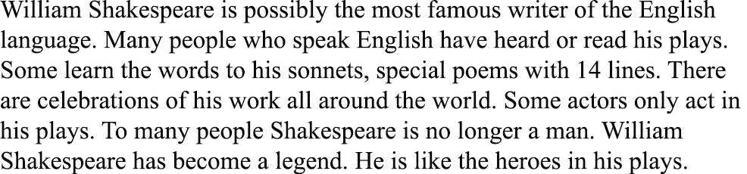

Student 4:
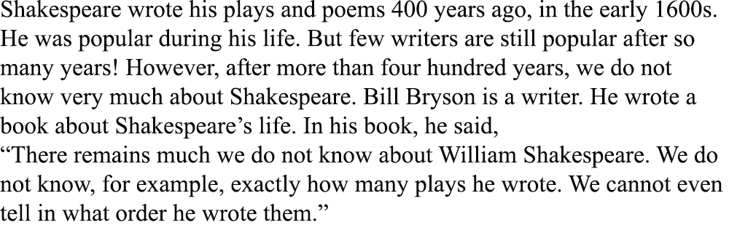
ІІІ. Основна частина заходу.

Student 5:
In spite of Shakespeare’s fame, we know very little about his life because he didn’t write any diaries. But it’s true to fact that he was born on the 23 of April, 1564 in Stratford- on- Avon, a small town in the centre of Great Britain.
In his childhood William went to the local Grammar School, where besides reading and writing he was taught Latin and Greek.
I’d like to add that at that time there were no theatres in England. Groups of actors travelled from town to town and played in different places, usually out- of- doors. Sometimes actors came to Stratford. Young William went to see all their shows and liked them very much. He wanted to become an actor. Sometimes he wrote little plays himself and staged them with his friends.
At the age of 18 William married Anna Hathaway, who was 9 years older than her husband. Their first daughter was born in 1583. And then twins- a son and a daughter followed in 1585.

Student 6 recites The Sonnet 130 Student 7 recites The Sonnet 130
My mistress’ eyes are nothing like the sun;  Coral is far more red than her lips’ red;  If snow be white, why then her breasts are dun;  If hairs be wires, black wires grow on her head.  I have seen roses damask’d, red and white,  But no such roses see I in her cheeks;  And in some perfumes is there more delight  Than in the breath that from my mistress reeks.  I love to hear her speak, yet well I know  That music hath a far more pleasing sound;  I grant I never saw a goddess go;  My mistress, when she walks, treads on the ground.  And yet, by heaven, I think my love as rare  As any she belied with false compare. | Её глаза на звёзды не похожи,  Нельзя уста кораллами назвать,  Не белоснежна плеч открытых кожа,  И чёрной проволокой вьётся прядь.  С дамасской розой, алой или белой,  Нельзя сравнить оттенок этих щёк.  А тело пахнет так, как пахнет тело,  Не как фиалки нежной лепесток.  Ты не найдёшь в ней совершенных линий,  Особенного света на челе.  Не знаю я, как шествуют богини,  Но милая ступает по земле.  И всё ж она уступит тем едва ли,  Кого в сравненьях пышных оболгали.
In English in Russian
And I’d like to recite the translation of the sonnet by Marshak:
Відеопрезентація №3 «Театр- Глобус».
Student 8:
- By the way, I know that W. Shakespeare lived in Stratford until he was about 21.
Then he left for London. I wonder why he left his native town.
Student 9:
- It is unknown. Probably life in Stratford was hard and he wanted to earn some money?
Student 8:
- Maybe, in London William joined a group of actors. The famous Globe Theatre was
the centre of London‘s theatrical life.
Shakespeare played on its stage and wrote plays for this theatre.
Would you like to listen about the theatre of the 16 century?
Student 9:
- Well, in the middle of the square there was a kind of a house.
There the actors dressed and kept the things used in the performance.
In front of it there was a platform on which the actors played.
They came out of the house to the stage through two large doors.
In front of the stage there was a large yard with three balconies round it.
People came here to see performances.
The yard and the greater part of the stage were open to the sky and
the women’s parts were played by boys or young men
Student 8:
- Yes, indeed. It’s just that I was going to say. Besides, an actor played 2 or 3
parts in one performance.
Student 9:
- The actors were often very good. They could play, sing and dance.
The performance began at 3 o’ clock. Londoners loved their theatre very much.
It is interesting to know that everybody went to the theatre in London-
both young and old, rich and poor. Poor people stood in the yard or sat on
the ground. The rich sat in the balconies and the aristocrats were allowed to
sit on the stage.
Student 8:
- And one more thing about the theatre: it played a very important part
in people’s lives as there were no newspapers, no radio or television in those days.
They came to the theatre not only for pleasure; they came to hear the news,
to learn something of the history of England or of some other country.
They were taught the great science of life there.

Student 10- Student 11
recites The Sonnet 90 in English recites The Sonnet 90 in Russian
Then hate me when thou wilt; if ever, now;  Now, while the world is bent my deeds to cross,  Join with the spite of fortune, make me bow,  And do not drop in for an after- loss:  Ah, do not, when my heart hath ‘scaped this sorrow,  Come in the rearward of a conquer’d woe;  Give not a windy night a rainy morrow,  To linger out a purposed overthrow.  If thou wilt leave me, do not leave me last,  When other pretty griefs have done their spite,  But in the onset come; so shall I taste  At first the very worst of fortune’s might,  And other strains of woe, which now seem woe,  Compared with loss of thee will not seem so. | Уж если ты разлюбишь - так теперь,  Теперь, когда весь мир со мной в раздоре.  Будь самой горькой из моих потерь,  Но только не последней каплей горя!  И если скорбь дано мне превозмочь,  Не наноси удара из засады.  Пусть бурная не разрешится ночь  Дождливым утром - утром без отрады.  Оставь меня, но не в последний миг,  Когда от мелких бед я ослабею.  Оставь сейчас, чтоб сразу я постиг,  Что это горе всех невзгод больнее,  Что нет невзгод, а есть одна беда -  Твоей любви лишиться навсегда.
Відеопрезентація № 4

(пісня «Сонет», співає А. Пугачова, переклад С. Маршака)
Student 12:
As you know, W. Shakespeare was an actor, a poet and a dramatist
at the same time. All in all, he wrote 37 plays, 2 poems and 154 sonnets
where he showed his creative genius.

(На экрані з’являються твори Шекспіра)
Student 13:
The first period (1590- 1600) of Shakespeare’s creative work consists
of comedies and historical dramas. In this period he wrote such histories
as “King Henry the IV”, “King Henry the V”, “King Richard the II”,
“King Richard the III” etc.
Here the author showed historical events and dramatic characters. Speaking about his
famous tragedies, I can say that they appeared in the second period of his literary work
between 1600 and 1608. In the plays of this time, the dramatist reaches his full maturity.
These are “Hamlet”, “King Lear”, “Macbeth”, “Othello”. “Romeo and Juliet”, I think,
is one of his best plays. It’s a tragedy but it is full of love, youth and humanism.

Відеопрезентація №5
Вікторина на знання творів В. Шекспіра
Teacher: And now try to guess what extracts of the films you’ll see on the screen.
Викладач пропонує студентам переглянути англомовні фрагменти екранізованих творів У.Шекспіра та пригадати імена улюблених героїв та назви творів англійською мовою.
Student 14:
English language is very different now. But this is partly because of William
Shakespeare. His writing influenced the English language.
People still use his words and sayings. Without Shakespeare, our words would
be just so different. He gave us special ways of expressing hope and depression,
sadness and anger. Even if you have never read his work, you may have used his
words. It is very difficult to avoid.

In 1612 Shakespeare left London for Stratford. He didn’t act any more.
Since 1613 he no longer wrote plays. Nobody knows what he did during
the last years of his life. Eventually, he died on the 23 of April 1616.
It’s incredible but true that he died on his birthday at the age of 52.

Pupil 15 Pupil 16
recites the Sonnet 116 in English recites the Sonnet 116 in Russian
Let me not to the marriage perfect minds  Admit impediments; love is not love  Which alters when it alternation finds,  Or bends with the remover to remove.  O, no, it is an ever-fixed mark  That looks on tempests and is never shaken;  It is the star to every wand’ring bark,  Whose worth’s unknown,  although his height be taken.  Love’s not Time’s fool, though rosy lips and cheeks  Within his bending sickle’s compass come;  Love alters not with his brief hours and weeks,  But bears it out to the edge of doom.  If this be error and upon me proved,  I never writ, nor no man ever loved. | Мешать соединенью двух сердец  Я не намерен.  Может ли измена  Любви безмерной положить конец?  Любовь не знает убыли и тлена.  Любовь - над бурей поднятый маяк,  Не меркнущий во мраке и тумане.  Любовь - звезда, которою моряк  Определяет место в океане.  Любовь - не кукла жалкая в руках  У времени, стирающего розы  На пламенных устах и на щеках,  И не страшны ей времени угрозы.  А если я не прав и лжет мой стих,  То нет любви - и нет стихов моих!

And I’d like to recite the translation of the sonnet by Pasternak:

Teacher: It must be admitted that British people are very proud of their great poet
and call him “Our National Bard”, “The Immortal Poet of Nature”,
“The Swan of Avon”, “The Great Unknown”.
Moreover, W. Shakespeare is beloved by all people.
His plays are staged in our theatres as well as all over the world and
are always a great success with the public.
And now let one of our teacher recite his
favourite sonnet.
Teacher recites the sonnet 106 in English and in Russian:

When in the chronicle of wasted time  I see descriptions of the fairest wights,  And beauty making beautiful old rhyme  In praise of ladies dead and lovely knights,  Then, in the blazon of sweet beauty's best,  Of hand, of foot, of lip, of eye, of brow,  I see their antique pen would have express'd  Even such a beauty as you master now.  So all their praises are but prophecies  Of this our time, all you prefiguring;  And, for they look'd but with divining eyes,  They had not skill enough your worth to sing:  For we, which now behold these present days,  Had eyes to wonder, but lack tongues to praise. | Когда читаю в свитке мертвых лет  О пламенных устах, давно безгласных,  О красоте, слагающей куплет  Во славу дам и рыцарей прекрасных,  Столетьями хранимые черты -  Глаза, улыбка, волосы и брови -  Мне говорят, что только в древнем слове  Могла всецело отразиться ты.  В любой строке к своей прекрасной даме  Поэт мечтал тебя предугадать,  Но всю тебя не мог он передать,  Впиваясь в даль влюбленными глазами.  А нам, кому ты наконец близка, -  Где голос взять, чтобы звучал века?
Teacher: Let’s read the phrases that became immortal through the Аges.
Відеопрезентація № 6
- To be or not to be that is the question.- Бути чи не бути, ось в чому питання.
-The beginning of the end - Початок кінця.
-All is well that ends well - Все добре що добре закінчується.
Life is not all cakes and ale - Життя прожити - не поле перейти.
Much ado about nothing - Багато галасу з нічого
Sweets to the sweet - Прекрасне - прекраснії.
Brevity is the soul of wit - Стислість сестра таланту.
To win golden opinions - Заслужити сприятливу думку.
The wrilling of time - Мінливості долі.

Teacher: We are coming to the end.
Thank you for taking part in the contest.

