WE ARE SMART SHOW
The teacher: Hello, everybody. This is ”We are smart show”. It is for those who are clever and intelligent. For those who love knowledge and we start with a What-question station. All these questions are connected with Britain.
(I Station)
1)What is the full name of Great Britain?
(The UK of Great Britain and Northern Ireland)
2)What is the capital of England?
(London)
3)What are the main colors of the Union Flag?
(Blue, red and white)
4)What is the favorite hot drink in Britain?
(Tea)
5)What do the English people drink their tea with?
(with milk)
6)What parts does Great Britain consist of?
(England, Scotland, Wales, Northern Ireland)
7) What is the kilt?
(It’s a man’s skirt in Scotland)
8)What is the name of the present British Queen?
(Elizabeth the II)
9)What is the name of the English writer or the Queen of Crime who wrote detective stories?
(Agatha Christie)
10)What is name of the well- known clock in London?
(Big Ben)
11)What are the Beatles?
12)What musical instrument did they play?
(guitars, drums)
13)What is the name of their song about the past?
(Yesterday)
14)What are the popular English Christmas songs?
("Jingle Bells")
15)What is the national flower of England?
(Rose)
16)What is the name of London buses?
(Double-deckers)
17)What are the oldest British Universities?
(Oxford and Cambridge)
18)What is the place for Crown's jewels?
(the Tower)
19)What are the birds which live in the Tower?
(crows)
20)What are the bank holidays?
(when banks are closed)
II. Station ”Who knows proverbs”
(Put the words so that you have a proverb, stand one by one in the correct order.
a. Everything is good in its season
b. Good health is above wealth
c. Lost time is never found again
d. Don’t put all your eggs in one basket
III. Station ”So many countries so many cultures”
(The teacher hands out placards to the students who work in two groups. They glue the mixed pictures, names of the countries and their capitals correctly)
The USA Washington, DC
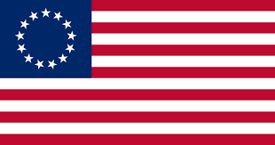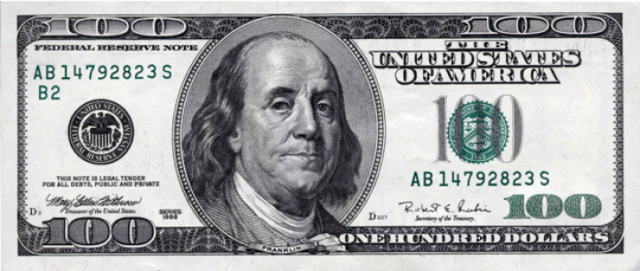
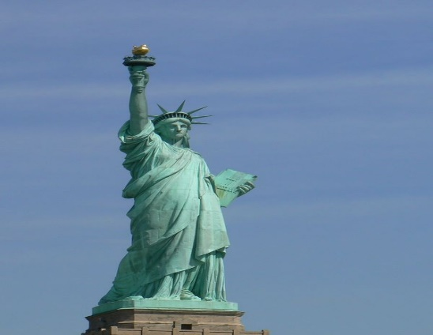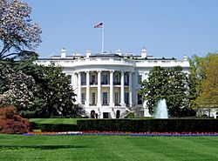
Australia, Canberra
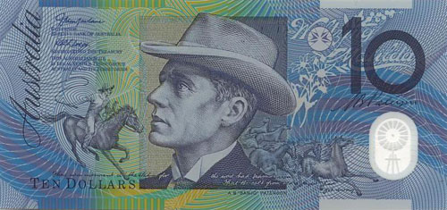
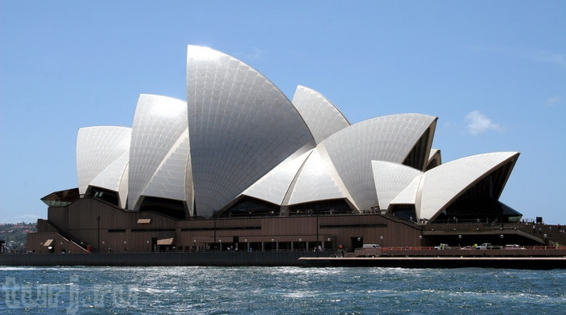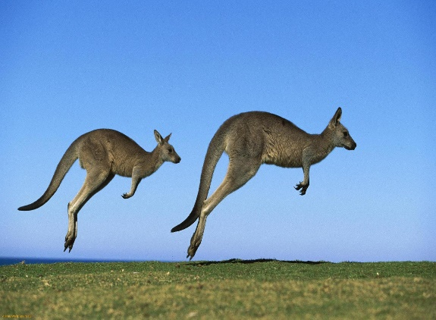
New Zealand, Wellington

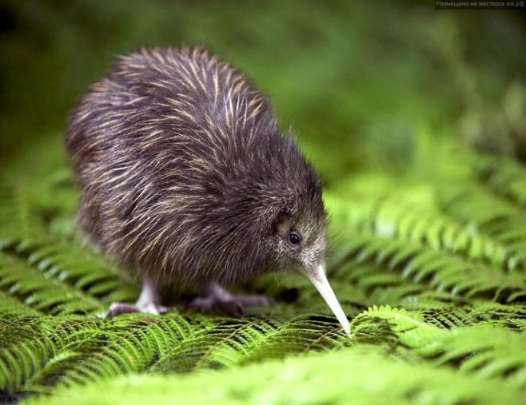 
(kiwi bird) Bridal Veil Falls.

Egypt, Cairo
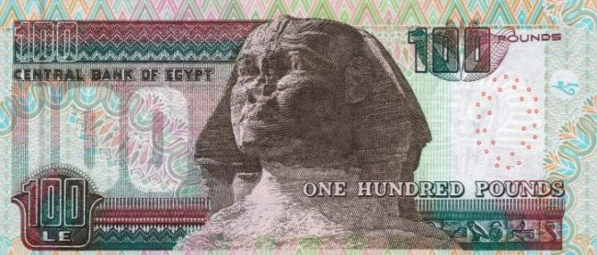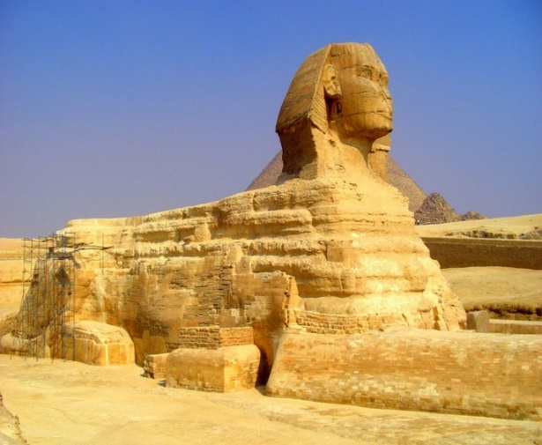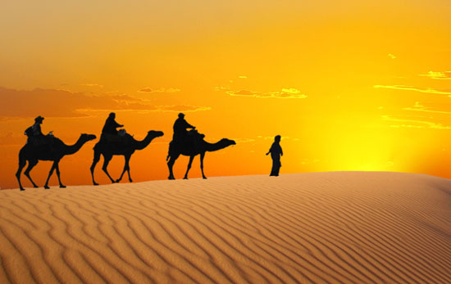
Canada ,Ottawa
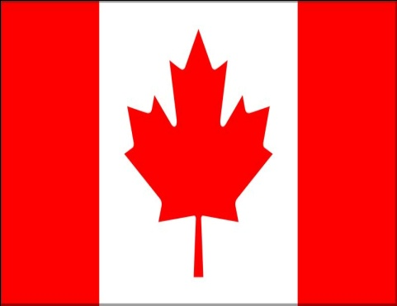 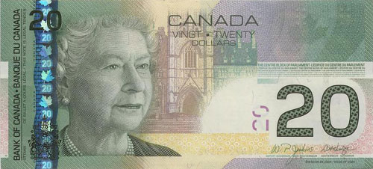
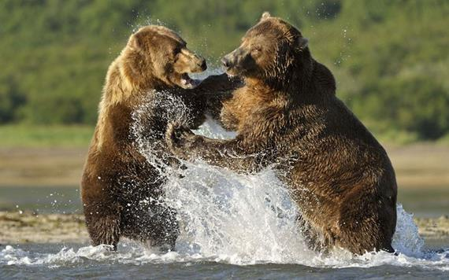
(Toronto) (grizzly bears)

Israel, Jerusalem
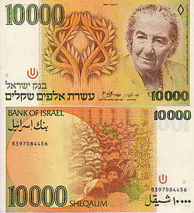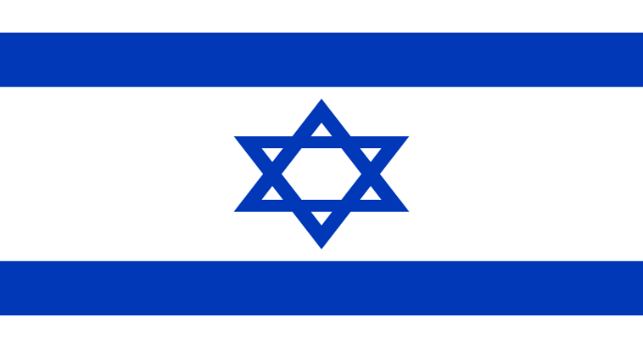
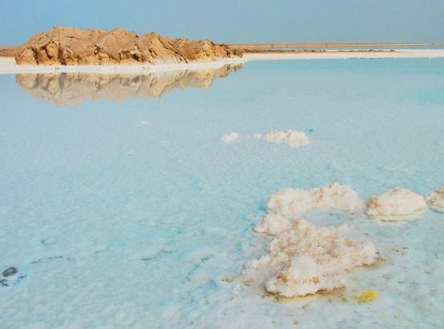 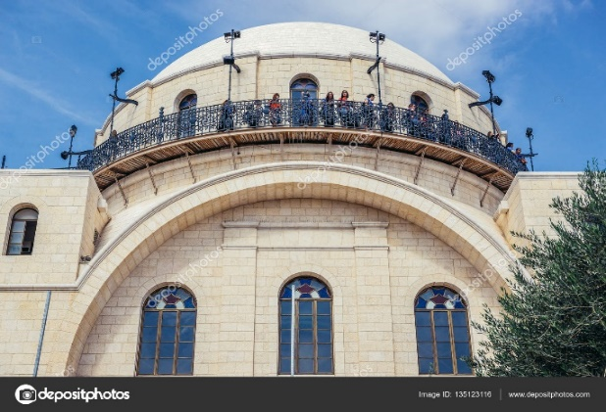
The DAED SEA (Synagogue)
Turkey , Ankara
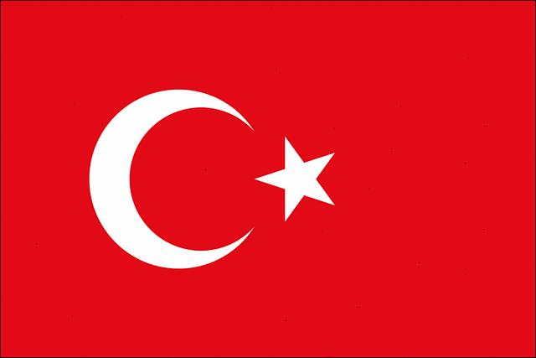 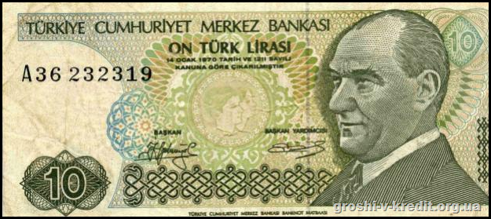
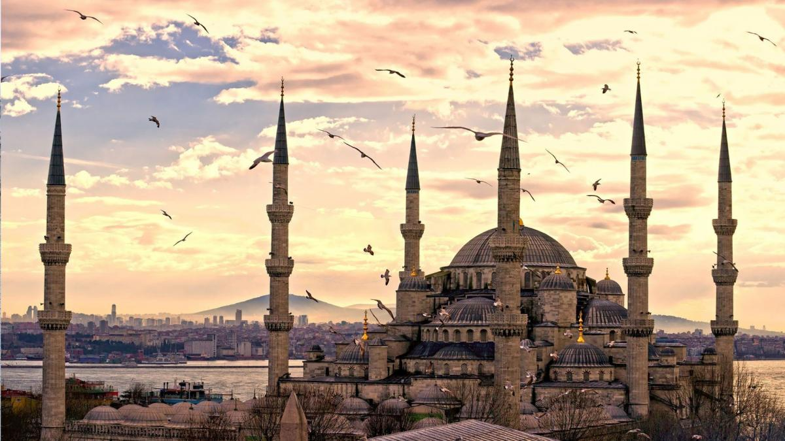 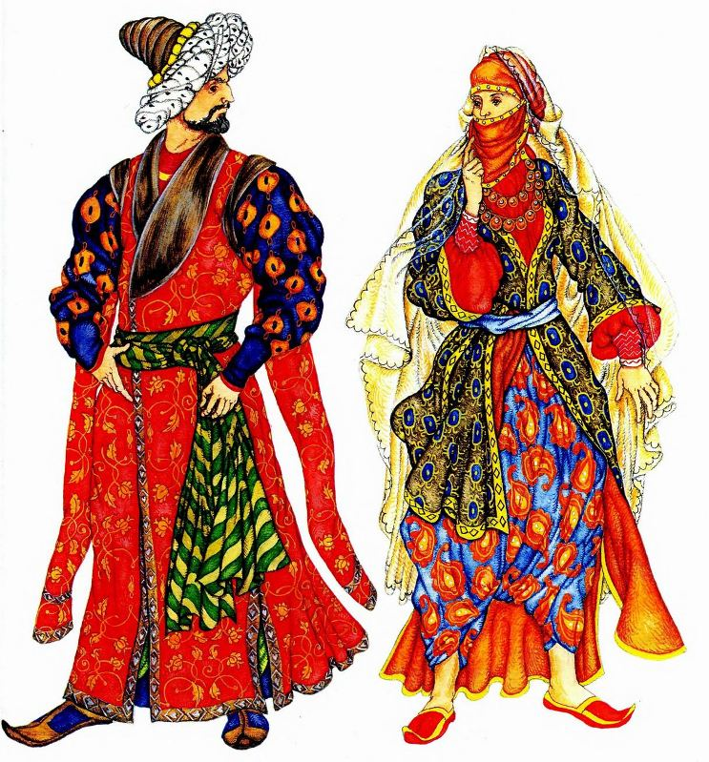
(Mosque)
France, Paris
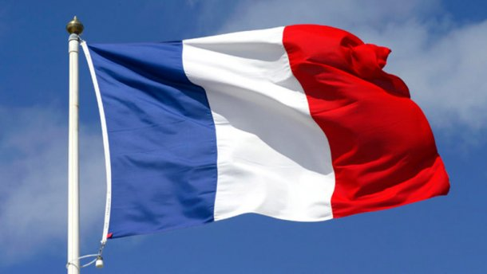 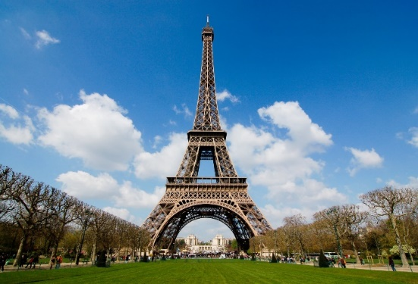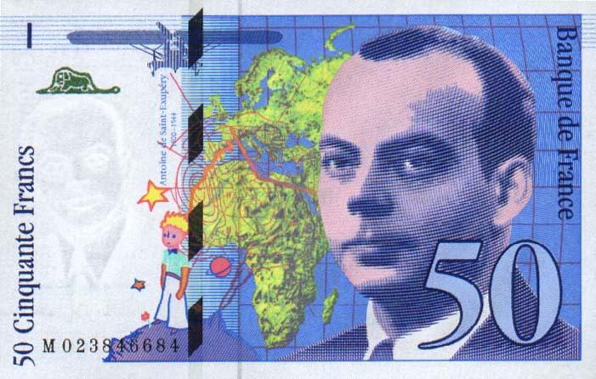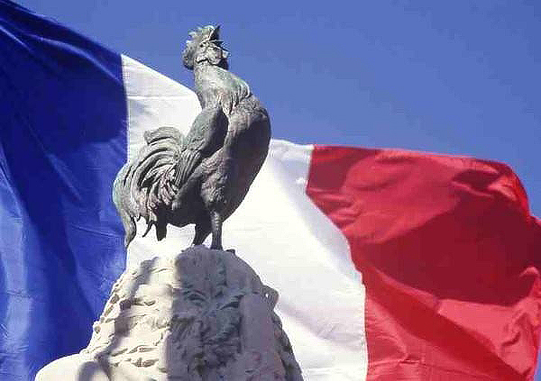
(Gallic Rooster) -Галльський півень)
IV. And this station is for those who like acting.
It’s ”The best performer”
The students act out the scenes from ” The adventure of Tom Sawyer
by Mark Twain”
Scene A Tom Sawyer and Aunt Polly
Characters : Tom Sawyer and Aunt Polly
Aunt Polly: Tom!... Tom!...(no answer). Where is the boy? Tom!
Tom (appearing): Here I am.
Aunt Polly: Oh, you have been to that closet. What were you doing there?
Tom : Nothing.
Aunt Polly: Nothing! Look at your hands. (Tom looks at his hands). And look at your mouth. What is that?
Tom: I don’t know, aunt Polly.
Aunt Polly: Well, I know. It’s jam , that’s what it is. (Pointing to a switch on the floor). Hand me that switch.
Tom : Oh, look behind, Aunt.
(Aunt Polly looks behind her. Tom runs away. Aunt Polly stands surprised for a moment, then she breaks into a laugh).
Scene B Tom Sawyer whitewashes the fence
Characters : Tom Sawyer ,Aunt Polly ,Ben ,Billy
Aunt Polly: Tom, go and whitewash the fence.
Tom: Oh, Auntie, I can’t. I’ll do it …. Tomorrow.
Aunt Polly: Whitewash the fence, I say.(goes away)
(Tom begins whitewashing the fence. Ben appears. He has an apple in his hand).
Ben : What are you doing?
Tom : I am whitewashing the fence.
Ben : Do you want to say you like it?
Tom: Of course, I do. Does a boy whitewash the fence every day?
(Tom goes on whitewashing the fence. He doesn’t look at Ben).
Ben : Tom ,let me whitewash the fence a little.
Tom : No , I can’t. Jim wanted to do it, but aunt Polly didn’t let him.
Ben : Tom, do let me. I’ll give you my apple.
Tom :all right. (Tom takes the apple , sits down and begins to eat it).
(Ben is whitewashing the fence. Billy appears).
Billy :Hello! What are you doing here?
Ben : Tom and I are whitewashing the fence.
Billy : You don’t think it is interesting, don’t you?
Ben : We do. Jim wanted to do it , but aunt Polly didn’t let him.
Billy : Let me whitewash it a little!
Ben No, I won’t!(They begin fighting)
Tom :Stop that! Now it’s your turn to whitewash, Billy…
Now it’s your turn to whitewash, Ben…
(Aunt Polly appearing): Oh, it’s done! You are a good boy ,Tom . you may go and play.
Tom : Hurrah! Let’s run to the river!
All the boys: Hurrah!(run away)
Scene C Tom Sawyer doesn’t want to go to school
Characters : Tom Sawyer ,Aunt Polly, Sid, his cousin
(Tom and Sid are in their beds. It is morning and time to get up. Tom doesn’t want to go to school. He wants to be ill. Then he could stay at home).
Tom(sitting): I don’t want to go to school. What can I do to stay at home? Oh ! my tooth is loose. That’s wonderful!... No, it won’t do. Aunt Polly will pull it out…
Oh ,what a wonderful idea came to me!(He lies back and begins to cry. But Sid is sleeping. Tom cries louder):Sid! Sid!
Sid (opens his eyes): What has happened, Tom?
(Tom doesn’t answer. He continues crying. Sid sits up and looks at Tom).
Sid : Tom! Say, Tom! Tom! What has happened to you?
(He gets up and comes up to Tom. Tom continues crying).
Tom : Oh, Sid I am dying. I am not angry with you.
Sid : Oh, Tom you are not dying! Don’t.
Tom: I am not angry with aunt Polly. Tell her so. And , Sid , give my cat with one eye to the new girl at school and tell her…
(Sid takes his clothes and runs out of the room).
Sid (shouting): Oh, Aunt Polly, come! Tom is dying!
Aunt Polly: dying!
Sid : Yes, come quickly!
Aunt Polly: Don’t say so!(She runs in and comes quickly up to Tom’s bed).
You , Tom, what’s happened to you , my boy?
Tom : Oh, Aunt Polly: at my right hand! It is red and hot.
Aunt Polly (seeing his hand is not red and hot): Oh, Tom , stop that nonsense and get up!
Tom: But, Auntie, it is so hot, that I’ve forgotten about my tooth.
Aunt Polly: Your tooth? And what has happened to your tooth?
Tom :It’s loose.
Aunt Polly: Open your mouth. Well, you are right. Your tooth is loose. Sid bring me some thread.
Tom :Oh, please, dear Auntie, don’t pull it out. It ‘s all right now.
(Sid brings the thread. Aunt Polly ties one end of the thread to Tom’s tooth and the other to bed. Then she suddenly claps her hands before Tom’s face. Tom falls back, you can see the tooth hanging on the thread).
Tom :Oh, Oh!(He covers his mouth with his hands). Oh! My tooth was all right. But I didn’t want to go to school.
Aunt Polly: Oh , Tom, so all this is because you didn’t want to go to school.
You want to go fishing. Tom, Tom, I love you so dearly, and you…Now get up quickly and get ready to go to school!
V. What Queen likes and dislikes
(Clap one time if she likes it and clap two times if she dislikes something. The teacher mixes all the variants)
The Queen likes:
1.Horse racing.
2.Scottish country dancing.
3.Jigsaw puzzles.
4.Bright red dresses.
5.Deerstalking.
6.Champagne.
7. Long-stemmed, deep-pink carnations.
8.Quiet evenings at home.
9.Sandringham.
10.The Beatles film, Yellow Submarine.
The Queen Dislikes:
1.Tennis,including Wimbledon.
2.Milk pudding.
3. The cold.
4.Charles Dickens.
5.Dictating letters.
6.Cigar smoke.
7.Sailing.
8.Listening to after-dinner speeches .
9.Ivy.
10.Snails.
(an extra activities if you have enough time) Riddles
- I ’am tall when I’m young and I’m short when I’m old. What am I?
(a candle)
- In a one- story pink house, there was a pink person , a pink cat, a pink fish a pink computer, a pink chair, a pink table, a pink telephone, a pink shower – everything was pink! What color were the stairs? (there were no stairs , it was a one story house)
- What is at the end of a rainbow?(the letter W)
- What starts with the letter ’’t’’, is filled with ’’t’’ and ends in ’’t’’?
- (a teapot)
- What gets wetter and wetter the more it dries? (a towel)
- Which weighs more, a pound of feathers or a pound of bricks? (neither they both weigh one pound)
- How many months have 28 days? (all 12 months)
- Name four days of the week that start with the letter ’’ t’’?(Tuesday, Thursday, today, tomorrow)
- Two mothers and two daughters went out to eat, everyone ate one burger, yet only three burgers were eaten in all. How is it possible? (There were a grandmother, mother and daughter)
- A cowboy rides into town on Friday, stays for three days, then leaves on Friday. How did he do it? (his horse’s name was Friday).
Teacher : well, dear it’s time to say good bye and never forget so many countries so many cultures. Be smart and curious , have a great desire to know something new.

