ДВНЗ
«Чернівецький політехнічний коледж»
Предмет Іноземна мова (англійська)
Тема заняття: Сучасні архітектори та їх проекти. Світові шедеври архітектури.
Мета: познайомити студентів з видатними архітекторами сучасності та їх знаковими спорудами. Ввести та активізувати англомовну лексику з теми.
Розвивати навички аудіювання, мовлення, читання та письма студентів.
Розширити знання студентів про архітектурні стилі та архітектурні шедеври світу.
Тип заняття: комбіноване заняття.
Обладнання: мультимедійний проектор, ноутбук, презентації, підручники, роздавальний матеріал.
Міжпредметні зв’язки: спец предмети зі спеціальності (історія архітектури, матеріалознавство), українська мова.
Література:
1. Голощук С.Л. Англійська мова для архітекторів: Навч. Посібник. – Львів: «Львівська політехніка», 2018.
2. V.Yanson A Practical Guide for Learners of English= Практичний курс англійської мови для студентів вищих навчальних закладів. Навч. Посібник. – Київ: ТОВ «ВП Логос-М», 2011.
3. Oxford Elementary Leaner’s Dictionary.
4. Інтернет ресурси.
Структура заняття
- Організаційний момент.
- Мовленнєва зарядка.
Дати відповіді на запитання.
- Мотивація навчальної діяльності, повідомлення теми і мети.
Слово викладача.
- Актуалізація вивченого матеріалу.
IV.1. Метод творчих завдань.
- Визначити архітектурний напрямок згідно прочитаної характеристики.
(додаток 1).
-З’єднати малюнок відповідно до архітектурного стилю (додаток 2).
IV.2. Розвиток мовленнєвих навичок. Бесіда.
- Прокоментувати архітектурні стилі, до яких належать нижчевказані будівлі (додаток 3).
- Назвати архітектурні стилі, які найбільше подобаються і є найбільш цікавими і чому .
V. Підготовка до вивчення нового матеріалу.
V.1. Дати відповіді на запитання.
V.2. Ввести новий лексичний матерал.
VI. Осмислення нового матеріалу.
VI.1. Читання уривків тексту та їх переклад. (додаток 4).
VI.2. Виконання вправ щодо активізації нової лексики. (додаток 5).
- Дати відповіді на запитання до тексту.
- Дати еквіваленти українською та англійською мовами.
- Знайти пояснення слова та перекласти його.
- Дібрати синонімічний ряд до поданих слів.
VII. Закріплення вивченого матеріалу.
VII.1. Презентації студентів про визначних архітекторів ХХ-ХХI століття та їх шедеври.
VII.2. Вибрати правильне твердження та продовжити речення. (тести)
(додаток 6).
VIII. Підведення підсумків заняття, виставлення та коментування оцінок.
IX. Домашнє завдання: читати та перекладати текст, вивчити нову лексику, ознайомитися з презентаціями «шедеври архітектури Європи та світу» на сайті
http://vk.com/ english_ for_ free

Структура заняття
- Організаційний момент.
Good morning! Glad to see you! This lesson is unusual for you and for me! You can see many guests today! I hope that our cooperation will be successful!
Now I want to know who is absent today.
- Мовленнєва зарядка.
As you already know there are different trends in architecture but let’s think and try to answer my questions.
- How do you understand the term”signature building”?
- Do you know such a building in your native city?
- What makes it distinctive?
- What is the purpose of this construction?
III. Мотивація навчальної діяльності, повідомлення теми і мети.
As you can guess our topic today is “Modern Architects and their Masterpieces”.
So, we are going to learn much about gifted architects and their signature buildings not only in Europe but in the whole world.
IV. Актуалізація вивченого матеріалу.
Last time we spoke about architectural styles. Let’s revise. I’ll read some facts about each style and you’ll try to guess what style I’m speaking about.
  - Визначити архітектурний стиль згідно прочитаної характеристики.
(додаток 1).

Egyptian Art  (2800-1700) B.C. | Gigantic royal pyramids were made in a terraced form and with smooth sides. Egyptian pyramids, temples and sculpture served primarily the worship of the dead. Sculptures of gods and pharaohs also decorated architecture.
Byzantine Art  (5th c. A.D.) | This style is characterized by a central dome over a square space, with mosaic incrustation and marble veneering of the walls, masonry construction, round arches, low domes, and the presence of fine spiky foliage patterns in low relief of stone capitals.
Renaissance Art  (14th-17th c.c.) | A group of architectural styles existed in Italy as adaptation of ancient Roman architectural details or compositional forms or contemporary uses, characterized at first by the free and inventive use of isolated details, later by the more imitative use of whole orders, and at all periods by an emphasis on symmetry, exact mathematical relationships between parts, and a general effect of simplicity and repose.
Baroque Art  (17th c.) | This style is highly-decorated originated in Italy which was fashionable in art, buildings, etc. in Europe during the 17th c., characterized by free and sculptural use of the classical orders, by forms in elevation and plan suggesting movement and dramatic effect.
Greek Art  (8th-4th c.c. B.C.) | The Acropolis was a fortified hill in Athens. The Pantheon, a Doric temple (448-438 B.C.) honoured the goddess Athena. The temples of the Doric order were monolithic, solemn and rigid.  In the Ionic order columns were slender, tall with a complex base. On the ornamented headpiece was a capital with a pair of curling spirals called volutes.
Empire  (19th c.) | The style of architecture prevailing in France and imitated to a greater or lesser extent in various other countries. It’s characterized by the use of delicate but elaborate ornamentation imitated from Greek and Roman examples and containing classical allusions, such as bas-relief of classical figures, motifs of wreaths, torches, lyres and urns.
Modernism  (20th c.) | A deliberate philosophical and practical divergence from the past in the arts occurring especially in the course of the 20th century and taking form in any of various innovative movements and styles.

  - З’єднати малюнок відповідно до архітектурного стилю (додаток 2).
Look at the pictures. Link each of them with one of the architectural styles.
  - Розвиток мовленнєвих навичок.
4.3.1. Прокоментувати архітектурні стилі, до яких належать нижчевказані будівлі (додаток 3).
The Temple of Apollo at Corinth (7th c. B.C.)
The Rheims Cathedral (1211-1430)
The Cathedral of Notre-Dame de Paris (12th c.)
Leaning Tower of Pisa (1063-1350)
Sultan Hassan Mosque (1356-1363)
Taj Mahal (1630-1653)
Versailles (17th-18th c. c)
The Winter Palace in St. Petersburg (1754-1764)
Arch of the former General Headquarter Building in St.Petersburg (1819-1829)
Hongkong and Shanghai Bank (1979-1986)
Millennium Dome (1999)
St.Sofia Cathedral (11th-18th A.D.)

4.3.2. Назвати архітектурні стилі, які найбільше подобаються і є найбільш цікавими і чому .
V. Підготовка до вивчення нового матеріалу.
5.1. Дати відповіді на запитання.
- What famous modern architects do you know?
- What are their buildings?
- Which architects and their works do you know in the English-speaking countries?
- What signature buildings are in Europe especially in Germany? In France?in Spain or Italy?
- What do you know about Ukrainian architects?
5.2. Ввести новий лексичний матеріал.
Please, memorize the essential vocabulary
Aesthetics – the study of beauty, especially beauty in art. (естетика)
Attempt – the act of trying to do smth., especially smth. difficult. (спроба, намагання)
Blob – a very small round mass of a liquid or sticky substance. (крапля, маленька кулька)
To curve – to bend or move in a shape of a curve. (вигинати)
debt – a sum of money that a person or organization owes. (борг)
To dedicate – to devote to a subject, task or purpose. (присвячувати)
flop – a total failure. (невдача, провал)
Hunt – a search for someone or something that is difficult to find. (полювання, пошук)
To mark – to show where something is situated. (відзначати)
Nickname – a familiar or humorous name for a person or thing. (прізвисько)
Pure – absolute, not mixed with any other substance or material. (чистий)
Reportedly – according to what some people say (згідно з повідомленнями)
Site – a place where something important or interesting happened. (місце знаходження).
Urbanist – a person who specializes in urban planning. (містобудівник)
Wide-ranging – including a wide variety of subjects, things or people. (широкомасштабний)
VI. Осмислення нового матеріалу.
6.1. Читання уривків тексту та їх переклад (додаток 4).
6.2. Виконання вправ щодо активізації нової лексики. (додаток 5).
6.2.1. Дати відповіді на запитання до тексту.
- Which building began the history of designing signature buildings?
- Why do cities hunt for signature buildings?
- What is meant by signature buildings?
- Why is it possible to construct such buildings nowadays?
- Would you name any signature building in your city?
- Who are the architects of signature buildings?
- Why is it important to have a signature building in your city?
6.2.2. Дати еквіваленти українською та англійською мовами.
Match each word in one section with its translation in another.

1.To remain | a.містобудівник
2. skyline | b.борг
3. Wide-ranging | c.залишатися
4. attempt | d.згідно з повідомленнями
5. nickname | e.широкомасштабний
6. gherkin | f.спроба, намагання
7. urbanist | g.прізвисько
8. reportedly | h.дрібний огірок
9.hunt | i.горизонт
10. pure | j.чистий
11. blob | k.крапля, маленька кулька
12. debt | l.пошуки
13.To curve | m.вигинати
6.2.3.Співставити слово з його поясненням Match each word with its definition
to curve | an area of ground on which something is located
site | an act of hunting
to dedicate | to form into a curve
nickname | to be in the same place or condition during further time
urbanist | the state of owing money
signature building | a name given to someone, especially by their friends or family
wide-range | a well-known to the public building
to remain | covering an extensive range
hunt | specialist in city studies
debt | to give all your attention and effort to one particular thing
6.2.4. Дібрати синонімічний ряд до поданих слів.
Find the synonyms for the given words.
To put up | Effort, try
To curve | Search, look
Attempt | To bend, to turn
To mark | To erect
Blob | Monumental, commemorative
Hunt | Horizon
Memorial | To devote, to commit, to give
Due to | To indicate, to label
To dedicate | Place, location, area
Site | Drop
Skyline | On account of, as a result of
VII. Закріплення вивченого матеріалу.
7.1. Презентації студентів про визначних архітекторів ХХ-ХХI століття та їх шедеври.
7.2. Вибрати правильне твердження та продовжити речення. (тести)
(додаток 6). Choose the right answer:
- The Guggenheim Museum in Bilbao
a) started the trend for signature buildings
b) was Frank Gehry’s first building
c) was designed but never built
d) was not a success.
- The fashion for signature buildings has
a) been bad for a lot of cities
b) caused an increase in building work around the world
c) made some architects become very famous
d) only become possible thanks to computers.
- What is the meaning of the word “gherkin” in the text?
a) a department store in Birmingham
b) a kind of pickled cucumber
c) an unusual shaped building in London
d) Norman Foster’s nickname.
- Santiago Calatrava’s buildings for the Olympic Games
a) are the same as the Pompidou centre
b) have cost the Greek government a lot of money
c) were all bridges
d) were of Spanish style.
- A lot of new architecture
a) has had commercial problems
b) is all ugly
c) has to have a funny nickname
d) is pure fantasy.
VIII. Підведення підсумків заняття, виставлення та коментування оцінок.
IX. Домашнє завдання: читати та перекладати текст, вивчити нову лексику, ознайомитися з презентаціями «шедеври архітектури Європи та світу» на сайті
http://vk.com/ english_ for_ free

APPENDIX
Додаток №1.
Define the style.
Gigantic royal pyramids were made in a terraced form and with smooth sides. Egyptian pyramids, temples and sculpture served primarily the worship of the dead. Sculptures of gods and pharaohs also decorated architecture.
This style is characterized by a central dome over a square space, with mosaic incrustation and marble veneering of the walls, masonry construction, round arches, low domes, and the presence of fine spiky foliage patterns in low relief of stone capitals.
A group of architectural styles existed in Italy as adaptation of ancient Roman architectural details or compositional forms or contemporary uses, characterized at first by the free and inventive use of isolated details, later by the more imitative use of whole orders, and at all periods by an emphasis on symmetry, exact mathematical relationships between parts, and a general effect of simplicity and repose.
This style is highly-decorated originated in Italy which was fashionable in art, buildings, etc. in Europe during the 17th c., characterized by free and sculptural use of the classical orders, by forms in elevation and plan suggesting movement and dramatic effect.
The Acropolis was a fortified hill in Athens. The Pantheon, a Doric temple (448-438 B.C.) honoured the goddess Athena. The temples of the Doric order were monolithic, solemn and rigid.
In the Ionic order columns were slender, tall with a complex base. On the ornamented headpiece was a capital with a pair of curling spirals called volutes.
The style of architecture prevailing in France and imitated to a greater or lesser extent in various other countries. It’s characterized by the use of delicate but elaborate ornamentation imitated from Greek and Roman examples and containing classical allusions, such as bas-relief of classical figures, motifs of wreaths, torches, lyres and urns.
A deliberate philosophical and practical divergence from the past in the arts occurring especially in the course of the 20th century and taking form in any of various innovative movements and styles.

Додаток №2.

Match the cards and pictures.
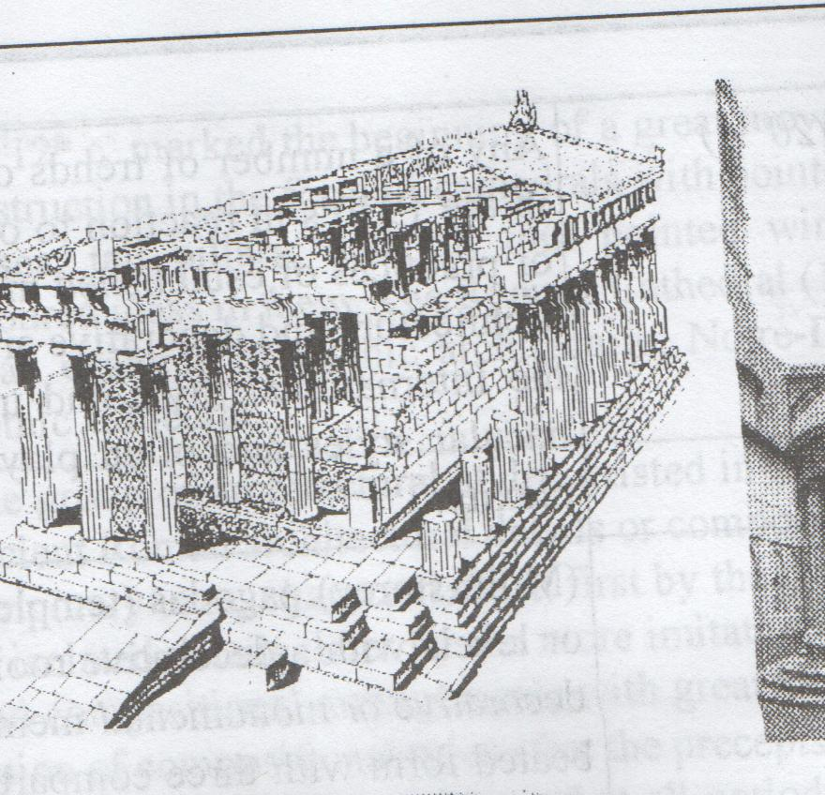 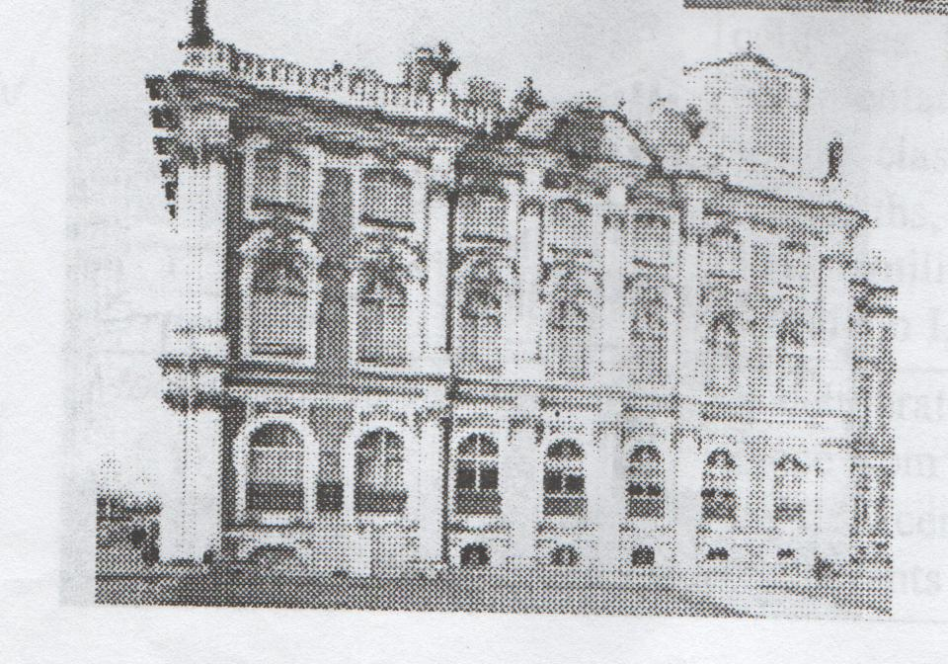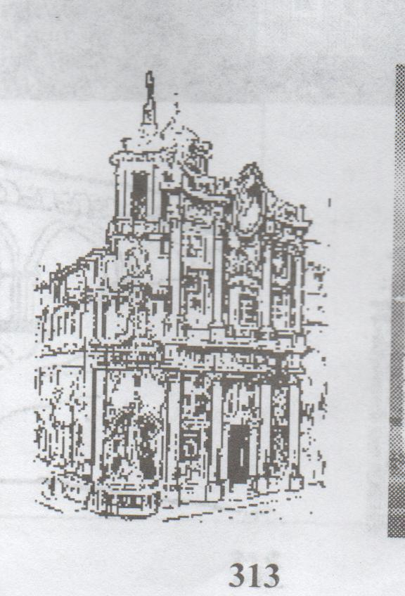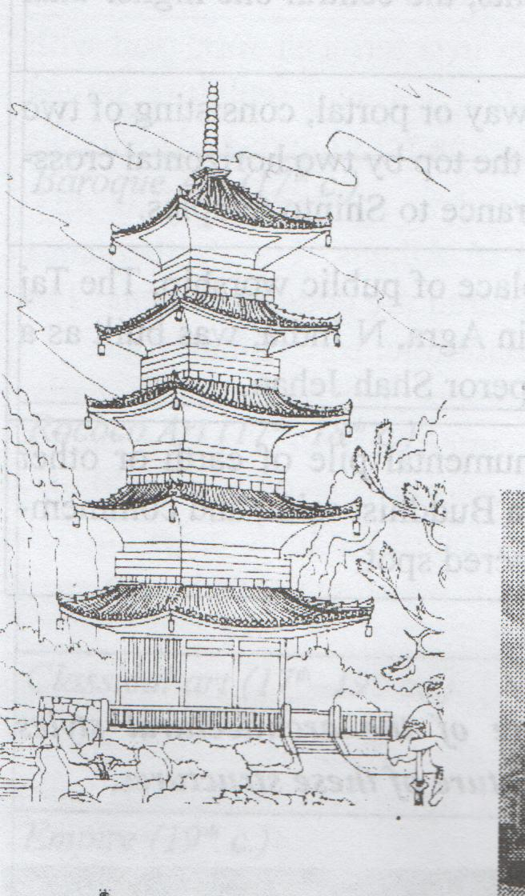 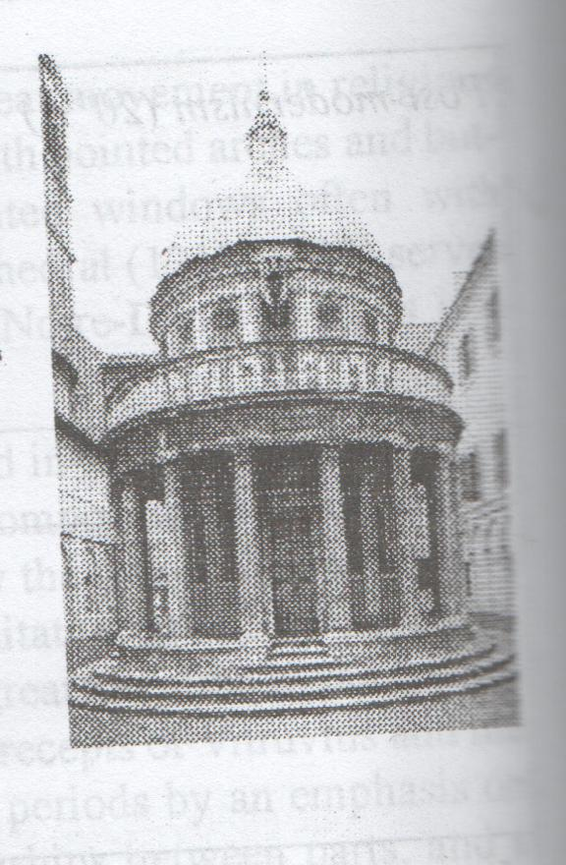
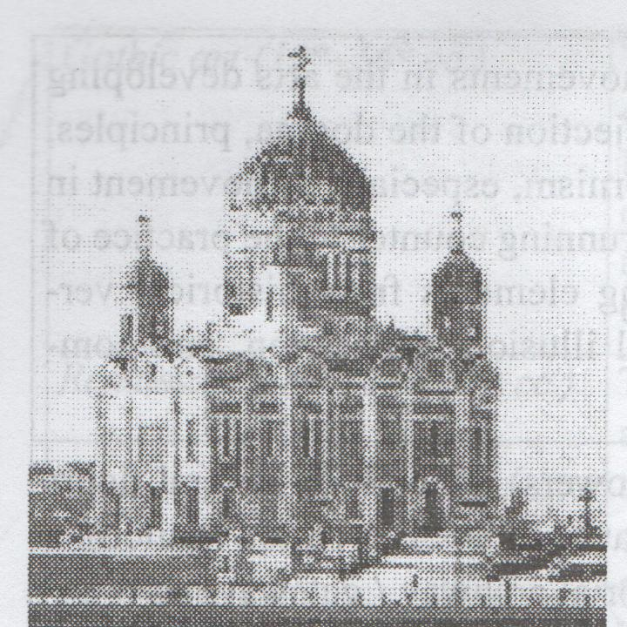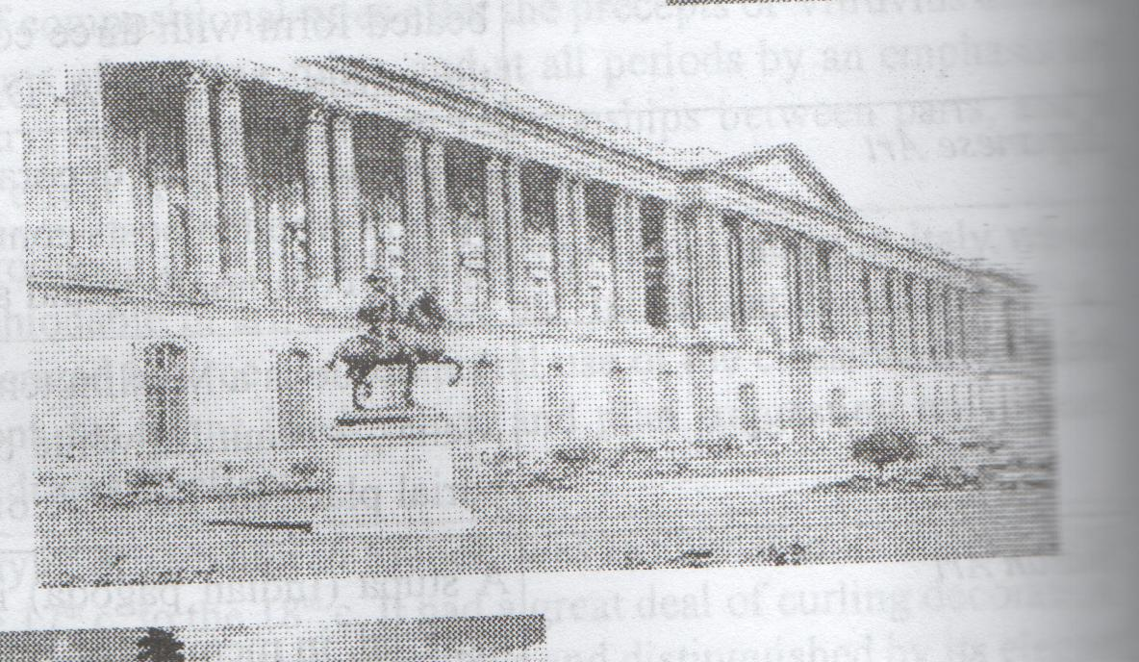
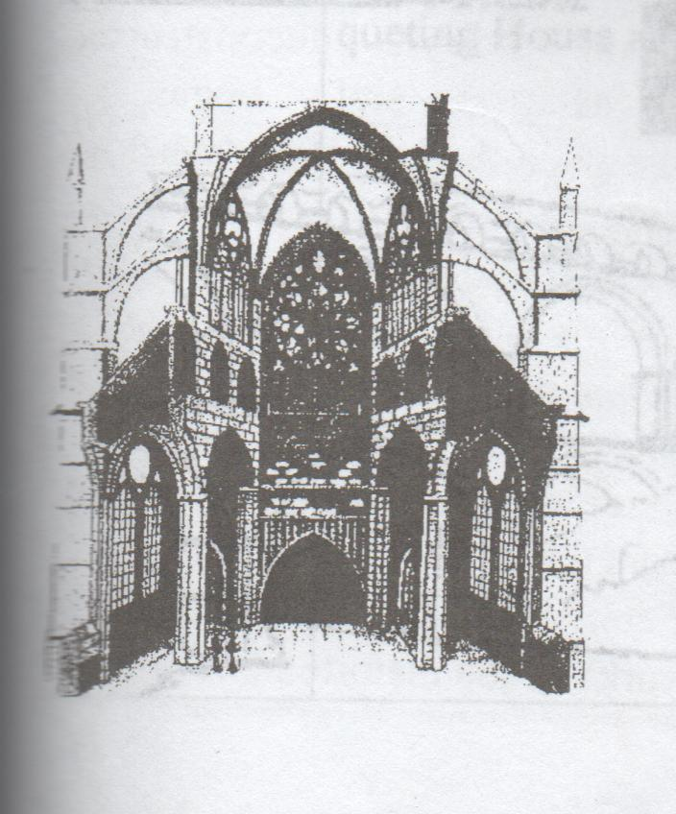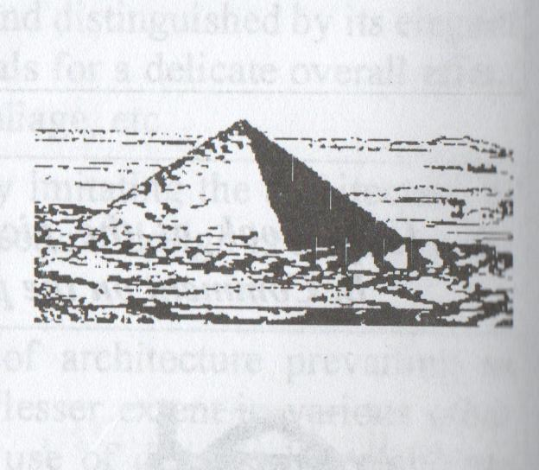

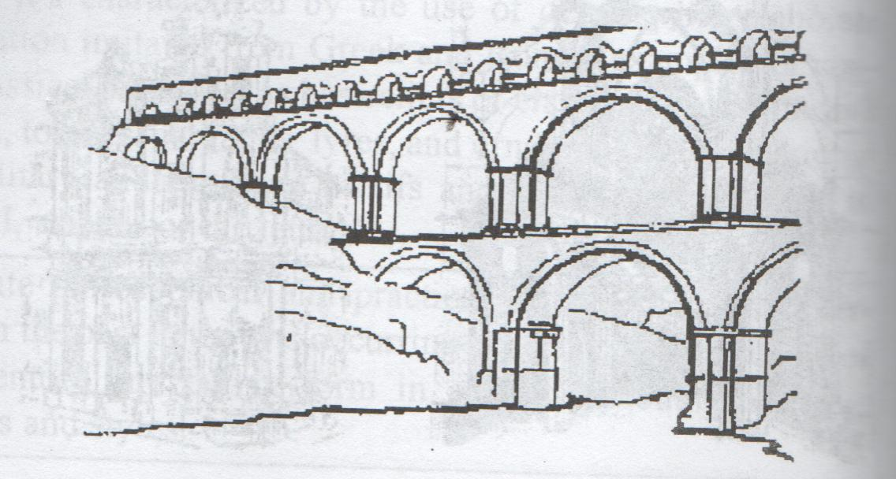

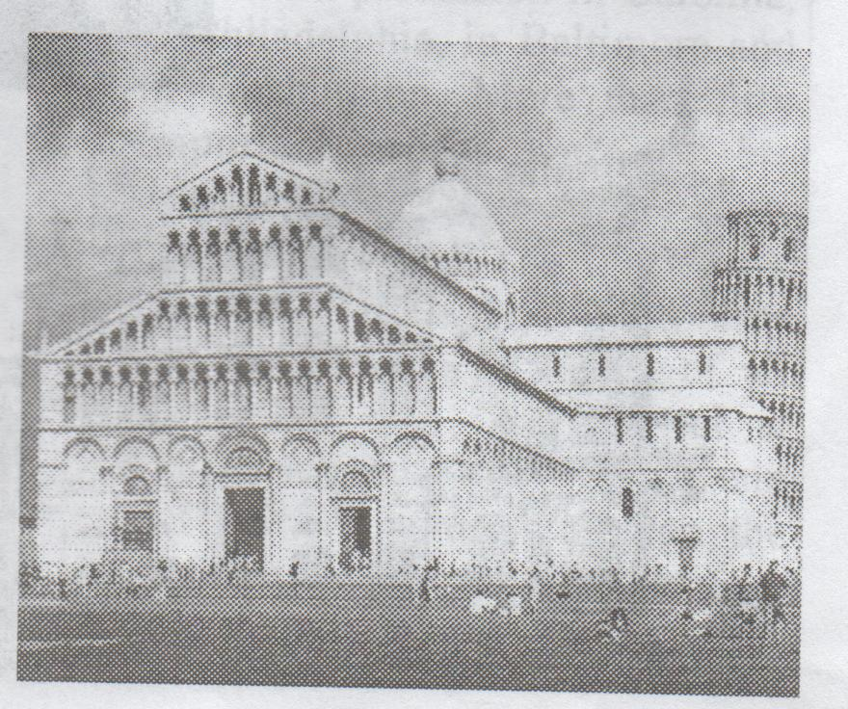

Додаток №3.
Name the architectural styles of the following buildings.
The Temple of Apollo at Corinth (7th c. B.C.)
The Rheims Cathedral (1211-1430)
The Cathedral of Notre-Dame de Paris (12th c.)
Leaning Tower of Pisa (1063-1350)
Sultan Hassan Mosque (1356-1363)
Taj Mahal (1630-1653)
Versailles (17th-18th c. c)
The Winter Palace in St. Petersburg (1754-1764)
Arch of the former General Headquarter Building in St.Petersburg (1819-1829)
Hongkong and Shanghai Bank (1979-1986)
Millennium Dome (1999)
St.Sofia Cathedral (11th-18th A.D.)

Додаток №4.
Read and translate the text.
SIGNATURE BUILDINGS
From signature buildings to the designs of the new urbanists the trends in architecture today are wide-ranging, in style, materials, aesthetics and practicality. It probably began with the Guggenheim Museum in Bilbao. American architect Frank O. Gehry designed an incredible building from curving pieces of metal. The building put the Spanish city on the map. Now people come from all over the world, not just to visit the museum itself, or even the city of Bilbao, but just to see the building.
Since the success of this building, many other cities have tried putting up incredible buildings in an attempt to make themselves become more well-known. These buildings are called 'signature' buildings.
In the hunt for signature buildings, a few architects have become very famous.
Frank O.Gehry as well as the Guggenheim in Bilbao, Gehry has also designed the Experience Music Project in Seattle and D.G.Bank in the centre of Berlin.
Daniel Libeskind – this architect became famous for his Jewish Museum in Berlin and the Imperial War Museum North in Manchester. His project of a memorial tower to mark the site of the Twin Towers in New York was the winner of competition I 2003.
Norman Foster – this British architect has recently built the Millennium and Swiss Rebuilding in London. People have called this building the “gherkin” because of its shape. It has changed London’s skyline.
Renzo Piano – this Italian architect designed the Pompidou Centre in Paris (together with Norman Foster), and has recently built a new Auditorium for music in Rome, a church dedicated to Padre Pio in Puglia in Southern Italy and Kansai in Osaka.
There are also younger architects, like the British Future System group who built Selfridges department store in Birmingham. Nicknamed the”Blob”, this looks like something out of a science fiction film.their next project is underground station in Naples with the sculptor Anish Kapoor.
Such incredible architecture is now largely possible due to computer programmes which make it possible to design and construct buildings which, even only 20 years ago, would have remained the pure fantasy of artists and architects.
Is it all looking bright for brave new architecture? Well - there are problems. Calatrava's buildings in Greece have reportedly left the Greek government with huge debts still to pay, and while Foster's gherkin building in London has transformed the city's skyline, it is still half empty. One critic says the gherkin has been an aesthetic triumph but a commercial flop.
Додаток №5.
Answer the following questions.
- Which building began the history of designing signature buildings?
- Why do cities hunt for signature buildings?
- What is meant by signature buildings?
- Why is it possible to construct such buildings nowadays?
- Would you name any signature building in your city?
- Who are the architects of signature buildings?
- Why is it important to have a signature building in your city?
Match each word in one section with its translation in another.
1.To remain | a.містобудівник
2. skyline | b.борг
3. Wide-ranging | c.залишатися
4. attempt | d.згідно з повідомленнями
5. nickname | e.широкомасштабний
6. gherkin | f.спроба, намагання
7. urbanist | g.прізвисько
8. reportedly | h.дрібний огірок
9.hunt | i.горизонт
10. pure | j.чистий
11. blob | k.крапля, маленька кулька
12. debt | l.пошуки
13.To curve | m.вигинати
Match each word with its definition.
1.to curve | a) an area of ground on which something is located
2.site | b) an act of hunting
3.to dedicate | c) to form into a curve
4.nickname | d) to be in the same place or condition during further time
5.urbanist | e) the state of owing money
6.signature building | f) a name given to someone, especially by their friends or family
7.wide-range | g) a well-known to the public building
8.to remain | h) covering an extensive range
9.hunt | i) specialist in city studies
10.debt | j) to give all your attention and effort to one particular thing

Find the synonyms for the given words.
1) To put up | a) Effort, try
2)To curve | b) Search, look for
3)Attempt | c) To bend, to turn
4)To mark | d) To erect
5)Blob | e) Monumental, commemorative
6)Hunt | f) Horizon
7)Memorial | g) To devote, to commit, to give
8)Due to | h) To indicate, to label
9)To dedicate | Place, location, area
10)Site | Drop
11)Skyline | On account of, as a result of

Додаток №6.
Choose the right answer:
- The Guggenheim Museum in Bilbao
a) started the trend for signature buildings
b) was Frank Gehry’s first building
c) was designed but never built
d) was not a success.
- The fashion for signature buildings has
a) been bad for a lot of cities
b) caused an increase in building work around the world
c) made some architects become very famous
d) only become possible thanks to computers.
- What is the meaning of the word “gherkin” in the text?
a) a department store in Birmingham
b) a kind of pickled cucumber
c) an unusual shaped building in London
d) Norman Foster’s nickname.
- Santiago Calatrava’s buildings for the Olympic Games
a) are the same as the Pompidou centre
b) have cost the Greek government a lot of money
c) were all bridges
d) were of Spanish style.
- A lot of new architecture
a) has had commercial problems
b) is all ugly
c) has to have a funny nickname
d) is pure fantasy.

