“RED RIDING HOOD”

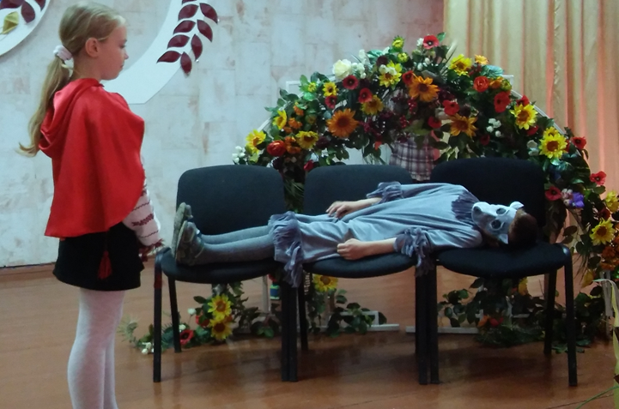

Objectives :
• to develop pupils’ speaking and listening skills;
• to develop pupils’ imagination, visual memory;
Characters:
Red Riding Hood, Mother, Grandmother, Wolf, Hares, Hunters, Author.

Scene I

Author:
Once upon a time there was a little girl who was loved by all who knew her. Her grandmother made her a little red cloak with a red hood. She often wore it, so people called her Red Riding Hood. One day her mother said to her.

Mother:
The sun is shining! The sky is blue! It isn’t raining! It’s a lovely day! Red Riding Hood! Red Riding Hood! Where are you?

Red Riding Hood:
I’m here, mother.

Mother:
Red Riding Hood! Take a basket of cakes to your grandmother. She isn’t very well. Don’t run, but don’t go too slowly. Go quickly! Don’t talk to anybody in the wood! Kiss your Grandmother and give her my love.

Red Riding Hood:
All right, Mummy!

Mother:
Good bye, Red Riding Hood!

Red Riding Hood:
Good bye! See you soon!

Scene II

Red Riding Hood:

My dear, dear Granny
Let me kiss your face,
I want you to be happy
Today and always.
Be happy, be happy
Today and always,
Be happy, be happy
Today and always.
Wolf:
Tick-tock, tick-tock
Says the clock
Tock-tick, tock-tick
What you have to do, do quick.

Wolf:
Where are you going, little girl?

Red Riding Hood:
Who are you? What is your name?

Wolf:
I'm Mr. Wolf. I live in the wood. And what's your name, little girl?

Red Riding Hood:
All call me Red Riding Hood. I live with my Mother.

Wolf:
Oh, Red Riding Hood. Good morning, Red Riding Hood!

Red Riding Hood:
Good morning, Wolf!

Wolf:
I’m glad to see you, Red Riding Hood!

Red Riding Hood:
I m glad to see you too, Wolf.

Wolf:
Where are going, Red Riding Hood?

Red Riding Hood:
I`m going to visit to my Grandmother, she is not very well.

Wolf:
What have you in your basket?

Red Riding Hood:
Some cakes to my Grandmother.

Wolf:
Oh, my dear, I can show you the shortest way. Go this way, Red Riding Hood. And now good-bye. I cannot go with you. I have something very important to do.

Red Riding Hood:
Thank you, Mr. Wolf. Good-bye!

Author:
But Wolf wanted to eat her Grandmother and decided to run to her house. He chose the shortest way and showed the longest way to Red Riding Hood.

Wolf:
Good bye!

Hares:

This is the way we wash our pads
Wash our pads, wash our pads.
This is the way we wash our pads
On a warm and summer morning!
This is the way
We wash our snout
Wash, our snout
Wash our snout.
This is the way
We wash our snout
On a warm and summer morning!
This is the way
We wash our ears,
Wash our ears.
Wash our ears.
This is the way
We wash our ears
On a warm and summer morning.

Scene III

Author:
So Red Riding Hood saw many lovely flowers and she began to pick the flowers. She listened to the birds in the trees but at this time Wolf went to the Grandmother’s house. And he ate the Grandmother. Soon Red Riding Hood came to her Grandmother’s house.
Wolf:
Who are you?

Red Riding Hood:
It’s me Red Riding Hood.

Wolf:
Come in, Red Riding Hood.

Red Riding Hood:
Good morning, Grandmother.

Wolf:
Good morning, Red Riding Hood.

Red Riding Hood:
How are you, Grandmother?

Wolf:
Fine, thanks.

Author:
But her Grandmother looked very strange.

Wolf:
I have a cold. I am quite ill.

Red Riding Hood:
Here are some presents for you, Granny! Some cakes, some berries and flowers.
Wolf:
Come here, child.

Wolf:
I like food,
I like eating lots and lots of food.
I like food,
I like eating lots and lots of food.
Bread and jam, and meat, and fish,
Cakes and biscuits too.
Beans and mustard, eggs and chips,
Mutton steaks, potatoes, peas,
And salted mushrooms too.
I like food,
I like eating lots and lots of food.
I like food,
I like eating lots and lots of food.
Cabbage, tomatoes, lettuce leaves,
Chocolate and cheese,
Toast and butter, soup and spices,
Onions, cereal, cucumber slices,
Marrows, pumpkins, beets.
Don’t forget I also like drinking, when I eat:
Coffee, tea and orange soda,
Fruity lemonade, coca-cola,
Sugar makes them sweet.
I like food,
I like eating lots and lots of food.
I like food,
I like eating lots and lots of food.
Some more, please.

Red Riding Hood:
Oh, Granny, Granny. What big ears you have?

Wolf:
The better to hear you with, my dear!

Red Riding Hood:
Oh, Granny, Granny. What big eyes to have?

Wolf:
The better to see you with, my dear.

Red Riding Hood:
Granny, Granny, what big hands you have?

Wolf:
The better to hug you with, my dear.

Red Riding Hood:
Oh, Granny, Granny, what big teeth you have?

Wolf:
The better to eat you with, my dear.

Red Riding Hood:
And you will eat me?! You ate my Granny and now you are going to eat me?!
Wolf:
Of course!

Red Riding Hood:
A-a-a-a-a!! Help me! Anybody, help!

The 1st Hunter:
Oh, it’s a wolf.

The 2nd Hunter:
Wolf done many bad things. Let’s kill.

Author:
At the same time Hunters went past the house. They heard the cry. Came to the house and killed the Wolf. Hunters saved the girl and her Grandmother.

Grandmother:
Good day, my dear Red Riding Hood! So I am glad to see you!

Red Riding Hood:
Good day, Granny! I have a present for you!
Grandmother:
It's wonderful!

