Theme: Makeup Essentials
Lesson aim: practice the use of thematic vocabulary; enable learners to apply it properly.
Objectives (teacher intentions): introduce essential vocabulary; do matching tasks; encourage learners to make a report; facilitate discussions between learners while reporting; check learners’ understanding of active vocabulary while listening; develop learners' ability to fill out a sale advertisement.
Learning outcomes: learners know and apply active vocabulary while practising; learners can scan the text, define the necessary parts of required information and list it; learners demonstrate the ability to create an advertisement using the suggested pattern; develop learners’ cognitive, verbal, intellectual skills.
By the end of the lesson learners will be able to: identify and name the basic makeup products used at a beauty salon; report about main features of day/night makeup; fill out the advertisement “New Items on Sale” accurately including relevant item details and definitions.
Textbook: “Career Paths. Beauty Salon” Jenny Dooley, Virginia Evans
Stage | Activity | Purpose | Procedure |  | Timing/mode of interaction | Materials
Stage | Activity | Purpose | Learners | Teacher | Timing/mode of interaction | Materials
Pre-task | Answer the questions | Practice learners’  relevant vocabulary | Revise lexical material relevant to lesson’s theme | Present the topic and give instructions on the task. The teacher can also introduce some vocabulary that will be useful to students while they complete the task | 2 min/  brainstorm | Questions
Introduction to topic and task | Match | Practice the active vocabulary | Apply thematic vocabulary, work with definitions of makeup products | Monitor the learners’ progress, help if it is needed, check the suggested ideas | 3 min/pair work | LearningApps Task
Introduction to topic and task | Match | Practice the active vocabulary |  |  | 5 min/pair work | Padlet Task
Task cycle
Task | Prepare a report | Scan the text, define the necessary parts of required information and list it | Work in groups, use active vocabulary and practise it verbally and collaboratively | Make sure students know exactly what to do during the task-based learning activity. Monitor the learners’ progress and offer encouragement or help where needed | 2 min/whole class work | Photos
 |  |  |  |  | 10 min/group work | Texts with instructions
Planning |  | Organize proper conditions for group work | Share responsibilities | Form 2 groups, offer support and help | 1 min/group work
Reporting | Report presentation | Encourage learners to make and deliver a report | Report back to the class | Give the feedback | 4 min/  individual/group work | Prepared reports
Language focus
Analysis | Discussion | Analyze the achievements of learners. Speak on language areas/aspects which need improvement | Discuss specific features of the task, how they approached them and what language skills were needed | Take elements from each of the learners’ reports and highlight the important or interesting parts | 2 min/learners’ reflection | Questions
Practice | Listening | Check the learners’ understanding of active vocabulary | Do some activities to improve their knowledge and confidence and see problematic language areas | Select important areas of the language that need extended practice | 5min/individual work | Audio, post-listening tasks
Practice | Writing | Develop the learners’ ability to create an advertisement using the suggested pattern |  |  | 7 min/pair work | Advertisement pattern
Ending the lesson
Feedback | Conversation | Motivate students to go ahead and improve their skills, praise them for their work | Speak about their emotions, relevant goals and needs. | Encourage students to share impressions, speak about their needs | 3 min/the whole class
Set homework | Create a dialogue (pair work) | Encourage students to practice dialogue speaking | Refer to a pattern and create a dialogue, practise speaking skills | Explain how to perform the task | 1min | Dialogue pattern

Procedure
- Pre-task (2 minutes).
Imagine a situation: you work a beautician at a reputable beauty salon. One day you had to deal with a foreign customer who was waiting for his wife (she was being made up) and asking you different questions. Let’s answer two of them:
- Why do women like to wear makeup?
- What kinds of makeup can women prefer?
Introduction to topic and task.
Pupils, as you’ve understood we are going to speak about makeup. At the end of the lesson, you are expected to know the names of makeup products, describe the difference between day and night makeup.
Vocabulary Practice (8 minutes).
Let’s work in pairs. Your first task is to label the makeup products, using the QR-code below. I think 3 minutes will be enough. Task is presented in LearningApps. 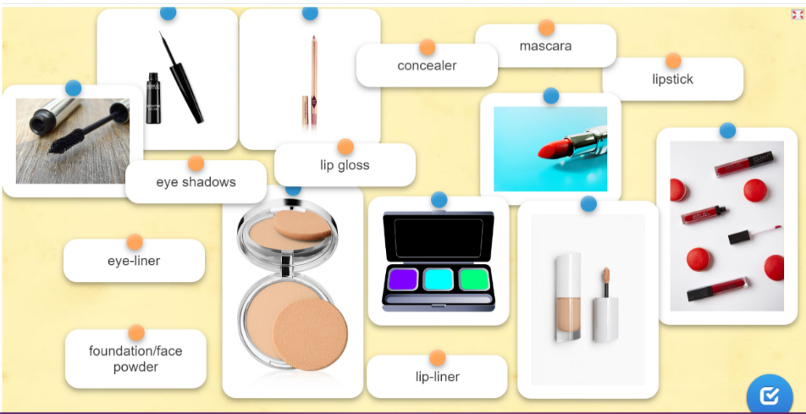 
Your second task is to match the makeup products with their definitions. You are expected to work with “My distinguished sandbox” in Padlet. Use the suggested QR-code. Your time limit is 5 minutes.
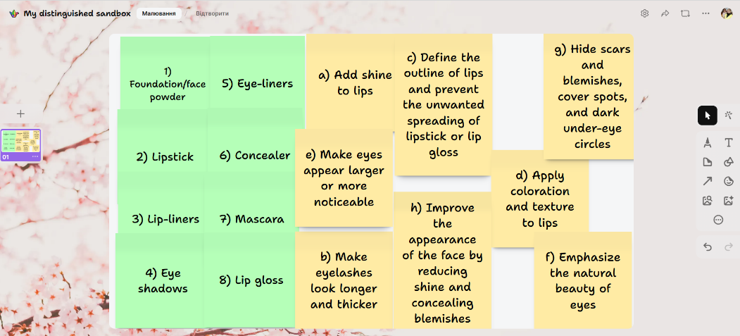

- Foundation/face powder | - Add shine to lips
- Lipstick | - Make eyelashes look longer and thicker
- Lip-liners | - Define the outline of lips and prevent the unwanted spreading of lipstick or lip gloss
- Eye shadows | - Apply coloration and texture to lips
- Eye-liners | - Make eyes appear larger or more noticeable
- Concealer | - Emphasize the natural beauty of eyes
- Mascara | - Hide scars and blemishes, cover spots, and dark under-eye circles
- Lip gloss | - Improve the appearance of the face by reducing shine and concealing blemishes
Keys:
1. H 2. D 3. C 4. F 5. E 6.G 7. B 8. A
2) Task cycle (2 minutes).
Look at the photos and say:
- which of them demonstrate day makeup?
- which of them demonstrate night makeup?
Explain your choice in 3-4 sentences.
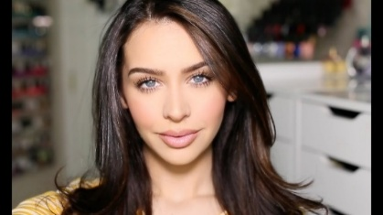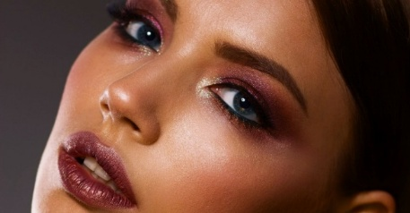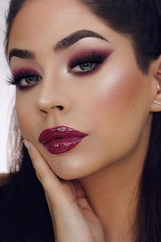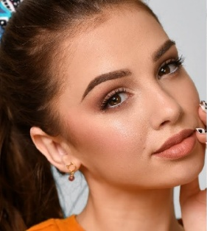
4
3
2
1

Makeup Word Bank by Category

Base / Foundation
Day Makeup | Night Makeup
- lightweight foundation  - natural glow  - minimal powder | - full coverage foundation  - setting powder  - high-impact glow  - concealer for extra coverage
Eyes
Day Makeup | Night Makeup
- neutral eyeshadow shades (beige, taupe, soft brown)  - light mascara  - soft eyeliner (brown or nude)  - natural brows | - smoky eyeshadow  - bold eyeliner (black, winged)  - volumizing mascara or false lashes  - defined brows

Lips
Day Makeup | Night Makeup
- nude lipstick  - soft pink or peach tones  - tinted lip balm or gloss | - deep red, berry, or wine lipstick  - matte or satin finish  - lip liner for definition
Cheeks
Day Makeup | Night Makeup
- soft pink or coral blush  - light bronzer for warmth  - natural flush | - richer blush tones (rose, plum)  - shimmering highlighter  - sculpted cheekbones
Speaking task. Group work (10 minutes).
I suggest working in 2 groups. Group 1, you work with the text “All You Need to Know About Day Makeup”. Group 2, you are going to deal with the text “All You Need to Know About Night Makeup”
Your task is to scan the texts and be ready to prepare a report about:
- products day/night makeup include;
- color range dominating in day/night makeup;
- aim of day/night makeup;
- features of day/night makeup.
Your report should consist of 8 sentences. You have 10 minutes to do it.
Planning.
I give you 1 minute to choose
- a time moderator;
- a spokesperson who will do reporting;
- 3-5 learners for scanning the text information;
- 1 person who will make notes.
Do you understand clearly what you are going to do?
(Students answers)

All You Need to Know About Day Makeup
The main difference between day makeup and night makeup is the color range. Daytime makeup tends to be lighter and more natural-looking than nighttime makeup because it needs to be versatile; it should still look good at the end of the day. Nighttime makeup is usually darker, richer, and more dramatic because it doesn’t need to last all night long.
Another critical difference between daytime and nighttime makeup is whether or not you use foundation. Foundation is typically used on special occasions, like weddings or if you have visible acne scarring. Foundation tends not to work well during the day if you’re going out somewhere with lots of sunlight.
Day makeup is the term used to refer to light, natural-looking makeup looks that you can wear during the day. Day makeup looks are usually characterized by a natural base, with a light application of blush and bronzer for color. Eye makeup tends to be minimal as well, either just mascara or maybe a soft eyeliner.
The aim is to let your natural features shine through, rather than covering them up with heavy products. Many women wear this type of makeup because it’s easy to put on and take off and doesn’t require much time or effort.
Day makeup includes all the same products as nighttime makeup, but they’re used differently.
Eye shadow is another essential part of day makeup because it helps open up your eyes more than they already are naturally. Eye shadow with shimmering tones such as gold, silver or bronze makes eyes appear larger than they are.
The first and foremost feature of day makeup is its natural matte look. It gives you a natural look, rather than an artificial one. Other features are flawless skin and non-greasy look.
All You Need to Know About Night Makeup
The main difference between day makeup and night makeup is the color range. Daytime makeup tends to be lighter and more natural-looking than nighttime makeup because it needs to be versatile; it should still look good at the end of the day. Nighttime makeup is usually darker, richer, and more dramatic because it doesn’t need to last all night long.
Another critical difference between daytime and nighttime makeup is whether or not you use foundation. Foundation is typically used on special occasions, like weddings or if you have visible acne scarring. Foundation tends not to work well during the day if you’re going out somewhere with lots of sunlight.
Night makeup is makeup that you wear at night. As the name suggests, the idea of night makeup is to look good when you’re out at night.
There are many different types of night makeup that women use every day. Some examples include mascara, eye shadow and lipstick.
Nighttime doesn’t mean you have to cover up your face entirely with a ton of foundation and concealer. You can still wear some eye-shadow or lip gloss if you want to look great.
Highlighters are also very important with night makeup because they bring out the best features in your face without too much work.
Night makeup is a type of makeup used for special occasions or parties.
Its main features are larger eyes which can be achieved with dark colors like black, grey and brown and more dramatic lips (use bold lip colors such as reds, oranges and pinks).
Reporting.
I am willing to listen to your reports. The spokesperson of each group is going to have 2 minutes for presenting his/her ideas.
- The reporter of group 1, you are welcome.
(Report 1)
- Group 2, do you have any questions to group 1 concerning their report?
(Possible questions)
- The reporter of group 2, please.
(Report 2)
- Group 1, do you want to ask some questions group 2 after listening to their report?
(Possible questions)
3) Language focus.
Analysis (2 minutes).
- Was it easy to you to perform this task?
- Which part of the report provoked the biggest discussion?
- What language skills were necessary to do most of the task successfully?
Practice.
Listening (5 minutes). AUDIO
We are going to practice the understanding of our thematic material while listening. You will work individually.
The task is to listen to the dialogue.
Do ex 6 after the 1st listening.
Do ex 7 after the 2nd one.
Listen to a conversation between two makeup artists. Then, choose the correct answers.
  - According to the dialogue, what is one of the benefits of using a Contessa's lipstick?
A It defines lips.
B It tastes nice.
C It does not need re-applying.
D It looks glossy.
2 Which of the following products is NOT mentioned in the dialogue?
A lip gloss
B concealer
C lipstick
D foundation
Listen again and complete the conversation.
Makeup Artist 1: Hi, Alex. I 1 _______ _______ Contessa Cosmetic's fall line is now available.
Makeup Artist 2: Really? I love Contessa's products. They're so glamorous!
Makeup Artist 1: Me, too. Which product is your 2 _________?
Makeup Artist 2: Hmm... It's so hard to 3 ________. My clients love their smooth 4 and fruity lip glosses.
Makeup Artist 1: My favorite is their bright 5 _________.
Makeup Artist 2: What do you like about them?
Makeup Artist 1: They 6 _________ all day.
Makeup Artist 2: Really? I'll take a look when I'm next in town.
Writing (7 minutes).
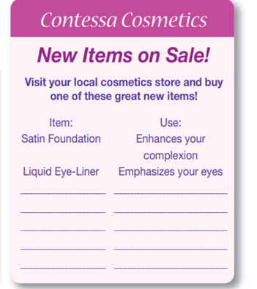
Let’s work in pairs again. Look at the suggested pattern. Your task is to fill out a sale advertisement. You should add 3 more makeup items and explain the aim of their use. You have 7 minutes to complete this task.

4) Feedback (3 minutes).
How well did you understand today's lesson?
What is the most difficult question you have about what you learned today?
How could the knowledge you learned today be used in the real world?
What is one thing you would like to practice again?
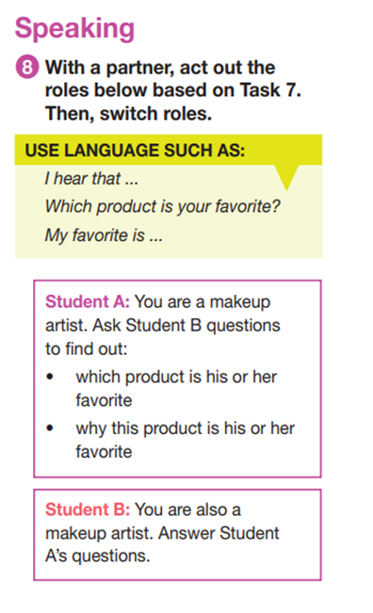
5) Set homework (1 minute).
Our next lesson we are going to start with dialogue speaking. To have such an opportunity you should work in pairs and create a dialogue using the pattern in Task 7 and directions given in Task 8. Your dialogue must involve 6 questions and 6 possible answers.

