Міністерство освіти і науки України
Професійно-технічне училище №6

Онлайн - олімпіада з англійської мови за програмою рівня стандарт для закладів професійної (професійно-технічної) освіти
2021-2022 навчальний рік
11 клас

Час виконання: 45 хв.

Викладач англійської мови Науменко Тетяна Анатоліївна
Спеціаліст вищої категорії, викладач-методист

м.Дніпро

1-8. Check your grammar.

1. Rice _____ in Britain.
a) does not grow
b) is not grow
c) has not growing
1 бал

2. There was _____ puddle on _____ floor.
a) a, -
b) the, the
c) a, the
1 бал

3. Are you going _____ home now?
a) to
b) -
c) at
1 бал

4. I want _____ a new car.
a) buying
b) buy
c) to buy
1 бал

5. I go _____ work _____ bus.
a) to, on
b) to, by
c) on, on
1 бал

6. There ___________ some interesting articles in the newspaper.
a) have
b) has
c) is
d) are
1 бал

7. Where is your mother? She ________ tea in the kitchen now.
a) drinks
b) has drunk
c) is drinking
d) drank
1 бал

8. A boat is __________ than a ship.
a) as small
b) the smallest
c) smaller
d) small
1 бал

9. Complete the sentence
Now mobile phones are a portable computer, there are a lot of …. that can be done by using mobile phones easily
a) invention
b) activities
c) device
d) сommunication
2 бала

10-12.Mark the problem connected with mobile phones which is represented in this picture.
10.
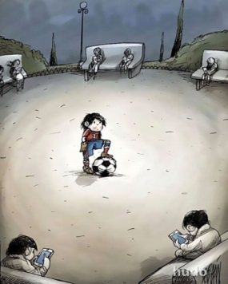
a) Mobil Phone Cause Health Problems
b) Mobile Phones Cause Isolation
c) Mobile Phones Cause Accidents
d) Mobile Phone Distraction
2 бала
11.
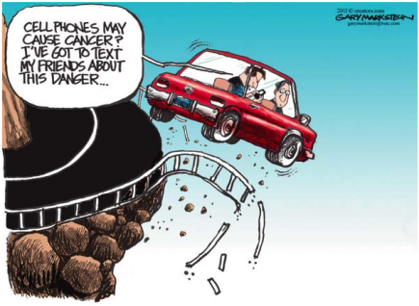

a) Mobile Phone Cause Distance from Relatives
b) Mobile Phone Cyberbullying
c) Mobile Phone Wastage of Time
d) Mobile Phones Cause Accidents
2 бала
12.
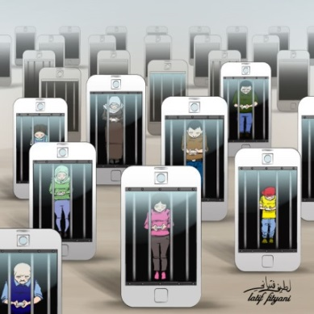

a) Sleeping Issues
b) Study Loss Due to High Usage of Mobile Phones
c) Mobile Phone Addiction
d) Mobile Phones Cause Accidents
2 бала
13. Match the paragraph with its heading:
The new mobile phones have big storage which can store a lot of data in GBs. Students can store their data information, books, magazines, assignments, etc. Mobile phones have internet accessing capabilities, students from anywhere can easily access different kinds of educational websites through the internet on their mobile phones. Also, there are a lot of education applications that can be installed on mobile phones by which students can easily get help and collect the relevant information. Different kinds of language dictionaries, translators, and other learning applications are available in the play store of mobile phones.
a) Mobile Phone as a Source of Communications
b) Mobile Phone as a Source of Information
c) Mobile Phone Save Life in an Emergency
d) More-Responsible Children
3 бала
14-17. Complete the sentences:
14. IT skills are...
a) Needed for everyone
b) Abilities to work with Information Technologies
c) Abilities to cook
d) Not actual nowadays
2 бала
15. Liza has an... of working as an interpreter for 7 years
a) Application
b) Experience
c) Master's Degree
d) Salary
2 бала
16. My elder brother Denis is a manager. His job is...
a) Old- fashioned
b) Well- paid
c) Not popular
d) Not necessary
2 бала
17. My cousin Kelly is an interpreter. She gets a good...
a) Food
b) Help
c) Attitude
d) Salary
2 бала
18-19. Choose the appropriate noun:
18. green house
a) affect
b) effect
1 бал
19. global
a) warning
b) warming
1 бал

20.
Use the plan below to write a for-and-against essay (at least 100 words) about
advantages and disadvantages of social networking. Use the plan below:

Write:
- State the topic.
- Define points for social networking.
- Define points against social networking.
- Sum up the advantages and disadvantages of social networking.

Write an essay of at least 100 words.

_________________________________________________________________________________________________________________________________________________________________________________________________________________________________________________________________________________________________________________________________________________________________________________________________________________________________________________________________________________________________________________________________________________________________________________________________________________________________________________________________________________________________________________________________________________________________________________________________________________________________________________________________________________________________________________________________________________________________________________________________________________________________________
____________________________________________________________________________________________________________________________________________________________________________________________________________________________________________________________________________________________________________________

Усього балів: 29 балів

