Маріупольське вище металургійне професійне училище

Методична розробка відкритого уроку
Англійської мови
Викладач Савіна Ольга Валентинівна
Тема “ Видатні художники сучасності”

Маріуполь 2019

План уроку.
Тема програми: «Мистецтво»
Тема: «Видатні художники сучасності».
Тип уроку: Урок введення та закріплення нових знань .
Вид уроку: урок –поглиблення у мистецтво.
Мета:
- Надати учням цікаву інформацію щодо сучасних художників,
- Удосконалювати вживання у мові учнів тематичну лексику та висловлювати свої думки на основі лексико-граматичного матеріалу,
- Вчити учнів на практиці застосовувати набуті знання, вміння та навички,
- Розвивати навички діалогічного мовлення та комунікативних здібностей,
- Розвивати критичне мислення та креативні здібності учнів,
- Виховувати любов учнів до вивчення іноземної мови,
- Виховувати почуття цікавості щодо різних видів мистецтв та спрагу дізнаватись нове.
Матеріально – технічне забезпечення :мультимедійний проектор, телевізійний екран, презентації за темою в програмі Power Point.
Хід уроку
- Організаційний момент ( 1 хв.)
Перевірка наявності учнів. Перевірка учнів готовності до уроку.
T: Hello, my dear friends. I see everyone is ready. We start our lesson. We have very curious and creative theme for today and some interesting tasks. So be attentive!
- Актуалізація опорних знань учнів. (5 хв.)
Повідомлення теми програми і уроку.
T: Today we are going to talk about contemporary artist and their influence on people’s mentality. You will listen to me, I am going to tell you interesting information about artists and this way you’ll train and develop your listening skills. We’ll also develop our communicative skills while talking a little bit and thinking. That is very important while learning the language. We’ll play the dialogue and find out a lot of new. So let’s start! Before I begin telling you about modern artists, I want to ask- why do people make art?
P1: To earn money
P2: To enjoy
P3: To create something new
P4: For self-expression
P5: To reveal their talent
T: Ok, thank you. You’re right. We’ll watch the short video concerning the reasons why people create art.
Учні дивляться коротке відео. ( 1хв. 35)
- Основна частина. Прослуховування нового матеріалу. ( 10 хв.)
( From Oxford Discover Level 4)
T: Now I will tell you very interesting information about new kinds of art. So the first modern artist is Kieron Williamson. When he was five, he started to draw sketches of boats that he saw on a family trip to Cornwall, England. This was the start of Kieron’s love of drawing. The more he drew the more complex his drawing became. He spent time with local artists in his hometown of Norfolk. They helped him build his skills in drawing and painting. He now creates pictures using oil paints, pastels and watercolors. Today nine-year-old Kieron is considered to be a child prodigy. Around the world, people admire his beautiful artwork, including many famous people. The young artist said: “I like creating art because it’s fun and inspiring”
The next innovative artist is Edgar Mueller. He is an expert street painter from Germany. You can find his painting all around the world at festivals and at public walkways. His three-dimensional paintings include waterfalls, canyons and more. Mueller uses washable paint or chalk, a variety of paintbrushes and string. His work helps people to look at a place differently.
Patrick Doherty is a unique sculptor. He combines his love of nature with his skills as a carpenter. His goal is “to build a great sculpture to excite people’s imaginations”. You can see his large-scale sculptures in many places around the world. Doherty’s sculptures are made of young trees or saplings. The saplings are flexible, so he can bend them into rounded shapes. He keeps them together by weaving the saplings around each other. Building the sculpture is a great job, so local community helps Doherty with his project. Many volunteers help to collect the saplings, mark out the space and build the sculpture. The sculptures are temporary. They will decompose or break down over time.
The next one is Sung Hee Cho. When you look at her artwork, you see small pieces of brightly colored paper on a large canvas. It may seem disorderly with colors scattered around. However, if you step back, you can imagine the stars, galaxies and the beauty of the universe. Cho combines traditional Korean paper with paint. First, she paints the canvas. Then she cuts out pieces of hanji into small shapes, such as flower petals. Next, she dyes and paints the small pieces of paper into a different color. The she glues thousands of them onto the canvas in layers to capture the glimmer of light. She repeats this process over and over again. She wants to create artwork that is as magical as stars.
Виконання завдань ( 7 хв.)
So what artist would you like to talk to? What questions would you ask him or her?
P1
P2
P3
T: You have listened to a new information and now I want you to do some tasks and answer the questions.
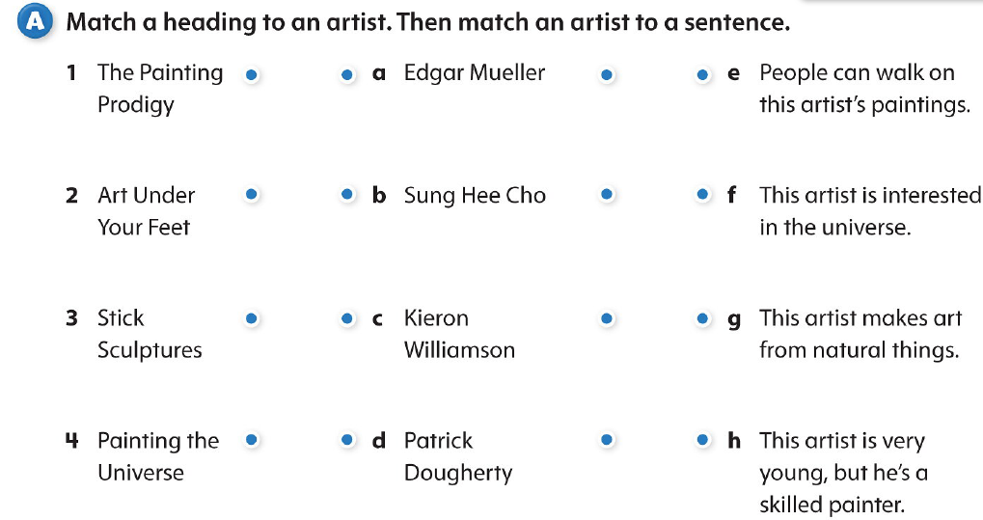
Task B. Answer the questions:
- Who helped Kieron Williamson build his skills?
- How do people become a part of an Edgar Mueller painting?
- Who helps Patrick Doherty build his sculptures?
- What is the Korean name for the paper Sung Hee Cho uses?
- What is your favorite type of art to create? Why do you create it?
T: Thank you. Let’s go further. Our pupils prepared some interesting dialogues concerning new kinds of art.
Інсценування діалогів ( 4 хв.)
Dialogue 1
Journalist: Tell us a little bit about yourself.
Painter: My name is Robert Aswani. I was born in 1971 in Kenya. I taught myself to draw and paint as a boy.
Journalist: Did you paint at school?
Painter: Yes, my teachers often asked me to draw sketches on the blackboard. I always painted colorful paintings after I visited the African markets with my mum.
Journalist: What do you paint now? What tools do you use?
Painter: I use paintbrushes and a canvas to show beautiful scenery of Africa. This scenes include sunrises and sunsets, markets and the life of Maasai people of Kenya.
Journalist: What people buy your paintings?
Painter: People all around the world buy my paintings.
Journalist: Thank you for an interview. I wish you a productive work.
Dialogue 2.
Journalist: Tell us about yourself.
Sculptor: My name is Robert Wise. I am a manager of a garbage company in California and I see how many things people throw away.
Journalist: What did you decide to do?
Sculptor: I started to turn people’s trash into beautiful three-dimensional works of art.
Journalist: Oh, that’s a great idea!
Sculptor: The city of Fortuna, California has three of my sculptures on display.
Journalist: Do you have awards?
Sculptor: Yes, I have some awards. I don’t see waste. I see potential.
Прослуховування пісні ( 7 хв.)
T: Thank you. It was very interesting to listen to you. Now we will listen to a song about art. There are some missing words and your task is to hear them.

Work of art.
Everyday is like a blank _1______
You know you can paint it anyway you want it
You can draw a black __2_____
You can make the sun __3_____
Coloring a___45_____
or use black and white
Open up your eyes and your _6_______
Come on let's write a __7____
A little _____8____
Take a ___9_______
Let's make some ___10____
You can make it anything
That you want it to be
If you follow your __11_____
Life is a work of ___12_____
Oh every night is like looking at a dark _13_____
You're never too young or too old to ___14____
You can make a fantasy into a ____15____
'Cause you're creating your own _____16_________
Close your eyes and dream it
Seeing is ____17____
Come on let's write a ___18___
A little ___19____
Take a ___20_____
Let's make some ___21____
You can make it anything
That you want it to be
If you follow your ___22_____
Life is a work of ___23___
Turn a simple thought into a __24_____
Turn a star into a __25_____
Make a little noise into a __26______
You're creating a ____27___
Missing words:
Cloud canvas photograph imagination galaxy dream poetry
Shine symphony memories rainbow screen masterpiece Galaxy heart art reality imagination song philosophy believing
T: What is this song about?
P: This song is about creating a masterpiece. When you have imagination, you can create a symphony, write a song or a poetry. We are never too old to dream.
T: Ok. Thank you. It was very impressive. I want you to remember it- use your imagination and your creativity. Everyone is talented, everyone is unique.
T: Today we have a special guest. This guest will tell us about his life, artist’s life.
Прослуховування поеми про життя художника та інтерв’ю з художником ( 4 хв.)
P: An Artist's Life
I thought of many pictures in my head
And in every book that I have read
I looked at the horizon
To look for an inspiration
I closed my eyes slowly
I skimmed images thoroughly
Then one light suddenly flickered
Like a giant glint of a light bulb
As I opened my eyes,
I saw a wooden table of mess
Mess made by used paints
Clutter from paintbrushes
Finishing a work of art
Is like fulfilling a life's half part
This is a story of my life
A story of an artist's life

P1: Is your life hard?
Artist: Sometimes yes, sometimes no.
P2: What do you paint?
Artist: I paint pictures from my childhood and from my imagination.
P3: What is your most famous picture?
Artist: “Galaxy”
P4: Are your pictures shown at the exhibitions?
Artist: Yes, my pictures are shown in Madrid, in Florence and soon I’ll have an exhibition in London. I invite you.
P5: Ok. Thank you. We’ll think about it.
- Підбиття підсумків. ( 4 хв.)
Аналіз діяльності учнів у процесі всього уроку
T: Ok. Thank you. Our lesson is coming to an end. Now you know a lot about art. You know some famous artists and their new trends in art. I hope it was really interesting for you. I would like you to define the level of knowledge and skills you’ve got by the end of the lesson:
- I can name some modern artists,
- I can lead a conversation on this topic,
- I can make up dialogue concerning this theme,
- I can answer the questions why people create art.
Повідомлення та обґрунтування оцінок
T: Your marks are…
Повідомлення домашнього завдання

T: Find the information about new trends in art and bring this information about new modern artists, about new directions and display us their works.

